Vocabulary

Dystopia - an imagined state or society in which there is great suffering or injustice, typically one that is totalitarian. | Utopia - an imagined place or state of things in which everything is perfect.
Divided - in disagreement. | United - joined together politically, for a common purpose, or by common feelings.
Tyrant – cruel and brutal leader | Democrat - an advocate or supporter of democracy.
Totalitarian - where the leader has complete control | Democracy – Where leaders are elected in by the public
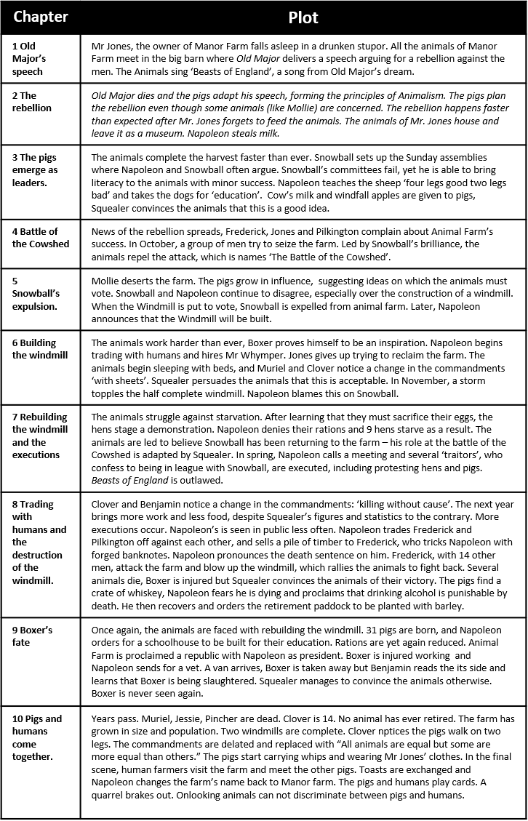
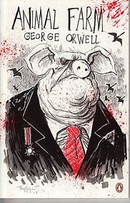
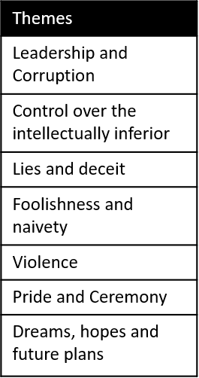
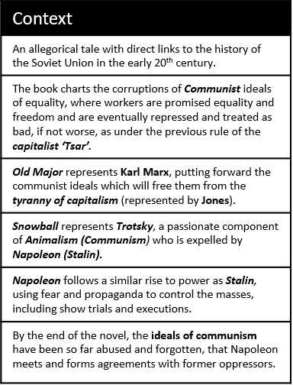
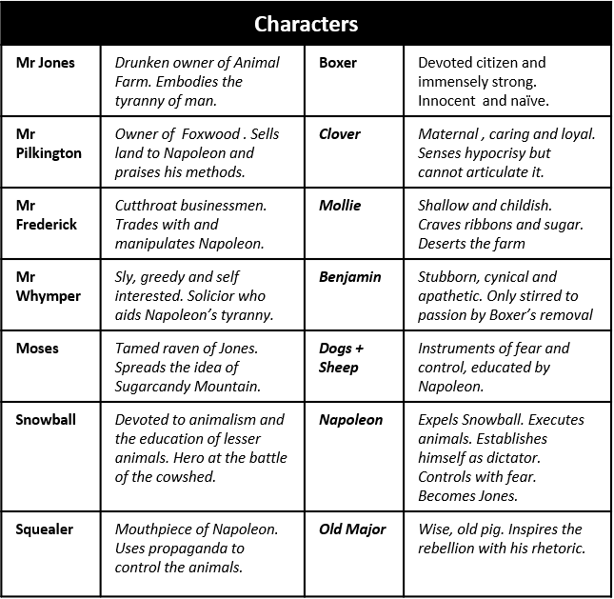
Animal Farm

