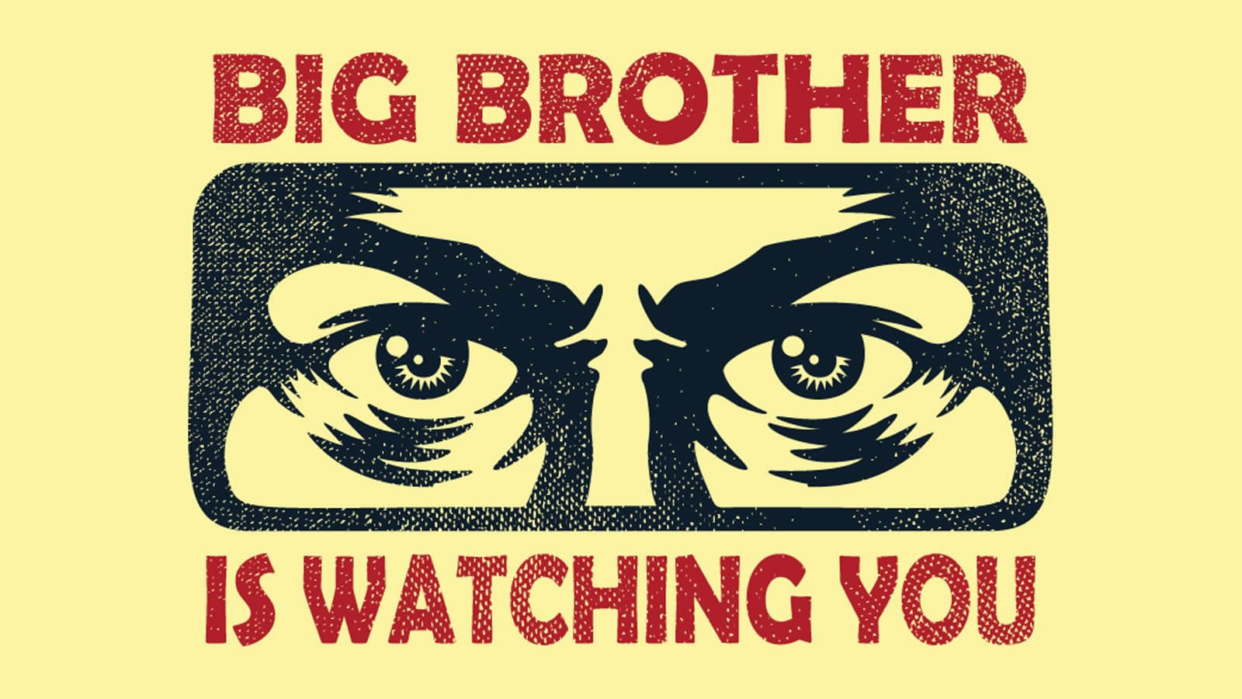

**Key Vocabulary:**

1) Credibility- How believable something really is- do we believe everything we read/hear?

2) Dominance- People taking charge and refusing to give up power

3) Turbulent- troubled and unsettling times

4) Compliance- following orders without question

5) Authoritarian/authority- those in charge/in power who do not listen to others

6) Pessimistic- Looking at life with a negative outlook

7) Optimistic- Looking at life with a positive outlook

8) Exploitation- To take advantage of those who are weaker in society.

9) Deceptive- Lying and hiding the truth

10) Oppression- To keep people down and unable to speak up for themselves.

**Key writing skills:**

Show, don’t tell – Describe things in a way that allows the reader to imagine and interpret ideas for themselves, rather than telling them explicitly what to think. For example, *the ruined city had a radioactive glow* shows, rather than tells, the reader that there has been a nuclear disaster.

Sensory description – Use the five senses when describing to recreate the character’s experience for the reader. Use show, don’t tell when doing this, avoiding clumsy phrases such as *I could see* or *I could hear*.

Contrast – Emphasise something by juxtaposing (placing) it with something that is completely different. For example, describe a character’s memory of utopia before describing the dystopia in which they live.

Drop, shift, zoom – Use this as a way of planning/structuring a description based on an image. Drop into one part of the image, shift to another focal point and then zoom into something specific.

**Key themes:**

Identity/ Loss of identity- losing who you are and what you stand for through oppression

Hope/Lack of hope- The spark inside a person to make them keep fighting and determined to survive, despite all odds.

Fragility/Frailty- exploring the vulnerabilities of mankind and society and just how a drop of weakness can change a world forever.

Power- How can people abuse power? By taking from the weak and destroying anyone who stands in their way.

**Dystopian authors we read:**

George Orwell- The trailblazer of dystopian fiction, Orwell wanted his readers to imagine worlds with oppressive governments and how far people are willing to go for power. He famously wrote the genre defining ‘1984’ as well as the commentary on the Russian revolution ‘Animal Farm’.

William Golding- Golding shows his concern for human nature and actions without consequences in his book ‘Lord of the Flies’ which looks at how people behave in a world with no social boundaries.

Margaret Atwood- Atwood explore the world where women are exploited for their basic human functions and are beaten into submission for daring to say no. Her novel ‘A Handmaid’s Tale’ is an eye opening take that has also been turned into a television series.

Kazuo Ishiguro- The novel ‘Never Let Me Go’ presents questions such as ‘What is the value of human life?’ and ‘How does our birth determine our chances and opportunities in life?’ He focuses on how we use one another and whether our destinies are predetermined or defy our roles in life.

Cormac McCarthy- A science fiction writer who imagines a post-apocalyptic world. His writing style is bare, choosing to focus on the characters and their actions after such a devastating event. ‘The Road’ which the characters follow is a symbol of everlasting hope.

Susan Collins- Collins decided to show the world how life would be if we used children to show the consequences of war. Her award winning trilogy ‘The Hunger Games’ shows how those who have nothing to lose can still summon the strength to fight back against injustice and inequality.