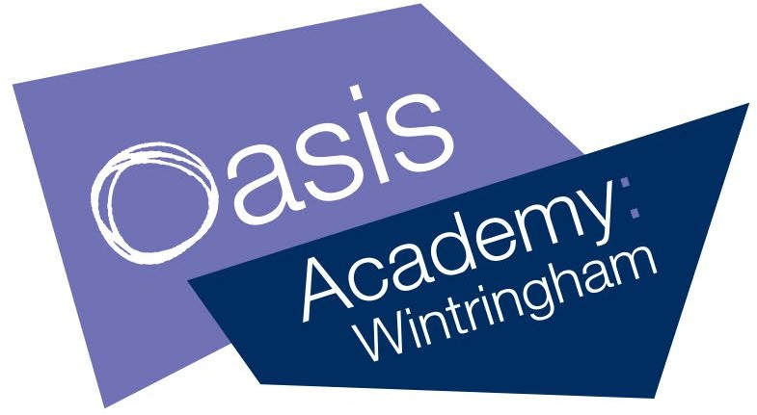

**KS3 Assessment – Head (Intellectual)**

Discuss your levels of fitness with refence to energy systems and components of fitness

Apply more complex tactics, formations and set plays to a range of sports demonstrating good knowledge of the rules and regulations

Plan and deliver activities to improve both fitness and sport performance

Describe basic rules and regulations and basic attacking/defensive tactics

Describe how and why the body moves in different sporting contexts using anatomical language

Describe how the body responds to exercise using anatomical language

Compare performances recognizing strengths and areas of

improvement

Describe your own strengths and areas of improvement in sports and fitness

Identify and implement basic formations and set plays with success