

Ensure the safety of all the players by checking equipment and playing areas.

Umpires and Referees

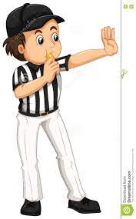

Be fit enough to keep up with the game

Hold the correct level of qualification for the level they are umpiring

Use a clear voice or blow their whistle loudly

Officiate the game and make crucial decisions when needed

Ensure a safe environment for spectators

Time the event

Keep score and produce accurate score cards for tournament organisers

Keep up to date with the most recent rules of the game and enforce them with players

Control the game and participants at all times and issue sanctions if players do not follow the rules

Wear a professional uniform so they can be clearly seen and are more respected!