Year 10 Foundation Unit 1 – Factors, multiples, and primes
Unit 1 – Factors, multiples, and primes
1.1 | Factor | A number that divides another number exactly
1.2 | Multiple | A number which is part of another number's times table
1.3 | Prime Number | A number that is only divisible by 1 and itself. Prime numbers only ever have 2 factors
1.4 | Prime factor decomposition | Expressing a number as a product of its prime factors
1.5 | HCF | Highest common factor
1.6 | LCM | Lowest common multiple

Year 10 Foundation Unit 2 – Powers and Roots
Unit 2 – Powers and Roots
2.1 | Square number | The product when an integer is multiplied by itself
2.2 | Cube number | The product when an integer is multiplied by itself twice
2.3 | The first 15 square numbers are | 1, 4, 9, 16, 25, 36, 49, 64, 81, 100, 121, 144, 169, 196, 225
2.4 | The first 5 cube numbers are | 1, 8, 27, 64, 125

Year 10 Foundation Unit 3- Indices
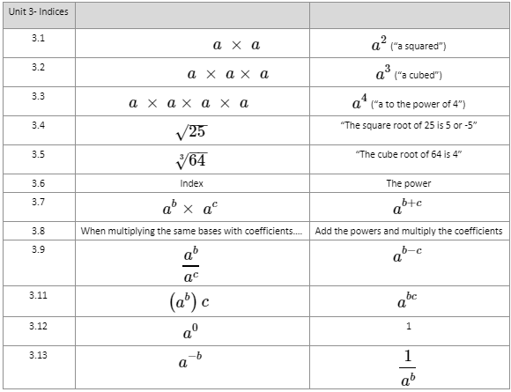

Year 10 Foundation Unit 4 – Standard Form
Unit 4 – Standard Form
4.1 | Standard form | A way of writing very big or very small numbers using powers of 10
4.2 | 10⁻² | 0.01
4.3 | 10⁻¹ | 0.1
4.4 | 10⁰ | 1
4.5 | 10¹ | 10
4.6 | 10² | 100
4.7 | 10³ | 1000
4.8 | 0.0004 | 4 x 10⁻⁴ (the number must be between 1 and 10)
4.9 | 40000 | 4 x 10⁴ (the number must be between 1 and 10)

Year 10 Foundation Unit 5 - Sequences
Unit 5 - Sequences
No. | Question | Answer
5.1 | A sequence or series is | A list of numbers that follow a pattern
5.2 | Term | A value in a sequence
5.3 | The term-to-term rule | Is how you find the next term in the sequence
5.4 | The nth term rule | Is a formula that can be used to generate any term in the sequence, this is sometimes called the position to term rule
5.5 | n | The position of a term in the sequence
5.6 | In a linear or arithmetic sequence | The difference between the terms is always the same
5.7 | In a geometric sequence | Multiply by a common ratio to get to the next term
5.8 | In a Fibonacci sequence | Add the two previous terms to get the next term
5.9 | The triangular number sequence | A sequence of numbers generated by adding one more than was added to find the previous term. For example, 1, 3, 6, 10, 15, 21, ...
5.11 | In a quadratic sequence | There is a common second difference
5.12 | a | First term in a geometric sequence
5.13 | b | Common ration
5.14 | Common ratio | The ratio between two consecutive terms in a sequence
5.15 | The nth terms of quadratic sequences are written in the form | ax²+bx+c

