Attempt some family yoga – follow the link for some free sessions

<https://hotpodyoga.com/studios/lincoln/prices/?session=23946134>

Be careful!

Challenge yourself and complete a range of fitness tests safely in your home. If you visit:

<https://www.brianmac.co.uk/eval.htm>

And scroll to the bottom there is an endless list of fitness tests you can attempt, although you will not be able to complete all of them. Why not challenge someone else and make a chart of your results over the next few weeks.

No one has beaten Mr Whiteley’s toilet roll keepy ups (don’t forget to ask though)

<https://www.youtube.com/watch?v=LRcQzT1jlVQ>

Keep your eyes pinned to our Twitter and Instagram pages to see new challenges Mr Whiteley will be setting @OAWSport and post your #healthyselfie

Recreate the clip of the family on the stairs

<https://www.youtube.com/watch?v=mYmT_nj4GO0>

Post your attempts to our Twitter page @OAWSport and when we return to school the Sport and Health department will attempt the challenge themselves (we might even rope Miss Revell in ☺)

Challenge yourself

Why not design a poster or create a video link with these ideas on

Have a chat with someone at home and think of some ideas for how some of our professional sports stars could help the current situation

Quiz against each other using one of the free quizzes from the link below:

<https://www.paulsquiz.com/free-quiz-questions/sports-quizzes>

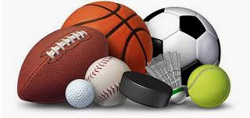

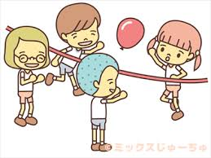

Sports Pictionary – draw clues about the actual sport or players of the sport and someone has to guess what you are drawing

Basic volleyball – a balloon or soft ball. Can be played inside or out and see how many touches you can have without it touching the floor

Guess the lyrics game – write down lyrics from a number of your favourite songs and get one person to sing them and everyone has to try and guess the song

Family fun

Test your knowledge and try the question of sport quiz

<https://www.bbc.co.uk/sport/50762593>

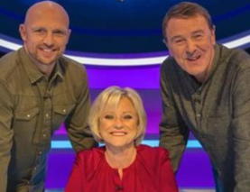

Create your own sports quiz from the knowledge you have from school – don’t forget to write a separate answer sheet for when you are quiz master!

Use your mind

Repeat the home workouts we’ve sent!

If you have any basic equipment at home you can keep your physical health up:

Tennis ball/football – any throwing and catching or passing the ball

Skipping ropes (or a piece of rope) – challenge yourself to skip non-stop for five minutes

Get moving

Access any of the just dance videos through YouTube for you and your family to have fun attempting



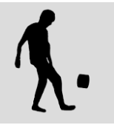

If you have a scooter and helmet why not perfect some basic tricks<https://www.youtube.com/watch?v=1sffoJ4-IOU>

Aerobics - <https://youtu.be/y4PG1fEeb1k>

Latin dance - <https://youtu.be/bm4WZyH5p2I>

Zumba - <https://youtu.be/bm4WZyH5p2I>

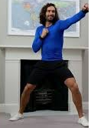

Joe Wicks has a number of fitness videos to follow:

<https://www.youtube.com/user/thebodycoach1>