In this booklet there are a variety of tasks for you to complete if you want to do a bit of extra English work. You can complete as many or as few as you like.

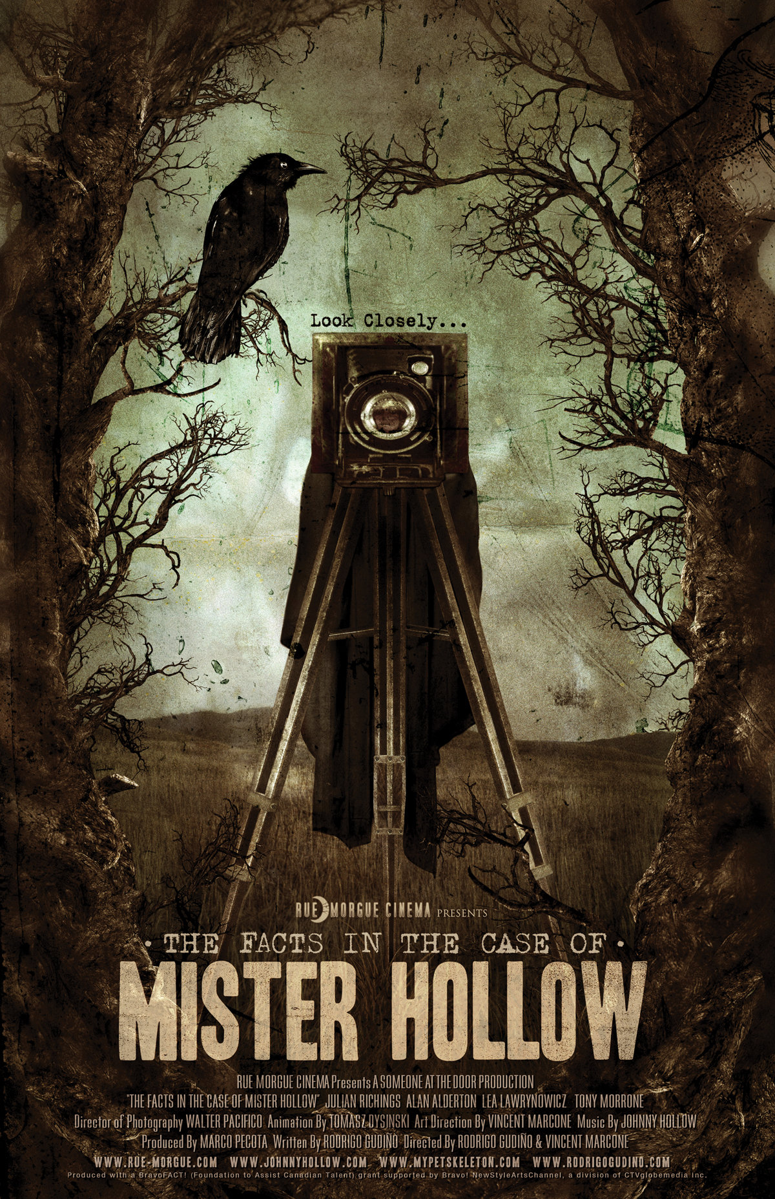

Learning Objective 1: How can I plan a well-structured short story?
Key words: Structure – how things are organised
Narrative Arc – this is the common structure of a story
Do Now: What’s the best story you have ever heard? Why?

Read and learn: One thing that makes a good story is that it takes the reader on a journey. It can help to think about the structure of a story as being like climbing a mountain.

The structure shown below is called a narrative arc.

Rising Action: Build up.
Work towards something dramatic. Events that drive the story forward.
Conflict: The problem.
Bring drama through a problem or dilemma.
Resolution: Solve the problem.
Bring the story to an end – or you could end on a cliff hanger!
Climax: The most exciting bit.
This is what the story has been building to…
Falling action: Wind down.
How does the character overcome the challenges?
Exposition: Set the scene.
Background information, characters and past events.

Starter: Inspiration Station – Often, the hardest part of writing a story is deciding what to write about. Today we are going to get some inspiration by stepping into a photograph. Watch The Facts in the Case of Mister Hollow: https://youtu.be/bzw8qdXCep8
Imagine you are the person who received the photograph and jot down the interesting things that you notice:

Interesting fact: In Greek mythology, the Keres were female death-spirits. They were the goddesses who represented violent death and who were drawn to bloody deaths on battlefields.

Main Task: Before you start writing a story it is important to plan. Let’s use the story mountain (or narrative arc) to think about what might happen at each stage of your story.
Remember; there are no right or wrong answers here. You are writing your interpretation of the film.

Opening: exposition

Where was the photograph taken?
Who are the people in the photograph?
How are the newspaper clippings connected to the photograph?
What does the reader need to know in order to understand what happens next?

Build Up: conflict and rising action

Whose story are you focusing on?
What is the dilemma / problem that they are facing?
What happens to move the story forward?
How are you going to create tension and suspense? What methods will you use? (i.e. adjectives, short sentences)

Climax: The most exciting bit

What is the big event in your story?
How do the characters respond?
How do you want the reader to feel at this point? Happy? Sad? Relieved? Shocked?

Ending: falling action and resolution, leave the reader satisfied and maybe wanting more

Is the problem solved? Who saves the day?
Is there a twist or a cliff hanger?
How do you tie up loose ends?
How do the characters feel?

Challenge: Can you link the ending to the beginning?

Top tip: Pause the video on interesting images and write down a few words to describe what is happening. Experiment with language until you get it right. Use ambitious adjectives and figurative language (i.e. simile and metaphor) to paint a vivid picture.
Learning Objective 2: How can I use ‘drop, shift, zoom’ to write an engaging opening?
Key words: Narrative Hook – opening your story in a way that gets the reader’s attention
Exposition – the background information to a story

Do Now: Which of these story starters is the most effective and why?
A. “In a hole in the ground, there lived a hobbit.” | C. “There was a hand in the dark. And it held a knife.”
B. “Mr and Mrs Dursley, of number four Privet Drive, were proud to say that they were perfectly normal, thank you very much.” | D. “All children, except one, grow up”

Read and learn: A narrative hook (or hook) is a literary technique in the opening of a story that "hooks" the reader's attention so that he or she will keep on reading. The "opening" may consist of several paragraphs for a short story, or several pages for a novel, but ideally the reader is hooked from the opening sentence.

Starter: Let’s look at some different ways we can hook the reader. Try to write your own example of each technique to create three different options for the start of your story.
Narrative Hook | My Example | Your example
The Puzzler: raises questions and drops hints or clues that the reader has to put together. | “I am not sure whether this is a real memory or just a story that has become more solid over time but this is what I know about how Jebediah Coleman got away with murder.”
The Painter: Very descriptive - paints a vivid visual (and sensory) picture to set the scene. | “The woods whispered secretively and a voice echoed through the darkness. The empty trees cast long, sinister shadows each time a slither of silver moonlight broke through the ghost-like clouds.”
The Weather Forecaster: sets the mood and creates atmosphere using pathetic fallacy. | “The sky was a shade of midnight, the air was as still as death and the moon shone a spotlight on the clearing where the car was parked.”
Drop, Shift, Zoom: This technique can be used for easy planning of an engaging opening. It will make any story more interesting.

Drop Drop the reader right into the action. Describe what is happening and who is there.
Where does your story start?
- Does it start with the narrator receiving the letter?
- Does it start with the people in the woods getting ready to have their photograph taken?
- Does it start with the story of the two priests who are hiding in the trees?
- Does it start by telling us about who Johnny Hollow is and why he is writing the letter?
All of these options would make an interesting opening to a story and you may have a different idea to hook the reader.
Challenge: Try opening with a short, simple sentence before introducing more detail.
Example: The photograph dropped from his hand. His face was pale with shock and his eyes shone with sudden realisation…

Shift to another time or place. For example, describe the past. A flashback can help the reader get all the background information they need to understand the story. Explain what led to this moment.
Don’t forget to signpost the reader with a connective or linking phrase.
Challenge: Create a contrast between the past and the present (i.e. confusion/calm or happy/sad)
Example: Six months earlier, Johnny Hollow had disappeared. He had been investigating the missing children and as far as Rodrigo knew, he had hit a dead end whilst trying to link the disappearances to a secretive pagan cult.
Useful phrases to help you if you get stuck: “Yesterday afternoon,”
“This morning it was all so different,” “The woman remembered the time before,”

Bring the reader back to now and zoom in on something in the scene, a small detail. Use vivid description to build tension.
You will need another linking phrase so the reader does not get confused.
Example: A loud noise startled him back to the present and he looked at the letter again. November 3rd. Why was that date so important? There was a tantalising detail hiding at the edges of his memory. He stared intently at the yellowing paper, which was curled and creased from being read so many times. The letter felt thick and heavy in his hand as if it understood its own importance. Another loud noise. The wind was banging angrily at the window and screaming into the night.

Challenge: Give the reader a hint or clue that something is going to go wrong or that there is a potential threat. What clues could you use?
- The writing in the letter is messy like it was typed in a rush.
- Crows are often symbols of death, magic and mystery.
Give me one more example of how a writer might give clues that things are not quite right

Challenge+: Use a single sentence paragraph at the end of your opening to highlight a key moment or a key thought.
Learning Objective 3: How can we build tension through the way we describe objects and small details in our story?
Do Now: Watch The Facts in the Case of Mister Hollow again: https://youtu.be/bzw8qdXCep8 with particular focus on building tension.
Look at the way the video zooms in on the clues to create doubt in the reader’s mind about what happened. For example, why do the men all have the same tattoo on their skin? What is going on behind the picture and why?
Starter: Complete the table below.
What are 5 questions you would ask the characters if you could? | 1. __________________________________________  2. __________________________________________  3. __________________________________________  4. __________________________________________  5. __________________________________________
What makes you ask these questions – why are you so desperate to know these things?
How has tension been created through the video? How could you replicate this in your writing?
What sort of vocabulary might you use to describe the setting as the story progresses?

Think about word choice: Vocabulary is very important when writing a narrative. The right word in the right place can create a wonderful sense of tension.
Find synonyms for these words to improve them:
Ran ______________ Laughed ______________ Flew ______________
Loud ______________ Quiet ______________ Shouted ______________
Crept ______________ Swayed ______________ Huge ______________

Give the reader hints and clues: A great way to build suspense in your writing is to zoom in on detail. Choose 3 of your details from above and elaborate on the description, making them as creepy as possible.
Example: The skeletal branches of the trees were like haunting ghostly fingers reaching out to grab and snare unsuspecting and unfortunate passers-by. As the boy sprinted through the darkness, they threatened to trip him over, maliciously scratching deep scars into his porcelain legs. They were closing in around him. Blocking his way out. Now what was he going to do? Suddenly, he tripped, twisting his ankle in one of those demonic tree roots. He cried out, as the sky darkened and the gargantuan monsters laughed into the wind, violently swaying this way and that. They had caught him.

1)

2)

3)

Let’s Write: Now you have these details, have a go at writing your own rising action – don’t write the climax yet – just the parts which build up to the climax – like the build-up before a jump scare in a scary film!
Don’t forget to include ambitious vocabulary to describe in detail and to add depth and tension to the situation. If you’re struggling, there are some sentence starters at the end of this lesson.

Now you should be at the point in your writing where the story is so tense, the worse/most exciting thing must happen now. This is where you put your main problem, or the main thing that your characters must overcome. Here are some steps to follow to create a good climax:
- Remind the reader, in one sentence what has already happened. EG. Two short hours ago they had been…but now they were…
- Reintroduce and explain the problem, briefly. EG. After all that had happened, what with this, and this, and this…the problem was only getting worse!
- Describe the main problem, and how it is affecting your main character/protagonist. EG. Struggling, he searched the darkness for some kind of sign…
- Conclude what the actual problem is and why it is such an issue. Start planning how to solve it. EG. He had to face this alone. It was going to be difficult, but it was their only hope…
- As you move into the falling action, you must start to show that your protagonist is going to be victorious or the winner. EG. He could see the light at the end of the tunnel. His journey was far from over, but at least now they had a plan.
Now have a go at writing your climax:

Sentence starters if you’re struggling:
- The weather had taken an usual turn…
- He had the strangest feeling that he was being followed…
- It was almost as though he had seen this before…
- What was that? Before him, he could see…
- Just looking at it, he felt small by comparison…
- The hairs rose to attention on the back of his neck as the sound of… drifted towards him.
- How strange! He could smell…
Learning Objective 4: What makes an effective ending?
Well done for making it this far with your story! You’re nearly at the end of your narrative. This part of the narrative is where you start to bring your events to a close. Your characters should now be starting to overcome the main conflict or problem.
Do Now: Here are some examples of great last lines from literature – but which one do you think is the best and why?
A. “I wish you all a long and happy life.” | C. “The knife came down, missing him by inches, and he took off”
B. “Are there any questions?” | D. “He was soon borne away by the waves, and lost in darkness and distance”

Starter: What makes an effective ending? Sort out the statements below from most important to least (1 = most important, 7 = least important)

_____ The ending should connect back to the beginning
_____ You should end with a twist – something unexpected
_____ You should end on a cliff hanger. The end should feel like the beginning of a new story.
_____ You should leave the reader with questions – make them work things out for themselves.
_____ Everything should get sorted out in the end. Make it a happy ending.
_____ The reader should feel something – relief, shock, happiness or sadness.
_____ The ending should be exciting

Challenge: Consider how the film ends. Is this an effective ending or not? Why?

Let’s Practise: Often, the endings of stories come full circle, and end in a similar way to how they start. For example, if you started with a description of a winter scene, maybe you could end with a lovely spring description of the same place. Have a go at writing a spring version of the description below:
Shrouded in glistening snow, the hilltops were ghostly orbs, lingering in front of the midnight sky. Hundreds of tiny, vicious icicles hung from every surface, slyly waiting for some unfortunate soul to walk under them, before dripping mercilessly down their neck. Everything was covered in a razor-sharp layer of ice, which would slice through skin at the slightest touch. The depressing grey sky hung moodily over the bleak landscape, filled with clouds that promised rain.

What are the different types of ending could you use?
Fill in the table below and think about which type of ending would suit your story.
Type of ending | Example | What do you like about it? What don’t you like about it?
A cliff-hanger – leaving your reader on an unanswered question. | “Tomorrow, I’ll think of some way to get him back. After all, tomorrow is another day.”
An ambiguous (uncertain) ending – leaving your reader with very few details so that they have to guess what happens next. | “And so I step up, into the darkness within, or else the light...”
An unexpected twist – shock your reader with an ending they were not ready for. | “I can see it now, that hand of hers; it had only one finger on it, and a thumb.”
A happy ending – everything is solved, there is nothing left to ask or say. | "He reached the top of the bank in a single, powerful leap. Hazel followed; and together they slipped away, running easily down through the wood, where the first primroses were beginning to bloom."
An exciting ending – this is usually very abrupt and still in the action. | “The knife came down, missing him by inches, and he took off”

Bullet point your thoughts about the ending of your story:

Let’s Write: Finish your story and write your own ending.

JFF (Just For Fun): Narrative Writing Word Search

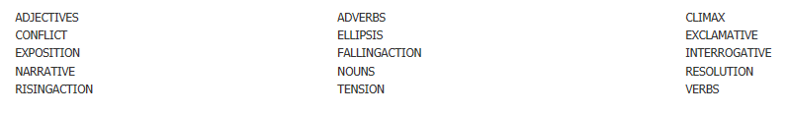
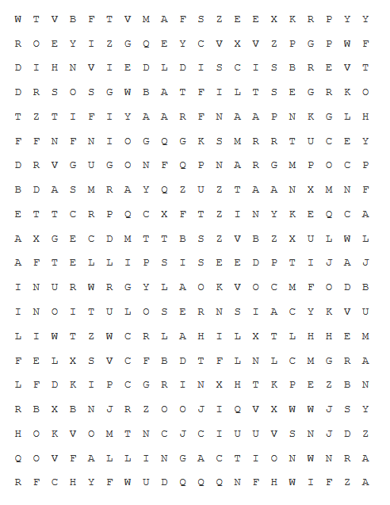

Below are some examples of narratives (stories) that are based in the pictures. Read the examples and then have a go at writing your own narrative based on the pictures
Narrative Exemplar 1
TASK: Write the opening part of a narrative set in a snowy place, as seen in the image above.
Robin lowered the axe he had been using to chop wood and peered towards the mountains, his eyes squinting in the sharp orange glow of the slowly setting Sun. He was sure he had seen a movement up there, a flash of scarlet against the sparkling white of the snow-capped peaks. But who would be mad enough to venture into the mountains at dusk, in winter, with snow and freezing temperatures forecast that night? Robin sighed wearily, deciding that it must have been his imagination playing tricks on him, as it so often did out here in the mountains.
A low, ominous rumble echoed down the valley, interrupting his thoughts. Robin froze momentarily, listening intently, then snapped into action, frantically gathering his tools as the sound grew louder and closer. Destructively and unstoppably, the avalanche roared towards his isolated home.

Narrative Exemplar 2
TASK: Write a story that has a twist at the end.
The Wood-cutter
One morning I was travelling alone to school when I decided to take a short cut through the woods. There was a shady path that ran through the trees. It was littered with dead leaves that rustled and crunched under my feet. As I travelled further and further into the woods, I began to realise that I was lost. There was not a soul around and I could hear nothing except the wind whistling through the branches.
Suddenly I heard a twig snap behind me and I turned to see a dark figure coming towards me from the trees carrying a huge axe. Without hesitation, I ran as fast as my legs could carry me through the woods, over bushes and under branches, further and further, without any idea where I was going, desperate to escape the terrifying figure that was pursuing me.
Finally I stumbled on a fallen tree branch and landed headfirst in a pile of leaves. Dazed and disorientated, I turned around to look for my pursuer but he was nowhere to be seen. As I crouched silently amongst the leaves I noticed something emerge from the trees. It was the axe-murderer! He had found me! As my killer advanced towards my hiding spot and prepared to deal the fatal blow I closed my eyes and prayed it would all end swiftly...
“Hello there,” came a friendly voice. “I think you dropped this by accident on the path a while back.” I opened my eyes and felt my heart-beat settle down again. It was just the local woodcutter and he was holding out my rucksack, smiling. “Sorry if I startled you there. I was busy cutting trees when you passed by.”
I breathed a sigh of relief and thanked the wood-cutter as he helped me to my feet and showed me the way through the woods and out to school. Next time, I told myself, I would go the long way round.

Narrative Exemplar 3
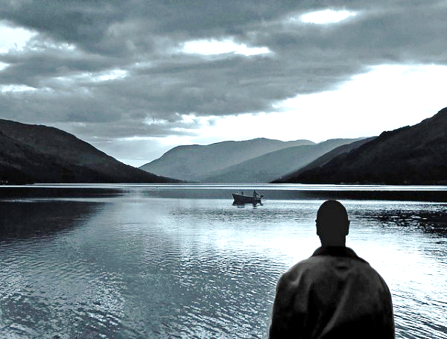
Write a narrative based on the image above.
Thick mist enveloped the lake; the air was cool and crisp, and the grassy banks around the water’s edge were damp from the day’s rain. Circling the landscape, somewhere across the still waters of the lake, grim hillsides loomed, sending over the ghostly fog that shrouded almost everything on that pale October evening. There was no sound other than the sniffing and panting of my dog, Munro, as we took our evening walk along the lakeside.
A sudden cry cut through the mist. A woman’s cry.
Staring intently into the fog, in the direction of that voice, I finally became aware of the silhouette of a small rowing boat floating atop the water, about forty metres or so from the shore. Then, as my eyes made sense of the moving shapes within the boat, I noticed two figures wrestling one another and then the sound of a man shouting aggressively. The mist cleared momentarily, and I could see the larger figure of the man trying to wrestle something from the woman; then the mist shrouded the boat once more.
Munro sniffed the air and let out an anxious bark. Then the unmistakable sound of a gunshot echoed across the lake. Munro whimpered at my feet with his ears down. The sound from the boat had stopped. It occurred to me that the woman’s life was in great danger.
Instinct took over. I threw off my raincoat and waded into the chilly, black water of the lake. Without thinking, I propelled myself forward and began swimming towards the boat. Munro’s frantic barking from the shore became fainter as I ploughed through the misty water. Soon, the boat appeared before me and I clambered over the side to survey the scene within.
“That’s close enough, pal.” came a husky female voice. Looking up, I found myself staring down the barrel of a shotgun being pointed towards me. At the other end of the gun were the magnetic blue eyes of a slim, pale-skinned woman, dressed from head to toe in a black wet suit. At her feet lay the larger, albeit crumpled figure of a man, also in a wet suit; now ripped apart and gushing with dark blood that formed a puddle in the centre of the boat. Before she executed me, I briefly caught sight of diving equipment – oxygen tanks and breathing apparatus – piled in the corner of the boat, together with two briefcases wrapped in plastic bags.
I had no final words; there was no time. The last thing I heard before she pulled the trigger was the faint sound of Munro some forty feet away on the shore. Still barking tragically.

There a variety of vocabulary tasks below. They are different levels of difficulty. You can do whichever ones you want.

The extract below is a bit boring. Can you change the words that are underlined to more interesting ones? Challenge: Can you finish the story?

Everyone who knew the woods said they were bad was scared of them. They were big and like a maze. The big trees towered over you, their outstretched branches tangled together to make the entrance look like a black hole - just looking into the woods was enough to scare anyone. Once you went in, it was rumoured, you never came back out! I know what you’re thinking - how can woods be that bad? It’s only a bunch of trees. How do I know you’re thinking that? Because I felt the same until…

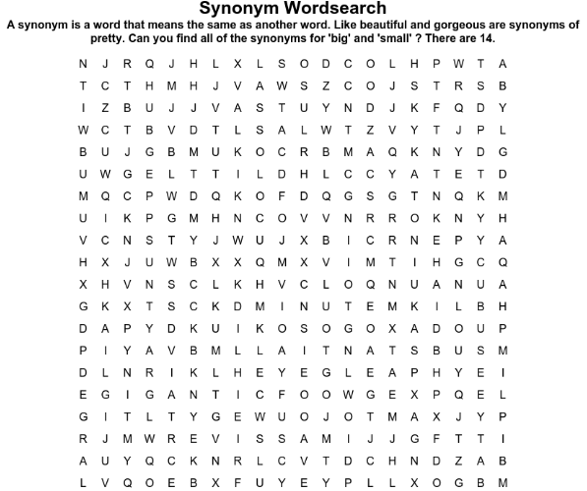
Synonyms for BIG
- Large
- Enormous
- Vast
- Huge
- Gigantic
- Massive
- Colossal
- Substantial
- Humongous

Synonyms for SMALL
- Tiny
- Petite
- Minuscule
- Minute
- Little

Match each word in the left column with its definition in the right.

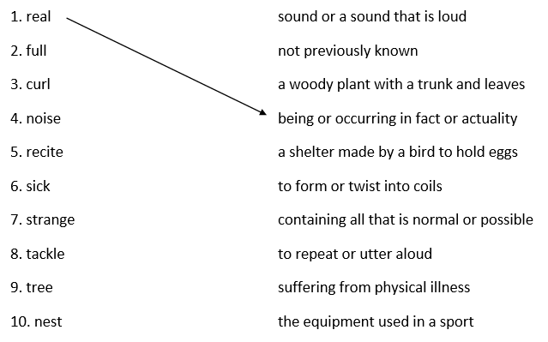

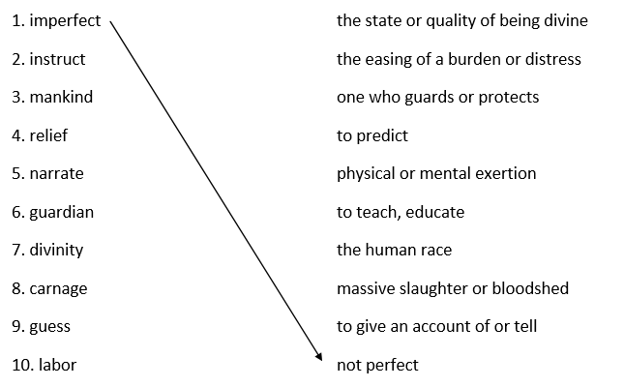

Challenge: Try to use some of these words in a sentence.

We often come across new words that we don’t know. Sometimes it’s possible to guess what a word means.
By looking at the whole sentence, or sometimes the whole paragraph, we are able to guess the meaning of a word, even if we aren’t sure of the exact definition.
For example: He was an obnoxious child who always argued with the teachers, treated his friends like dirt and was rude to his classmates.
You can tell that ‘obnoxious’ is a negative word for someone who behaves badly even if you can’t pin it down to ‘very unpleasant or rude’. You can use the clues around the word to work out the meaning.

Sometimes a contrast will give us a clue. For example: She was very audacious, not a snivelling, little coward.
Here we can use contrast to work out the meaning. ‘Audacious’ must, in some way, be opposite to ‘snivelling, little coward’. We can guess it means ‘brave’.

See if you can guess the meanings of these words:
1. She was a malevolent ruler without a good bone in her body.
- fragile
- happy
- evil
- generous

2. Although he claimed he was a doctor, he was a charlatan with no medical education.
- surgeon
- GP
- nurse
- fake

3. Mr Smith was dilatory in arriving at lessons and so the class would get restless and fool about while they waited.
- slow or late
- fast
- confident
- early

4. Her pituitary gland was swollen so she went to see the doctor.
What is a pituitary gland?
- a part of the body
- a cat
- a plant.

5. Her ambiguous statement left us unsure about what to do.
What does ambiguous mean?
- specific
- unpleasant
- unclear

6. He was unrepentant. He did not believe he had done anything wrong.
What does unrepentant mean?
- felt no guilt
- happy
- like a dog

7. He was a sceptic. He never believed anything he read.
What does sceptic mean?
- believer
- doubter
- giver

8. His watch was very precious to him. It had been a gift from his grandad.
What does precious mean?

9. The children were ecstatic that it was the summer holidays.
What does ecstatic mean?

10. John was very lazy. He seldom got out of bed before 11:30!
What does seldom mean?

Sensory Description
In your creative writing, creating an image of what you’re describing in the reader’s mind is very important. One way of doing this is by using sensory description, describing what someone might see, smell, hear or touch or even taste.

Task: Read this extract from a novel called Chocolat by Joanne Harris. Underline and label where the author has used sensory description. Challenge: think about the impact of the detail.
Touch – felt on skin- refreshing?

We came on the wind of the carnival. A warm wind for February, laden with the hot greasy scents of frying pancakes and sausage and powdery-sweet waffles cooked on the hotplate right there by the roadside, with the confetti sleeting down collars and cuffs and rolling in the gutters.

Task: Look at this picture and consider how you’d use sensory description, then complete the table with your ideas. Tip: Remember to add as much detail as you can. Challenge: Use a simile!
Describe the texture of the silk dresses and hand. Would it be comforting?
Describe the colour and brightness of the sky.
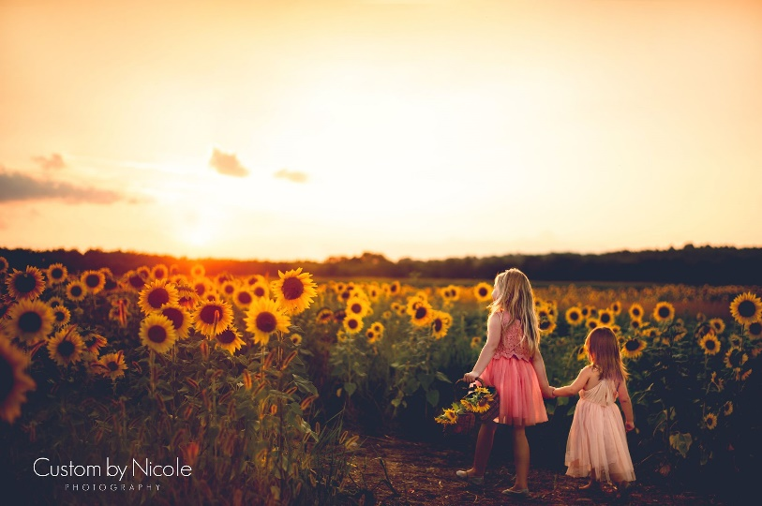
Describe the way the sun shines through the flowers
What would the weather be like? How would the wind/heat feel on your face?
Touch
Smell/ taste
Touch
Sight

Ambitious Vocabulary
Read this extract from a Holocaust survivor, describing what he saw on his way to work outside the camp:
Our column suddenly came to a halt at the crossroads. I noticed on the left of the street there was a military cemetery. It was enclosed by a low barbed wire fence. The wires were threaded through sparse bushes and low shrubs, but between them you could see the graves aligned in stiff rows.
I stared spellbound. The Flower heads seemed to absorb the sun’s rays like mirrors and draw them down into the darkness of the ground as my gaze wandered down from the sun flower to the grave. It seemed to penetrate the earth and suddenly I saw before me a periscope. Colourful butterflies fluttered from flower to flower. Were they carrying messages from grave to grave? Were they whispering something to each flower to pass on to the soldier below? Yes, that is just what they were doing; the dead were receiving light and messages. Suddenly I envied the dead soldiers. Each had a sunflower to connect them with the living world. For me there would be no sunflower. I would be buried in a mass grave, where corpses would be piled on top of me. No sunflower would ever bring light into my darkness, and no butterflies would dance above my dreadful tomb.
Task: you’re creative writing should have some ambitious vocabulary to create a specific image in the reader’s mind. Find the definition of each of these words and create a sentence of your own containing each that you might include in your creative writing based on these pictures.
Word | Definition | Your own sentence (Try and use the connectives: because, though, so, however)
Enclose/d | Surrounded or closed off | The daffodils were enclosed by a rickety wooden fence.
Sparse | Thinly dispersed or scattered
Stare/d | Look fixedly or vacantly with eyes wide open.
Spellbound
Absorb
Gaze | Look intently, especially in admiration, surprise or thought.
Flutter/ed

Task: Complex sentences (sentences with more than one clause (bit)) are important in your creative writing. Often we do this using conjunctions (however, although, because). Combine these simple sentences into one complex sentence using the conjunction suggested in brackets either at the start or middle of the sentence. The first has been done for you.
1. I gazed at the twilight sky. The sun’s rays were overpowering. (Although)
Although the sun’s rays were overpowering, I gazed at the twilight sky.
2. The butterfly fluttered its wings beautifully. I stared at it spellbound. (so)

3. The other fields were sparse. This field was packed full of spectacular sunflowers (However)

4. My sister played in the rows of sunflowers. I tried to absorb the wonderful view (while)
Task: Write a few paragraphs describing a field of sunflowers. You can use these pictures and your notes to help. Remember to use ambitious vocabulary and use sensory description.
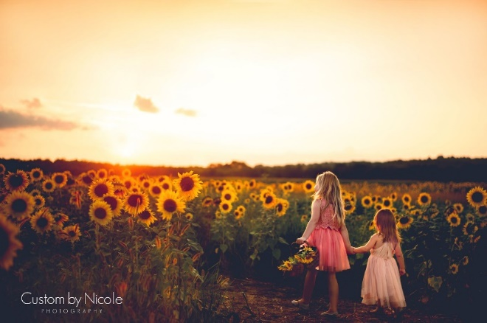

Writing frame if you are stuck:
Stretching far beyond the horizon there was an ocean of giant sunflowers, standing to attention with their heads slightly swaying in the gentle mid-summer breeze. The heads of each of the sunflowers were…

In the distance there were… The sky was like… The hill gently sloped…

The girls… Their dresses felt like…. The fields smelt like… The sun’s rays…

How can we use show don’t tell in our descriptive writing?
‘Show me don’t tell me.’ Do you recognise this term?
‘Show, don’t tell’ is when language and structure are used to give clues to the reader about what is happening in a piece of descriptive writing.
This skill is used by many writers so they avoid making obvious statements.
So, rather than saying:
‘The boy was sad.’
We might say.
‘Silent and motionless. As the rain drizzled miserably on the window pane and the wind rushed through the trees, he sensed that maybe just maybe, things were going to change. Staring reluctantly out of the window, he saw other people out in the bad weather, either dashing to get inside or embracing the puddles that dominated the street.
Feeling a world away from these people, he turned to leave the room and continue with his day. Trudging down the stairs to make his breakfast, he noticed that the rain was heavier and more relentless than ever.’
More examples:
Telling: ‘It was an unusual cat.’
Showing: ‘With its mouth full of sharp, pointed teeth and its growl like a tiger, I knew that the animal was no ordinary cat.’
Telling: ‘The man was furious.’
Showing: ‘The man stormed in the room. Smoke blew from his ears as he threw himself into the nearest chair.’
How do we know if someone is feeling the following? Write your ideas next to the emotion. Use the five senses to help you.
- Upset – Teary eyes, crying, sniffling
- Angry –
- Shocked –
- Heartbroken –
- Injured –
- Hungry –
- Happy –
- Excited -
Your Turn:
How is the man in the picture below feeling?
How can you show me this?
I don’t want you to write ‘The man feels angry, he doesn’t like carrying all his belongings.’
I want you to show me!
What sort of actions would he be doing as he walks that show he doesn’t want to carry his belongings?
Write your ideas around the image. Challenge: include a simile in your ideas.
Huffing and puffing.

Imagine this man has a long way to walk, being forced to walk a long way whilst carrying heavy bags. How might you describe him?
Shuffling along the street, James….
Remember, you can’t tell the reader that your character is miserable; you’ve got to show it!
Challenge: use the senses in your description.
Write your description below:

Similes, Metaphor and Personification.

A simile is a comparison of something to something else, using the words ‘like’ or ‘as.’ Similes often contain exaggeration.
Examples:
John is as strong as a bull.
The sun is like a golden coin.
In the first sentence John’s strength is compared to an ox.
In the second sentence the suns colour is compared to a gold and shiny coin.
Come up with your own.
Write three similes to describe someone you know.
1)
2)
3)
Write three similes to describe an object or a part of nature.
1)
2)
3)

A metaphor is a figure of speech that describes one thing as something else.
For example:
My little brother is an angel.
Sarah’s house is a pig pen.
In the first sentence, the little brother is not literally an angel but it makes us imagine a child who is well behaved.
In the second sentence, Sarah’s house is so messy it is compared to a pigs house.
Write a metaphor about someone who is a fast runner.

Write a metaphor about a tree.

Write a metaphor about stormy weather.

Personification is giving an object that is not human; the qualities of a human.

Examples:
The trees danced in the wind.
Angry clouds marched across the sky.
The first sentence tells us that the wind was blowing so much the trees were swaying as if they were dancing.
In the second sentence we can infer that the clouds were getting ready to storm.

Your Turn.
Write an example of personification to describe heavy rain.

Write an example of personification to describe a car.

Write your own example of personification on anything.

Write a description of an event in your life, it can be any event; made up or real, that includes all three of the methods we have looked at. Really think about how you can incorporate each of these methods into your description.

Putting it All Together

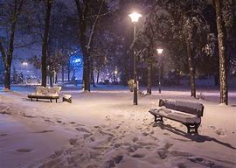
TASK: Writing to describe – Write a description based on one of the images below.
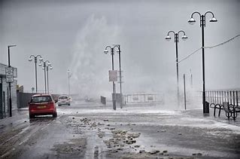

Remember to use the skills you’ve been working on in this pack and in class. Including: sensory description, show don’t tell, vocabulary, similes etc.
Potential sentence starters if you’re stuck:
In the depths of night… Through the murky fog… Illuminated by streetlamps…
The cold was… People trudged through…. In the distance…

Below are some examples of really good descriptive writing. Read the example and then try to describe the picture yourself.

Descriptive Writing 1
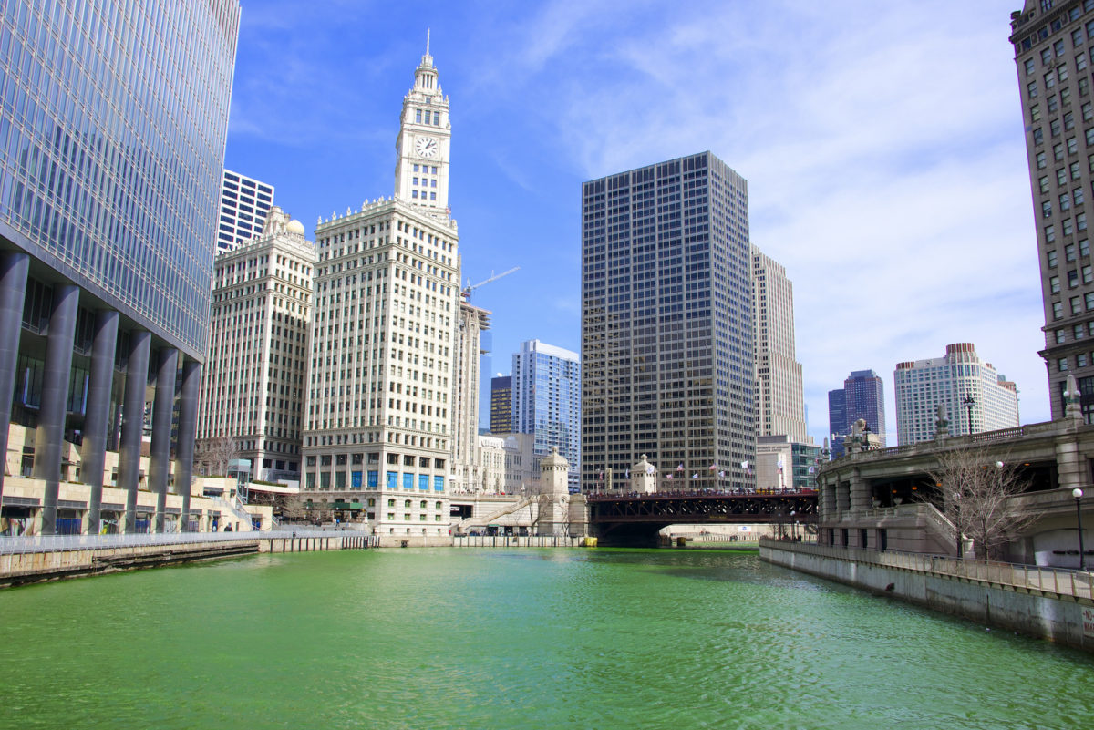
TASK: Write a descriptive paragraph about a busy city, based on the image above.
In the heart of the city there was a wide, green river than ran between the roads and the buildings. The surface of the water was like emeralds, shimmering in the midday sunshine. Nothing disturbed the peace and quiet of the river; not a canal boat or flock of geese in sight. On either side of the water stood huge glass soldiers, tall buildings that leaned threateningly over the streets below, reflecting the violent rays of light from the sky. On the streets, little people went to and fro like ants, amid the beeping and honking of horns from the gridlocked traffic. And high above, the sky stretched out far and wide, smudged occasionally by the cotton wool clouds that drifted aimlessly across a sheet of pure, brilliant blue.
Descriptive Writing 2
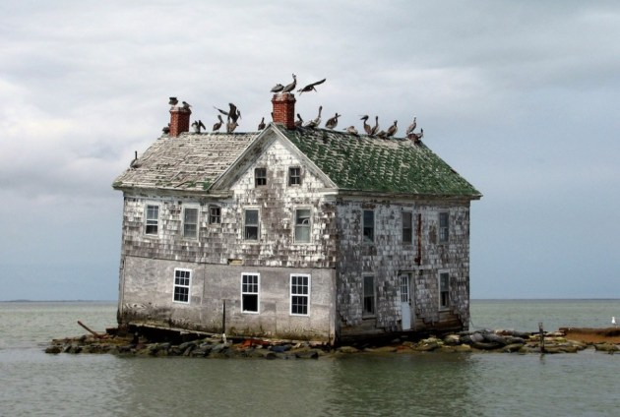
TASK: Write a description about an abandoned place, based on the image above.
The house stood at the edge of a rocky outcrop that stretched out into the sea like a jagged finger. Decades ago, the outcrop was part of a stony beach that made up the derelict end of Fisherman’s Bay. Now all sand was submerged under the rising sea level and the vacant house was surrounded by water, like a stranded bait-digger in high tide.
When the sea level first began to rise, the family of fishermen that once lived here fled quickly as their home began sinking around them. Taking with them only their four children and a landing net full of valuables, they sailed away in two fishing boats and never returned.
From the outside, the effects of the weather had taken its toll on the building. Salty winds had gradually eroded the grey brick-work, leaving large patches of chalky white. Fierce storms had scattered roof tiles and a warren of holes in which sea-gulls soon took shelter. The birds themselves stood guard along the roof ridge, taking ownership of the forsaken structure that now subsided pathetically into the sinking stones on which it lay precariously.
Stepping through the broken doorway and into the ground floor, you would instantly recoil from the festering stench of birds’ droppings and murky sea-water that rose waist deep at high tide. Abandoned furniture floated in the brine and gloom, and the light from the windows showed picture frames and photographs of family members long departed.
The remains of a crumbling stair-case still allowed access to the first floor, where any visitor would be greeted by the fluttering and cawing of sea gulls nesting in the bedrooms. Soggy wall-paper peeled away from the walls and the filthy bedsheets were scattered with fish-bones, feathers and egg shells. In one of the rooms, a child’s toy box had been tipped over and the faded building blocks and dolls’ heads within lay scattered; splattered with slime and excrement and all manner of foul substances that dripped from gaps in the ceiling above.

Descriptive Writing 3
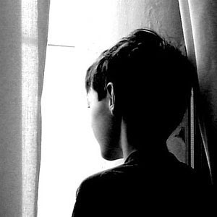
TASK: Write a description inspired by the image above.
Early morning sunlight shone weakly between the branches. Here, the woodland was dense, with black, towering trees stood in formation either side of the road, like a grid-iron fence through which nothing could pass. The road itself seemed to grow narrower as it passed deeper into the woodland; it felt as though the natural world was gradually encroaching further into human territory. Or perhaps it was the other way round…
Tucked away in the forest, at the end of the thinning road, was an ancient building. A remnant of the Victorian era; a faded mansion that had been converted into a solemn government facility. It was shielded behind an unsympathetic, grey wall that completely circled the ground. The only entrance was through electronic gates of reinforced steel, controlled by an intercom system.
Once inside the gates, you would be confronted by the stony façade of the facility. The brickwork was grey and unwelcoming, like burning ash. And from the earth climbed an insidious brown moss that had corrupted all sides of the building. Above a flight of steps leading up from the gravel, was a forbidding, arched doorway that never opened, and seventeen grim, barred windows behind which every pair of curtains had been pulled shut.
Every pair except for one, that is …
In the far left corner of the building, on the third floor, a solitary figure was staring out from inside the facility. It was a young boy, about ten years old. From behind the dirty glass, he stood motionless, expressionless, waiting for a visitor that never arrived. If you could get close enough to the facility, you would notice that his grey-brown hair was ragged and unkempt, his menacing eyes were ringed with dark circles, and his skin was pale and undernourished.
But that would be close enough. Before long, a voice would bellow from inside, and the boy’s curtain would be yanked shut like the rest.
Below are some more writing tasks. Have a go at whichever ones you want.
Writing for purpose
When you are asked to read a new piece of writing, make sure you can answer these 3 questions – once you’ve got them sorted, you’ll know that text a lot better!

Fill in the table below.
PURPOSE
Why has the text been written? e.g.:
- To argue
- To explain
- To persuade
- To inform
- To advise

What is the writer trying to do?
AUDIENCE
Who is the text aimed at?
e.g.:
- Adults
- Children
- Teenagers
- Pensioners
- Men
- Women
- People with a specific interest (e.g. film fans)
- Parents
- Peers
- Professionals
TEXT
What kind of writing is it?

- Persuade – to change a reader’s opinion
- Advise – to help people decide what to do
- Argue – to make the case for something
- Explain – to make clear why or how something works
- Inform – to tell a reader about something
- Instruct – to tell a reader how to do something

Text (underline the type of text) | Audience | Purpose
Letter to a school magazine explaining your viewpoint on whether to have a prom or not. | Teenager/Friend | To explain how you feel about school proms and whether they are appropriate.
Article to a teenage magazine about the negativity of social media
A speech for your head teacher about why you need longer break times
Article to the Daily Telegraph about your views on zoos/animal captivity
Letter to your MP to protect local wildlife
Letter to the Council to Protest Against Sport Centre Closure

Writing to Persuade, Argue, Advise

What do we do when we write to PERSUADE?
When we write to persuade we are trying to make the audience do or think something that they had not originally intended to. In other words, we are trying to change someone’s mind. Therefore, we have to use language carefully to make sure that they come to agree with us.

When might we need to write to persuade?

What do we do when we write to ARGUE?

When we write to argue, just like when we write to persuade, we are aiming to convince the reader of a particular point of view. We may still be trying to get them to think or do something, but in this situation we are acknowledging that their view or opinion is different to ours and then trying to get them to think like us. Just like when we write to persuade, hopefully, by the time the audience have finished reading our text, they will agree with us.

When might we need to write to argue?

What do we do when we write to ADVISE?

When we write to advise, we are offering advice to the reader so that they can make an informed decision about something. This is similar to the previous two types of writing because we might hope that by giving the reader particular advice, they will then come to share our point of view.

When might we need to write to advise?

The table below has some really useful methods that we can use when writing for purpose.
Language | Example | Explanation | Your Own Example
Adjectives | Outrageous, horrific, unbelievable, fantastic, breathtaking | Words to describe what is going on that appeal to the reader’s feelings and emotions
Exaggeration | This will be the single greatest mistake you will ever make. | This helps to show the reader the importance of acting upon what is written.
Tripling | This was one of the most brutal, cold and barbaric acts I’ve ever seen. | Three words in the same word class in a row to emphasise the importance.
Rhetorical Question | How would you react if this was your only chance? | Rhetorical questions help to make the audience think about what has been written.
Facts and Statistics | A recent survey found that 75% of people thought this was a terrible idea. | Using facts and statistics like this helps to persuade the reader because it makes the writing seem factually true.

Martin Luther King’s speech – persuasive writing example.

I am not unmindful that some of you have come here out of great trials and tribulations. Some of you have come fresh from narrow jail cells. And some of you have come from areas where your quest -- quest for freedom left you battered by the storms of persecution and staggered by the winds of police brutality. You have been the veterans of creative suffering. Continue to work with the faith that unearned suffering is redemptive. Go back to Mississippi, go back to Alabama, go back to South Carolina, go back to Georgia, go back to Louisiana, go back to the slums and ghettos of our northern cities, knowing that somehow this situation can and will be changed.
Which word is repeated throughout?

Why do you think Martin Luther King chooses to repeat this particular word?

Highlight any negative language used throughout the speech.

Why is it important for Martin Luther King to raise these issues?

Highlight any positive language used in the speech.

Why should Martin Luther King use hopeful language in his speech for his audience to hear?

Look at the section in bold. What does this mean? Why is this significant to drive change?
Let us not wallow in the valley of despair, I say to you today, my friends.
Look at the underlined section. What is the method?

What does this suggest about how people have been treated?

Challenge: Why use words associated with the weather?

And so even though we face the difficulties of today and tomorrow, I still have a dream. It is a dream deeply rooted in the American dream.
I have a dream that one day this nation will rise up and live out the true meaning of its creed: "We hold these truths to be self-evident, that all men are created equal."
I have a dream that one day on the red hills of Georgia, the sons of former slaves and the sons of former slave owners will be able to sit down together at the table of brotherhood.
I have a dream that one day even the state of Mississippi, a state sweltering with the heat of injustice, sweltering with the heat of oppression, will be transformed into an oasis of freedom and justice.
Key Words

Veterans: a person who has had long experience in a particular field.
Tribulations: a cause of great trouble or suffering.
Persecution: bad treatment, especially because of race, or political/ religious beliefs.
Oppression: cruel or unjust treatment or exercise of authority.
Oasis: spot in a desert, where water is found.

I have a dream that my four little children will one day live in a nation where they will not be judged by the colour of their skin but by the content of their character.
I have a dream today!
I have a dream that one day, down in Alabama, with its vicious racists, with its governor having his lips dripping with the words of "interposition" and "nullification" -- one day right there in Alabama little black boys and black girls will be able to join hands with little white boys and white girls as sisters and brothers. I have a dream today.
Look at this example where they have been asked to write a speech for year six pupils to encourage them to read for pleasure.

Do you ever get fed up of school? Does it sometimes feel like an exam factory? After all, everyone learns the same things, sat in the same places, at the same time. Sometimes life can feel that way too, the same boring routine: get up, bus, school, bus, homework, television, computer, bed. Repeat. Repeat. Repeat. What you need is an escape route. Freedom. A journey into the unknown. What you need is a book!
Let me guess, you weren’t exactly expecting that to be the answer. Perhaps a sunny holiday abroad, or a trip to a theme park, but not books. Books? But consider it… every time you open the cover of a book, you’re entering a new world. And, as it’s your choice what you read, you have freedom. Reading gives you the power to follow your passion, learn more about our world, or even escape into another: why not join Harry in Hogwarts, Katniss in Panem or Bilbo in Middle Earth?
Now, you might be thinking: ‘The thought of reading a huge novel makes me feel ill!’ That’s fine. Don’t. All reading is good for you. The wonder of reading is the range: from short stories to comics, newspapers to magazines, it all counts and it’s all good for you. Can you think of a better way to develop your imagination or creativity? A little voice inside might be muttering: ‘I prefer the telly or films’, but almost everything found on a screen began life on the page anyway!
Also, reading doesn’t have to be opposed to technology. If you’re waiting for the bus and have ten minutes to spare, why don’t you pull out your mobile and read whilst you wait? You can download a Kindle app - for free - and read anywhere. Plus, there are so many YouTube channels for group reading (it doesn’t have to be a solo activity), not to mention blogs, Instagram accounts, I really could go on and on…
But try not to get distracted by Facebook! Seeing hundreds of selfies will rot your brain, if not bore you to tears. Instead, read and expand your mind. I think the best thing about reading is that it allows you to slip into a dream someone else has created. Is there anything more relaxing that enjoying a good book - especially at this time of year, when the weather is miserable and the sky is dark mid-afternoon? Go on, grab a hot chocolate, a warm blanket and get yourself cosy in front of the fire with a good book.
I’m not trying to say you should spend every waking hour with your nose stuck in a book, although confession time: that sounds like heaven! No, I’m saying you should read regularly for your own health. It’s like exercise: everyone wants to take care of their body and look and feel their best, so why not use books to do the same with your mind? Recent research, carried out by experts at Manchester University, has proven that reading for pleasure not only leads to higher exam results in school, but a better career in the future. So there you go, if nothing else, reading will help to fill your future wallet!
I know that in the past most of you were enthusiastic readers. Everyone has those special memories of being read to at bed time by their parents. But, the thing is, the older people get, the less they read. Don’t let that person be you. As you grow older, you don’t have to let reading go. Good books never grow old. As a famous author once said: “A reader lives a thousand lives before he dies. The man who never reads lives only one.”
So, there you go. I hope I’ve managed to inspire some of you to pick up a book, if not a kindle or a newspaper. In this world, it’s easy to get stuck in a rut, following the same routines. But you really can banish boredom with a book. Futuristic cities, haunted woods, and everything in between is waiting for you. Go on, take a journey with a good book today!

Each of the underlined phrases are methods. Identify the methods used in the paragraph about banning uniform.
Method 1:
Method 2:
Method 3:
Method 4:
Method 5:

One way to make your writing much more credible (believable) is to include an expert opinion.
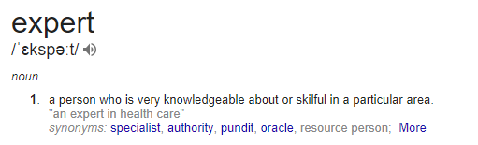
Your expert needs to know about the things you are talking about.

Match up the expert to the topic.
Mr Andrew Bab, CEO at an animal welfare charity. |  | An article in the local newspaper about how brilliant Oasis Academy Wintringham is
Mrs Susan Green, works at the Department for Education |  | A letter to persuade the local MP to protect the wildlife at Cleethorpes Boating Lake
Professor Ashley Bench, studied and now teaches childcare at the University of Leeds |  | A speech about the effects of young people spending too much time on social media

Who would be a good expert when writing about the following: (Remember these can all be made up people)
- Which fast food restaurant is the best?
- Abolishing/ reintroducing the death penalty?
- Keeping all leisure centres in the local area open?

Below are some choices to help you make the expert sound believable.
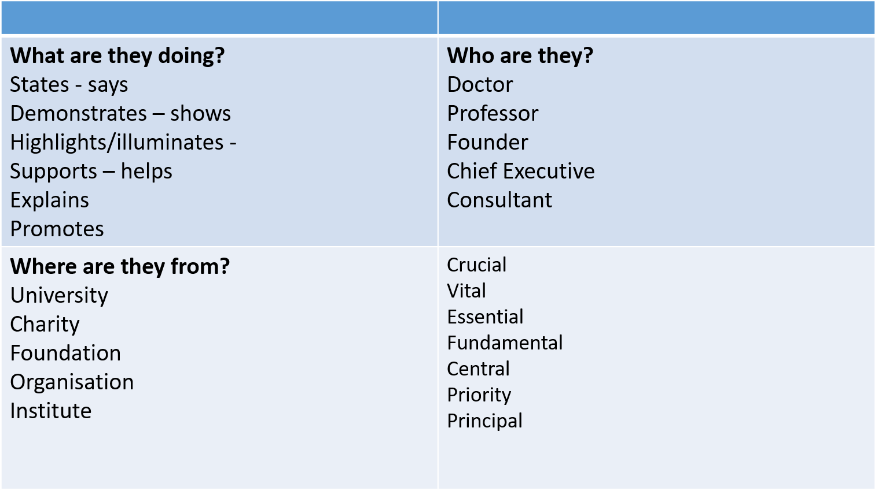

What is emotive language and why should we use it?

Writers use emotive language in order to have a greater emotional impact on their audience. Words can evoke positive emotions, as in: 'Brave gran risks life to save emaciated orphan'. Or the goal can be more negative: 'Abandoned children found in filthy, flea-infested flat'. It's important both to be aware of the effect this language can have on you as a reader, and to be able to achieve the same effect in your own writing.

Which are the most emotive words in these sentences? Underline or put a tick next to the most emotive option

1.
'Doctor escapes jail for botched surgery' - Which are the emotive words in this headline?
- Doctor, jail
- Doctor, botched
- escapes, jail
- escapes, botched

2.
'If you could hear, at every jolt, the blood / Come gargling from the froth-corrupted lungs / Bitter as the cud / Of vile, incurable sores on innocent tongues' - Which are the emotive words used by Wilfred Owen in these lines from 'Dulce et Decorum Est'?
- jolt, blood, lungs, cud, sores
- gargling, froth-corrupted, lungs
- hear, gargling, bitter, tongues
- jolt, gargling, froth-corrupted, bitter, vile, incurable sores, innocent

3.
'Devious employee fleeces nursing home owner' - Which are the emotive words in this headline?
- Devious, employee, owner
- Devious, employee, home
- Devious, fleeces
- Employee, Employer

4.
'Thugs taunt victim after brutal mugging' - Which are the emotive words in this headline?
- Thugs, victim
- Thugs, mugging
- Thugs, taunt, brutal
- Thugs, taunt, victim, brutal, mugging

5.
'Can you really abandon these puppies to life in such filthy kennels?' - Which are the emotive words in this appeal?
- Can, abandon, kennels
- you, really, abandon
- really, puppies, filthy
- abandon, puppies, filthy

6.
'Gorgeous-looking model in immaculate condition - test drive today!' - Which are the emotive words in this car advert?
- Gorgeous-looking, model
- Gorgeous, immaculate
- model, condition, test
- immaculate, test, today

7.
'Our obesity-conquering cookbook is bursting with easy, fun recipes to try!' - Which are the emotive words in this blurb?
- obesity, bursting, try
- obesity-conquering, bursting, easy, fun
- obesity-conquering, easy, recipes, try
- bursting, recipes, try

Now you know how it is done, can you have a go at turning these sentences into more emotive examples?

- People feel angry when they see children damaging property
- A man crashed his car into a shopping centre and hurt lots of people.
- It can be hard to lose weight but it will make you feel good about youself.
- People can help this cause if they work together for their community.
Have a look at how the professionals do it
Martin Luther King was a man who needed to persuade audiences all over America to listen what he had to say. Look at how he uses emotive language to really emphasise his point!

“I have a dream that one day on the red hills of Georgia, sons of former slaves and sons of former slave-owners will be able to sit down together at the table of brotherhood. I have a dream that one day even the state of Mississippi, a state sweltering with the heat of injustice, with the heat of oppression, will be transformed into an oasis of freedom and justice.”
A speech delivered by Martin Luther King Jr., during the 1963 March on Washington for Jobs and Freedom.
This speech includes a number of examples of emotive language. For instance:
- The phrase “I have a Dream” uses personal pronouns, inviting those listening to share in King’s vision of a better world. This phrase is repeated emphatically throughout the speech.
- “Brotherhood” is an abstract noun - a word describing an idea or concept. King uses this emotive phrase to appeal to the audience’s desire for the things that “brotherhood” denotes - acceptance, equality and community.
- King also uses metaphorical language, describing the state of Mississipi as ‘sweltering’ with injustice and describing the cool ‘oasis’ of freedom that it could be. Using sensory descriptions of heat helps to illustrate the difficulty of the struggle for civil rights, as well as reminding his audience what they are striving for. This section of the speech is intended to motivate civil rights activists to keep protesting for their rights.
- Key words such as ‘freedom’ and ‘justice’- these are important words for people as they need to feel valued and important and that they will have the right to be heard and listened to. Key words hold more value than others and will encourage an audience or a reader to feel strongly about an issue.

Practice writing for purpose tasks
First, read this statement.
‘Many people call children lazy and entitled. However, 20% of under 18s have a job where there is a low minimum wage and can often be working 8+ hours a day at the weekend for less than £5 an hour as well as studying full time.’

Write a letter to your MP to persuade them to raise minimum wage for all employees regardless of age.
Remember to use emotive language

Before you start writing, plan what you are going to include. Some ideas are there to help you get started
You can be doing the same job at 17 and 18- it’s unfair to be paid less just because you are younger to be doing the same job as an 18 year old.
Jobs mean children can learn important life skills and become independent, such as working in cafes learning food hygiene- this should be rewarded

Why should under 16s be entitled to a minimum wage

‘Many people call children lazy and entitled. However, 20% of under 18s have a job where there is a low minimum wage and can often be working 8+ hours a day at the weekend for less than £5 an hour as well as studying full time.’

Write a letter to your MP to persuade them to raise minimum wage for all employees regardless of age.
Remember to use emotive language
Task:
What is the type of text?
Who is the audience?
What is the purpose?

Now it’s time to write your letter. Remember to keep your writing powerful and emotive if you want to really change their mind.

Dear MP for Grimsby,

The government has decided that serious crime in Britain has become such a problem that they are going to consider reintroducing the death penalty for murder. Write a letter to the local MP to argue for or against the death penalty being brought back.

Task:
What is the type of text?
Who is the audience?
What is the purpose?
Plan
Should the death penalty be brought back?

Decide if you are for or against the death penalty, finish off the plan for the side you are on. What reasons are you for or against the death penalty?

For | Against
If they reintroduce the death penalty, at least then people will get properly punished rather than just being locked up for a few years! | We can’t bring back hanging! It’s cruel and doesn’t help to solve the real problems! I think it’s a bad idea. We have got to help criminals learn to lead better lives!
What if they get the wrong person? We can’t bring people back once they’ve been killed can we? The risk is far too great! | It will be a good deterrent! Criminals will think twice before they commit a crime, especially if they know that it might cost them their lives!

Tick off the different features in the checklist below when you have included them in your letter:

Rhetorical Questions
Personal Pronouns
Emotive Adjectives
Expert Opinion
Facts and Statistics
Paragraphs
Appropriate Closing

Your local Sports Centre is going to be closed down. People have been told they can use another centre 20km away.

You want to start a campaign to save the Sports Centre. You decide to write an article for the local newspaper to everyone who lives in the area, arguing that the Sports Centre should be saved.

Task:
What is the type of text?
Who is the audience?
What is the purpose?

A place for all people to keep fit and remain healthy.
Gives the community a place to come together and meet each other.

Plan: Arguments to save the local Sports Centre.

