Sport and Health Department

BTEC TECH Health and Social Care
Unit 2A - Services and Values
Work Pack

Name:…………………………………………………………………………………..
Teacher:………………………………………………………………………………..

Lesson 1 - Physical Barriers

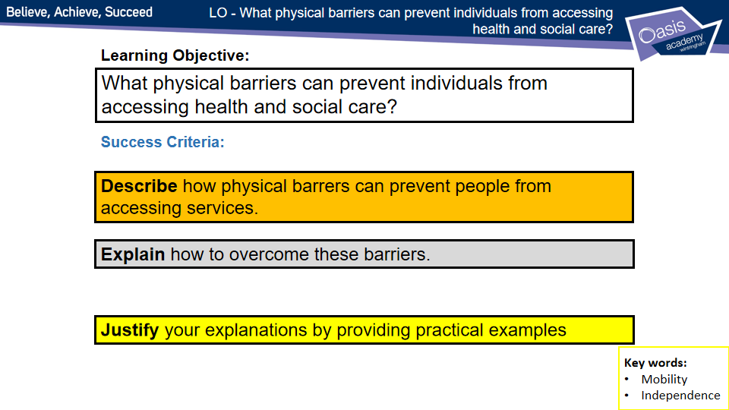
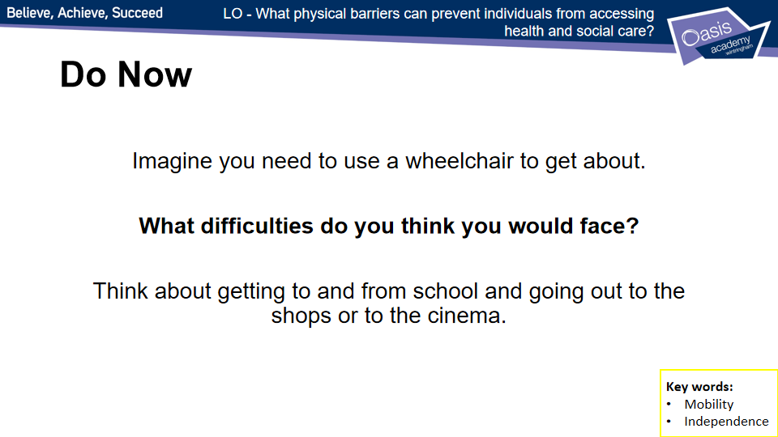
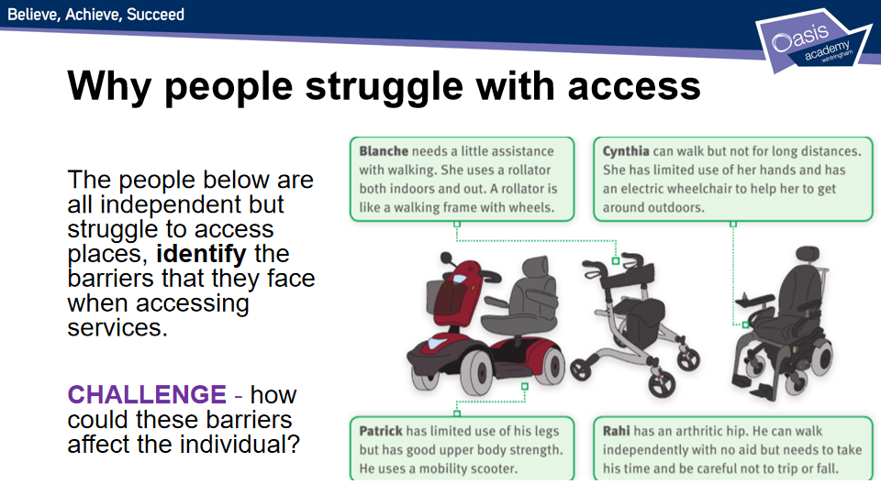
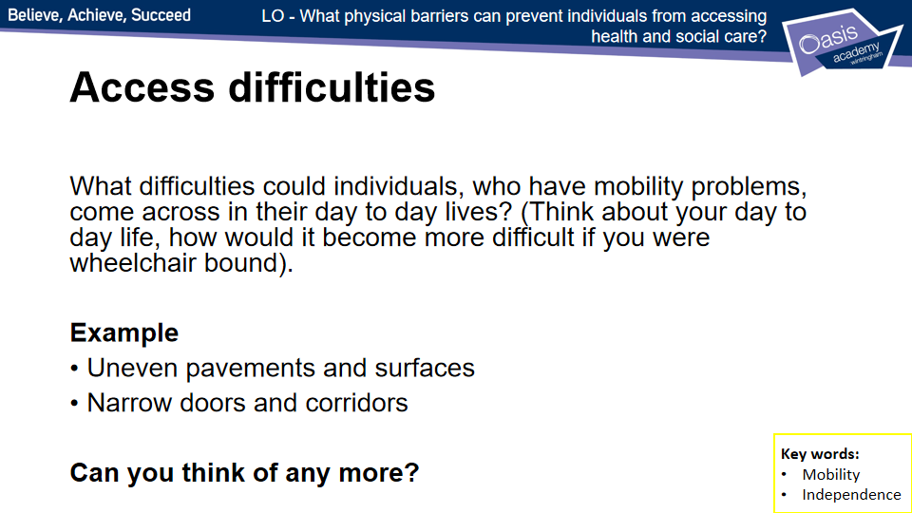

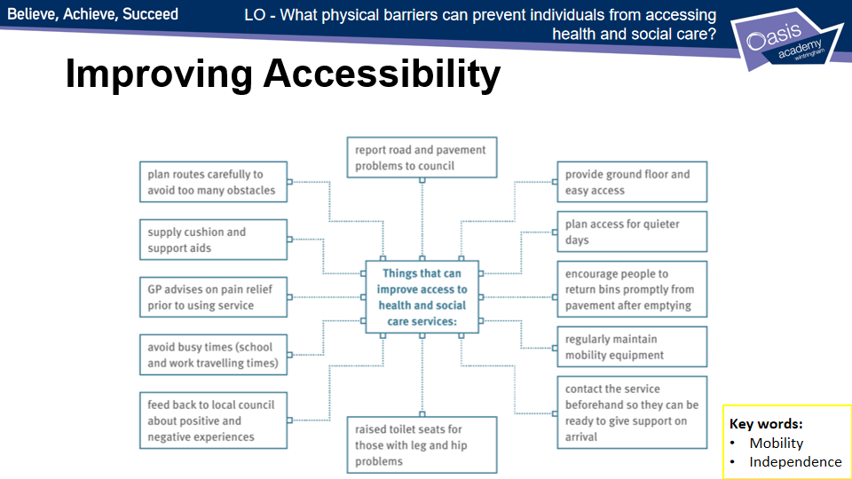

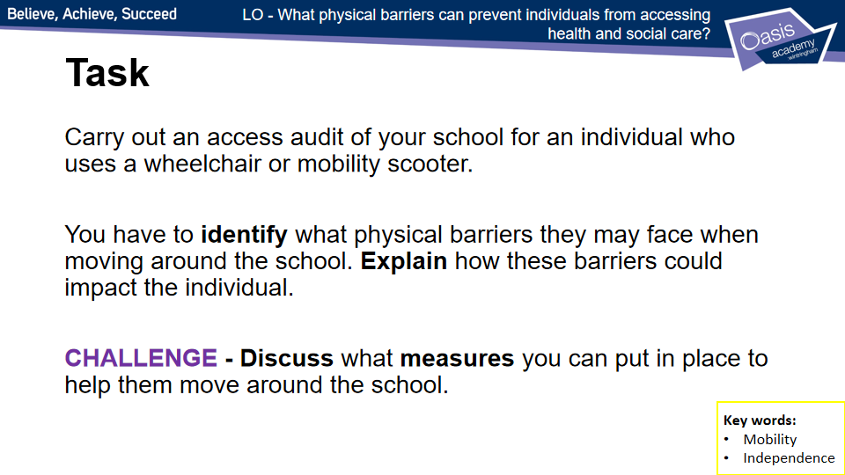

Lesson 1 - Worksheets

Physical barriers: an access audit

In groups, carry out an access audit of your school for an individual who uses a wheelchair or mobility scooter.
Area | What difficulties might be encountered? | How could access difficulties be improved?
Approach to the school entrance. | There may be steps to the main doors | A portable ramp could be used

Lesson 2 - Sensory Barriers
*Some tasks on lesson 1 worksheet
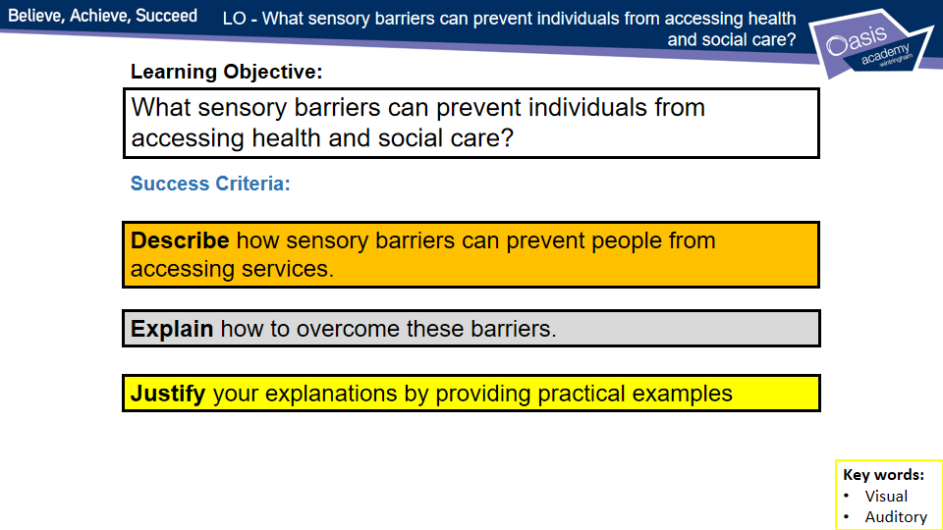
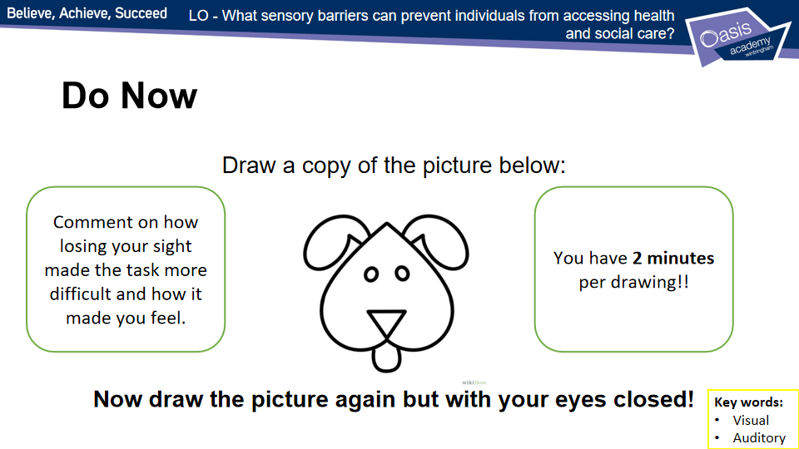
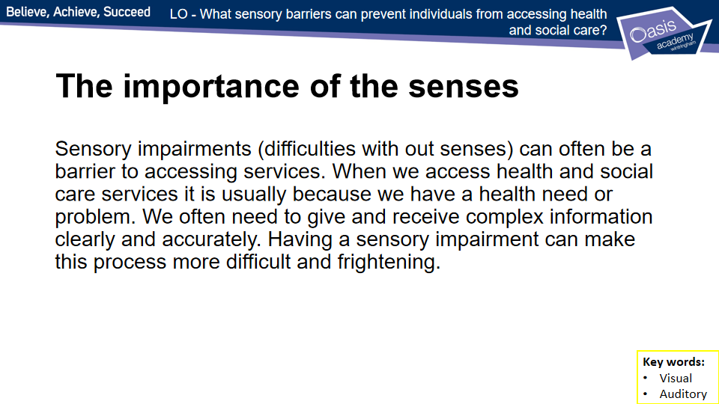
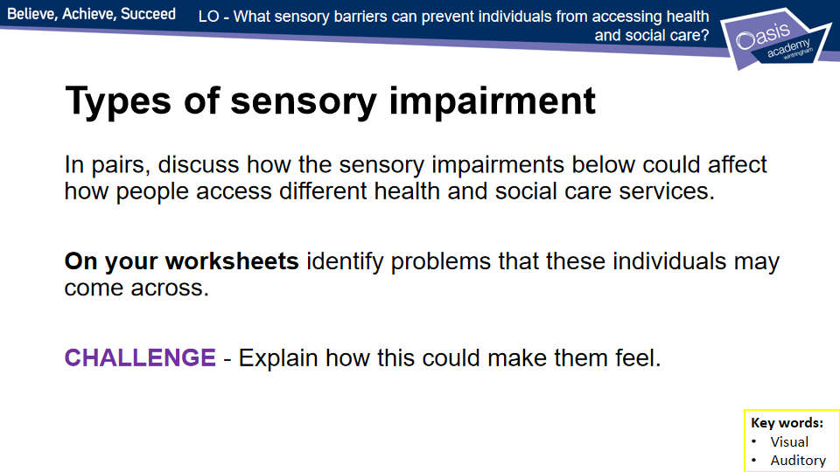
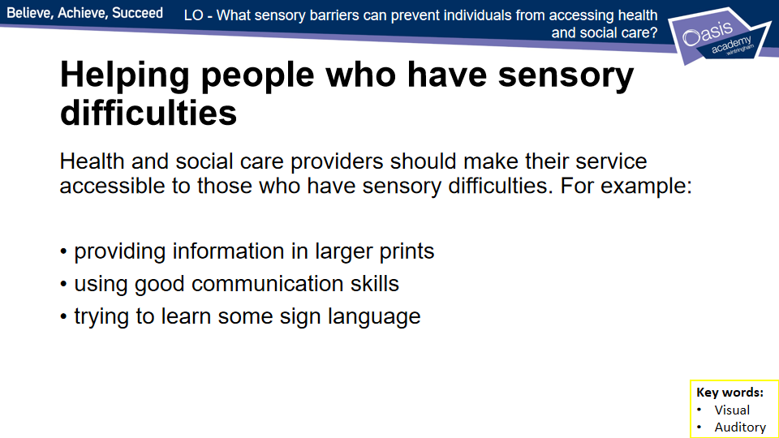
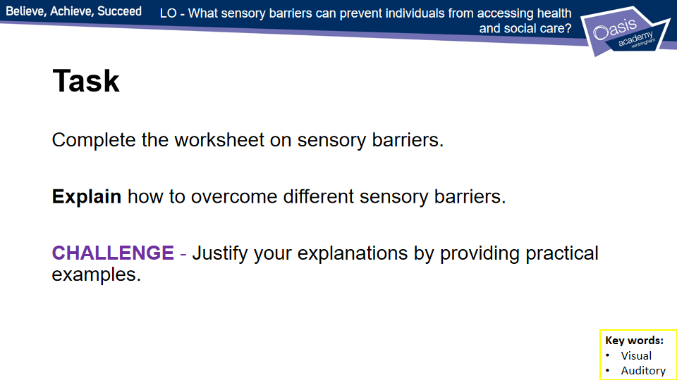

Lesson 2 - Worksheets

Sensory barriers
Many people have sensory difficulties, such as a sight or hearing impairment. These difficulties may prevent them from communicating easily.

- (a) If you were a sight-impaired person, what helpful ways could people communicate with you? List three different methods.

Method 1: ___________________________________________________________________________

Method 2:
___________________________________________________________________________

Method 3:
___________________________________________________________________________

(b) Now imagine you are a hearing-impaired person. List three methods people could use to communicate with you.

Method 1: ___________________________________________________________________________

Method 2: ___________________________________________________________________________

Method 3: ___________________________________________________________________________

- Fingerspelling is a simple way to communicate with individuals who have hearing impairments.
  - Look up the following documents online, or even print them out. They will show you how to fingerspell using your right hand or your left hand.

www.british-sign.co.uk/wp-content/uploads/2013/05/BSL-Fingerspelling-Right-Handed.pdf

www.british-sign.co.uk/wp-content/uploads/2013/05/BSL-Fingerspelling-Left-Handed.pdf

  - Working with a partner, use the fingerspelling charts to communicate:
- your favourite food
- your favourite place
- a book with a one-word title
- your favourite sport/activity.

Lesson 3 - Sensory Barriers
*Some tasks on lesson 1worksheet
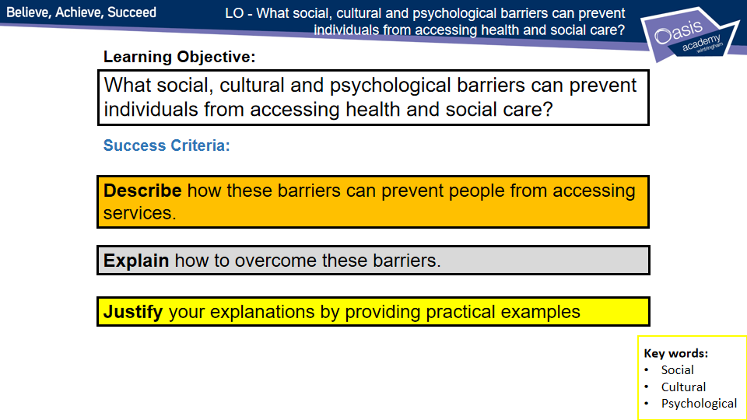
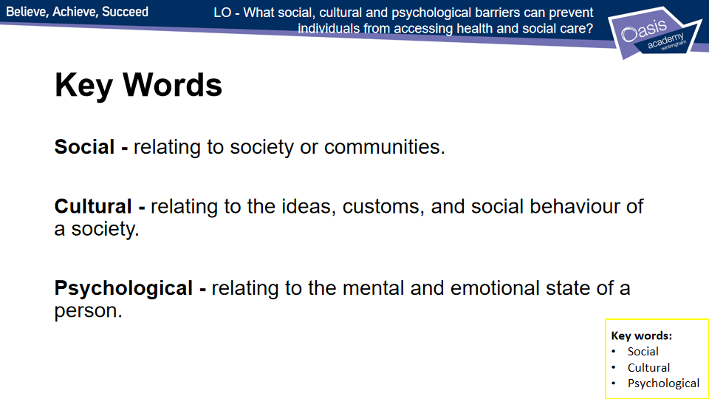
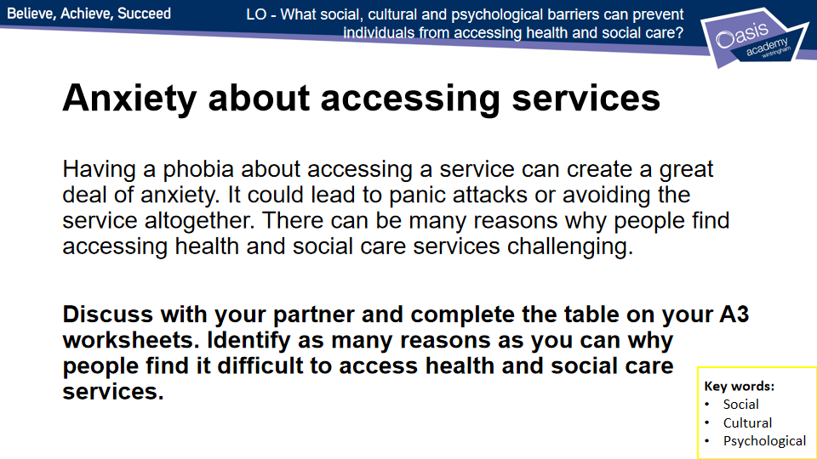
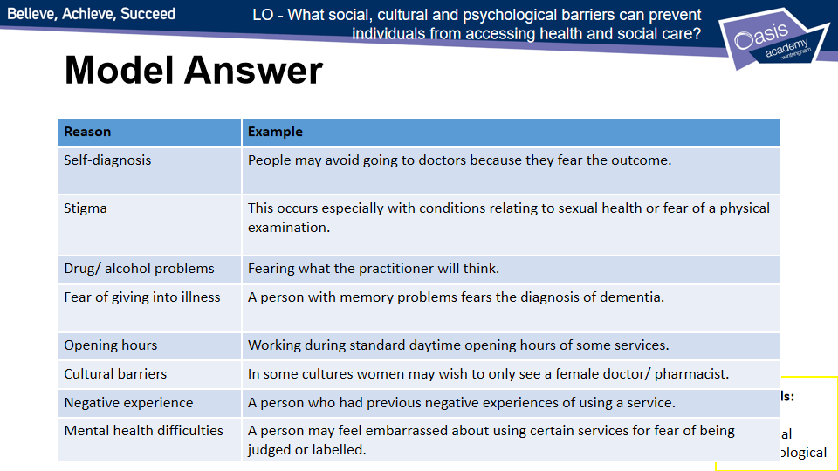
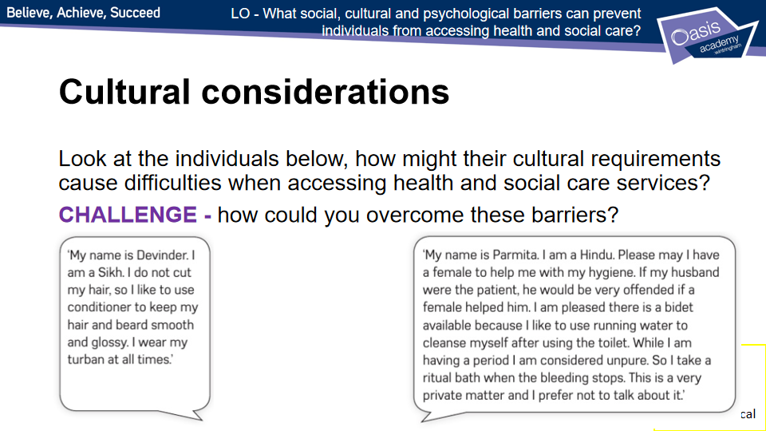
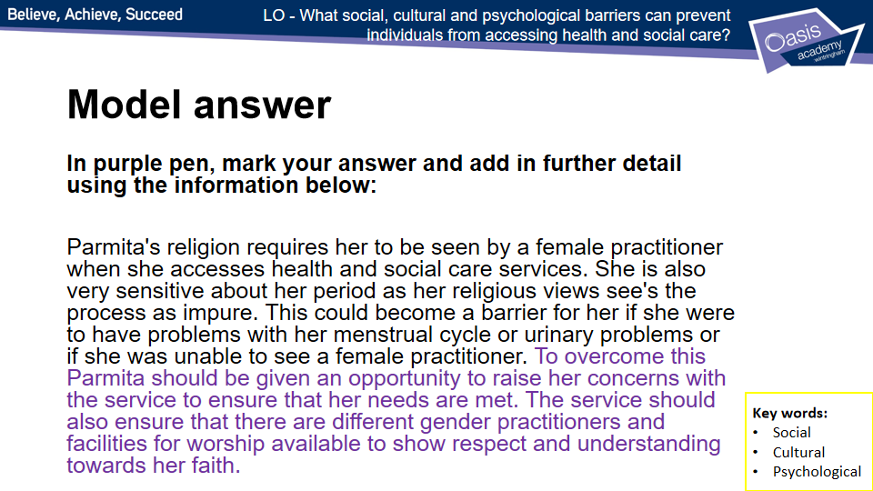

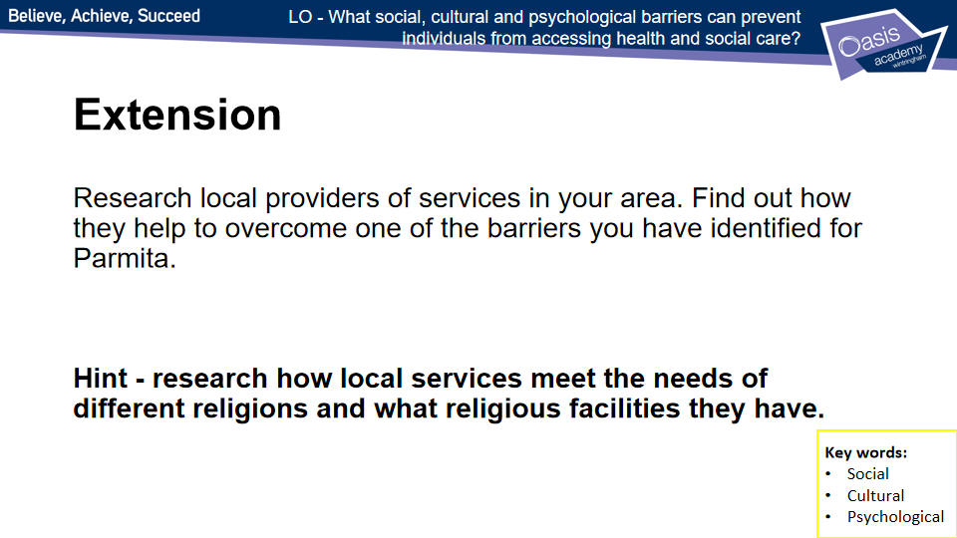

Lesson 3 - Worksheets

Social, cultural and psychological barriers
- Read the scenario below. Then think about the questions that follow.
Hint
These questions all relate to cultural barriers. You could do some research to help you with your answers.
Parmita, 39, has been having some mobility problems. She has to spend two days in hospital for a series of examinations. She is a Hindu and is married. She is very particular about her personal hygiene. She and her husband do not eat meat or fish. She is concerned about the doctors and consultants who will be examining her. Parmita finds it hard to talk openly about some of these things.

    - Why might Parmita be concerned about who will be examining her?
____________________________________________________________________
____________________________________________________________________

    - How could these barriers be overcome?
____________________________________________________________________
____________________________________________________________________
    - Why might Parmita be concerned about her personal hygiene during her hospital stay?
____________________________________________________________________
____________________________________________________________________

    - How can this barrier be overcome?
____________________________________________________________________
____________________________________________________________________

    - Find one other barrier that Parmita may face in hospital and outline how it could be overcome.
____________________________________________________________________
____________________________________________________________________

Extension
Research local providers of services in your area. Find out how they help to overcome one of the barriers you have identified above.

Lesson 4 - Language Barriers
*Some tasks on lesson 1 worksheet
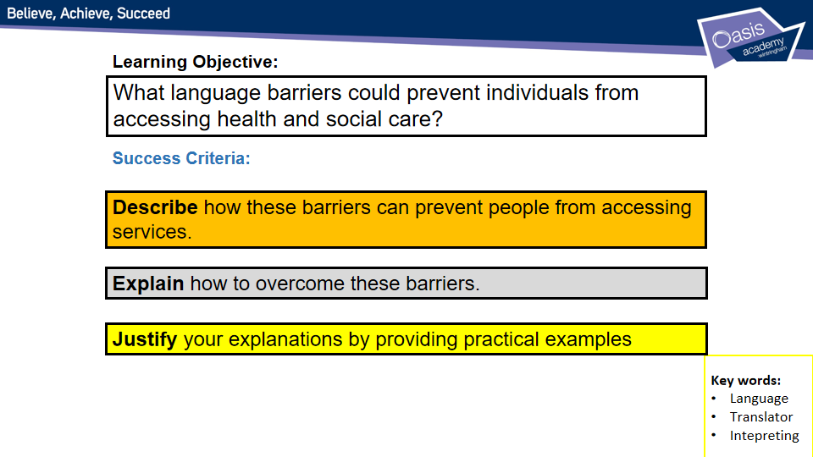
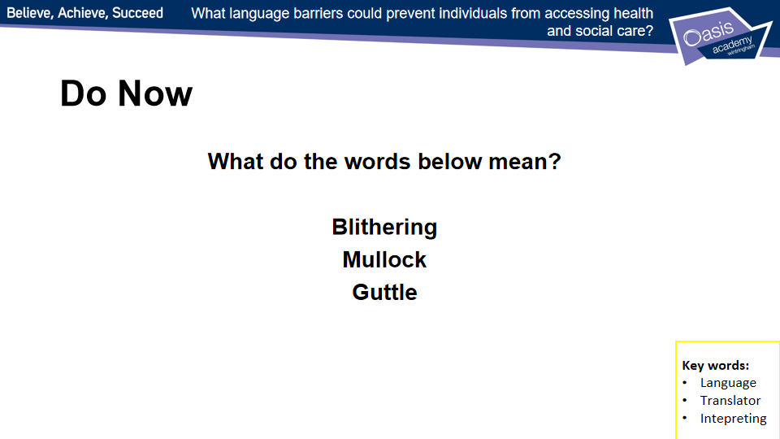
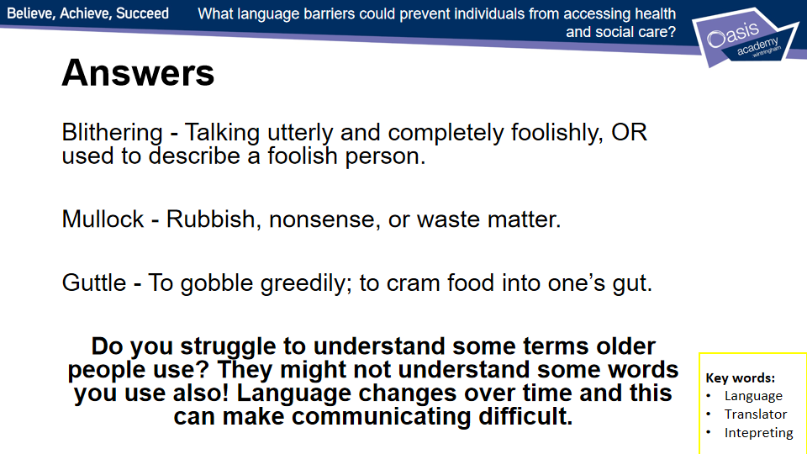
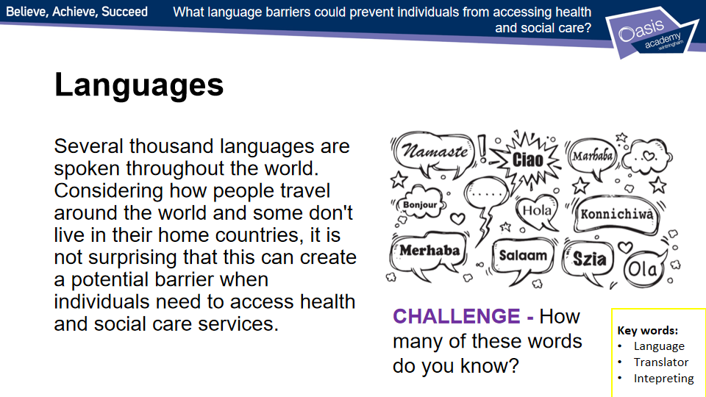
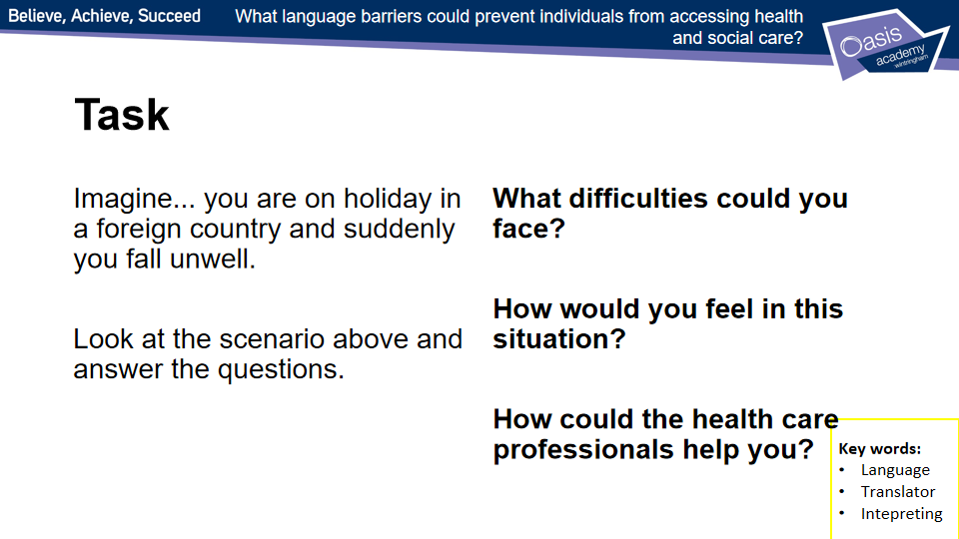
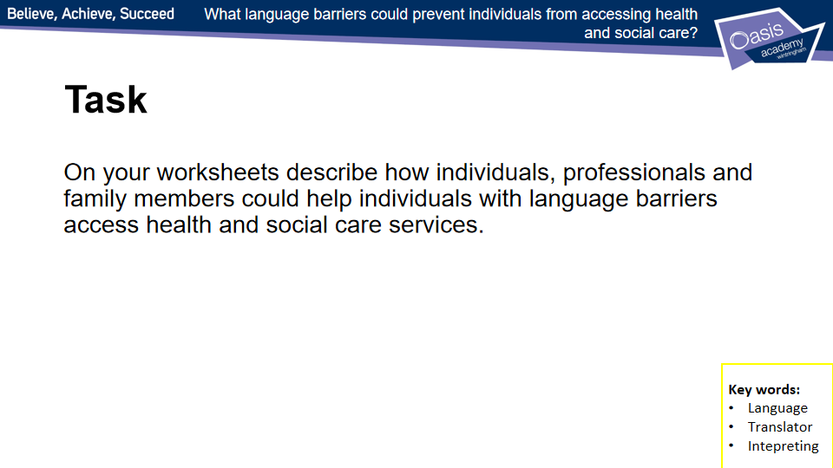

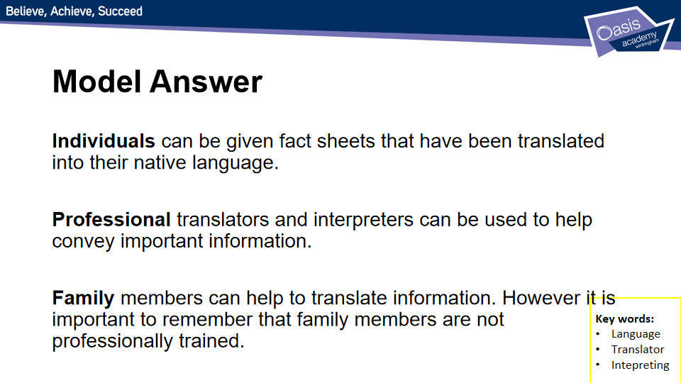
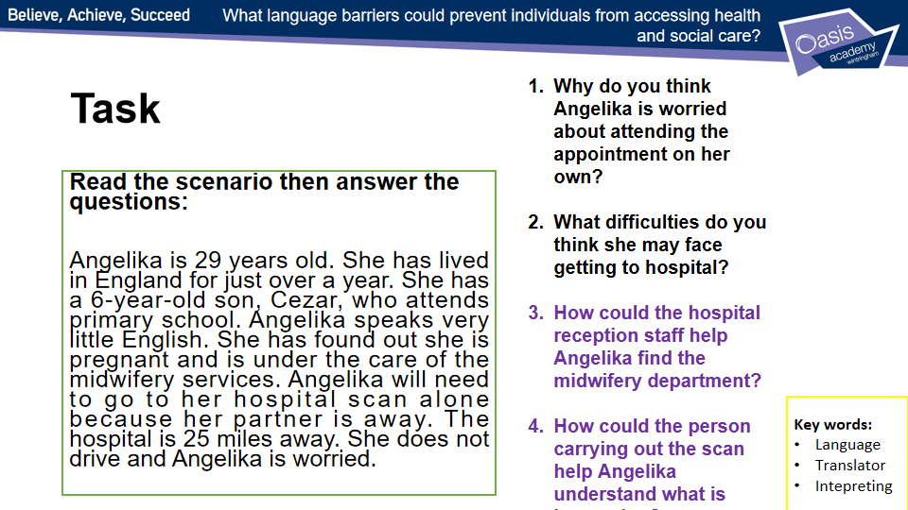
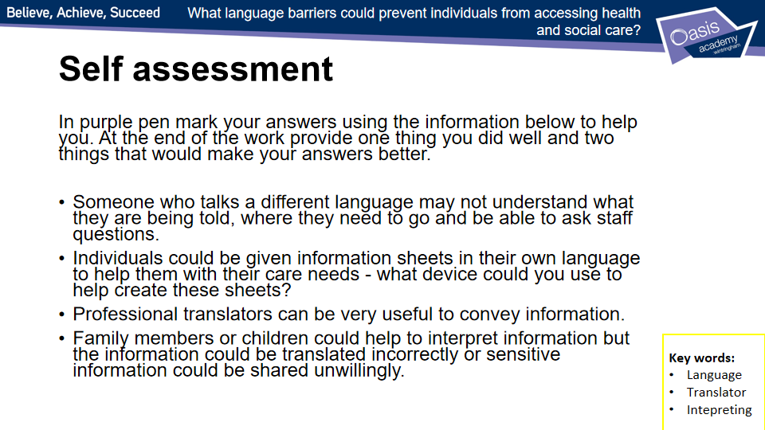

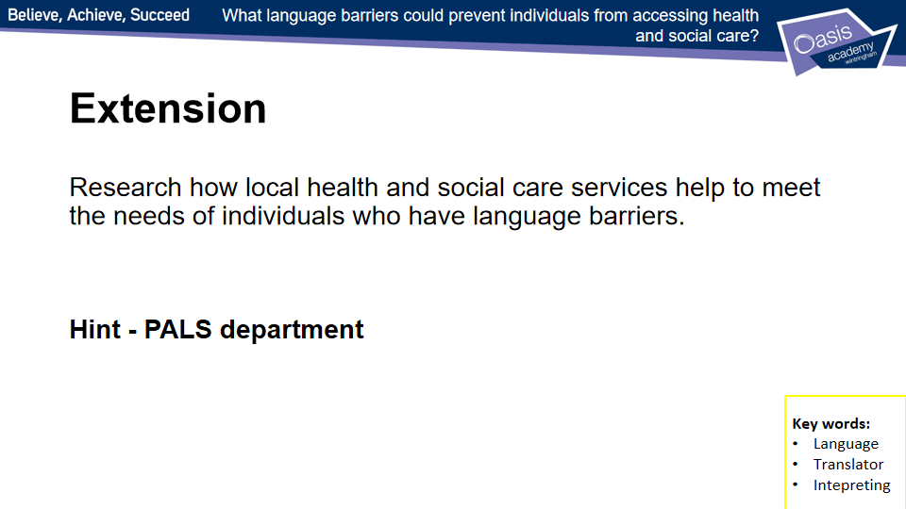

Lesson 4 - Worksheets
Language can be a real barrier to accessing services, especially for people who do not speak English as their first language. Imagine they have a hospital appointment – they may feel very anxious about understanding information they have been given, such as where to go, who to ask for, what will happen and how long it will take.

- Read this scenario, then answer the questions that follow.

Angelika is 29 years old. She has lived in England for just over a year. She has a 6-year-old son, Cezar, who attends primary school. Angelika speaks very little English. She has found out she is pregnant and is under the care of the midwifery services. She has received a letter to attend hospital for a scan.

  - In addition to the letter, what could the hospital send to Angelika that would be really useful and helpful?
________________________________________________________________________________________________________________________________________________________________________________________________________________________________________________________________________________________________________

  - What additional service/help would be useful for Angelika when she arrives at the hospital? Why?
________________________________________________________________________________________________________________________________________________________________________________________________________________________________________________________________________________________________________

- You are the receptionist at the hospital. You have to pass on important information to Angelika. What could you do to help her? List three things.

I could: ______________________________________________________________________________________________________________________________________________________________________

I could: ______________________________________________________________________________________________________________________________________________________________________

I could: ______________________________________________________________________________________________________________________________________________________________________

Lesson 5 - Geographical Barriers
*Some tasks on lesson 1 worksheet
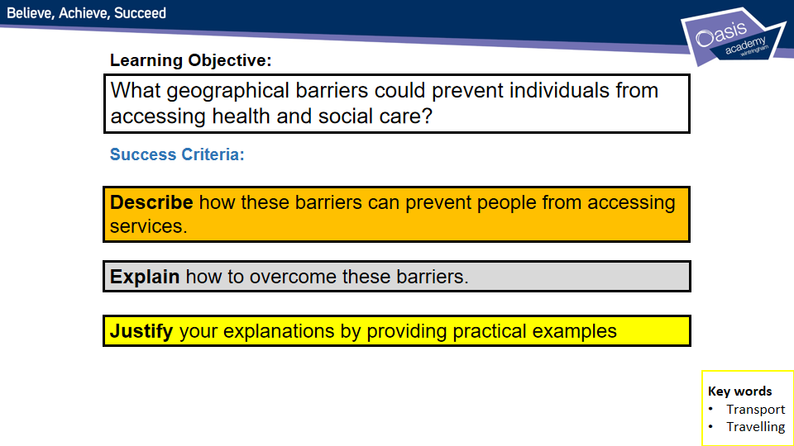
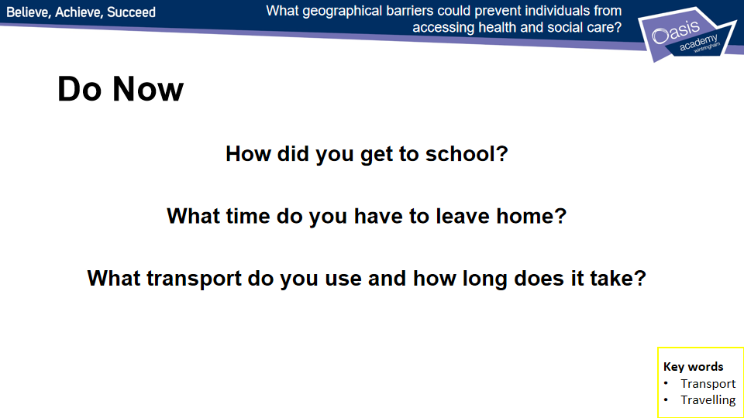
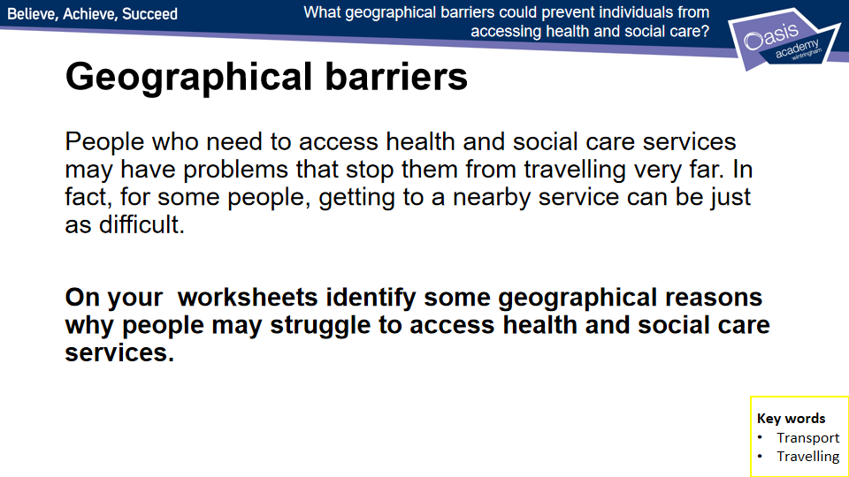
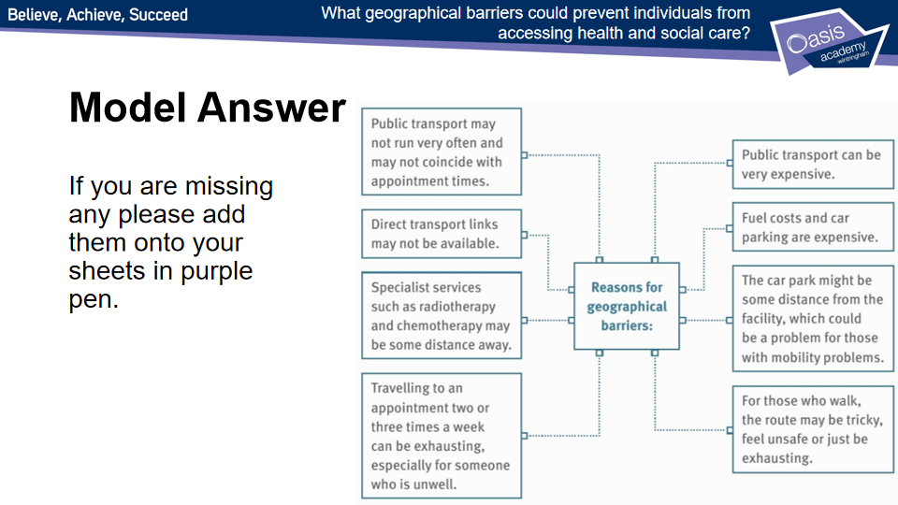
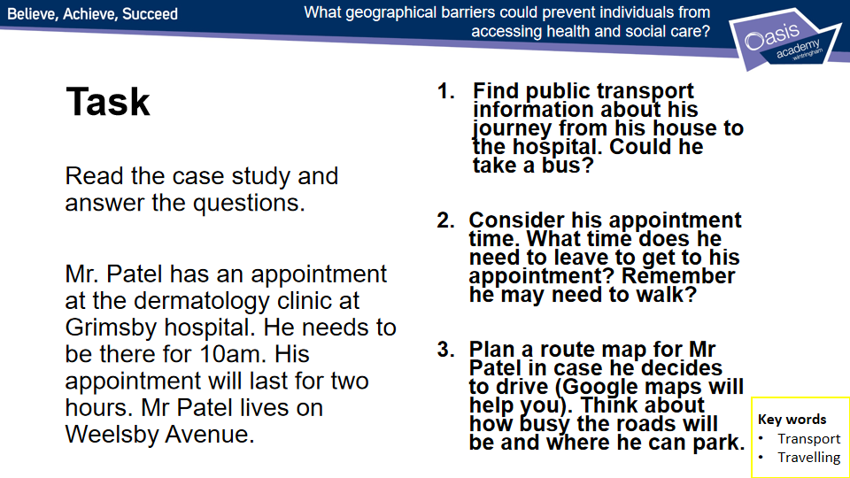
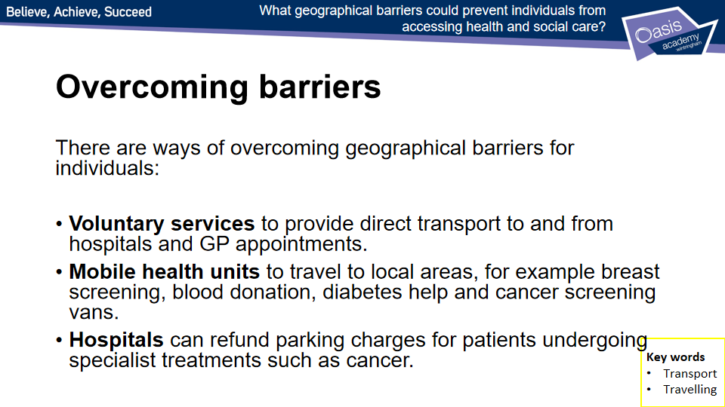
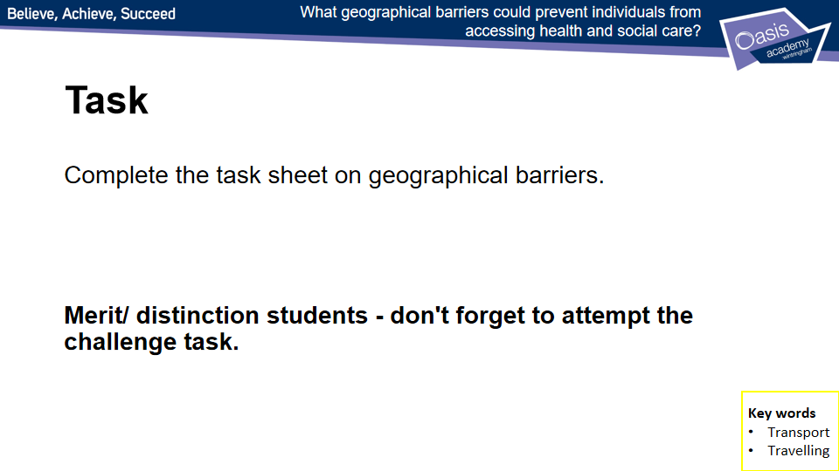

Lesson 5 - Worksheets
Some people find it difficult to travel. This can create a barrier to accessing health and social care services.

- Read the scenario below, then answer the questions.

You have a dental appointment. You work six days a week in a small village; you also live in the village. Your nearest dentist is in a town 14 miles away; it is open Monday to Friday. There are two buses into town in the morning and one back at 5 pm. There is a regular train that goes into town, but the station is 6 miles away and there is no bus to the station. You can drive, but you do not have your own transport.

  - Give three geographical barriers to visiting your dentist.

Barrier 1:
__________________________________________________________________________
__________________________________________________________________________

Barrier 2: __________________________________________________________________________
__________________________________________________________________________
Barrier 3: __________________________________________________________________________
__________________________________________________________________________

  - Suggest how you could overcome these barriers.

Overcoming barrier 1:
__________________________________________________________________________
__________________________________________________________________________

Overcoming barrier 2: __________________________________________________________________________
__________________________________________________________________________

Overcoming barrier 3: __________________________________________________________________________
__________________________________________________________________________

CHALLENGE - Some voluntary services provide direct transport to and from hospitals and GP appointments for a reasonable cost. Research services like this in the county you live in. Then draft a leaflet advising others what’s available. Remember to make your information clear and easy to understand. (You can use the space below and a notebook to answer.)

Lesson 6 - Intellectual Barriers
*Some tasks on lesson 1 worksheet
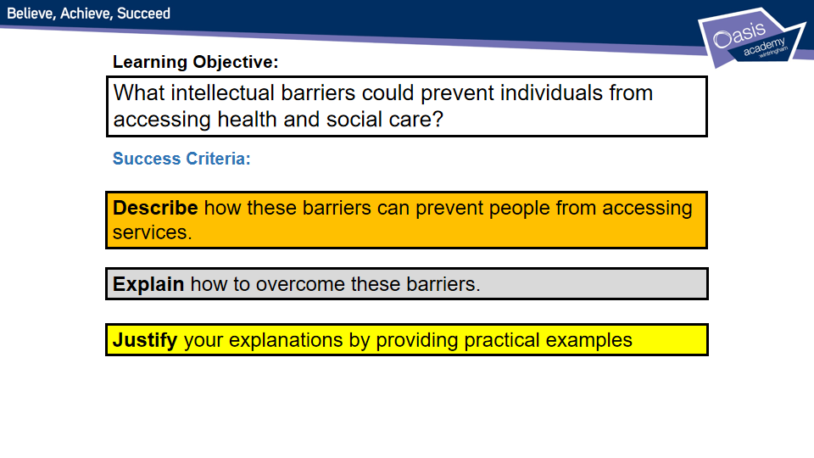
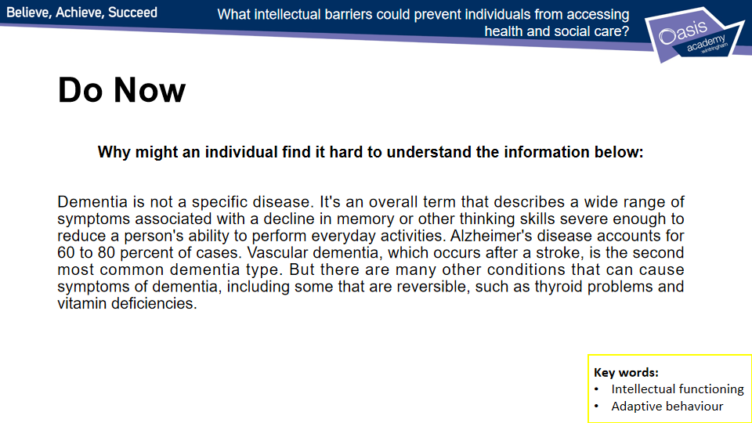
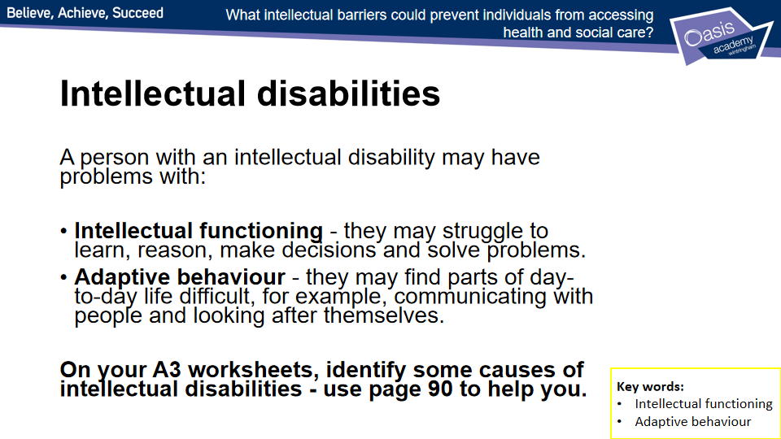

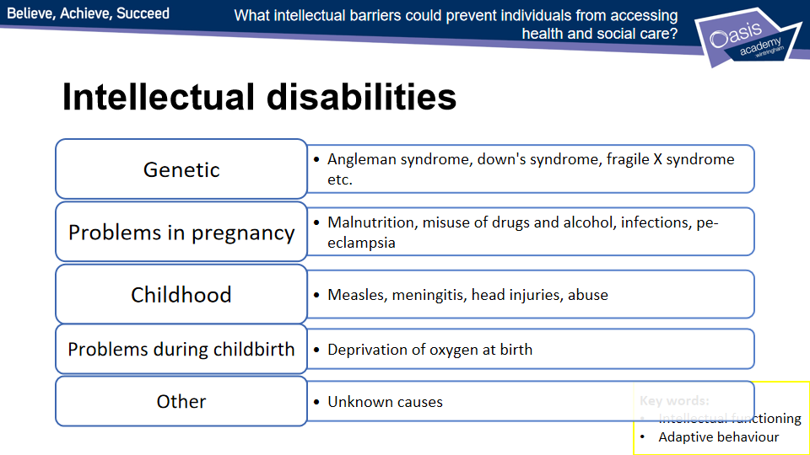
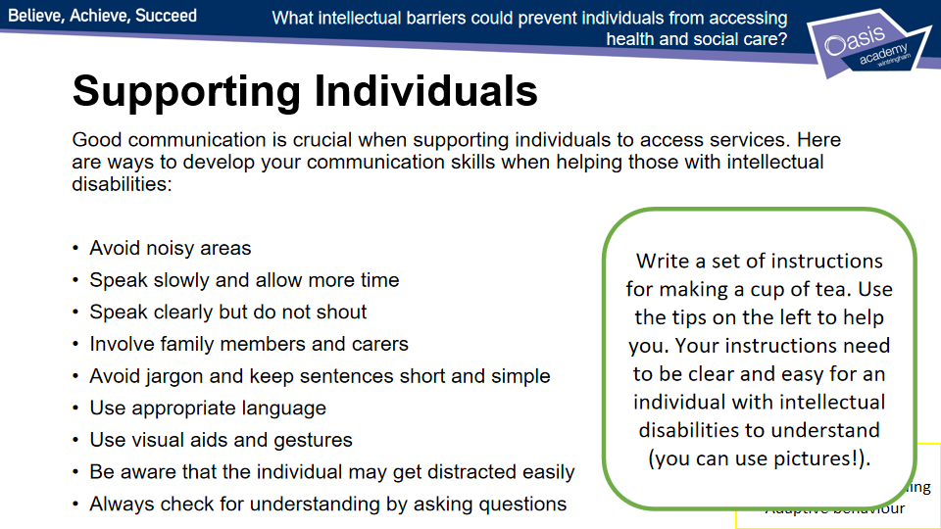

Lesson 6 - Worksheet
Learning aim A: Understand the different types of health and social care services and barriers to accessing them
Learning aim A2: Barriers to accessing services
Some people can have intellectual difficulties that make accessing services difficult.
- Give two reasons why a person might have an intellectual disability.

Reason 1: ____________________________________________________________

Reason 2: ____________________________________________________________

- Read the scenario below. Then add simple instructions to the table that Jay can understand.

Jay has a learning disability. He finds it difficult to read and understand complicated text. Jay has just moved into supported living accommodation. Kelly, his key worker, wants to make sure he remembers important information.

Hint
Sometimes it is easier to use an image or a diagram than to write out a long explanation.

Safely making a hot drink using the kettle | Remembering to take medication twice a day – morning and night
Not answering the door unless the person is known to Jay | Contacting key worker, Kerry

Lesson 7 - Resource Barriers
*Some tasks on lesson 1 worksheet
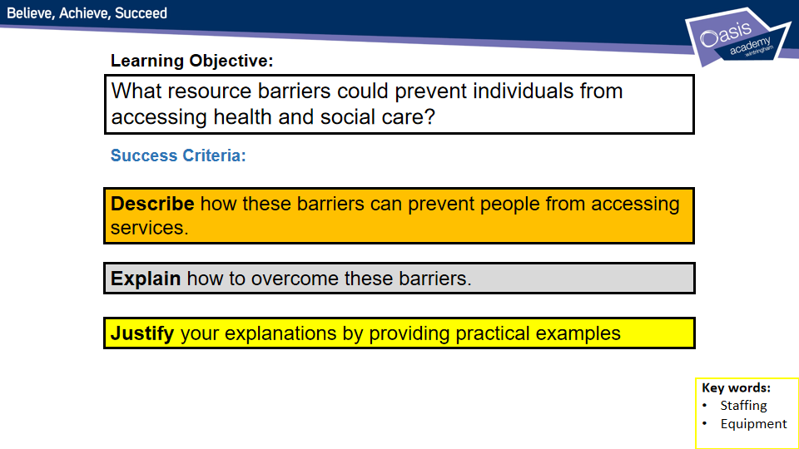
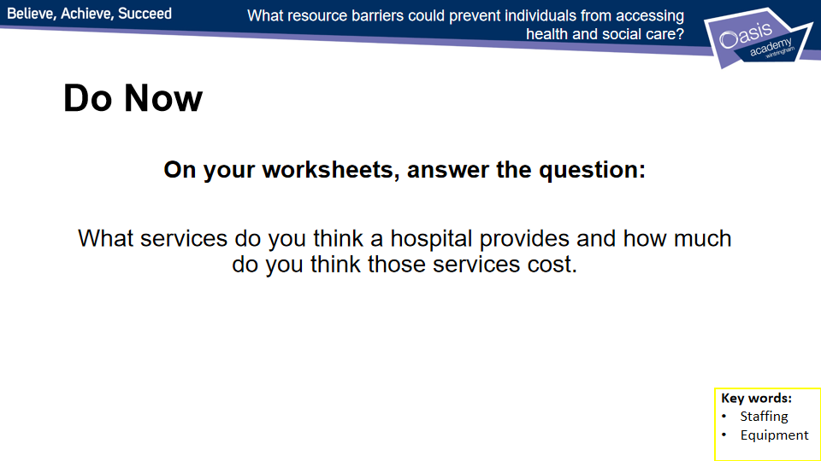
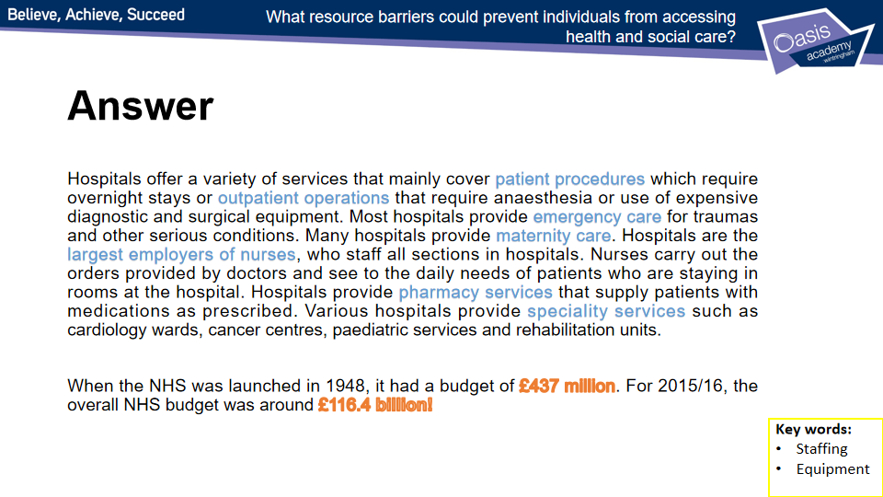
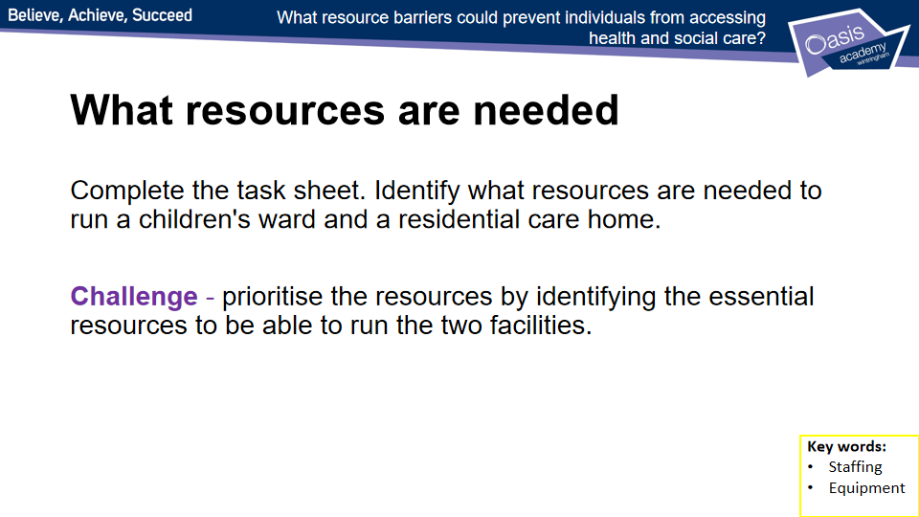
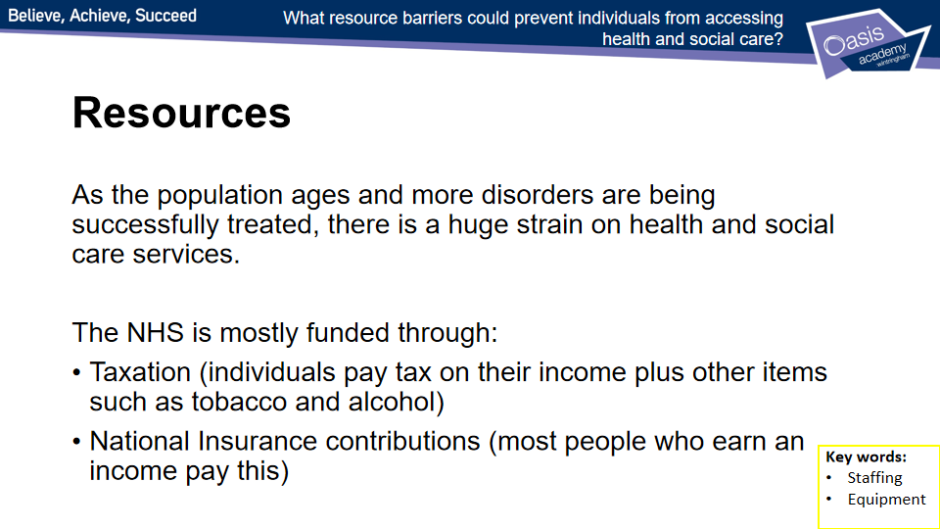
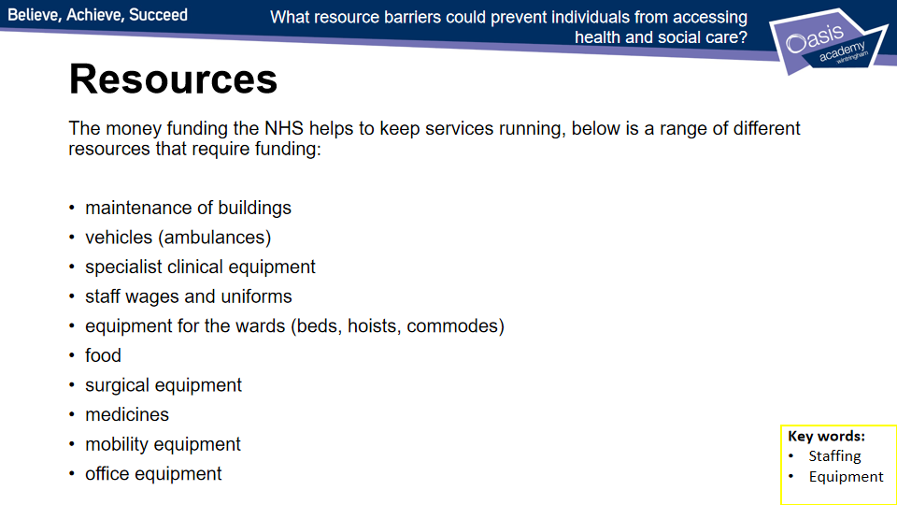

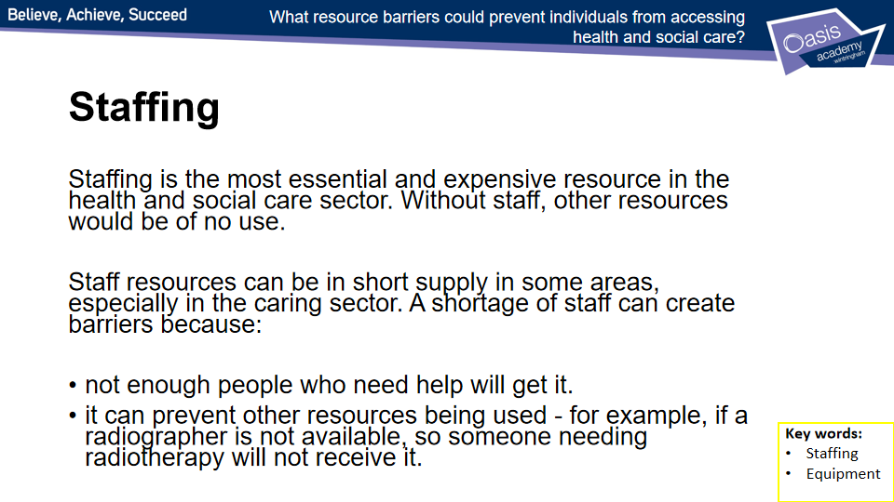
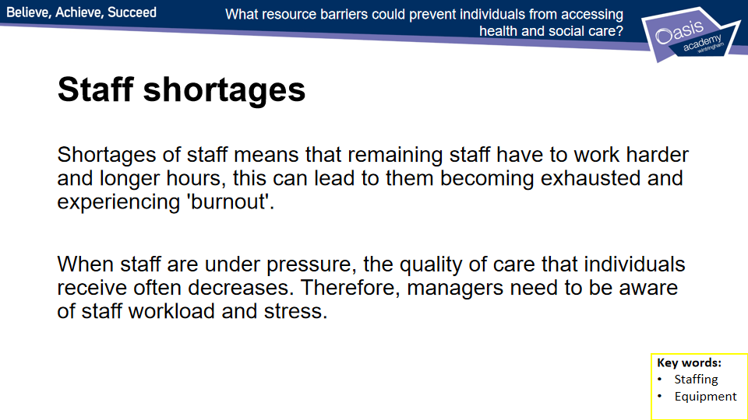
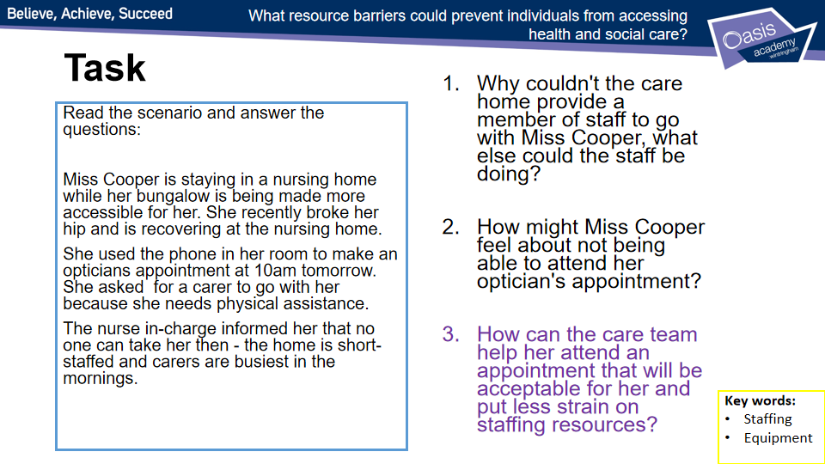
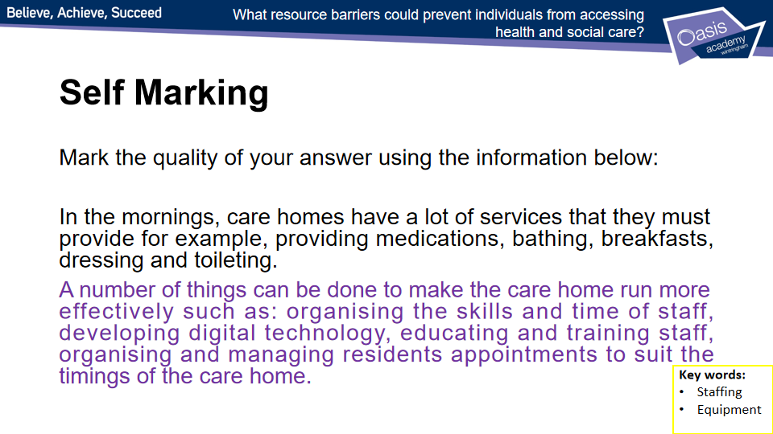

Lesson 8 - Financial Barriers
*Some tasks on lesson 1 worksheet
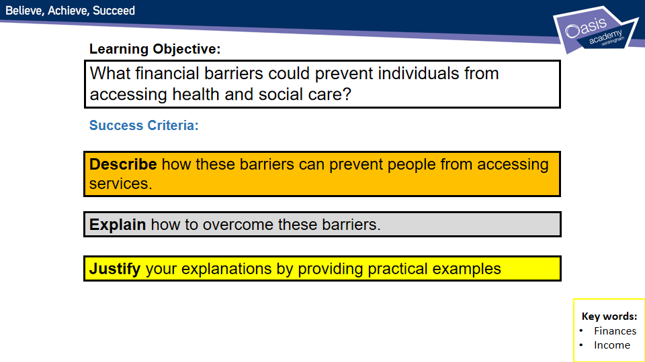
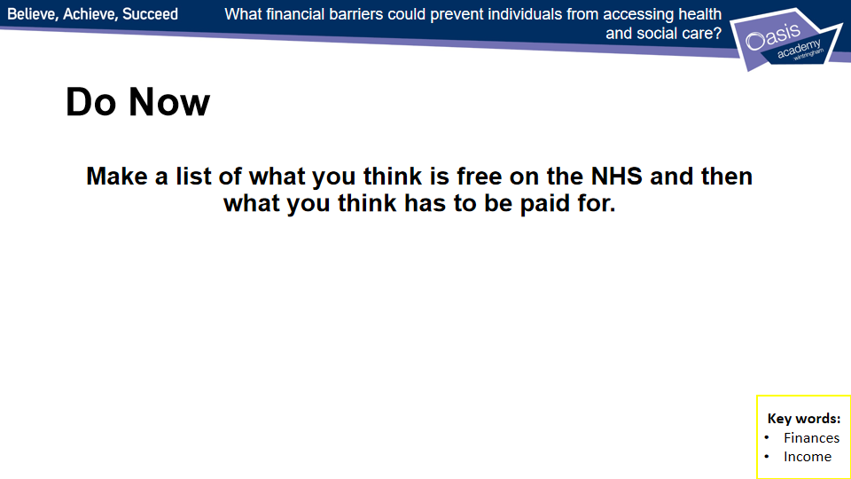
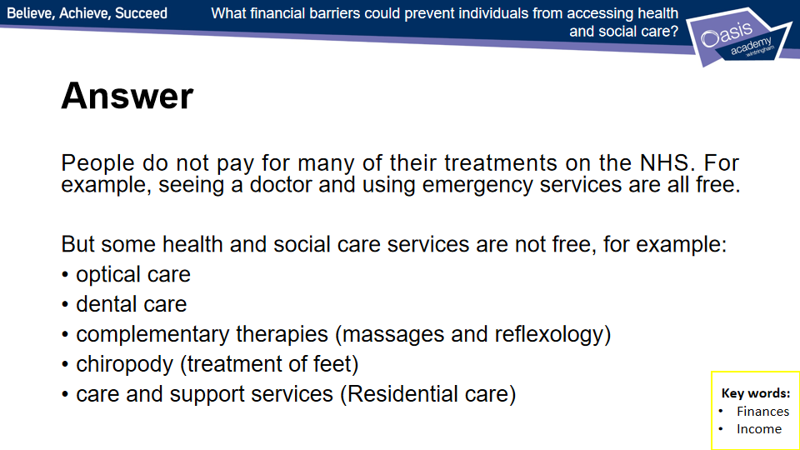
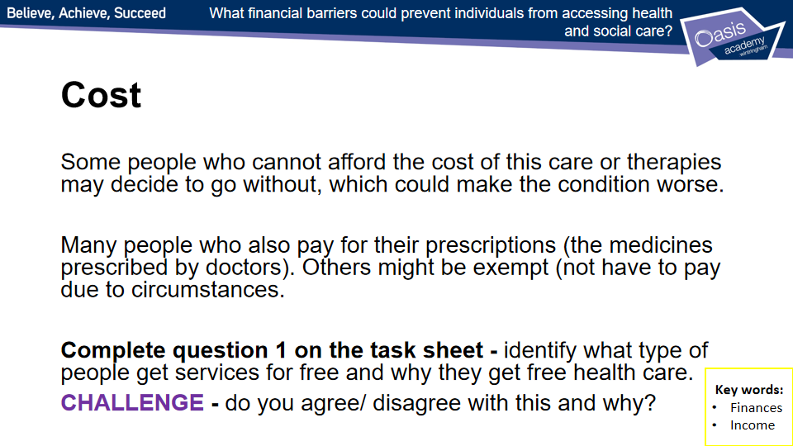
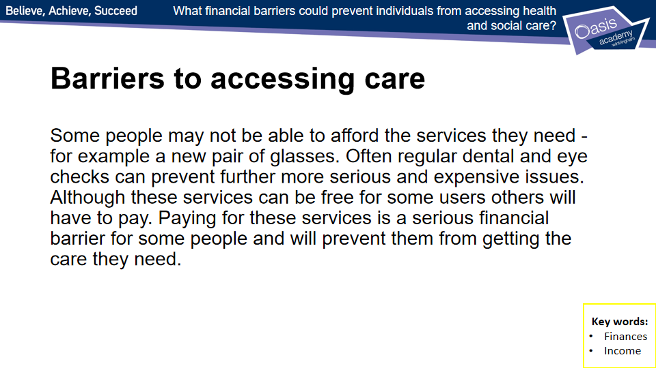
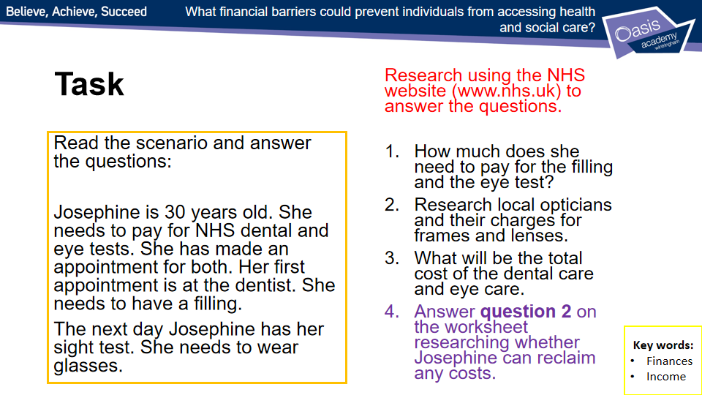
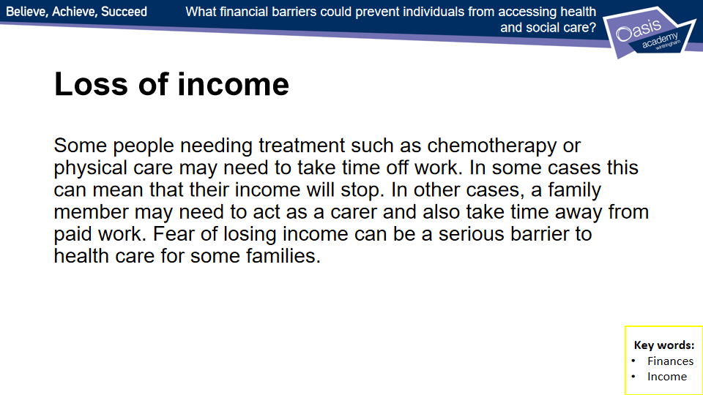
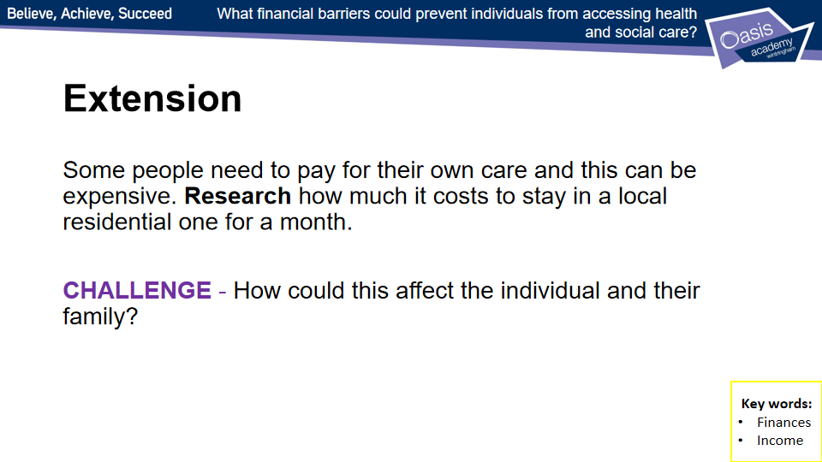

Lesson 8 - Worksheets
- Treatments for some people are free on the NHS but others must pay a contribution. Look at the table below, which shows who pays and who does not. List two people you know who, according to this table, can get free care.

Free prescriptions | Free dental care | Free eye care
People over 60 | People under 18 | People over 60
People under 16 | People under 19 in full-time education | People under 16
People under 19 in full-time education | Pregnant women | People aged 16, 17 and 18 in full-time education
Pregnant women | Women who have had a baby in the last 12 months | People registered as partially sighted or blind
Women who have had a baby in the last 12 months | Some people on low income and benefits | People diagnosed with glaucoma or diabetes and/or who are over 40 with a family history of glaucoma
Some people on low income and benefits | Patients in an NHS hospital when needing treatment | Some people on low income and benefits
People with cancer |  | A prisoner on leave

Person 1 (____________________) can get free __________________________________________
because __________________________________________________________________________

Person 2 (____________________) can get free __________________________________________
because __________________________________________________________________________

- Read the scenario below. Can Josephine claim back any travel costs?
Josephine, 30, needs to pay for NHS dental and sight tests. She has made an appointment for both. She needs one filling at the dentist, and she needs new glasses at the opticians. Her journey to the dentist and optician means she needs to take a bus, a train and a taxi. Josephine is hearing impaired and walks with an aid due to a back injury. She needs someone to help her when she travels.

Hint
The NHS website gives lots of information about making claims for travel and other costs. You could start your research here.

Lesson 9 - Case Studies
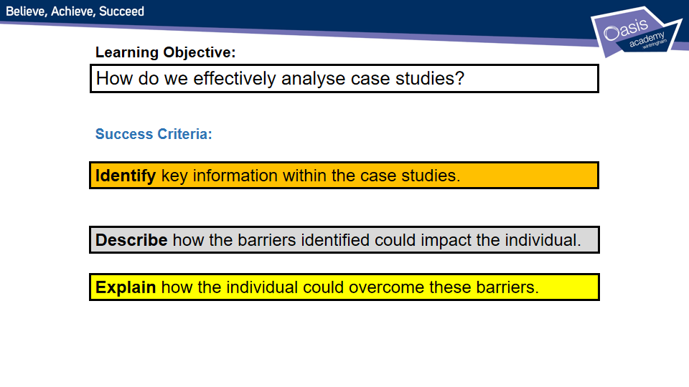
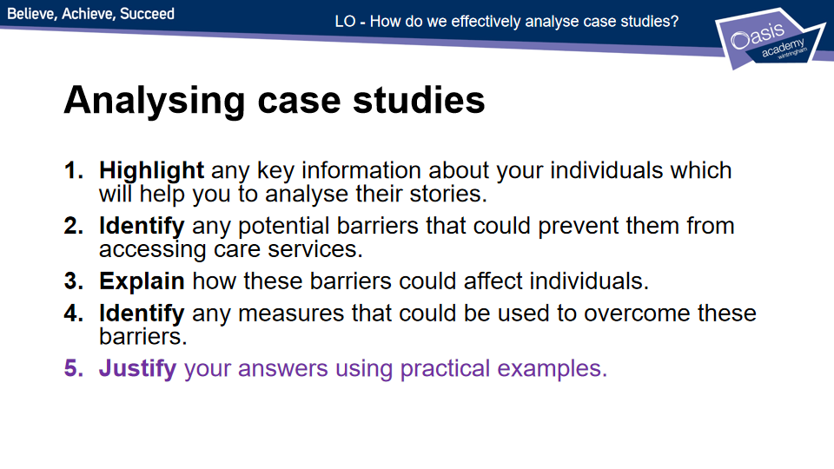

BTEC Tech Award Health and Social Care - Assignment Guide
Unit 2 – Health and Social Care Services and Values
Assignment 2A

Providing good health and social care services is very important and a set of ‘care values’ exists to ensure this happens. Care values are important because they enable people who use health and social care services to get the care they need and to be protected from different sorts of harm.

Title: Understand the different types of health and social care services and barriers to accessing them.

PASS 1
Choose ONE case study from below which you will refer to throughout the review:
- Verna and Sam Williams
- Myra and Elizabeth McDermott
- Amiya and Rajiv Dutta

Carry out research to find local services that will meet your individuals’ needs. You must cover any of the following that applies to your case study:
- Different health care services:
  - Primary care – GPs, dental care, optometry, community health care.
  - Secondary and tertiary care – specialist medical centres.
  - Allied health professionals – physiotherapy, occupational therapy, speech and language therapy, dieticians.
- Different social care services:
  - Services for children and young people – foster care, residential care, youth work.
  - Services for adults or children with specific needs (learning disabilities, sensory impairments, long-term health issues) – residential care, respite care, domiciliary care.
  - Services for older adults - residential care, respite care, domiciliary care.
  - The role of informal social care provided by relatives, friends and neighbours.

PASS 1
Research, present and explain ways in which suitable health and social care services meet the needs of the individuals in your chosen case study.

THEN

From your case study and explain how barriers could affect their use of one health or social care service.

You should cover any of the following that apply to your individual:
- Physical barriers (mobility/ access difficulties)
- Sensory barriers (hearing/ sight)
- Social, cultural and psychological barriers (anxiety/ cultural backgrounds)
- Language barriers (English is not first language/ speech difficulties)
- Geographical barriers (Public transport/ travelling costs)
- Intellectual barriers (Intellectual disabilities/ difficulty reading and writing)
- Resource barriers (Staffing/ medical equipment)
- Financial barriers (Paying for dental care, optical care etc./ loss of income)

You will explain barriers to one service in greater detail than the rest this will be key to your ability to more onto a merit.

MERIT 1
Suggest how the barriers discussed in PASS 1 can be overcome for your chosen individual.
THEN
Analyse the extent to which health and social care services meet the needs of your chosen individuals (both individuals should be discussed).

DISTINCTION 1
Assess the suitability of the health and social care services for meeting the needs of your chosen individuals (both individuals should be discussed). Provide an overall judgement, which could result in rankings or scores, together with clear information about how you have reached this judgement.
THEN
Provide realistic suggestions for how the barriers discussed in MERIT 1 for your chosen individual can be overcome, justify your answers. Explain why these suggestions are realistic and highlight why other possibilities might not work.

Pearson BTEC Level 1/Level 2 Tech Award in Health and Social Care

Component 2 Health and Social Care Services and Values
Learning aim A: Understand the different types of health and social care services and barriers to accessing them

Case study 1: Verna and Sam Williams
Verna Williams is forty-eight years old and lives with her husband Sam, and their two cats. They live on the second floor of a block of flats. The lift is often broken. This means that access to the street is down two flights of stairs. The block of flats is on a new estate half a mile from the nearest bus stop.
Verna has a medical condition which affects her mobility. Verna uses a walking stick to get around most of the time, but some days she needs to use a wheelchair.
Verna also has asthma which has recently got much worse. She has type two diabetes. She takes medication and has a diet plan to cope with the diabetes.
Sam Williams is fifty-two years old He has recently left his job at a local supermarket because he had an argument with the manager. Sam and Verna are now living on a reduced income.
Sam has a hearing impairment for which he uses a hearing aid. Sam also has a learning disability and a speech impairment. This means that he has difficulty communicating with people and he becomes frustrated when asked to repeat what he has said.

Case study 2: Myra McDermott and Elizabeth McDermott
Myra McDermott is forty-two years old and lives with her daughter Elizabeth in a rural village. The village has very few services. People have to travel into the nearest town for healthcare and shopping.
Myra has a skin condition which means that her skin is itchy and flakes regularly. She needs to use creams provided by the G.P, and cannot sleep when her skin becomes really uncomfortable.
Myra also has gum disease and is now experiencing bleeding when she brushes her teeth. Myra is afraid that she will need to have all of her teeth removed if she goes to the dentist and so has not made an appointment.
Elizabeth McDermott is twelve years old and attends the academy which is within walking distance from home.
Elizabeth is autistic and has behavioural difficulties. The head teacher at the academy has told Myra that Elizabeth is becoming too difficult for the staff to manage. She has said that the school will be discussing what to do with the Local Authority. This could mean that Elizabeth is transferred to a school for children with additional needs.
This means that Elizabeth would need to travel by school bus to her new school. She will have to leave her friends and travel, with other children she doesn’t know, to the new school which is five miles away. Elizabeth’s family needs advice.

Case study 3: Amiya and Rajiv Dutta
Amiya Dutta is eighty-four years old and lives, with her husband Rajiv, in the centre of a large city.
Amiya has dementia and needs ‘round the clock care’ as she is vulnerable. Amiya likes to go shopping but tends to wander away from her husband and become lost. She has twice been brought home by the local police, very upset and confused.
Amiya has now become incontinent which means that she has no control over her bladder and needs to have her clothes changed several times a day. Amiya also wakes up in the night and wanders around the house.
Rajiv Dutta is eighty two years old and has severe headaches, which mean that he sometimes cannot keep to his daily routine because of the pain. Rajiv also has high blood pressure and needs medication. Because Rajiv has to provide personal care for Amiya, he finds it difficult to visit the G.P. for a prescription. He does not always take his medication regularly.

Mr Broderick’s ideas

Amiya
- 84yrs old – what are the possible age problems (ONLINE would be problem, mobility issues, transport barriers)
- In town centre – busy but near care, very busy could be dangerous if she wonders
- Dementia – what is dementia? What support is out there? GP? Neurology?
- ‘round the clock care’ – how can this be achieved? Domiciliary care ?
- Police have returned her home – this is primary care service but not appropriate could they support or sign post to correct care? Does she need residential care?
- Incontinent - Wets herself – who could help? Occupational therapist (allied) ?
- Wakes in night and wonders around hospice or home tertiary care?
Rajiv
- 82yrs – problem come with that age must be impossible to care for Amiya (respite care?) page 76 shows other problems with ageing. Physiotherapy?
- Serve headache – GP? Neurology? How can he pick up prescription?
- Doesn’t always take medication (Domiciliary care?, charity like ‘help the aged’)

Lots of health care service can assist Amiya and Rajiv
- Describe what health care services can help and explain how
- What are the potential barriers to them being accessed?
- Say how barriers can be overcome and justify why you have recommended these solution
- Go into detail about one particular service to really secure the distinction

