ROLL AND WRITE A SCRIPT

Roll a dice and use the instructions below to find out the Given Circumstances! (If you don’t have a dice ask a volunteer to pick a number from 1 to 6)
Remember that your script must include a description of your setting at the start, character names in the margin and stage directions in brackets or italics.
Protagonist/s (The main character/s in your script):

Students
A Magician
An Inventor
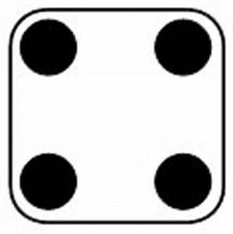 Explorers
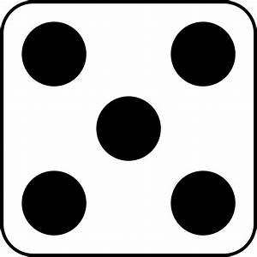 A Detective
A Ghost

Antagonist (A character who is against your Protagonist):

A pirate

A Teacher

A Criminal Mastermind

An Alien

A Ghost

A Scientist

Setting/location:

An old deserted Mansion
The Jungle
A Museum
A Ship
A Cave
A School

Important Object:

A Ring

A Book

A Painting

A Goblet

A Toothbrush

An Apple

A line of dialogue that must appear in your script:

Nooooooooooo!

I am not sure we should be doing this.

Look out!

There is no escape now.

Quick run!

Oops.

A drama technique that you must include:

Freeze Frame
Speaking in Unison
Slow Motion
Flashback
A Dramatic Pause.
A Song.

