Performing a Monologue
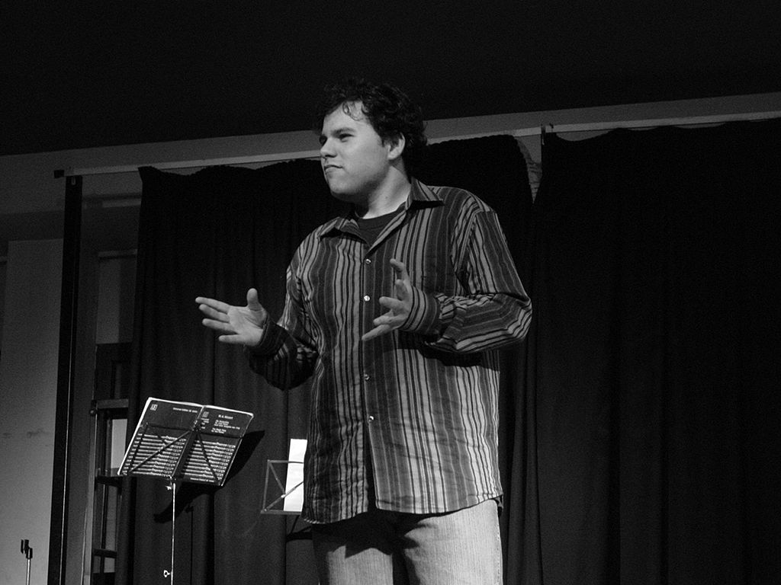Choose 1monologue from the below list

Summer Term 2020
Performance Skills

INTRODUCTION
Read the below monologues and decide which one you think you could perform to the best of your ability.

Style
Think about the style of performance you enjoy doing, and choose your piece based on this..

Performance Skills
Make sure you think about the below in your performance.
- Voice
- Facial Expressions
- Body Language
- Gestures

Setting
Think about what your character might wear and if you can use costume.
Think about where your character might be in this piece and if you can use props/set that are available to you. Don’t just perform in your room, if the piece better fits the sofa, garden etc.

Monologue Choices
Monologue | Play | Character
1 | A Midsummer Night’s Dream by William Shakespeare | Puck
2 | Shakers by John Godber | Nikki
3 | DNA by Dennis Kelly | Leah
4 | Macbeth by William Shakespeare | Lady Macbeth
5 | Too Much Punch for Judy by Mark Wheeler | Judy
6 | Romeo and Juliet by William Shakespeare | Juliet
7 | Educating Rita by Willy Russell | Rita
8 | West by Stephen Berkoff | Mike
9 | Top Girls by Caryl Churchill | Gret
10 | Look Back in anger by John Osbourne | Jimmy

Monologue 1

Puck:

If we shadows have offended,
Think but this, and all is mended,
That you have but slumber’d here While these visions did appear,
And this weak and idle theme,
No more yielding but a dream,
Gentles, do not reprehend:
If you pardon, we will mend:
And, as I am an honest Puck,
if we have unearned luck
Now to ’scape the serpent’s tongue,
we will make amends ere long;
Else the Puck a liar call;
So goodnight unto you all,
Give me your hands if we be friends,
and Robin shall restore amends.

[Exit]

Monologue 2

Nikki:

It’s something that I’ve put together myself. Er… I’ve written all of the words down onto a bit of paper so you can test me. Yeah. Right. It’s called “The smile”. (Pause) Right, I’ll start shall I? (Pause) I’m a bit nervous, so it might be a bit shit. She’d been in the hospital for about four days. She was seventy. She went into hospital for a hysterectomy; the operation had been a great success. I went to see her and she looked great, she even showed me the stitches. She’s my gran, by the way. So at work I was having a laugh and a good time. Then they rang, the hospital, said she’d had a stroke. So I went on the bus to the hospital, I felt sick, travelling all that way on a bus. She was on the sixth floor, I remember that, in a side cubicle on a ward full of old ladies. I walked into the room. My Mam and Dad were looking out of the window, looking across the parkland of the hospital. And my Uncle and Auntie were there, looking out of the window; they were crying. My gran was laid in bed; half of her face was blue and deformed, her mouth was all twisted and taut, one eye was closed. She looked at me, and I tried to smile. I remuthe crying in the background. She tried to speak, but said nothing, she just laid there. “Hello gran” I said. “Hello. What’s all the bloody nonsense about having a stroke? Eh?”. And she just smiled at me. She just smiled.

Monologue 3

Leah
Apparently bonobos are our nearest relative. For years people thought they were chimpanzees, but they’re not, they are completely different. Chimps are evil. They murder each other, did you know that? They kill and sometimes torture each other to find a better position within the social structure. A chimp’ll just find itself on the outside of a group and before he knows what’s happening it’s being hounded to death by the others, sometimes for months. For years we’ve thought that chimps were our closest living relative, but now they’re saying it’s the bonobos. Bonobos are the complete opposite of chimps. When a stranger bonobo approaches the pack, the other bonobos all come out and go ‘Hello, mate. What you doing round here? Come and meet the family, we can come and eat some ants.’ And if a bonobo damages its hand, whereas the chimps’ll probably cast it out or bite its hand off, the bonobos will come over and look after it, and they’ll all look sad because there’s a bonobo feeling pain. I saw it on a program. Such sadness in those intelligent eyes. Empathy. That’s what bonobos have. Amazing really, I mean they’re exactly like chimps, but the tiniest change in their DNA… The woman was saying that if we’d discovered bonobos before chimps our understanding of ourselves would be very different.

Monologue 4

Lady Macbeth:

Out, damned spot! Out I say: one: two: why, then’ time to do’t . Hell is murky! Fie ,my lord, fie! A soldier, and afeard! What need we fear who knows it, when none can call our power to account? Yet who would have thought the old man to have so much blood in him?

Wash your hands, put on your nightgown; look not so pale. I tell you yet again, Banquo’s buried; he cannot come out of’s grave…. To bed, to bed: there's knocking at the gate. Come, come, come, come give me your hand. What’s done cannot be undone. To bed, to bed, to bed.

Monologue 5

Judy:

The accident happened on the 20th May 1983. Resigned… I think that’s the word. I’m resigned to the fact that it has happened.

If you go through life with a big guilt complex afterwards, you just end up hurting everybody else as well as yourself, ‘cos you get bitter and wound up. Nothing I can do is going to change it, ever. I wouldn’t have harmed Joanna, my sister, not on purpose, so I don’t feel guilty about killing her… because it was… an accident.

You get so sure of yourself, so clever, well, not clever,... you just don’t think, ‘cos you do it all the time. It only takes one person to point it out to you and you might not do it.

Before it happens you think… “Oh, I won’t get caught!” … I would probably never have got stopped and breathalysed. I’m having to pay for my mistake in a different way.
I still think about it everyday. It may just be a one second thought through my mind… like… “Why did I ever do that?”, but I did… didn’t I? And that’s all there is to it.
At first I kept thinking the phone was going to ring and it’s going to be Joanna, and she’s going to say “Ha ha this was a joke”, - and I’d think… “Oh what a sick joke!”... I used to think that there’d be a knock at the door and things like that. You think of anything except facing the truth of what’s happened. I thought that for about six months… I just couldn’t accept it.
I remember thinking that the next morning it would turn out to have been a nightmare. I’d be at home in my bed and I’d think… “what a horrible nightmare that was.” But it wasn’t...obviously… I was just in a kind of daze.

I actually did have a nightmare not long ago about it. All I can remember is that I turned round and saw Joanna sitting in the car… really horrible… munched up and she turned to me and said… “Look what you’ve done to my face!” That really freaked me out, because for the first time it made me wonder… would she have forgiven me if she had survived. Well, would you?
Needless to say, I didn’t sleep at all for the rest of that night. When I got my clothes back they were, like… smothered in big globs of blood… it was horrible… wasn’t expecting it… I had to have it cleaned.

I hadn’t talked to anyone about the accident before Mark Wheeller interviewed me for this play, three years after Jo’s death. Chris Caten said it might do some good… so that’s why I did it. Without this I’d’ve probably never talked about it.
If I had one wish in the whole world, it’d be to go back to that night and… but I can’t… I realise that… so.. resigned...I think that’s the word… I’m resigned to the fact that it’s happened.
There’s no way that I'm suddenly a pure white character with no faults. It hasn’t put me off drink. I still have a glass of wine, or half a lager… but I will never drink and drive again as long as I live… never ever… I just couldn’t do it.

Monologue 6

JULIET
(not knowing ROMEO hears her) Oh, Romeo, Romeo, why do you have to be Romeo? Forget about your father and change your name. Or else, if you won’t change your name, just swear you love me and I’ll stop being a Capulet.
It’s only your name that’s my enemy. You’d still be yourself even if you stopped being a Montague. What’s a Montague anyway? It isn’t a hand, a foot, an arm, a face, or any other part of a man. Oh, be some other name! What does a name mean? The thing we call a rose would smell just as sweet if we called it by any other name. Romeo would be just as perfect even if he wasn’t called Romeo. Romeo, lose your name. Trade in your name—which really has nothing to do with you—and take all of me in exchange.

Monologue 7
Rita:
But I don’t wanna be charming and delightful: funny. What’s funny? I don’t wanna be funny. I wanna talk seriously with the rest of you, I don’t wanna spend the night takin’ the piss, comin’ on with the funnies because that’s the only way I can get into the conversation. I didn’t want to come to your house just to play the court jester.
But I don’t want to be myself. Me? What’s me? Some stupid woman who gives us all a laugh because she thinks she can learn, because she thinks one day she’ll be like the rest of them, talking seriously, confidently, with knowledge, livin’ a civilised life. Well, she can’t be like that really but bring her in because she’s good for a laugh!
I’m all right with you, here in this room; but when I saw those people you were with I couldn’t come in. I would have seized up. Because I’m a freak. I can’t talk to the people I live with anymore. An’ I can’t talk to the likes of them on Saturday, or them out there, because I can’t learn the language. I’m a half- caste. I went back to the pub where Denny was, an’ me mother, an’ our Sandra, an’ her mates. I’d decided I was n’t comin’ here again. I went into the pub an’ they were singin’, all of them singin’ some song they’d learnt from the juke- box. An’ I stood in that pub an’ thought, just what the frig am I trying to do? Why don’t I just pack it in an’ stay with them, an’ join in the singin’?
(Angrily) You think I can, don’t you? Just because you pass a pub doorway an’ hear the singin’ you think we’re all O.K., that we’re all survivin’, with the spirit intact. Well I did join in with the singin’, I didn’t ask any questions, I just went along with it. But when I looked round me mother had stopped singin’, an’ she was cryin’, but no one could get it out of her why she was cryin’. Everyone just said she was pissed an’ we should get her home. So we did, an’ on the way home I asked her why. I said, ‘Why are y’ cryin’, Mother?’ She said, ‘Because- because we could sing better songs than those.’ Ten minutes later Denny had her laughing and singing again, pretending she hadn’t said it. But she had. And that’s why I came back. And that’s why I’m staying

Monologue 8
Mike:
Do you wanna dance / I took her on the floor / the crystal ball smashed the light into a million pieces / a shattered lake at sunrise / the music welled up / and the lead guitarist / plugged into ten thousand watts zonging in our ears / callused thumb whipping chords / down the floor we skate / I push her thigh with mine / and backwards she goes to the gentle signal / no horse moved better / and I move my left leg which for a second leaves me hanging on her thigh / then she moves hers / swish / then she’s hanging on mine / like I am striding through the sea / our thighs clashing and slicing past each other like huge cathedral bells / whispering past flesh-encased nylon / feeling / all the time knees / pelvis / stomach / hands / fingertips / grip smell / moving interlocking fingers / ice floes melting / skin silk weft and warp / blood-red lips gleaming / pouting / stretching over her hard sharp and wicked-looking Hampsteads / words dripping out her red mouth gush like honey / I lap it up / odours rising from the planet of the flesh / gardens after light showers / hawthorn and wild mimosa / Woolie’s best / crushed fag ends / lipstick / powder / gin and tonic / all swarming together on one heavenly nerve-numbing swill / meanwhile huge mountains of aching fleshy worlds are drifting past each other holding their moons / colliding and drifting apart again / the light stings / the journey is over / the guitarist splattered in acne as the rude knife of light stabs him crushes his final shattering chord / the ball of fire stops / and I say thank you very much.

Monologue 9
Gret:
We come to hell through a big mouth. Hell’s black and red. It’s like the village where I come from. There’s a river and a bridge and houses. There’s places on fire like when the soldiers come. There’s a big devil sat on a roof with a big hole in his arse and he’s scooping stuff out of it with a big ladle and it’s falling down on us, and it’s money, so a lot of the women stop and get some. But most of us is fighting the devils. There’s lots of little devils our size, and we get them down all right and give them a beating. There’s lots of funny creatures round your feet, you don’t like to look, like rats and lizards, and nasty things, a bum with a face, and fish with legs, and faces on things that don’t have faces on. But they don’t hurt, you just keep going. Well we’d had worse, you see, we’d had the Spanish. We’d all had family killed. My big son die on a wheel. Birds eat him. My baby, a soldier run her through with a sword. I’d had enough, I was mad, I hate the bastards. I come out of my front door that morning and shout till my neighbours come out and I said, “Come on, we’re going where the evil come from and pay the bastards out.”And they all come out just as they was from baking or from washing in their aprons, and we push down the street and the ground opens up and we go through a big mouth into a street just like ours but in Hell. I’ve got a sword in my hand from somewhere and I fill a basket with gold cups they drink out of down there. You just keep running on and fighting, you didn’t stop for nothing. Oh we give them devils such a beating.

Monologue 10
Jimmy: Anyone who’s never watched somebody die is suffering from a pretty bad case of virginity.
[His good humour of a moment ago deserts him, as he begins to remember] For twelve months, I watched my father dying — when I was ten years old. He’d come back from the war in Spain, you see. And certain god-fearing gentlemen there had made such a mess of him, he didn’t have long left to live. Everyone knew it — even I knew it. But, you see, I was the only one who cared… His family were embarrassed by the whole business. Embarrassed and irritated… As for my mother, all she could think about was the fact that she had allied herself to a man who seemed to be on the wrong side in all things. My mother was all for being associated with minorities, provided they were the smart, fashionable ones.
We all of us waited for him to die. The family sent him a cheque every month, and hoped he’d get on with it quietly, without too much vulgar fuss. My mother looked after him without complaining, and that was about all. Perhaps she pitied him. I suppose she was capable of that. [With a kind of appeal in his voice.] But I was the only one who cared! Every time I sat on the edge of his bed, to listen to him talking or reading to me, I had to fight back my tears. At the end of twelve months, I was a veteran. All that that feverish failure of a man had to listen to him was a small, frightened boy. I spent hour upon hour in that tiny bedroom. He would talk to me for hours, pouring out all that was left of his life to one, lonely, bewildered little boy, who could barely understand half of what he said. All he could feel was the despair and the bitterness, the sweet, sickly smell of a dying man.
You see, I learnt at an early age what it was to be angry — angry and helpless. And I can never forget it. I knew more about — love … betrayal … and death, when I was ten years old than you will probably every know all your life.

