Still Image Theatre!

**Using toy figures and an ornament I have created four still images, photographed them and put them together to make a short piece of drama.**

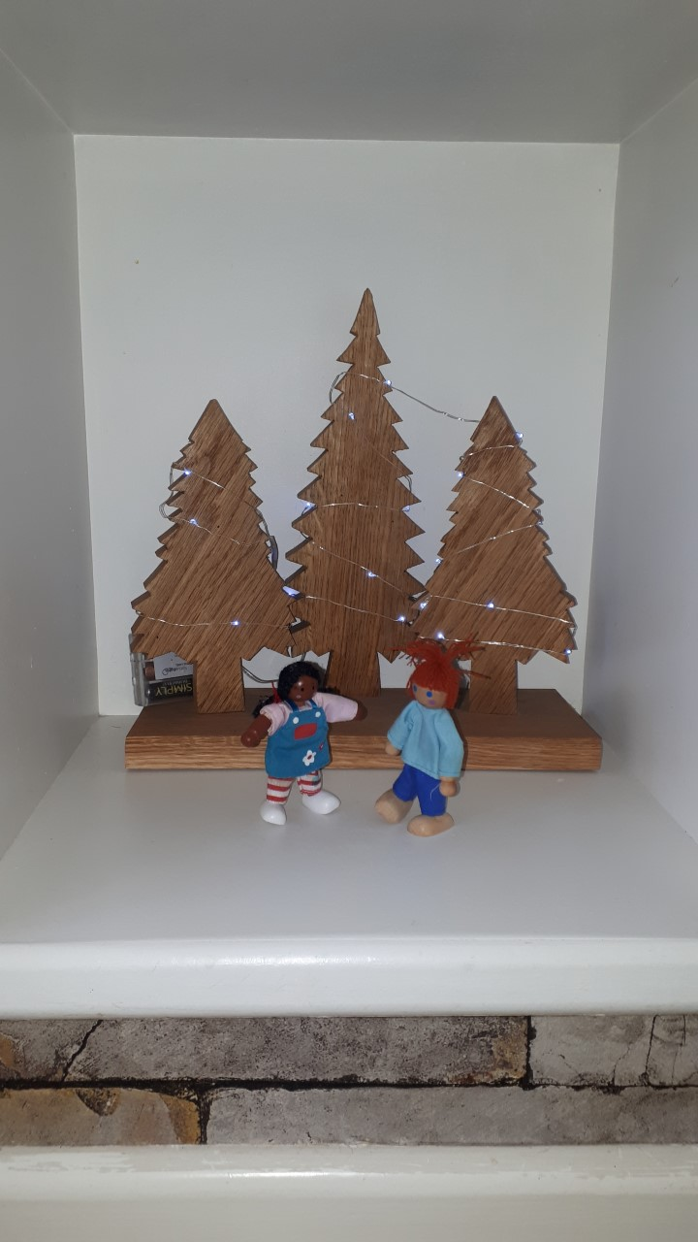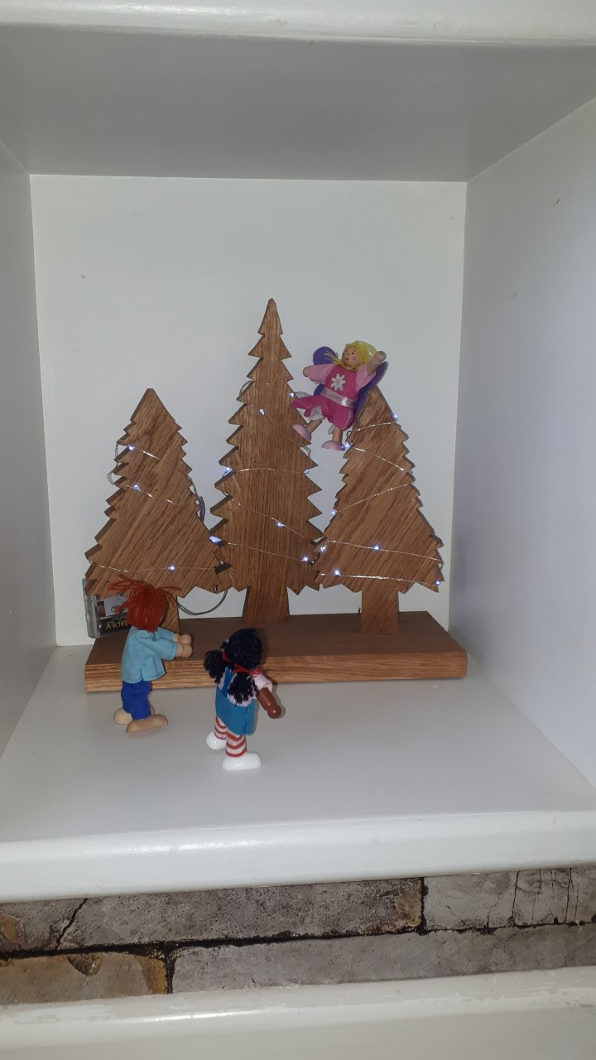

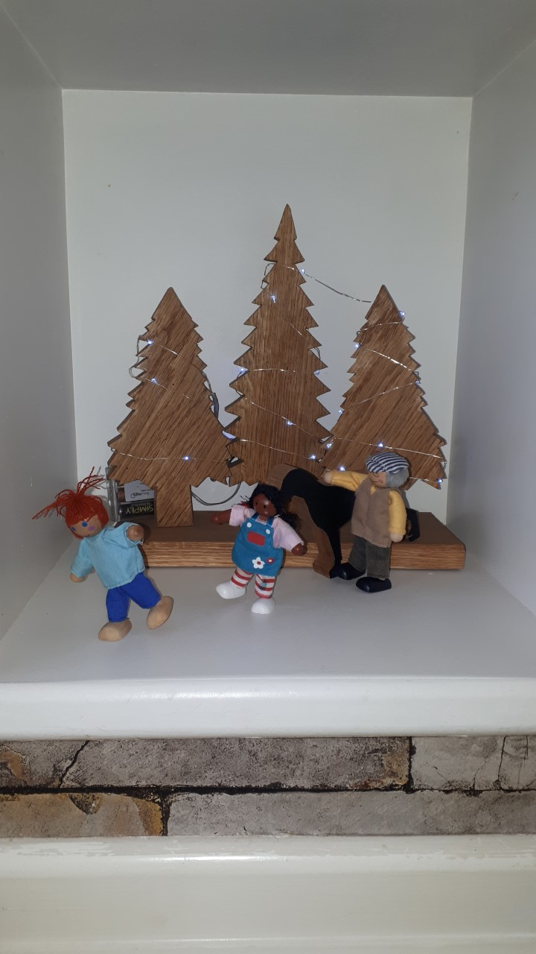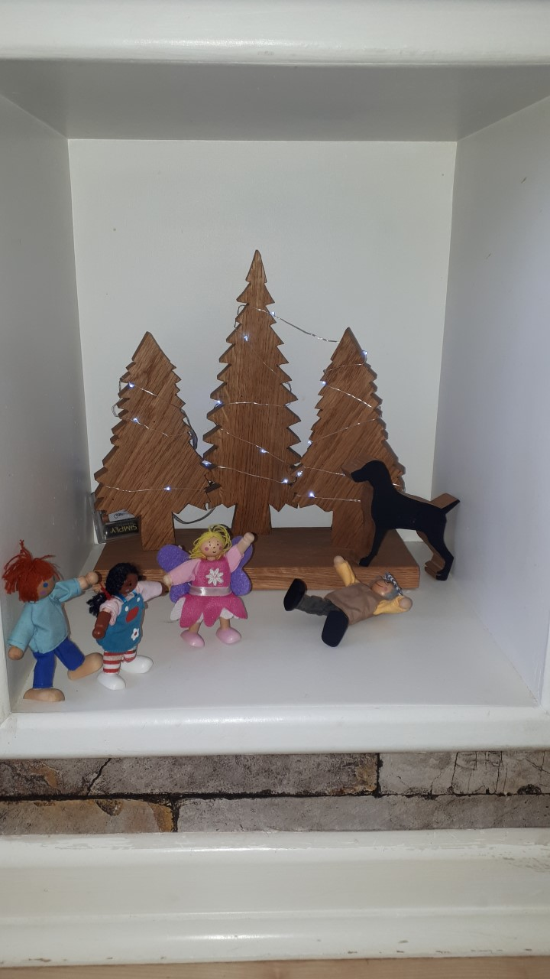

Use figures and objects from around the house to make your own **Still Images** that link to create a piece of drama. Can you find a way of adding **Speech Bubbles** or **Thoughts out Loud**?

