**Year 10 Combined Higher Science**

**Mock Exam Revision**

**Paper 1**

Instead of a year 10 end of year exam this year, you will be sitting a science mock paper.

This paper will include all topics learnt in both year 9 and year 10.

This revision homework must be completed weekly.

The format of each homework is the same:

* **Section 1**: 3 x look, cover, write, check for both sets of knowledge.  
  Each set must have a title and have a number (1,2 or 3)>  
  An example of what this looks like is shown below:

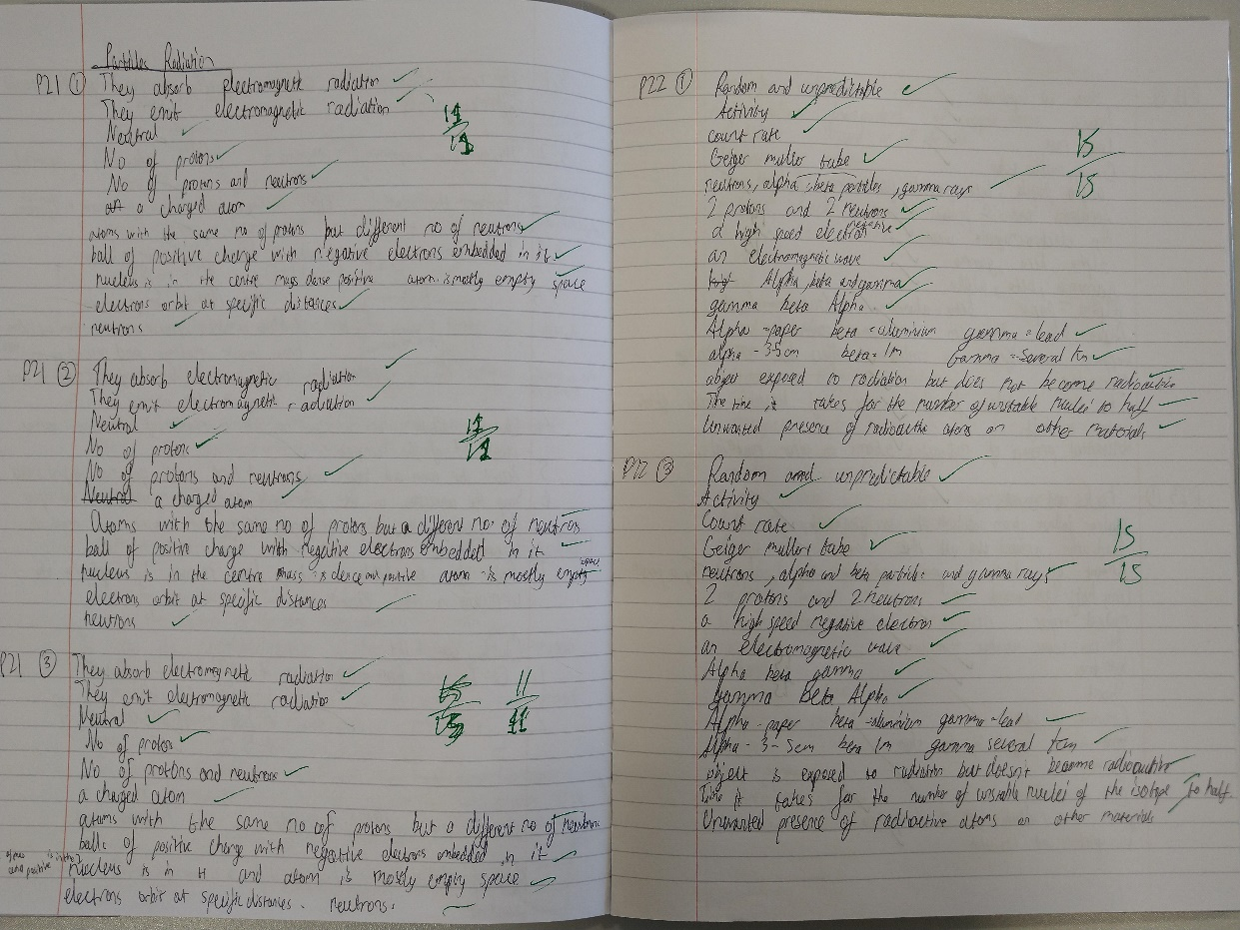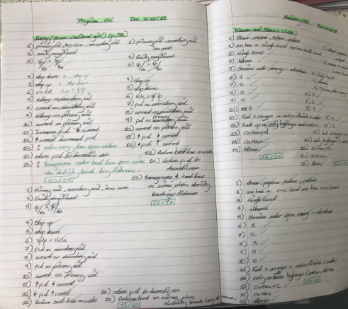

* **Section 2**: answer the mastery matrix statements and self-assess using the knowledge and/or your revision guide
* **Section 3**: answer the exam questions and self-assess using the mark scheme

**Revision Homework 1: Biology**

**Section 1: Knowledge**

|  |  |  |
| --- | --- | --- |
|  | **Topic:** | **Transport in cells (diffusion, active transport and osmosis) (B.19)** |
| 1 | Substances moving from a high concentration to a low concentration is called… | Diffusion |
| 2 | Two examples of diffusion in humans are: | CO2 + O2 in gas exchange, urea from cells to blood |
| 3 | Three factors that affect the rate of diffusion are: | Concentration gradient, temperature, surface area of the membrane |
| 4 | How are single celled organisms adapted for diffusion? | Large surface area : volume ratio |
| 5 | How is the small intestine adapted for exchanging materials? | *Villi for large S.A. *villi one cell thick *good blood supply |
| 6 | How is the lungs adapted for exchanging materials? | *Alveoli large surface area: volume ratio, surface is moist, good blood supply |
| 7 | How is the gills adapted for exchanging materials? | *large S.A. *moist *good blood flow to maintain concentration gradient |
| 8 | How is the roots adapted for exchanging materials? | *Large SA to volume ratio *lots of mitochondria for respiration -> energy for active transport |
| 9 | How is the leaves adapted for exchanging materials? | *Stomata *thin so that distance for diffusion is smaller |
| 10 | Four ways that to increase the rate of transport | *Large surface area, thin membrane, efficient blood supply (in animals), well ventilated (in animals) |
| 11 | Water moves from a dilute to concentrated solution across a partially permeable membrane via... | Osmosis |
| 12 | Pure water will move into a potato because of | Osmosis |
| 13 | (RP) How can you tell the concentration of sugar in a piece of potato? | 1) Place into different concentrations of sugar solution. 2) Plot graph 3)Find concentration where change in mass is 0 |
| 14 | When a substance moves against the concentration gradient, it is called.. | Active transport |
| 15 | Active transport requires ________ from _________. | energy respiration |

|  |  |  |
| --- | --- | --- |
|  | **Topic** | **Required Practical: Osmosis** |
| 1 | What is the independent variable? | The concentration of the solution |
| 2 | What is the dependent variable? | The percentage change in mass |
| 3 | Name 5 control variables | 1)Length of potato 2) Diameter of potato 3) Volume of solution 4) Time potato is left for 5) Temperature of solution |
| 4 | Give 3 ways to make the results accurate | 1) Read the volume of the solution from the meniscus 2) Dab the potatoes dry before measuring the mass 3) Use a digital top pan balance |
| 5 | Name one risk and precaution | Risk = cutting yourself with the potato borer Precaution = push the borer down towards the desk not upwards |
| 6 | What is the purpose of the distilled water? | To act as a control to compare your results to |
| 7 | How is the concentration inside the tissue estimated? | Plot a graph of concentration against % change in mass and find where the line of best fit crosses 0% |
| 8 | How is the percentage change in mass calculated? | % change in mass = change in mass / initial mass |
| 9 | Why is percentage change calculated rather than just the change? | The potato may be slightly different sizes and shapes to begin with |
| 10 | Why does the tissue increase in mass? | Water has entered the tissue by osmosis in more dilute solutions |
| 11 | How can you tell if there has been an increase in mass? | The % change in mass is +ve |
| 12 | Why does the tissue decrease in mass? | Water has left the tissue by osmosis in more concentrated solutions |
| 13 | How can you tell if there has been a decrease in mass? | The % change in mass is -ve |
| 14 | What does no change in mass mean? | The concentration of the solution is the same as the concentration inside the tissue |
| 15 | What are possible variations on this method? | 1) Using any other vegetable/plant tissue 2) Using any other food substance  3) Using a salt solution |

**Section 2:**Mastery matrix statements to be answered and then self-assessed using https://www.bbc.co.uk/bitesize and knowledge

|  |  |
| --- | --- |
| 6.1 | Define ‘diffusion’ and give examples of diffusion in plants and animals (gas exchange and urea in the kidney) |
| 6.2 | Explain how different factors affect the rate of diffusion (concentration, surface area, temperature) |
| 6.3 | Calculate surface area: volume ratios |
| 6.4 | Explain how surface area: volume ratio of a single celled organism (amoeba) allows sufficient molecule transport |
| 6.5 | Explain adaptations for exchange materials in: small intestines, lungs, gills, roots and leaves |
| 3.4 | Describe the process of osmosis |
| 3.5 | Calculate the rate of water uptake by a plant |
| 3.6 | Calculate the percentage change in mass following osmosis |
| 3.7 | Analyse and draw graphs relating to osmosis |
| 3.8 | RP Osmosis: Analyse the range of concentrations of solutions on the change in mass of plant tissue |
| 3.9 | Describe the process of active transport and explain why it is necessary |
| 3.10 | Compare diffusion, osmosis and active transport |
| 3.11 | Describe the process of active transport and how root hair cells are adapted to this |

**Section 3: Exam questions**

A student used cubes of potato to investigate the effect of surface area and volume on the rate of osmosis.

The diagram shows two of the cubes of potato the student used.

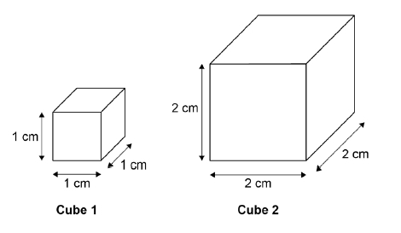

The surface area to volume ratio of **cube 1** is 6:1.

(a)     Calculate the total surface area of **cube 2**.

___________________________________________________________________

___________________________________________________________________

Total surface area of **cube 2** = ____________________ cm2

**(1)**

(b)     Calculate the volume of **cube 2**.

___________________________________________________________________

___________________________________________________________________

Volume of **cube 2** = ____________________ cm3

**(1)**

(c)     Calculate the surface area to volume ratio of **cube 2**.

Use the equation:



___________________________________________________________________

___________________________________________________________________

Surface area to volume ratio of **cube 2** = ____________________ : 1

**(1)**

This is the method used.

1.   Cut two cubes of potato of size 2 cm × 2 cm × 2 cm

•   Cut one of these cubes into 8 cubes of potato of size 1 cm × 1 cm × 1 cm (sample **A**).

•   Do not cut the other cube (sample **B**).

2.   Measure the mass of each sample **A** and the mass of sample **B**.

3.   Place all the cubes into a beaker of distilled water.

4.   Leave for 30 minutes.

5.   Remove the cubes from the beaker and dry the surfaces with a paper towel.

6.   Measure the mass of each sample of cubes.

(d)     Why were 8 cubes of size 1 cm × 1 cm × 1 cm but only one cube of size 2 cm × 2 cm × 2 cm cube used?

___________________________________________________________________

___________________________________________________________________

**(1)**

(e)     Why did the student dry the surface of each potato cube in step **5** of the method?

___________________________________________________________________

___________________________________________________________________

**(1)**

The table below shows the student’s results.

|  |  |  |  |
| --- | --- | --- | --- |
|  | **Mass at start in g** | **Mass at end in g** | **Mass change in g** |
| **Sample A**  **Eight cubes, each measuring 1 cm × 1 cm × 1 cm** | 10.4 | 12.2 | 1.8 |
| **Sample B**  **One cube, measuring 2 cm × 2 cm × 2 cm** | 9.9 | 10.7 | **X** |

(f)      Calculate mass change **X** in the table above.

___________________________________________________________________

___________________________________________________________________

Mass change **X** = ____________________ g

**(1)**

(g)     Explain why the masses of both samples of cubes increased.

___________________________________________________________________

___________________________________________________________________

___________________________________________________________________

___________________________________________________________________

**(2)**

(h)     It would be better to calculate percentage change in mass rather than change in mass. Why is this a more valid method? Tick **one** box.

|  |  |  |
| --- | --- | --- |
| Because it makes it a fair test. |  |  |
| Because it makes the investigation of the samples of cubes more accurate. |  |  |
| Because the samples of cubes were different masses at the start of the investigation. |  |  |

**(1)**

(i)      Explain why the mass of the cubes in sample **A** increased more than the mass of the cube in sample **B**.

___________________________________________________________________

___________________________________________________________________

___________________________________________________________________

___________________________________________________________________

**(2)**

**(Total 11 marks)**

**Mark schemes**

(a)     (surface area =) 24 (cm2)

**1**

(b)    (volume =) 8 (cm3)

**1**

(c)     3 (:1)

*allow ecf from (a) and (b)*

**1**

(d)     to keep the volume (of the cubes) the same in both sets

*allow to compare with the 2 × 2 × 2 cube*

**or**

so both sets of cubes are 8 cm3

*ignore to keep it fair*

**1**

(e)     so that excess water does not contribute to the mass of the cubes

**1**

(f)      0.8 (g)

*if no answer given, check for answer in the table*

**1**

(g)     (because) water moved into the cubes (by osmosis)

*allow water moves in by diffusion*

**1**

because the solution outside the cubes was more dilute than inside the cells

*allow converse*

*allow because the concentration of water was higher outside the cubes / in the beaker / solution than inside the cells*

**1**

(h)     because the samples of cubes were different masses at the start of the investigation

**1**

(i)      more water was taken in

**1**

because they had a larger surface area to volume ratio

*allow more / faster osmosis happened* **1[11]**

**Revision Homework 2: Biology**

**Section 1: Knowledge**

|  |  |  |
| --- | --- | --- |
|  | **Topic:** | **The Heart (B.15)** |
| 1 | Which type of vessel leaves the heart? | Arteries |
| 2 | Which type of vessel enters the heart? | Veins |
| 3 | What is the name of the 4 chambers of the heart? | Top: Left/right Atrium Bottom: Left/right ventricle |
| 4 | Where is the body's natural pacemaker (cells that control the bodies resting heart rate)? | Right atrium |
| 5 | What is the name of the blood vessel that enters the heart from the body? | Vena Cava |
| 6 | What is the name of the blood vessel that enters the heart from the lungs? | Pulmonary vein |
| 7 | What is the name of the blood vessel that goes to the lungs from the heart? | Pulmonary artery |
| 8 | What is the name of the blood vessel that goes from the heart to the rest of your body? | Aorta |
| 9 | Which side of the heart is thicker? | Left |
| 10 | Which side of the heart pumps oxygenated blood out of it and which side pumps deoxygenated? | Oxygenated = Left Deoxygenated = Right |
| 11 | What is the name for removing a heart from one person and placing it into another person? | Transplant |
| 12 | What is the name of the drug that reduces that amount of cholesterol in a persons body? | Statins |
| 13 | Which organ does a statin effect? | Liver |
| 14 | State 3 adaptations of a red blood cell | *no nucleus, *biconcave shape, *small |
| 15 | State 2 adaptations of a white blood cell | Cytoplasm contains enzymes, flexible cell membrane |
|  | | |
|  | **Topic:** | **The Blood (B.16)** |
| 1 | Which type of blood vessel has thin walls but a large lumen? | Vein |
| 2 | Which type of blood vessel has thick walls but a small lumen? | Artery |
| 3 | Which type of blood vessel has valves? | Veins |
| 4 | Which type of blood vessel has a pulse? | Artery |
| 5 | Give one non-surgical intervention that can reduce the changes of heart disease/a heart attack | Exercise/diet |
| 6 | What is the name of the specialised cell that is designed to carry oxygen? | Red Blood Cell |
| 7 | What is the name of the specialised cell that is designed to fight pathogens? | White Blood Cell |
| 8 | What is the name of the specialised cell that helps to clot our blood? | Platelets |
| 9 | What is the name of the liquid part of blood that carries dissolved substances? | Plasma |
| 10 | Give one substance that is carried in the plasma of blood | Carbon dioxide/urea/glucose |
| 11 | What is the name of the substance that can block arteries? | Cholesterol |
| 12 | What is the name of a disease that occurs when the blood vessels in the muscle of the heart get blocked? | Coronary Heart Disease |
| 13 | What are the blood vessels that provide the heart with oxygen called? | Coronary arteries |
| 14 | What is the name of the piece of wire mesh put inside a blood vessel to keep it open? | Stent |
| 15 | State the equation to calculate blood flow rate calculations | "Cardiac output = heart rate x stroke volume |

**Section 2:**Mastery matrix statements to be answered and then self-assessed using https://www.bbc.co.uk/bitesize and knowledge

|  |  |  |
| --- | --- | --- |
|  |  |  |
| 2.1 | Blood and the heart | Describe the structure and function of the human heart |
| 2.2 | Describe the roles of the four blood vessels associated with the heart |
| 2.3 | Describe the 3 different types of blood vessel in the body and their structure |
| 2.4 | Carry out rate calculations for blood flow |
| 2.5 | Describe how our body controls our natural resting heart rate |
| 2.6 | Describe the composition of blood and know the functions of each of the components |
| 2.7 | Draw blood cells from under a microscope and recognise different types of blood cells from a photo or diagram, explaining how they are adapted to their functions |
| 2.8 | Describe coronary heart disease |
| 2.9 | Describe what a ‘stent’, ‘statin’, ‘mechanical/biological valve replacement’, ‘pacemaker’ and ‘transplant’ are |
| 2.10 | Evaluate the advantages and disadvantages of treating cardiovascular diseases using drugs, mechanical devices or transplants |
| 2.11 | Evaluate risks associated with the use of blood products |

**Section 3: Exam questions  
Q1.** The heart pumps blood to the lungs and to the cells of the body.

(a)     Name the blood vessel that transports blood from the body to the right atrium.

___________________________________________________________________

**(1)**

(c)     Describe the route taken by oxygenated blood from the lungs to the body cells.

___________________________________________________________________

___________________________________________________________________

___________________________________________________________________

___________________________________________________________________

___________________________________________________________________

___________________________________________________________________

___________________________________________________________________

___________________________________________________________________

**(4)**

**2**(a)     (i)      Name the red pigment found in red blood cells.

______________________________________________________________

**(1)**

(ii)     Describe, in detail, the function of this red pigment.

______________________________________________________________

______________________________________________________________

______________________________________________________________

______________________________________________________________

**(2)**

(b)     Describe **one**other way in which the structure of a red blood cell is different from the structure of a white blood cell.

___________________________________________________________________

___________________________________________________________________

**(1)**

**(Total 4 marks)**

Mark schemes

**Q1.**

(a)     vena cava **1**

(b)     0.5 mm = 0.05 cm **1**

time =   **1**

24.875 **1**

25 (s)

**Q2.**

(a)     (i)      haemoglobin / oxyhaemoglobin

*must be phonetic*

**1**

(ii)     carries oxygen **or**forms oxyhaemoglobin

*Ignore references to CO2/ iron  
cancel if extras like food / glucose*

**1**

from lungs to tissues

**1**

(b)     no nucleus **or**biconcave disc (described)

*ignore references to size  
ignore vague references to being  
‘round’ / ‘donut’ shaped etc.*

**1**

**[4]**

**Revision Homework 3: Biology**

**Section 1: Knowledge**

|  |  |  |
| --- | --- | --- |
|  | **Topic:** | **Preventing pathogens from making us unwell (B.9)** |
| 1 | State 3 ways that pathogens can be spread | Direct contact, water, air |
| 2 | How do bacteria make us feel unwell? | Produce toxins (poisons) that damage tissues |
| 3 | How do viruses make us feel unwell? | Live & reproduce in cells causing cell damage |
| 4 | Name 4 of the body's non-specific defence systems | Skin, nose, trachea, stomach |
| 5 | How does the skin prevent pathogens from making us unwell? | Prevent them from entering body |
| 6 | How does the nose prevent pathogens from making us unwell? | Mucus to trap dirt & pathogens, ciliated cells to sweep it out |
| 7 | How does the trachea prevent pathogens from making us unwell? | Mucus to trap dirt & pathogens, ciliated cells to sweep it out |
| 8 | How does the stomach prevent pathogens from making us unwell? | Stomach acid to kill pathogens |
| 9 | State three ways that white blood cells can help to defend us against pathogens | Phagocytosis, antibody production, antitoxin production |
| 10 | Which type of white blood cell carries out phagocytosis? | Phagocytes |
| 11 | Which type of white blood cell carries out antibody and antitoxin production? | Lymphocytes |
| 12 | State one thing that can trigger cancers to form | Viruses in cells |
| 13 | What causes tumours to form? | Changes in cells that lead to uncontrolled growth and division |
| 14 | Define "benign tumour" | Growth of abnormal cells contained in ONE area in a membrane |
| 15 | Define "malignant tumour" | Growth of abnormal cells that SPREAD to other parts of the body in blood and INVADE other tissues. |
|  | | |
|  | **Topic:** | **Developing new medicines (B.10)** |
| 1 | State three ways that drugs can be produced | Extracted from plants, microorganisms & synthesised |
| 2 | Where does the heart drug digitalis originate from? | Foxgloves (plant) |
| 3 | Where does the pain killer aspirin originate from? | Willow trees |
| 4 | Where does the antibiotic penicillin originate from? | Penicillium mould |
| 5 | State three things that drugs are tested and trialled for before use | 1) Toxicity (safe), 2) efficacy (does it work), 3) dose (quantity) |
| 6 | What is used to test drugs during preclinical testing? | Cells, tissues & live animals |
| 7 | Who are medicines tested on in stage 1 of clinical trials? | Healthy volunteers (low doses - test for toxicity) |
| 8 | Who are medicines tested on in stage 2 of clinical trials? | Patient volunteers (low doses - test for efficacy & dose) |
| 9 | What is a double blind trial? | Neither experimenter or patient knows if they are taking medicine or placebo |
| 10 | What is a placebo? | A substance that contains no medicine (a control) |
| 11 | What is the name for the injection given to patients to prevent them from catching an infectious disease? | Vaccination |
| 12 | Describe step 1 of vaccinations | 1) small quantity of dead/inactive pathogen |
| 13 | Describe step 2 of vaccinations | 2) white blood cells produce correct antibody (slowly) |
| 14 | Describe step 3 of vaccinations | 3) pathogen enters body & WBC produce correct antibodies (quickly) |
| 15 | State two benefits of vaccination | Prevent illness in an individual & prevent spread to others |

**Section 2:**Mastery matrix statements to be answered and then self-assessed using https://www.bbc.co.uk/bitesize and knowledge

|  |  |  |
| --- | --- | --- |
| 3.1 | Preventing pathogen from making us unwell | Describe how the body prevents entry of pathogens into the body |
| 3.2 |  | Describe how the immune system tackles pathogens once they have made it into the body (phagocytosis, antibody production and antitoxin production) |
| 3.3 |  | Explain how vaccines work |
| 3.4 |  | Discuss the global use of vaccination in the prevention of disease |
| 3.5 |  | Explain the use of antibiotics and other medicines |
| 4.1 | Developing new medicines | Describe how bacteria have developed resistance to antibiotics – in particular MRSA (and use this as an example of evolution) |
| 4.2 |  | Explain the issues with the development of new antibiotics in the race against antibiotic resistance and what we can do as a society to reduce the rate of development of antibiotic resistance bacteria (linking to medicine and agriculture) |
| 4.3 |  | Describe how many new drugs are still developed from plants and microorganisms (including digitalis and aspirin) |
| 4.4 |  | Explain how preclinical and clinical trials are used to test new drugs (including tests for safety, effectiveness, toxicity and dosage) |
| 4.5 |  | Explain the production and use of monoclonal antibodies (separate only) |
| 4.6 |  | Evaluate the advantages and disadvantages of using monoclonal antibodies (separate only) |
| 4.7 |  | Compare and contrast painkillers and antibiotics |
| 4.8 |  | Explain the benefits and drawbacks of antibiotics and limitations of antivirals |

**Section 3: Exam questions:**

**Q1.**

Pathogens are microorganisms that cause infectious disease.

(a)     Draw **one** line from each disease to the way the disease is spread.

|  |  |  |
| --- | --- | --- |
| **Disease** |  | **Way the disease is spread** |

|  |  |  |
| --- | --- | --- |
|  |  | Animals that draw blood |
|  |  |  |
| Cholera |  | Drinking contaminated water |
|  |  |  |
| Cold |  | Droplets in the air when people cough or sneeze |
|  |  |  |
| Malaria |  | Eating food that is contaminated |
|  |  |  |
|  |  | Breathing air polluted with carbon dioxide |

**(3)**

(b)     One way the human body protects itself against the entry of pathogens is by producing antimicrobial chemicals.

Antimicrobial chemicals kill pathogens.

Give **two** other ways the human body protects itself against the **entry** of pathogens.

1. _________________________________________________________________

___________________________________________________________________

2. _________________________________________________________________

___________________________________________________________________

**(2)**

(c)     Measles is a childhood disease caused by a microorganism.

Measles is **not** treated by antibiotics.

Give the reason why.

___________________________________________________________________

**(1)**

(d)     Vaccinations help people become immune to infections.

In 2013, 92% of children in the UK had two vaccination injections against measles.

The figure below shows how the concentration of antibodies in the blood changes after each measles vaccination.

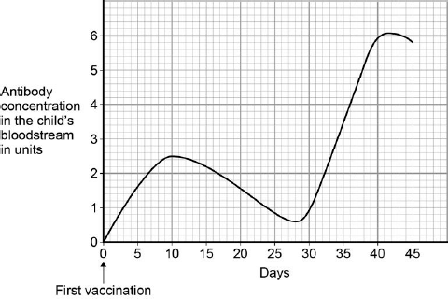

Suggest what day the second vaccination was given.

___________________________________________________________________

**(1)**

(e)     What is the highest concentration of antibodies produced by the first vaccination?

___________________________________________________________________

**(1)**

(f)     How will the number of children getting measles change as more children are vaccinated against measles?

Give a reason for your answer.

Change   ___________________________________________________________

Reason ____________________________________________________________

___________________________________________________________________

**(2)**

**(Total 10 marks)**

**Q2.**

People can be immunised against a pathogen by injecting them with a vaccine.

(a)     What does a vaccine contain?

___________________________________________________________________

___________________________________________________________________

**(1)**

(b)     A person was injected with a vaccine. A few weeks later the person was exposed to the pathogen they had been immunised against.

The graph shows how the concentration of antibodies in the blood changed after injection of the vaccine and after exposure to the pathogen.

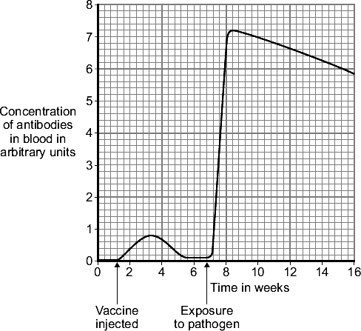

(i)      Describe in detail the differences between antibody production after the injection of the vaccine **and** after the person was exposed to the pathogen.

______________________________________________________________

______________________________________________________________

______________________________________________________________

______________________________________________________________

______________________________________________________________

______________________________________________________________

______________________________________________________________

______________________________________________________________

**(3)**

(ii)     Suggest an explanation for the differences you have described in part (b)(i).

______________________________________________________________

______________________________________________________________

______________________________________________________________

______________________________________________________________

______________________________________________________________

______________________________________________________________

______________________________________________________________

______________________________________________________________

**(3)**

**(Total 7 marks)**

Mark schemes

**Q1.**

(a)     **Disease**       **Way the disease is spread**

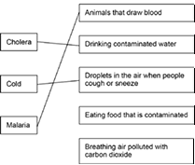

*extra lines from left cancel the mark*

**3**

(b)     any **two** from:

•        skin acts as a barrier

•        blood clots (over cuts)

•        nose (hairs) catch particles (breathed in)

•        mucus (in trachea / bronchi) traps microorganisms

•        acid in stomach kills microorganisms

**2**

(c)     because measles is a virus

**1**

(d)     28 / twenty eight

*± 0.5 small square tolerance*

**1**

(e)     2.5

**1**

(f)     number will decrease

**1**

less likely to come into contact with someone with measles / the disease

**1**

**[10]**

**Q2.**

(a)     dead / inactive form of pathogen / microorganism / bacterium / virus

*ignore disease (for organism)*

*ignore toxins / antibodies*

**1**

(b)      (i)      any **three** from:

(after exposure):

•     greater number of antibodies produced / higher concentration

•     antibodies stay (in higher concentration) for longer

•     antibodies produced quicker

•     quantitative, eg 9 times higher / 0.8 to 7.2

*scores* ***2*** *marks for increased to 9 times higher / from 0.8 to 7.2*

**3**

(ii)     white cells

*allow lymphocytes / leucocytes*

*do* ***not*** *accept phagocytes / macrophage*

**1**

have had previous exposure to pathogen / recognise pathogen on re-entry /  
familiar with pathogen / reference to memory cells

*ignore knows how to kill pathogen  
ignore live pathogen introduced on exposure*

**1**

therefore antibodies produced (more) rapidly

*this marking point dependent on previous marking point*

**1**

**[7]**

**Revision Homework 4: Chemistry**

**Section 1: Knowledge**

|  |  |  |
| --- | --- | --- |
|  | **Topic:** | **Types of bonding (C.7)** |
| 1 | Which type of bonding occurs between metals and non-metals? | Ionic |
| 2 | Which type of bonding occurs between non-metals? | Covalent |
| 3 | Which type of bonding occurs between metals? | Metallic |
| 4 | When electrons leave the shells of an atom, they are said to be ……? | Delocalised |
| 5 | Which type of ions are formed by metals? | Positive ions |
| 6 | Which type of ions are formed by non-metals? | Negative ions |
| 7 | What is graphene? | A single layer of graphite |
| 8 | What is a fullerene? | Hollow carbon structures |
| 9 | What is Buckminster Fullerene? | Spherical carbon shape with 60 carbon atoms |
| 10 | What is an allotrope? | Two or more different physical arrangements of the same atom e.g. diamond, graphite, graphene |
| 11 | What is a carbon nanotube? | A cylindrical fullerene with a very high length to diameter ratio |
| 12 | Describe what happens in ionic bonding | Electrons are transferred from a metal atom to a non-metal atom = strong electrostatic attraction between oppositely charged ions |
| 13 | Describe what happens in covalent bonding | Electrons are shared between atoms = strong electrostatic attraction between electrons and nucleus |
| 14 | Describe what happens in metallic bonding | Electrons become delocalised creating a sea of negative charge = strong electrostatic attraction with positive metal ions & sea of delocalised electrons |
| 15 | Why do noble gases not form compounds? | Because they already have a full outer shell of electrons |
|  | | |
|  | **Topic:** | **Elements, compounds (C.2)** |
| 1 | What is the name for substances made of only ONE type of atom? | Elements |
| 2 | What is the name for substances made of two or more types of atoms NOT chemically bonded together? | Mixtures |
| 3 | What is the name for substances made of two or more types of atoms chemically BONDED together? | Compounds |
| 4 | What is the formula for water? | H2O |
| 5 | What is the formula for Methane? | CH4 |
| 6 | Define "alloy" | A mixture of a metal and at least one other element |
| 7 | Why are alloys harder than pure metals? | Different sized atoms distort the regular rows so that the layers can't slide over each other |
| 8 | What is the word for an element that always exists as two atoms bonded together? | Diatomic |
| 9 | Is an alloy an element, compound or mixture? | Mixture |
| 10 | What is the formula for glucose? | C6H12O6 |
| 11 | Which elements exist diatomically? | N2, H2, O2 and all of group 7 |
| 12 | How many electrons can be held in the first shell and then second and third shell of an atom? | First shell is TWO, all other shells EIGHT |
| 13 | What is the different between Ar (relative atomic mass) and Mr (relative molecular mass) | Ar = for an element Mr = for a compound |
| 14 | Define "ion"? | An electrically charged atom that has gained or lost electrons |
| 15 | How do you calculate Ar of an element | It is it's mass number |

**Section 2:**Mastery matrix statements to be answered and then self-assessed using https://www.bbc.co.uk/bitesize and knowledge

|  |
| --- |
| * 1. Describe the structure and properties of giant ionic structures |
| 1.2. Link the structure of giant ionic structures to it’s properties |
| 1.3. Describe the structure and properties of simple covalent structures |
| 1.4. Describe the structure and properties of giant covalent structures (including diamond, graphite and silica) |
| 1.7. Describe how a substance bonds metallically |
| 1.8. Link the structure of giant metallic structures to their properties |

**Section 3: Exam questions**

**Q1.** This question is about structure and bonding.

(c)     Graphite and fullerenes are forms of carbon. Graphite is soft and is a good conductor of electricity. Explain why graphite has these properties. Answer in terms of structure and bonding.

___________________________________________________________________

___________________________________________________________________

___________________________________________________________________

___________________________________________________________________

___________________________________________________________________

___________________________________________________________________

___________________________________________________________________

___________________________________________________________________

**(4)**

(d)     **Figure 1** shows a model of a Buckminsterfullerene molecule.

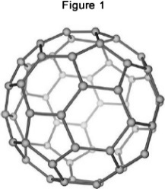

A lubricant is a substance that allows materials to move over each other easily.

Suggest why Buckminsterfullerene is a good lubricant.

Use **Figure 1**.

___________________________________________________________________

___________________________________________________________________

___________________________________________________________________

___________________________________________________________________

**(2)**

Silver can form cubic nanocrystals.

**Figure 2** represents a silver nanocrystal.

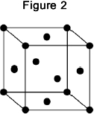

(e)     A silver nanocrystal is a cube of side 20 nm

Calculate the surface area to volume ratio of the nanocrystal.

___________________________________________________________________

___________________________________________________________________

___________________________________________________________________

___________________________________________________________________

___________________________________________________________________

Surface area to volume ratio = ____________________

**(3)**

(f)      Silver nanoparticles are sometimes used in socks to prevent foot odour.

Suggest why it is cheaper to use nanoparticles of silver rather than coarse particles of silver.

___________________________________________________________________

___________________________________________________________________

___________________________________________________________________

___________________________________________________________________

**(2)**

**Q2.**

This question is about the properties and uses of materials.

Use your knowledge of structure and bonding to answer the questions.

(a)     Explain how copper conducts electricity.

___________________________________________________________________

___________________________________________________________________

___________________________________________________________________

___________________________________________________________________

___________________________________________________________________

**(2)**

(b)     Explain why diamond is hard.

___________________________________________________________________

___________________________________________________________________

___________________________________________________________________

___________________________________________________________________

___________________________________________________________________

**(2)**

Mark schemes

**Q1.**

(c)     each (carbon) atom forms three covalent bonds **1**

forming layers (of hexagonal rings) **1**

(soft)

(because) layers can slide over each other **1**

(conducts electricity)

(because of) delocalised electrons **1**

(d)     molecules are spherical **1**

(so molecules) will roll **1**

(e)     surface area (= 20 × 20 × 6) = 2400 (nm 2) **1**

volume (= 203) = 8000 (nm 3) **1**

ratio = 0.3 (nm 3): 1 (nm 3)

ratio = 0.3 (nm 3): 1 (nm 3)

**or**

1 (nm 3): 3.33 (nm 3) **1**

(f)      (nanoparticles) have a larger surface area to volume ratio **1**

so less can be used for the same effect **1**

**Q2.**

(a)     has delocalised/free electrons **1**

(so electrons) can move through the structure/metal **1**

(b)     giant structure/giant lattice **1**

strong bonds/strong covalent bonds **1**

**Revision Homework 5: Chemistry**

**Section 1: Knowledge**

|  |  |  |
| --- | --- | --- |
|  | **Topic** | **Chemical calculations, volumes and concentrations** |
| 1 | State the 'law of conservation of mass' | No atoms are lost or made during a chemical reaction |
| 2 | The sum of the Mr of the reactants must equal | The sum of the Mr of the products |
| 3 | State one example of when a reaction may APPEAR to lose mass | When a gas is produced and escapes |
| 4 | State the value of Avogadro's constant (HT only) | 6.02 x 10 23 |
| 5 | State the equation to calculate moles from mass and Mr (HT only) | Moles (mol) = mass (g) /Mr |
| 6 | State how to calculate Mr (relative formula mass) | The sum of the Ar (atomic masses) of each atom |
| 14 | When a symbol equation is balanced, what is shown by the large numbers in front of a formula e.g. 2HCl? | The ratio of moles of each substance |
| 15 | What is the volume of 1 mole of any gas at room temperature and pressure? | 24dm3 |

**Section 2:**Mastery matrix statements to be answered and then self-assessed using https://www.bbc.co.uk/bitesize and knowledge

|  |  |  |
| --- | --- | --- |
| 5.1 | Chemical calculations | Link changes in mass to the word equation for a reaction (combined only) |
| 5.2 |  | Calculate the relative formula mass of a substance (combined only) |
| 5.3 |  | Recall Avogadro's constant (6.02 x 1023) (HT only) (combined only) |
| 5.4 |  | Use the formula moles = mass/Mr to calculate moles in a substance (HT only) (combined only) |
| 6.1 | Volumes and concentrations | Calculate masses from balanced symbol equations (combined only) |
| 6.2 |  | Calculate the mass of solute in a given volume of solution |
| 6.3 |  | Explain how the mass of a solute and the volume of a solution is related to the concentration (HT only) |
| 6.4 |  | Calculate the moles of a solute in a given volume of solution |

**Section 3: Exam questions**

**Q1.**

Formulae and equations are used to describe chemical reactions.

(a)     Aluminium reacts with sulfuric acid (H2SO4) to produce aluminium sulfate, Al2(SO4)3 and hydrogen (H2).

Complete and balance the equation for this reaction.

____Al     +   _____________  _____________  +  ____________

**(2)**

(b)     Calcium carbonate reacts with nitric acid to produce calcium nitrate.

Calculate the relative formula mass (*M*r) of calcium nitrate, Ca(NO3)2

Relative atomic masses (*Ar*): N = 14; O = 16; Ca = 40

___________________________________________________________________

___________________________________________________________________

Relative formula mass (*M*r) =   __________________

**(2)**

(c)     Zinc carbonate decomposes when heated.

A student heated 25 g zinc carbonate (ZnCO3).

The figure below shows how he set up the apparatus.

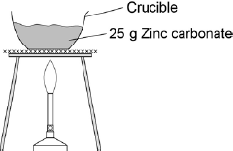

The balanced chemical equation for the decomposition reaction is:

ZnCO3 (s)          ZnO (s)   +   CO2 (g)

The student measured the mass of solid product after heating until there was no further change in mass.

The student did the experiment four times. The table below shows the results.

|  |  |  |  |  |
| --- | --- | --- | --- | --- |
| **Experiment** | 1 | 2 | 3 | 4 |
| **Mass of solid product in g** | 17.4 | 19.7 | 17.6 | 16.9 |

Calculate the mean mass of the solid product.

Do **not** use any anomalous results in your calculation.

___________________________________________________________________

___________________________________________________________________

Mean mass = _________________ g

**(2)**

**(Total 6 marks)**

**Q2.**

Aqamed is a medicine for children.

(a)     The medicine is a formulation.

What is meant by a formulation?

___________________________________________________________________

___________________________________________________________________

**(1)**

(b)     Children often do not like taking medicine.

Suggest a substance that could be added to Aqamed to increase the desire for children to take it.

Give a reason for your suggestion.

Substance _________________________________________________________

Reason ____________________________________________________________

___________________________________________________________________

**(2)**

(c)     The main ingredient in Aqamed is a painkiller called paracetamol.

The figure below represents a molecule of paracetamol.

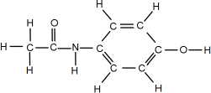

Give the molecular formula of paracetamol.

Calculate its relative formula mass (*M*r).

Relative atomic masses (*A*r): H = 1; C = 12; N = 14; O = 16

Molecular formula ____________________________________________________

Relative formula mass ________________________________________________

___________________________________________________________________

*M*r = _____________________________

**(2)**

(d)     Aspirin is a medicine for use by adults.

An aspirin tablet contains 300 mg of acetylsalicylic acid.

Calculate the number of moles of acetylsalicylic acid in one aspirin tablet.

Give your answer in standard form to three significant figures.

Relative formula mass (*M*r) of aspirin = 180

___________________________________________________________________

___________________________________________________________________

___________________________________________________________________

___________________________________________________________________

___________________________________________________________________

___________________________________________________________________

Number of moles = ______________________

**(4)**

**(Total 9 marks)**

Mark schemes

**Q1.**

(a)     2Al   +   3H2SO4       Al2(SO4)3   +   3H2

*formulae correct*

**1**

*balancing correct*

**1**

(b)     40 + 2(14 + (3 × 16))

**1**

= 164

*allow 164 with no working shown for* ***2*** *marks*

**1**

(c)     (17.4 + 17.6 + 16.9) / 3

**1**

= 17.3

*allow 17.3 with no working shown for* ***2*** *marks*

**1**

**[6]**

**Q2.**

(a)     (medicine is) a mixture **and**

(designed as) a useful product

**1**

(b)     sugar / flavouring

**1**

to make it taste better

**or**

colouring

to make it look more attractive

**1**

(c)     C8H9NO2

*any order of elements*

**1**

151

**1**

(d)     mass of acetylsalicylic acid = 0.3 g

**1**

= 

*method mark – divide mass by Mr*

**1**

= 0.00167 (mol)

*allow 0.0016666(66)*

**1**

1.67 × 10-3 (mol)

*correct answer with or without working scores* ***4*** *marks*

*allow ecf from steps1, 2 and 3*

**1**

**[9]**

**Revision Homework 6: Chemistry**

**Section 1: Knowledge**

|  |  |  |
| --- | --- | --- |
|  | **Topic:** | **Reversible reactions and low grade copper ores (C.18)** |
| 1 | What is a reversible reaction? | A reaction that can go both forwards (to form the products) and backwards (to form the reactants) |
| 2 | Give two examples of reversible reactions | Ammonium chloride ⇌ ammonia + hydrogen chloride Hydrated copper sulphate (blue) ⇌ anhydrous copper sulphate (white) + water |
| 3 | Is ammonium chloride -> ammonia + hydrogen chloride an endothermic or exothermic reaction? | Endothermic |
| 4 | What is it called when the forward and reverse reactions occur at exactly the same rate? | Equilibrium |
| 5 | The effects of changing conditions on a system at equilibrium can be predicted using …? (HT only) | Le Chatelier's Principle |
| 6 | Which 3 factors affect the position of equilibrium? | Pressure (gases), temperature, concentration |
| 7 | When the pressure of a system is increased, equilibrium will shift towards which side? (HT only) | Least molecules |
| 8 | When the pressure of a system is decreased, equilibrium will shift towards which side? (HT only) | Most molecule |
| 9 | When the temperature of a system is increased, the equilibrium will shift towards which side? (HT only) | Endothermic reaction |
| 10 | When the temperature of a system is decreased, the equilibrium will shift towards which side? (HT only) | Exothermic reaction |
| 11 | If the concentration of the reactants are increased, which reaction will be favoured? (HT only) | The forwards reaction (to make more product) |
| 12 | If the concentration of the reactants are decreased, which reaction will be favoured? (HT only) | The backwards reaction (to make more reactants) |
| 13 | What is a closed system? | A reaction (system) where no reactants are added or products removed. |
| 14 | What is the symbol for a reversible reaction? | ⇌ |
| 15 | What is the general equation for a reversible reaction? | A + B ⇌ C + D |

**Section 2:**Mastery matrix statements to be answered and then self-assessed using https://www.bbc.co.uk/bitesize and knowledge

|  |  |  |
| --- | --- | --- |
| 4.1 | Reversible reactions | Use the appropriate symbol to denote a reversible reaction |
| 4.2 |  | Explain energy changes in reversible reactions (ammonium chloride and hydrated copper sulphate) |
| 4.3 |  | Explain what is meant by the term ‘equilibrium’ |
| 4.4 |  | Explain and use Le Chatelier principle to make predictions about reactants and products (HT only) |
| 4.5 |  | Explain the effect of changing concentration, pressure and temperature on equilibrium (HT only) |

**Section 3: Exam questions**

**Q1.**

Hand warmers use chemical reactions.

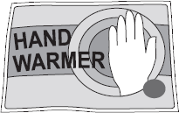

(a)     The table shows temperature changes for chemical reactions **A**, **B** and **C**.

|  |  |  |  |
| --- | --- | --- | --- |
| **Reaction** | **Starting temperature in °C** | **Final temperature in °C** | **Change in temperature in °C** |
| **A** | 18 | 25 | + 7 |
| **B** | 17 | ___________ | + 5 |
| **C** | 18 | 27 | + 9 |

What is the final temperature for reaction **B**? Write your answer in the table.

**(1)**

(b)     (i)     What name is given to reactions that heat the surroundings?

______________

**(1)**

(ii)     Which reaction, **A**, **B** or **C**, would be best to use in a hand warmer?

Reaction    

Give a reason why you chose this reaction.

______________________________________________________________

______________________________________________________________

**(2)**

(c)     A student added water to some anhydrous copper sulfate.

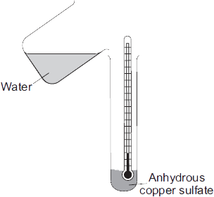

The equation for the reaction is shown.

anhydrous copper sulfate      +      water             hydrated copper sulfate

         CuSO4                 +     5 H2O             CuSO4.5H2O

The student measured the temperature before and after the reaction.

(i)      The measurements showed that this reaction can be used for a hand warmer.

Draw a ring around the correct answer to complete the sentence.

When water is added to anhydrous copper sulfate the temperature

|  |  |
| --- | --- |
|  | increases. |
| of the mixture | decreases. |
|  | stays the same. |

**(1)**

(ii)     Anhydrous copper sulfate is white.

What colour is seen after water is added to the anhydrous copper sulfate?

                                          ________________________________________

**(1)**

(iii)    What does the symbol  mean?

______________________________________________________________

**(1)**

(iv)     The student heated a tube containing hydrated copper sulfate.

Name the solid substance produced.

______________________________________________________________

**(1)**

**(Total 8 marks)**

**Q2.**

This question is about ammonia (NH3).

(a)     Complete the diagram to show the bonding electrons in ammonia.

Show the outer electrons only.

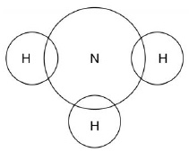

**(2)**

Ammonia is produced from nitrogen and hydrogen.

N2(g) + 3H2(g) ⇌ 2NH3(g)

The forward reaction is exothermic.

(b)     A low pressure is used.

Explain the effect on the yield of ammonia.

___________________________________________________________________

___________________________________________________________________

___________________________________________________________________

**(2)**

(c)     A high temperature is used.

Explain the effect on the yield of ammonia.

___________________________________________________________________

___________________________________________________________________

___________________________________________________________________

___________________________________________________________________

**(2)**

(d)     Ammonia is removed from the reaction mixture.

Explain the effect on the position of equilibrium.

___________________________________________________________________

___________________________________________________________________

___________________________________________________________________

___________________________________________________________________

**(2)**

**(Total 8 marks)**

Mark schemes

**Q1.**

 (a)     22

**1**

(b)     (i)      exothermic

**1**

(ii)     C

**1**

gives out most heat energy

*accept has largest temperature change / increase*

*allow has highest (final) temperature* ***or*** *hottest*

**1**

(c)     (i)      increases

**1**

(ii)     blue

*ignore pale / dark etc*

**1**

(iii)     reversible (reaction)

*allow goes both ways* ***or*** *two / either way*

**1**

(iv)     anhydrous copper sulfate

**1**

**[8]**

**Q2.**

(a)     3 × bonding pairs of electrons

**1**

2 × unbonded electrons on nitrogen

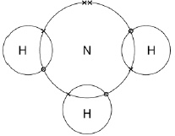

**2**

(b)     decreases yield

**1**

more moles on left hand side

**1**

(c)     decreases yield

**1**

exothermic reaction

**1**

(d)     moves to right hand side

**or**

more ammonia produced

**1**

to replace the ammonia

**1**

**Revision Homework 7: Physics**

**Section 1: Knowledge**

|  |  |  |
| --- | --- | --- |
|  | **Topic:** | **Electricity introduction (P.29)** |
| 1 | What does LED stand for? | Light emitting diode. |
| 2 | What does LDR stand for? | Light dependent resistor. |
| 3 | State the equation for charge flow | Q=It Charge flow (C) = current (A) x time (S) |
| 4 | State the units for charge flow | Coulombs (C ) |
| 5 | Define 'electrical current' | Rate of flow of electrical charge |
| 6 | What do the symbols I, t and Q represent? | I - current, t - time, Q - charge flow. |
| 7 | State the units for resistance | Ohms (Ω) |
| 8 | How does resistance affect current? | The higher the resistance, the lower the current (inversely proportional) |
| 9 | What is an ohmic conductor? | Electrical component where current and voltage are DIRECTLY PROPORTIONAL |
| 10 | What is a non-ohmic conductor? | Electrical component where current and voltage are NOT directly proportional |
| 11 | Write Ohm's law as an equation | V=IR |
| 12 | Units for potential difference. | Volts (V) |
| 13 | State the units for current. | Amperes (A) |
| 14 | Which piece of equipment is used to measure current in a circuit? | Ammeter |
| 15 | Which piece of equipment is used to measure voltage in a circuit? | Voltmeter |
|  | **Topic:** | **Series and parallel circuits (P.30)** |
| 1 | Do series circuits have one loop or multiple loops? | 1 loop |
| 2 | Do parallel circuits have one loop or multiple loops? | Multiple loops |
| 3 | Describe the distribution of current in a series circuit | It is the same everywhere |
| 4 | Describe the distribution of potential difference in a series circuit | Split between components |
| 5 | Describe the distribution of current in a parallel circuit | Split up in the different loops |
| 6 | Describe the distribution of potential difference in a parallel circuit | The same in each loop |
| 7 | Name the component used to measure current | Ammeter |
| 8 | Name the component used to measure voltage | Voltmeter |
| 9 | Are voltmeters connected in series or parallel? | in parallel |
| 10 | Are ammeters connected in series or parallel? | In series |
| 11 | State the equation for calculating resistance in a series circuit | Rtotal = R1 +R2 |
| 12 | How do you calculate total resistance in a series circuit? | Sum the resistance of each component |
| 13 | What affect does adding resistors have in a series circuit on the resistance? | Increases the total resistance |
| 14 | What affect does adding resistors have in a parallel circuit on the resistance? | Decreases the total resistance |
| 15 | Equation for resistance in a parallel circuit: | 1/Rtotal = 1/R1 + 1/R2 |

**Section 2:**Mastery matrix statements to be answered and then self-assessed using https://www.bbc.co.uk/bitesize and knowledge

|  |  |  |
| --- | --- | --- |
| 2.1 | Electricity Introduction | Identify the key circuit symbols. |
| 2.2 |  | Define current, charge and potential difference. |
| 2.3 |  | Use and rearrange equations for calculating current. |
| 2.4 |  | Predict the current at given points within a series and parallel circuit. |
| 2.5 |  | Predict the potential difference (voltage) at given points within a series and parallel circuit. |
| 2.6 |  | Describe the relationship between current, potential difference and resistance. |
| 2.7 |  | Use and rearrange equations for calculating current, potential difference and resistance. |
| 2.8 |  | Recall units for current, potential difference and resistance. |
| 2.9 | Series and Parallel Circuits | Compare and contrast series and parallel circuits in terms of current and potential difference. |
| 2.10 |  | Calculate resistance in series circuits and describe resistance in parallel circuits. |
| 2.11 |  | **RP Resistance:** Use circuit diagrams to set up circuits to investigate the factors affecting resistance (length of a wire at constant temperature and combinations of resistors in series and parallel.) |

**Section 3: Exam questions**

**Q1.**

**Figure 1** shows the circuit symbol for three different components.

**Figure 1**

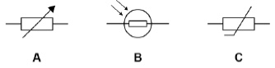

(a)     Which component is a variable resistor?

Tick **one** box.

|  |  |  |  |  |  |
| --- | --- | --- | --- | --- | --- |
| **A** |  | **B** |  | **C** |  |

**(1)**

(b)     Which component is a thermistor?

Tick **one** box.

|  |  |  |  |  |  |
| --- | --- | --- | --- | --- | --- |
| **A** |  | **B** |  | **C** |  |

**(1)**

(c)     In which component will the resistance decrease when the temperature increases?

Tick **one** box.

|  |  |  |  |  |  |
| --- | --- | --- | --- | --- | --- |
| **A** |  | **B** |  | **C** |  |

**(1)**

(d)     In which component will the resistance decrease when the light intensity increases?

Tick **one** box.

|  |  |  |  |  |  |
| --- | --- | --- | --- | --- | --- |
| **A** |  | **B** |  | **C** |  |

**(1)**

**Figure 2** shows four different arrangements of resistors.

**Figure 2**

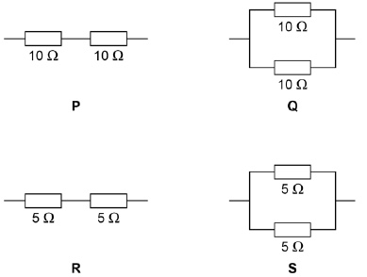

(e)     Two of the arrangements are in series and two are in parallel.

Describe the difference between a series and a parallel arrangement.

___________________________________________________________________

___________________________________________________________________

___________________________________________________________________

___________________________________________________________________

**(2)**

(f)      Which arrangement has a resistance of 10 Ω?

Tick **one** box.

|  |  |  |  |  |  |  |  |
| --- | --- | --- | --- | --- | --- | --- | --- |
| **P** |  | **Q** |  | **R** |  | **S** |  |

**(1)**

(g)     Which arrangement has the highest resistance?

Tick **one** box.

|  |  |  |  |  |  |  |  |
| --- | --- | --- | --- | --- | --- | --- | --- |
| **P** |  | **Q** |  | **R** |  | **S** |  |

**(1)**

(h)     A student connects a resistor to a cell for 60 seconds.

The current through the resistor is 0.97 A

Calculate the charge flow.

Use the equation:

charge flow = current × time

Give your answer to 2 significant figures.

___________________________________________________________________

___________________________________________________________________

___________________________________________________________________

___________________________________________________________________

___________________________________________________________________

___________________________________________________________________

Charge flow = ____________________ C

**(3)**

**(Total 11 marks)**

**Q2.**

Components can be connected in electrical circuits in different ways.

(a)     Draw **one** line from each circuit symbol to the name of the component it represents.

|  |  |  |
| --- | --- | --- |
| **Circuit symbol** |  | **Name of component** |
|  |  | cell |
|  |  |  |
|  |  | diode |
|  |  |  |
|  |  | fuse |
|  |  |  |
|  |  | lamp |
|  |  |  |
|  |  | variable resistor |

**(2)**

(b)     Complete the sentence.

Choose the answer from the box.

|  |  |  |  |
| --- | --- | --- | --- |
| **charge** | **energy** | **potential difference** | **resistance** |

Electric current is the rate of flow of ____________________.

**(1)**

**Figure 1** shows a parallel circuit.

**Figure 1**

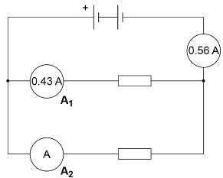

(c)     Calculate the current measured by ammeter **A2**.

Current = ____________________ A

**(1)**

(d)     The circuit is connected for 300 s

The total current in the circuit stays at 0.56 A

Calculate the total charge flow.

Use the equation:

charge flow = current × time

___________________________________________________________________

___________________________________________________________________

___________________________________________________________________

___________________________________________________________________

Charge flow = ____________________ C

**(2)**

(e)     The potential difference supplied by the battery is 4.5 V

Calculate the total energy transferred in 300 s

Use the equation:

energy transferred = charge flow × potential difference

Use your answer to part (d).

___________________________________________________________________

___________________________________________________________________

___________________________________________________________________

___________________________________________________________________

Energy transferred = ____________________ J

**(2)**

(f)      **Figure 2** shows a series circuit.

**Figure 2**

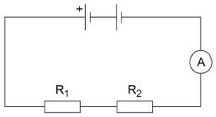

Resistor **R2** breaks.

What happens to the reading on the ammeter?

___________________________________________________________________

**(1)**

(g)     **Figure 3** shows a parallel circuit.

**Figure 3**

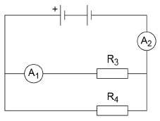

Resistor **R3** breaks.

What happens to the readings on the ammeter?

Ammeter **A1** _________________________________________________________

Ammeter **A2** _________________________________________________________

**(2)**

**Figure 4** shows how the resistance of a component varies with temperature.

**Figure 4**

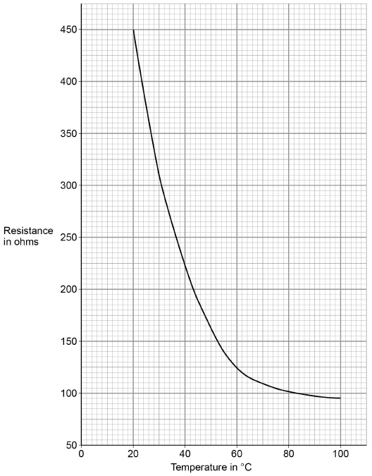

(h)     What is the name of the component?

Tick **one** box.

|  |  |
| --- | --- |
| LED |  |
| LDR |  |
| Resistor |  |
| Thermistor |  |

**(1)**

(i)      What is the resistance of the component at a temperature of 50 °C?

Resistance = ____________________ Ω

**(1)**

**(Total 13 marks)**

Mark schemes

**Q1.**

(a)     **A**

**1**

(b)     **C**

**1**

(c)     **C**

**1**

(d)     **B**

**1**

(e)     a series circuit has only one path/loop/branch

**1**

a parallel circuit has a branch(es) to provide more than one path / loop

*allow answers that describe the difference in terms of potential difference, current or resistance*

**1**

(f)      **R**

**1**

(g)     **P**

**1**

(h)     Q = 0.97 × 60

**1**

Q = 58.2 (C)

**1**

Q = 58 (C)

*an answer of 58 (C) scores* ***3*** *marks*

**1**

**[11]**

**Q2.**

(a)

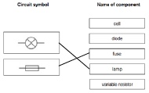

*extra lines from circuit symbols negate the mark*

**1**

**1**

(b)     charge

**1**

(c)     0.13 (A)

**1**

(d)     0.56 × 300

**1**

168 (C)

*an answer of 168 (C) scores* ***2*** *marks*

**1**

(e)     168 × 4.5

**1**

756 (J)

*an answer of 756 (J) scores 2 marks*

*allow ecf from part (d)*

**1**

(f)      decreases to zero

*allow reads zero*

**1**

(g)     (A1) decreases to zero

*allow reads zero*

**1**

(A2) decreases

*do* ***not*** *accept ‘to zero’ for A2*

**1**

(h)     thermistor

**1**

(i)     answer in range 160–165 (Ω)

**1**

**[13]**

**Revision Homework 8: Physics**

**Section 1: Knowledge**

|  |  |  |
| --- | --- | --- |
|  | **Topic:** | **Radioactive decay and radiation (P.22)** |
| 1 | What two words can we use to describe the process of radioactive decay? | Random and unpredictable |
| 2 | What is the word to describe the rate at which a source of unstable nuclei decays | Activity |
| 3 | What is the word to describe the number of decays recorded each second by a detector | Count rate |
| 4 | What is the equipment for measuring radiation. | Geiger-Muller tube |
| 5 | Name the four types of nuclear radiation | alpha particle, beta particle, gamma ray, neutron |
| 6 | Describe the structure of an alpha particle | 2 neutrons & 2 protons (helium nucleus) |
| 7 | What is a beta particle? | A negative electron |
| 8 | What is a gamma ray? | An electromagnetic wave |
| 9 | Three main types of radiation in order of high to low ionising power. | alpha, beta, gamma |
| 10 | Three main types of radiation in order of high to low penetrating power. | gamma, beta, alpha |
| 11 | Which materials are able to stop each type of radiation? | Alpha = paper, beta = aluminium, gamma = nothing, thick lead absorbs some of it |
| 12 | Distances alpha, beta and gamma can go in air. | Alpha: 3-5cm, Beta: ~1m, Gamma: several hundred km |
| 13 | Define "irradiation" | Exposing an object to nuclear radiation.  The irradiated object does not become radioactive. |
| 14 | Define "half life" | The time it takes for the number of unstable nuclei of the isotope in a sample to halve |
| 15 | Define "radioactive contamination" | The unwanted presence of radioactive atoms on other materials |
|  |  |  |
|  | **Topic:** | **Background decay and radiation (P.23)** |
| 1 | State two natural sources of background radiation | Rocks and cosmic rays |
| 2 | State two man made sources of background radiation | Fallout from nuclear weapons testing, nuclear accidents |
| 3 | Define 'background radiation' | Radiation around us all the time. |
| 4 | Define 'radiation dose' | The amount of radiation that is absorbed by a person (Sv) |
| 5 | Would a long or short half life radioactive material be more dangerous in the long term? | Long half life material. |
| 6 | State 2 medical uses of nuclear radiation | Exploring internal organs, control/destruction of unwanted tissue. |
| 7 | Why is using nuclear radiation to treat a tumour a risk? | The radiation might cause a tumour |
| 8 | Give an example of an internal organ that would be explored with radiation | Intestines - to look for blockages. |
| 9 | Would you use a short or long half life material for using a tracer in the intestine? | Short - an hour or so - you don't want to leave the hospital if you are still give out high levels of radiation. |
| 10 | What kind of radiation is used to look at internal organs? | Beta |
| 11 | Why can't alpha be used to look at internal organs? | Stopped by skin |
| 12 | What kind of radiation is used to destroy tumours? | Gamma rays (sometimes beta) |
| 13 | Why is gamma used to destroy tumours? | Ionising & can penetrate the skin and bones |
| 14 | Why is a long half life material high risk? | It will still be giving out radiation in years to come |
| 15 | State 2 factors that affect the amount of background radiation people are exposed to | Occupation (job) & location |

**Section 2:**Mastery matrix statements to be answered and then self-assessed using https://www.bbc.co.uk/bitesize and knowledge

|  |  |  |
| --- | --- | --- |
| 2.1 | Radioactive decay and Radiation | Describe what radioactive decay is |
| 2.2 |  | Recall the definition and units for activity and count rate |
| 2.3 |  | Describe what makes up alpha, beta, gamma and neutron radiation |
| 2.4 |  | Describe the properties of each type of radiation |
| 2.5 |  | Use nuclear equations to represent radioactive decay |
| 2.6 |  | Define half-life |
| 2.7 |  | Complete half-life calculations from graphs or other data |
| 2.8 |  | Use ratios to describe radioactive decay (HT only) |
| 2.9 |  | Describe the impact and precautions for radioactive contamination |
| 2.10 |  | Analyse data about the effects of radiation on people |

**Section 3: Exam questions**

**Q1.**

A teacher used a Geiger-Muller tube and counter to measure the number of counts in 60 seconds for a radioactive rock.

(a)  The counter recorded 819 counts in 60 seconds. The background radiation count rate was 0.30 counts per second.

Calculate the count rate for the rock.

___________________________________________________________________

___________________________________________________________________

___________________________________________________________________

___________________________________________________________________

Count rate = ______________________ per second

**(3)**

(b)  A householder is worried about the radiation emitted by the granite worktop in his kitchen.

1 kg of granite has an activity of 1250 Bq. The kitchen worktop has a mass of 180 kg.

Calculate the activity of the kitchen worktop in Bq.

___________________________________________________________________

___________________________________________________________________

___________________________________________________________________

___________________________________________________________________

Activity = ___________________ Bq

**(2)**

(c)  The average total radiation dose per year in the UK is 2.0 millisieverts.

The table below shows the effects of radiation dose on the human body.

|  |  |
| --- | --- |
| **Radiation dose in millisieverts** | **Effects** |
| 10 000 | Immediate illness; death within a few weeks |
| 1000 | Radiation sickness; unlikely to cause death |
| 100 | Lowest dose with evidence of causing cancer |

The average radiation dose from the granite worktop is 0.003 millisieverts per day.

Explain why the householder should **not** be concerned about his yearly radiation dose from the granite worktop.

One year is 365 days.

___________________________________________________________________

___________________________________________________________________

___________________________________________________________________

___________________________________________________________________

**(2)**

(d)  Bananas are a source of background radiation. Some people think that the unit of radiation dose should be changed from sieverts to Banana Equivalent Dose.

Suggest **one** reason why the Banana Equivalent Dose may help the public be more aware of radiation risks.

___________________________________________________________________

___________________________________________________________________

___________________________________________________________________

___________________________________________________________________

**(1)**

**(Total 8 marks)**

**Q2.** Smoke alarms contain an alpha radiation source and a radiation detector. **Figure 1** shows part of the inside of a smoke alarm.

**Figure 1**

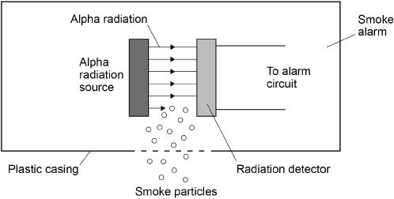

(a)  The smoke alarm stays off while alpha radiation reaches the detector.

Why does the alarm switch on when smoke particles enter the plastic casing?

___________________________________________________________________

___________________________________________________________________

___________________________________________________________________

**(1)**

(b)  Why is it safe to use a source of alpha radiation in a house?

___________________________________________________________________

___________________________________________________________________

___________________________________________________________________

**(1)**

(c)  The smoke alarm would not work with a radiation source that emits beta or gamma radiation. Explain why.

___________________________________________________________________

___________________________________________________________________

___________________________________________________________________

___________________________________________________________________

**(2)**

(d)  **Figure 2** shows how the count rate detected from the radiation source in the smoke alarm changes with time.

**Figure 2**

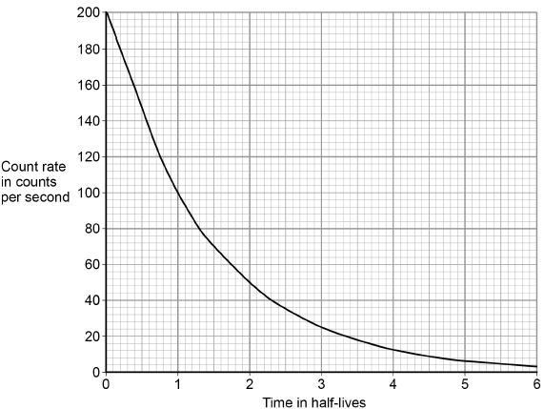

The smoke alarm switches on when the count rate falls to 80 counts per second.

Explain why the radiation source inside the smoke alarm should have a long half-life.

___________________________________________________________________

___________________________________________________________________

___________________________________________________________________

___________________________________________________________________

**(2)**

(e)  A patient who been injected with a radioactive source for medical diagnosis.

Explain the ideal properties of a radioactive source for use in medical diagnosis.

___________________________________________________________________

___________________________________________________________________

___________________________________________________________________

___________________________________________________________________

___________________________________________________________________

___________________________________________________________________

___________________________________________________________________

___________________________________________________________________

**(4)**

**(Total 10 marks)**

**Q3.**

Alpha particles, beta particles and gamma rays are types of nuclear radiation.

(a)     Describe the structure of an alpha particle.

___________________________________________________________________

___________________________________________________________________

**(1)**

(b)     Nuclear radiation can change atoms into ions by the process of ionisation.

(i)      Which type of nuclear radiation is the least ionising?

Tick (✔) **one** box.

|  |  |
| --- | --- |
| alpha particles |  |
| beta particles |  |
| gamma rays |  |

**(1)**

(ii)     What happens to the structure of an atom when the atom is ionised?

______________________________________________________________

______________________________________________________________

**(1)**

(c)     People working with sources of nuclear radiation risk damaging their health.

State **one** precaution these people should take to reduce the risk to their health.

___________________________________________________________________

___________________________________________________________________

**(1)**

**(Total 4 marks)**

Mark schemes

**Q1.**

(a)  

**1**

count rate = 13.65

**1**

corrected count rate = 13.35 (per second)

*allow an answer of*

*background = 0.30 × 60*

*= 18 (per minute)*

*corrected count rate*

*= 819 – 18*

*corrected count rate*

*= 801 per minute*

**1**

*an answer of 13.35 (per second) scores* ***3*** *marks*

*an answer of 13.95 (per second) scores* ***2*** *marks*

*an answer of 801 (per second) scores* ***2*** *marks*

(b)  activity = 1250 × 180

**1**

activity = 225 000 (Bq)

**1**

*an answer of 225 000 (Bq) scores* ***2*** *marks*

(c)  yearly dose = 0.003 × 365

*allow yearly dose = 1.095 (mSv)*

**1**

which is << 100 (mSv)

**or**

(well) below the lowest dose with evidence of causing cancer / harm

**1**

(d)  people are able to compare a radiation risk / dose / hazard to the radiation dose from (eating) bananas

**1**

**[8]**

**Q2.**

(a)  smoke absorbs / stops alpha radiation

*allow alpha particles for alpha radiation*

*alpha radiation does not reach the detector is insufficient*

**1**

(b)  alpha radiation is not very penetrating

*allow alpha particles for alpha radiation*

**or**

alpha radiation does not penetrate skin

*allow alpha radiation does not travel very far (in air)*

**1**

(c)  beta and gamma radiation will penetrate smoke

*allow beta and gamma radiation will not be stopped by smoke*

**1**

no change (in the count rate) would be detected

*allow the change detected (in the count rate) would be too small*

**1**

(d)  (a long half-life means) the count rate is (approximately) constant

*allow activity of source is (approximately) constant*

**or**

a short half-life means the count rate decreases quickly

**1**

until 1.3 half-lives the count rate is above 80 per second

*allow after 1.3 half-lives the count rate is below 80 per second*

**or**

until 1.3 half-lives the count rate is above the threshold for the smoke alarm to be activated

**or**

after 1.3 half-lives the smoke alarm will be activated all the time

*so don’t have to replace source or smoke detector is insufficient*

**1**

(e)  **Level 2:** Relevant points (reasons / causes) are identified, given in detail and logically linked to form a clear account.

**3−4**

**Level 1:** Relevant points (reasons / causes) are identified, and there are attempts at logically linking. The resulting account is not fully clear.

**1−2**

**No relevant content**

**0**

**Indicative content**

•   short half-life or half-life of a few hours

•   (short half-life means) less damage to cells / tissues / organs / body

•   low ionising power

•   (low ionising power means) less damage to cells / tissues / organs / body

•   highly penetrating

•   (highly penetrating means) it can be detected outside the body

•   emits gamma radiation

**[10]**

**Q3.**

(a)     2 protons and 2 neutrons

*accept 2p and 2n*

*accept (the same as a) helium nucleus*

*symbol is insufficient*

*do not accept 2 protons and neutrons*

**1**

(b)     (i)      gamma rays

**1**

(ii)     loses/gains (one or more) electron(s)

**1**

(c)     any **one** from:

•        wear protective clothing

•        work behind lead/concrete/glass shielding

•        limit time of exposure

•        use remote handling

*accept wear mask/gloves*

*wear goggles is insufficient*

*wear protective equipment/gear is insufficient*

*accept wear a film badge*

*accept handle with (long) tongs*

*accept maintain a safe distance*

*accept avoid direct contact*

**1**

**[4]**

**Revision Homework 9: Physics**

**Section 1: Knowledge**

|  |  |  |
| --- | --- | --- |
|  | **Topic:** | **Nuclear physics (P.21)** |
| 1 | What is the size of the atom? | 1 x 10-10m |
| 2 | Which two sub atomic particles are found in the nucleus? | Protons and neutrons |
| 3 | What is the radius of nucleus compared to radius of atom. | 1/10000 of the size (one ten thousandth of the size) |
| 4 | Electrons go up an energy level when… (HT only) | They absorb electromagnetic radiation. |
| 5 | Electrons move down an energy level when… (HT only) | They emit electromagnetic radiation. |
| 6 | Are atoms positive, negative or neutral? | Neutral |
| 7 | What is the atomic number? | Number of protons |
| 8 | What is the mass number? | Number of protons AND neutrons. |
| 9 | What is an "ion"? | A charged atom (lost or gained electrons) |
| 10 | What are isotopes? | Atoms of the same element with the SAME number of protons but a DIFFERENT number of neutrons. |
| 11 | Describe the plum pudding model | The atom is a ball of positive charge with negative electrons embedded in it |
| 12 | What is the name of the current model of the atom? | Nuclear model |
| 13 | State two conclusions from the alpha scattering experiment | 1) mass of an atom is concentrated in a nucleus in the centre 2) nucleus is positive |
| 14 | State the conclusion provided by Niels Bohr | Electrons orbit the nucleus |
| 15 | State the conclusion provided by James Chadwick | Discovered neutrons |
|  | **Topic:** | **Nuclear fission and fusion (P.24)** |
| 1 | Define 'Nuclear fission' | Splitting a large & unstable nucleus. |
| 2 | State 2 examples of elements that undergo fission. | Uranium & plutonium |
| 3 | Spontaneous fission is rare. What usually causes fission? | An unstable nucleus absorbs a neutron |
| 4 | State the 3 products of nuclear fission | 2 smaller nuclei, 2 or 3 neutrons, gamma rays |
| 5 | In what form is energy released in a fission reaction? | Gamma rays |
| 6 | How do the sizes of the two nuclei produced in a fission reaction compare? | Roughly the same size. |
| 7 | The nuclei and neutrons produced after a fission reaction have lots of _____________? | Kinetic energy |
| 8 | What is a chain reaction? | Neutrons from a fission reaction are absorbed by another nucleus & start another fission reaction |
| 9 | How is a fission reaction in a nuclear power station controlled? | Control rods absorb neutrons (slow down the chain reaction) |
| 10 | In a nuclear weapon, is the chain reaction controlled or uncontrolled? | Uncontrolled. |
| 11 | Define 'nuclear fusion' | The joining of two light nuclei to form a heavier nucleus with some mass converted to energy. |
| 12 | Where does nuclear fusion happen? | In stars e.g. the sun. |
| 13 | Why does nuclear fusion happen in the sun? | High temperature & pressure |
| 14 | Why does fusion need a high temperature and pressure? | To overcome the repulsion force between the 2 positive nuclei |
| 15 | State two elements that undergo nuclear fusion | Hydrogen and helium |

**Section 2:**Mastery matrix statements to be answered and then self-assessed using https://www.bbc.co.uk/bitesize and knowledge

|  |  |  |
| --- | --- | --- |
| 1.1 | Nuclear Physics | Describe the structure and size of an atom |
| 1.2 |  | Calculate the number of protons, neutrons and electrons in an atom |
| 1.3 |  | Describe how electrons can change energy level |
| 1.4 |  | Describe isotopes |
| 1.5 |  | Describe what an ion is |
| 1.6 |  | Describe the development of the model of the atom (Plum-pudding, Rutherford, Neils Bohr and Chadwick). |

**Section 3: Exam questions**

**Q1.**

**Figure 1** shows two models of the atom.

**Figure 1**

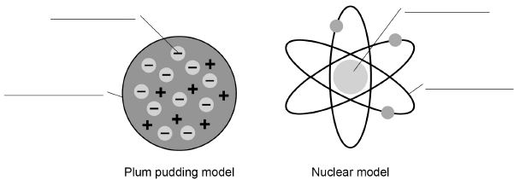

(a)  Write the labels on **Figure 1**

Choose the answers from the box.

|  |  |  |
| --- | --- | --- |
| **atom** | **electron** | **nucleus** |
| **neutron** | **orbit** | **proton** |

**(4)**

(b)  Explain why the total positive charge in every atom of an element is always the same.

___________________________________________________________________

___________________________________________________________________

___________________________________________________________________

___________________________________________________________________

**(2)**

(c)  The results from the alpha particle scattering experiment led to the nuclear model.

Alpha particles were fired at a thin film of gold at a speed of 7% of the speed of light.

Determine the speed of the alpha particles.

Speed of light = 300 000 000 m/s

___________________________________________________________________

___________________________________________________________________

Speed = _____________________ m/s

**(2)**

(d)  **Figure 2** shows two atoms represented as solid spheres.

**Figure 2**

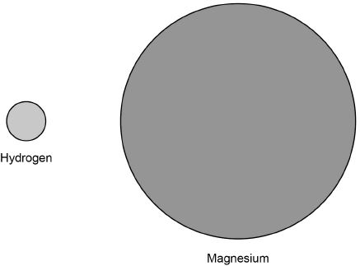

A hydrogen atom has a radius of 2.5 × 10−11 m

Determine the radius of a magnesium atom.

Use measurements from **Figure 2**

___________________________________________________________________

___________________________________________________________________

Radius = _____________________ m

**(2)**

**(Total 10 marks)**

**Q2.**

Neon is an element. Neon is used in advertising signs.

**Figure 1** shows a neon sign.

**Figure 1**



(a)  Explain why the atoms of neon give out electromagnetic radiation when the tube is connected to an electricity supply.

___________________________________________________________________

___________________________________________________________________

___________________________________________________________________

___________________________________________________________________

___________________________________________________________________

___________________________________________________________________

___________________________________________________________________

___________________________________________________________________

**(4)**

Some elements can have different isotopes.

(b)  An isotope of carbon can be shown as 

**Figure 2** shows an **incorrect** diagram of the structure of an atom of 

**Figure 2**

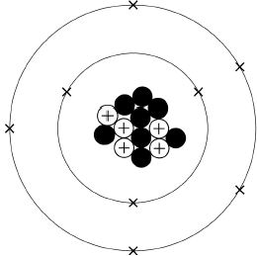

Explain why the diagram of the atomic structure shown in **Figure 2** is incorrect.

Give a reason for your answer.

___________________________________________________________________

___________________________________________________________________

___________________________________________________________________

___________________________________________________________________

___________________________________________________________________

___________________________________________________________________

___________________________________________________________________

___________________________________________________________________

**(4)**

Carbon-14 () is a radioactive isotope of carbon. Carbon-14 undergoes **beta** decay.

**Figure 3** shows an incomplete nuclear equation for the radioactive decay of carbon-14.

**Figure 3**



(c)  Which of the following correctly completes the nuclear equation in **Figure 3**?

Tick **one** box.

|  |  |
| --- | --- |
|  |  |
|  |  |
|  |  |
|  |  |

**(1)**

(d)  Explain the change in atomic number in the nuclear equation shown in **Figure 3**.

___________________________________________________________________

___________________________________________________________________

___________________________________________________________________

___________________________________________________________________

**(2)**

(e)  The half-life of carbon-14 is 5730 years.

Carbon-14 is used for carbon dating. Carbon dating can tell us how old some objects are.

A skeleton was carbon dated. The results showed that there was only 12.5% of the original amount of carbon-14 left in the skeleton.

Calculate the age of the skeleton.

___________________________________________________________________

___________________________________________________________________

___________________________________________________________________

___________________________________________________________________

Age of skeleton = ______________ years old

**(2)**

**(Total 13 marks)**

Mark schemes

**Q1.**

(a)  electron

**1**

atom

**1**

nucleus

**1**

orbit

**1**

(b)  positive charge is provided by protons

**1**

(every atom of the same element contain the) same number of protons

*do* ***not*** *accept same number of protons and neutrons*

*ignore reference to electrons*

**1**

(c)  

*allow any correct method of determining 7% of 300 000 000*

**1**

v = 21 000 000 (m/s)

*allow 2.1 × 107 (m/s)*

**1**

*an answer of 21 000 000 scores* ***2*** *marks*

(d)  r = 6 × 2.5 × 10−11

*allow a ratio in the range of 5.7−6.3 or measurements that would give this range, correctly substituted*

**1**

r = 1.5 × 10−10 (m)

*allow 1.4 × 10−10 to 1.6 × 10−10*

*their ratio × 2.5 × 10−11 correctly calculated scores* ***1*** *mark*

**1**

*an answer in the range 1.4 × 10−10 to 1.6 × 10−10 scores* ***2*** *marks*

**[10]**

**Q2.**

(a)  atoms / electrons gain energy

**1**

(some) electrons move to a higher energy level

*allow (sub) shell for energy level*

**1**

(so) as the electrons fall to a lower / original energy level

*allow (sub) shell for energy level*

**1**

(EM) radiation with a frequency / wavelength within the visible region of the spectrum is emitted

**1**

(b)  there should be two electrons on the inner shell (not three)

**1**

there should only be four electrons in the outer shell

**or**

there should only be six electrons in total

**1**

there should be one more proton

*allow should be six protons*

**1**

there should be one fewer neutron

*allow should be seven neutrons*

**1**

*allow* ***2*** *marks for one of the neutrons should be a proton*

(c)  

**1**

(d)  a neutron splits into a proton **and** an electron

*allow beta particle for electron*

**1**

so there is an extra proton (in the nucleus)

**1**

(e)  12.5% is 3 half lives

**or**

5730 × 3

**1**

17 190 (years old)

**1**

*an answer of 17 190 (years old) scores* ***2*** *marks*

**[13]**

**Revision Homework 10: Chemistry**

**Section 1: Knowledge**

|  |  |  |
| --- | --- | --- |
|  | **Topic:** | **The periodic table (C.6)** |
| 1 | How are elements arranged in the periodic table? | In order of atomic number (lowest to highest) |
| 2 | What does the column (group) in the periodic table tells us? | Number of electrons in the outer shell |
| 3 | What are the rows of the periodic table called? | Periods |
| 4 | What did Mendeleev do when creating the modern periodic table? | Left gaps to make the pattern fit |
| 5 | Where are alkali metals found in the periodic table? | Group 1 |
| 6 | Where are non-metals found in the periodic table? | Right |
| 7 | Name the groups in the periodic table (1, 7, 0) | 1 = Alkali metals, 7 = Halogens, 0 = Noble gases |
| 8 | State 3 properties of group 7 | Non-metal, highly reactive, diatomic |
| 9 | What happens to reactivity as you move down group 7? | They become less reactive - it is harder to gain an electron |
| 10 | What is the name of the elements found in the middle of the periodic table that are not part of a group? | Transition metals |
| 11 | Give 4 properties of metals | 1) High melting point, 2) Good thermal and electrical conductors, 3) Ductile, 4) Malleable |
| 12 | Give 3 properties of non-metals | 1) Low melting point, 2) Poor thermal and electrical conductors, 3)Brittle |
| 13 | Give 5 properties of the alkali metals | 1) Highly reactive, 2) Low melting and boiling points, 3) Low density, 4) Shiny when cut, 5) Soft |
| 14 | What is formed when alkali metals react with water? | Alkaline metal hydroxide |
| 15 | What happens to reactivity as you move down group 1? | They become more reactive - it is easier to lose their outer electron. |

**Section 2:**Mastery matrix statements to be answered and then self-assessed using https://www.bbc.co.uk/bitesize and knowledge

|  |  |  |
| --- | --- | --- |
| 4.1 | Metals in the periodic table | Describe how Mendeleev has arranged the periodic table |
| 4.2 |  | Explain why something is classified as a metal or non-metal |
| 4.3 |  | Describe the uses of metals |
| 4.4 |  | Describe the key properties of the transition metals (chromium, manganese, iron, cobalt, nickel and copper) (separate only) |
| 4.5 |  | Define a ‘chemical reaction’ and given examples |
| 4.6 |  | Describe corrosion as a reaction and explain how to prevent it (separate only) |
| 5.3 |  | Describe the key properties (molecular mass, boiling and melting point) of group 7 |
| 5.4 |  | Describe and explain how the reactivity changes as you move down group 7 |

**Section 3: Exam questions**

**Q1.**

This question is about the halogens.

(a)  Which group in the periodic table is known as the halogens?

Tick **one** box.

|  |  |
| --- | --- |
| Group 1 |  |
| Group 2 |  |
| Group 7 |  |
| Group 0 |  |

**(1)**

(b)  A fluorine atom has 7 electrons in the outer shell.

The diagram below shows part of a dot and cross diagram to represent a molecule of fluorine (F2).

Complete the dot and cross diagram.

You should show only the electrons in the outer shells.

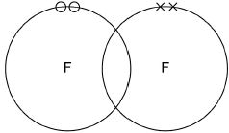

**(2)**

(c)  Chlorine reacts with potassium bromide solution.

Complete the word equation.

        potassium               _________________

chlorine  +  bromide  ⟶ _________________ +

                           _________________

**(2)**

(d)  What type of reaction happens when chlorine reacts with potassium bromide solution?

Tick **one** box.

|  |  |
| --- | --- |
| decomposition |  |
| displacement |  |
| neutralisation |  |
| precipitation |  |

**(1)**

(e)  Complete the sentence.

Choose the answer from the box.

|  |  |  |  |
| --- | --- | --- | --- |
| **an atom** | **an electron** | **a neutron** | **a proton** |

Chlorine is more reactive than bromine.

This is because chlorine gains ________________________________ more easily.

**(1)**

(f)  How does the size of a chlorine atom compare with the size of a bromine atom?

Complete the sentence.

Choose the answer from the box.

|  |  |  |
| --- | --- | --- |
| **bigger than** | **the same size as** | **smaller than** |

A chlorine atom is ______________________________________ a bromine atom.

**(1)**

(g)  Give a reason for your answer to part **(f)**

Reason ____________________________________________________________

___________________________________________________________________

**(1)**

(h)  Fluorine reacts with chlorine to produce ClF3

Balance the chemical equation for the reaction.

Cl2 + ________F2 ⟶ 2 ClF3

**(1)**

(i)   Explain why fluorine is a gas at room temperature.

Use the following words in your answer:

**energy**    **forces**    **molecules**    **weak**

___________________________________________________________________

___________________________________________________________________

___________________________________________________________________

___________________________________________________________________

___________________________________________________________________

___________________________________________________________________

___________________________________________________________________

___________________________________________________________________

___________________________________________________________________

___________________________________________________________________

___________________________________________________________________

**(3)**

**(Total 13 marks)**

**Q2.**

This question is about the periodic table.

In 1864 John Newlands suggested an arrangement of elements.

**Figure 1** shows the arrangement Newlands suggested.

**Figure 1**

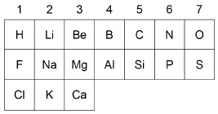

(a)     Give **two** differences between column 1 in **Figure 1** and Group 1 in the modern periodic table.

Use the periodic table to help you.

1. _________________________________________________________________

___________________________________________________________________

2. _________________________________________________________________

___________________________________________________________________

**(2)**

(b)     In 1869 Mendeleev produced his periodic table.

Complete the sentence.

Choose the answer from the box.

|  |  |  |  |
| --- | --- | --- | --- |
| **insoluble** | **magnetic** | **undiscovered** | **unreactive** |

Mendeleev left gaps in his periodic table for elements that were

_________________________________________ .

**(1)**

(c)     How are the elements ordered in the modern periodic table?

Tick **one** box.

|  |  |
| --- | --- |
| Atomic mass |  |
| Atomic number |  |
| Melting point |  |
| Reactivity |  |

**(1)**

**Figure 2** shows part of the modern periodic table.

**Figure 2**

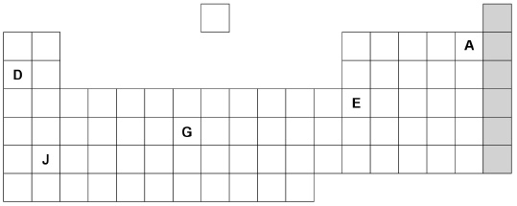

(d)     Complete the sentences about the elements in **Figure 2**.

Choose the answers from the box.

|  |  |  |  |  |
| --- | --- | --- | --- | --- |
| **A** | **D** | **E** | **G** | **J** |

Sodium is an alkali metal and is represented by the letter ____________________.

An element in group 3 is represented by the letter ____________________.

A gaseous non-metal element is represented by the letter ____________________.

**(3)**

(e)     **Figure 3** shows the electronic structure of an atom.

**Figure 3**

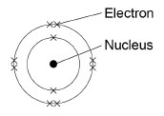

This element is in the shaded group on **Figure 2**.

Why is this element unreactive?

___________________________________________________________________

___________________________________________________________________

**(1)**

(f)      Name the group of elements in the shaded column on **Figure 2**.

___________________________________________________________________

**(1)**

**(Total 9 marks)**

Mark schemes

**Q1.**

(a)  group 7

**1**

(b)

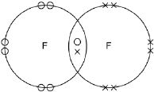

*one shared pair anywhere in overlap between two circles* ***or*** *on intersection*

*6 other electrons on each atom*

*allow dots* ***or*** *crosses* ***or*** *mixture for all marks*

*ignore any inner shell electrons*

**1**

**1**

(c)  bromine

**1**

potassium chloride

**1**

*either order*

*allow correct chemical formulae*

(d)  displacement

**1**

(e)  (an) electron

**1**

(f)  smaller than

**1**

(g)  (chlorine has) fewer levels / shells (of electrons)

*allow converse for bromine*

*allow (chlorine has) fewer electrons*

*allow Cl has 3 levels / shells and Br has 4 levels / shells*

*ignore atomic number*

***or*** *mass number*

***or*** *number of protons*

**1**

*mark independent of answer to part* ***(f)***

(h)  3

*allow multiples*

**1**

(i)   there are weak forces

*do* ***not*** *accept weak bonds*

**1**

between molecules

**1**

*allow weak intermolecular forces for the first* ***2*** *marks*

which require little energy to overcome / break

*allow does not need much energy to boil*

**1**

**[13]**

**Q2.**

(a)     any **two** from:

•        hydrogen is in group 1 on Newlands table

•        fluorine / chlorine / halogens are in group 1 on Newlands table

•        alkali metals are in group 2 on Newlands table

*allow converse arguments relating to modern table*

*allow lithium / sodium / potassium for alkali metals*

**2**

(b)     undiscovered

**1**

(c)     atomic number

**1**

(d)     **D**

**1**

**E**

**1**

**A**

**1**

*must be in this order*

(e)     has a complete outer shell of electrons

*allow because has a stable arrangement of electrons*

**1**

(f)      noble gases

**1**

**[9]**