KS3 Geography Project – May Half Term 2020 – Ocean Plastic
Part of Geography is looking at how humans are affecting the natural world. Plastic pollution is one of the major global man-made problems, and is a particular disaster for our oceans.
An approximate 8 million tonnes of plastic ends up in the oceans each year and causes harm to many species. As plastic can take up to 1000 years to decompose, the amount of plastic in the ocean is going up and up.
For example, a species affected by plastic pollution is the albatross, a sea bird with the longest wing-span of any bird on the planet. Watch this clip from the BBC’s Blue Planet II to find out more: https://www.bbc.co.uk/programmes/p05q49hq.
Using the internet, list ten species that are harmed by plastic pollution in our oceans

- Albatross

Challenge – on this map (http://app.dumpark.com/seas-of-plastic-2/#) each white dot represents 20kg of floating plastic in the oceans. Where in the world’s oceans is the plastic pollution most concentrated?
______________________________________________________________________________________________________________________________________________________________________________________________________________________________________________________

At this point you are probably wondering, how does all this plastic get into the ocean in the first place? Click the link to discover the answer: https://www.wwf.org.uk/updates/how-does-plastic-end-ocean
The three main ways plastic can enter the oceans are:

One of the major sources of plastic pollution is single-use plastic – a plastic product (often packaging) that is thrown out having been used just once. Examples would include a crisp packet or a toothpaste tube. Your task is to tally up the amount of single-use plastic in your house using the table below:
ROOM | ITEMS OF SINGLE USE PLASTIC | TOTAL
Kitchen

Now draw a bar chart to show the data you have collected:
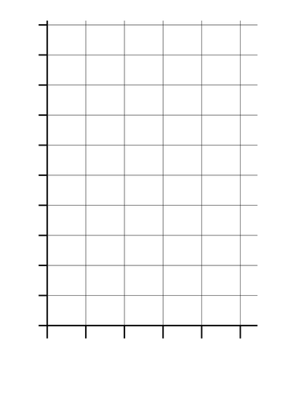

In which room did you find most single-use plastic in your house?
_______________________________________________________

Can you think of any ways you could reduce the problem of single-use plastic in your house? Hint: remember the three Rs?
____________________________________________________________________________________________________________________________________________________________________________________________________________________________________________________________________________________________________________________________________________________________________________________________________________________________________________________________________________________________________________

Challenge – why might it be difficult to reduce the amount of single-use plastic we use?
______________________________________________________________________________________________________________________________________________________________________________________________________________________________________________________

Extension (related viewing):
“War on Plastic with Hugh and Anita” https://www.bbc.co.uk/iplayer/episode/m0005xgz/war-on-plastic-with-hugh-and-anita-series-1-episode-1
Blue Planet II Episode 7 https://www.bbc.co.uk/iplayer/episode/b09jbn5f/blue-planet-ii-series-1-7-our-blue-planet

