Lasagne
Complexity: medium-high
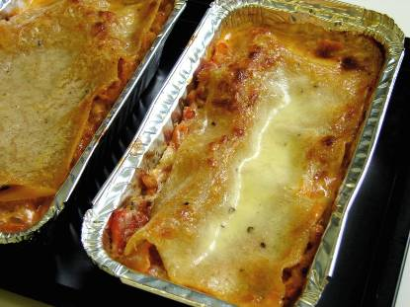
Ingredients
I onion
1 clove garlic
1 carrot
1 x 15ml oil
250g lean minced beef
400g canned chopped tomatoes
1 x 15ml spoon tomato puree
100ml water
1 x 5ml spoon mixed herbs
Black pepper
6 lasagne sheets (oven cook)
25g butter/soft spread
25g plain flour
300ml semi-skimmed milk
50g Cheddar cheese

Equipment
Chopping board, vegetable knife, garlic press, vegetable peeler, large frying pan, mixing spoon, can opener, measuring jug, small saucepan, grater, ovenproof dish.

Method
1. Preheat the oven to 190°C or gas mark 5.
2. Prepare the vegetables:
- peel and chop the onion;
- peel and crush the garlic;
- peel and slice the carrot.
3. Fry the onion, garlic and carrot in the oil.
4. Add the meat and cook until the mince is lightly browned.
5. Add the tomatoes, tomato puree, mixed herbs and water and mix all the ingredients together. Then add a few twists of black pepper.
6. Bring to the boil, then simmer for 20 minutes.
7. While the meat is cooking, make the sauce:
- place the butter or soft spread, flour and milk into a small saucepan;
- bring the sauce to a simmer, whisking it all the time until it has thickened;
- reduce the heat and simmer for 2 minutes;
- grate the cheese and stir in (leave a little to sprinkle on top).
8. In an ovenproof dish or foil tray, spread some meat mixture in the bottom, cover with lasagne sheets and a little cheese sauce. Repeat this, finishing with the sauce on top.
9. Sprinkle the remaining grated cheese on top and bake for 20 minutes.

Top tips
- For a vegetarian alternative, use Quorn, lentils or mixed beans instead of the minced beef.
- Minced chicken could be used instead of beef
- Why not try using lasagne sheets flavoured with spinach?
- The carrot and onion is optional
- You could add mushrooms or peppers

Food skills
Weigh and measure
Peel
Chop and slice
Crush
Fry
Boil and simmer
Whisk
Grate
Bake

