The Carbon Cycle Name:______________ Date:_______
Learning Objectives Self-assessment
- Define photosynthesis,respiration, combustion, decomposition.
- Label the carbon cycle diagram
- Describe the carbon cycle.

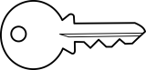
TASK 1: Draw lines to match the key word with its meaning.
KEYWORD DEFINITION
The process by which fuels react with oxygen to release carbon dioxide and heat energy.

Photosynthesis
RESPIRATION
Green plants do this to make glucose. It uses light energy to react carbon dioxide with water. Oxygen is released.

COMBUSTION
(BURNING)
(

A chemical reaction that releases energy. It uses up glucose and oxygen. Carbon dioxide and water are produced.

Decomposition
The scientific word for ROTTING ! Fungi, bacteria and detritus feeders (e.g.maggots) break down dead organisms. The nutrients go into the soil. Carbon dioxide is released into the air.

TASK 2: Write word equations for the following:
RESPIRATION: ………………………………………………………………………………………………………………….
PHOTOSYNTHESIS:………………………………………………………………………………………………………….
COMBUSTION:……………………………………………………………………………………………………………………
Extension: Can you write the balanced symbol equations for the reactions above?
TASK 3: Add labels to complete the Carbon Cycle Diagram
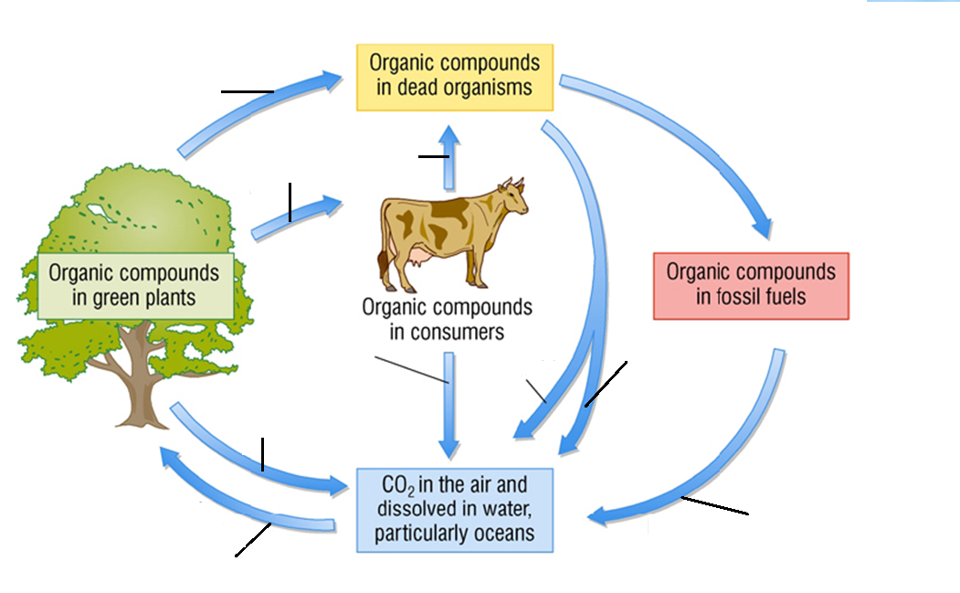

Use these labels:
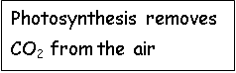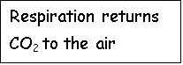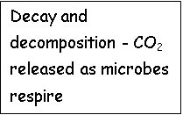
Photosynthesis removes CO₂ from the air
Photosynthesis removes CO₂ from the air
TASK 4: WRITE A PARAGRAPH TO DESCRIBE THE CARBON CYCLE.
The constant cycling of carbon in nature is called ‘The carbon ​cycle'. Each Autumn ,trees lose their leaves .Describe how the ​carbon in the leaves is recycled so that the trees can use it ​again.(6 marks)
Tips: Make use of the key words and definitions overleaf.
…………………………………………………………………………………………………………………………………………………………………………
…………………………………………………………………………………………………………………………………………………………………………
………………………………………………………………………………………………………………………………………………………………………
………………………………………………………………………………………………………………………………………………………………………………………………………………………………………………………………………………………………………………………………..Mark /6

