Velocity Time Graphs
The following table represents the movement of a car:-
Velocity (m/s) | 0 | 5 | 10 | 15 | 15 | 15 | 12 | 9 | 6 | 3 | 0
Time (seconds) | 0 | 1 | 2 | 3 | 4 | 5 | 6 | 7 | 8 | 9 | 10
Draw a Velocity time graph (with time on the x-axis)
Answer the questions below:
- What is the acceleration of the car between 0 and 3 seconds?
[Remember acceleration is equal to the change in velocity ÷ time]
- Between 3 and 5 seconds the car is still accelerating – true or false? Explain your answer.
- How would you describe the movement of the car between 5 and 10 seconds?
- What distance does the car travel in the first 3 seconds?
- What distance does the car travel in the total journey?
More difficult
A racing car (at rest) accelerates uniformly from the starting grid on the race track and reaches a top velocity of 30 meters/second/second after 5 seconds. For the next 4 seconds the acceleration is 0 and finally the car decelerates (brakes) at 4meters/second/second for 5 seconds.
Draw a Velocity time graph (with time on the x-axis). If you are stuck, try marking what the velocity would be after each second!
Answer the questions below:
- What distance does the car travel in the first 5 seconds?
- What is the velocity of the car after 7 seconds?
- What is the velocity of the car after 14 seconds?
- If the car carried on decelerating at 4m/s², how many more seconds would it take before it came to a stop?
- What is the acceleration in the first 5 seconds?

Answers!! Velocity Time Graphs

Velocity (m/s) | 0 | 5 | 10 | 15 | 15 | 15 | 12 | 9 | 6 | 3 | 0
Time (seconds) | 0 | 1 | 2 | 3 | 4 | 5 | 6 | 7 | 8 | 9 | 10

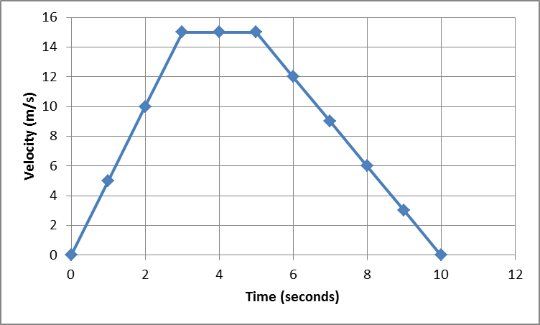
- What is the acceleration of the car between 0 and 3 seconds?
[Remember acceleration is equal to the change in velocity ÷ time]
Acceleration = 15 ÷ 3 = 5 m/s²
- Between 3 and 5 seconds the car is still accelerating – true or false? Explain your answer. False – constant speed of 15m/s
- How would you describe the movement of the car between 5 and 10 seconds?
Constant deceleration (of 3m/s²)
- What distance does the car travel in the first 3 seconds?
Area of triangle = (bxh)÷2 = 3 x 15 ÷ 2 = 45÷2 = 22.5m
- What distance does the car travel in the total journey?
Area of first triangle = 22.5m
Area of rectangle = 2x15 = 30m
Area of second triangle = 15x5÷2 = 37.5m Total=90m

Answers!! More difficult
A racing car (at rest) accelerates uniformly from the starting grid on the race track and reaches a top velocity of 30 meters/second/second after 5 seconds. For the next 4 seconds the acceleration is 0 and finally the car decelerates (brakes) at 4meters/second/second for 5 seconds.
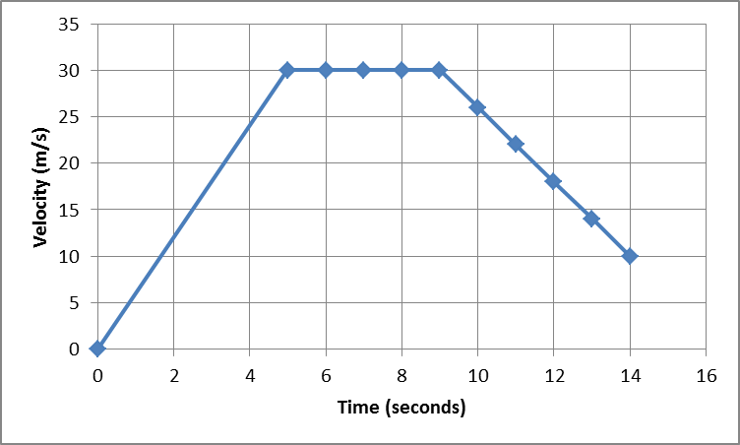
- What distance does the car travel in the first 5 seconds?
Area of triangle = 5x30÷2 = 75m
- What is the velocity of the car after 7 seconds? 30m/s
- What is the velocity of the car after 14 seconds? 10m/s
- If the car carried on decelerating at 4m/s², how many more seconds would it take before it came to a stop? 2.5 seconds
(decreasing at a pace of 4m/s², after 1 more second the speed would be 6m/s, after 2 more it would be 2m/s etc)
- What is the acceleration in the first 5 seconds?
Gradient = change in velocity÷time = 30÷5 = 6m/s²

