Q1.
A student wanted to determine the density of a small piece of rock.
(a) Describe how the student could measure the volume of the piece of rock.
___________________________________________________________________
___________________________________________________________________
___________________________________________________________________
___________________________________________________________________
___________________________________________________________________
___________________________________________________________________
___________________________________________________________________
___________________________________________________________________
___________________________________________________________________
___________________________________________________________________
(4)
(b) The volume of the piece of rock was 18.0 cm³.
The student measured the mass of the piece of rock as 48.6 g.
Calculate the density of the rock in g/cm³.
Use the equation:
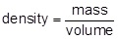
___________________________________________________________________
___________________________________________________________________
___________________________________________________________________
___________________________________________________________________
Density = _______________________ g/cm³
(2)
The graph below shows the densities of different types of rock.
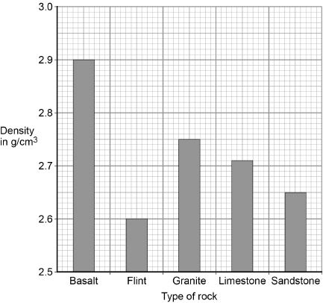
(c) What is the most likely type of rock that the student had?
Tick one box.

Basalt
Flint
Granite
Limestone
Sandstone
(1)
(d) Give one source of error that may have occurred when the student measured the volume of the rock.
___________________________________________________________________
___________________________________________________________________
(1)
(e) How would the error you described in part (d) affect the measured volume of the rock?
___________________________________________________________________
___________________________________________________________________
(1)
(Total 9 marks)
Q2.
The figure below shows a balloon filled with helium gas.
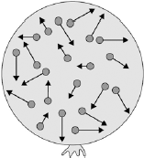
(a) Describe the movement of the particles of helium gas inside the balloon.
___________________________________________________________________
___________________________________________________________________
___________________________________________________________________
___________________________________________________________________
(2)
(b) What name is given to the total kinetic energy and potential energy of all the particles of helium gas in the balloon?

Tick one box.
External energy
Internal energy
Movement energy
(1)
(c) Write down the equation which links density, mass and volume.
___________________________________________________________________
(1)
(d) The helium in the balloon has a mass of 0.00254 kg.
The balloon has a volume of 0.0141 m³.
Calculate the density of helium. Choose the correct unit from the box.

m³ / kg kg / m³ kg m³
___________________________________________________________________
___________________________________________________________________
___________________________________________________________________
___________________________________________________________________
Density = __________________ Unit _________
(3)
(Total 7 marks)
Q3.
Solid, liquid and gas are three different states of matter.
(a) Describe the difference between the solid and gas states, in terms of the arrangement and movement of their particles.
___________________________________________________________________
___________________________________________________________________
___________________________________________________________________
___________________________________________________________________
___________________________________________________________________
___________________________________________________________________
___________________________________________________________________
___________________________________________________________________
___________________________________________________________________
___________________________________________________________________
___________________________________________________________________
(4)
(b) What is meant by ‘specific latent heat of vaporisation’?
___________________________________________________________________
___________________________________________________________________
___________________________________________________________________
___________________________________________________________________
(2)
(c) While a kettle boils, 0.018 kg of water changes to steam.
Calculate the amount of energy required for this change.
Specific latent heat of vaporisation of water = 2.3 × 10⁶ J / kg.
___________________________________________________________________
___________________________________________________________________
___________________________________________________________________
Energy required = __________________ J
(2)
(d) The graph shows how temperature varies with time for a substance as it is heated.
The graph is not drawn to scale.
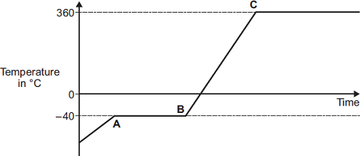
Explain what is happening to the substance in sections AB and BC of the graph.
Section AB _________________________________________________________
___________________________________________________________________
___________________________________________________________________
___________________________________________________________________
___________________________________________________________________
Section BC _________________________________________________________
___________________________________________________________________
___________________________________________________________________
___________________________________________________________________
___________________________________________________________________
(4)
(Total 12 marks)
Q4.
A student investigated how the pressure exerted by a gas varied with the volume of the gas.
Figure 1 shows the equipment the student used.
Figure 1
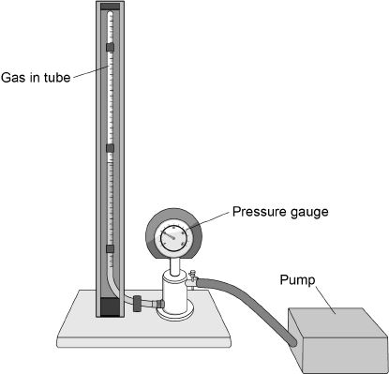
A pump was used to compress the gas in a tube. As the volume of the gas decreases, the pressure of the gas increases.
(a) The student only recorded one set of results.
Give two reasons why taking repeat readings could provide more accurate data.
1. _________________________________________________________________
___________________________________________________________________
2. _________________________________________________________________
___________________________________________________________________
(2)
(b) Figure 2 shows the position of the student’s eye when taking volume measurements.
Figure 2
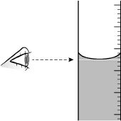
Explain what type of error would be caused if the student’s eye was not in line with the level of the liquid in the tube.
___________________________________________________________________
___________________________________________________________________
___________________________________________________________________
___________________________________________________________________
(2)
(c) If the gas is compressed too quickly the temperature of the gas increases.
Explain how the temperature increase would affect the pressure exerted by the gas.
___________________________________________________________________
___________________________________________________________________
___________________________________________________________________
___________________________________________________________________
(2)
(d) One of the student’s results is given below.
pressure = 1.6 × 10⁵ Pa
volume = 9.0 cm³
Calculate the volume of the gas when the pressure was 1.8 × 10⁵ Pa.
The temperature of the gas was constant.
___________________________________________________________________
___________________________________________________________________
___________________________________________________________________
___________________________________________________________________
Volume = _____________________ cm³
(3)
(e) Figure 3 shows a person using a bicycle pump to inflate a tyre.
Figure 3
The internal energy of the air increases as the tyre is inflated.
Explain why.
___________________________________________________________________
___________________________________________________________________
___________________________________________________________________
___________________________________________________________________
(2)
(Total 11 marks)

Mark schemes
Q1.
(a) Level 2: The method would lead to the production of a valid outcome. Key steps are identified and logically sequenced.
3−4
Level 1: The method would not necessarily lead to a valid outcome. Some relevant steps are identified, but links are not made clear.
1−2
No relevant content
0
Indicative content
• part fill a measuring cylinder with water
• measure initial volume
• place object in water
• measure final volume
• volume of object = final volume − initial volume
• fill a displacement / eureka can with water
• water level with spout
• place object in water
• collect displaced water
• measuring cylinder used to determine volume of displaced water
(b) 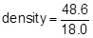
1
density = 2.70 (g/cm³)
1
an answer of 2.70 (g/cm³) scores 2 marks
(c) limestone
1
(d) eye position when using measuring cylinder
or
water level in can (at start) not at level of spout
or
not all water displaced by stone is collected in container
1
(e) volume would be lower / higher
1
[9]
Q2.
(a) range of speeds
1
moving in different directions
accept random motion
1
(b) internal energy
1
(c) density = mass / volume
1
(d) 0.00254 / 0.0141
1
0.18
1
accept 0.18 with no working shown for the 2 calculation marks
kg / m³
1
[7]
Q3.
(a) solid
particles vibrate about fixed positions
1
closely packed
accept regular
1
gas
particles move randomly
accept particles move faster
accept freely for randomly
1
far apart
1
(b) amount of energy required to change the state of a substance from liquid to gas (vapour)
1
unit mass / 1 kg
dependent on first marking point
1
(c) 41000 or 4.1 × 10⁴ (J)
accept
41400 or 4.14 × 10⁴
correct substitution of
0.018 × 2.3 × 10⁶ gains 1 mark
2
(d) AB
changing state from solid to liquid / melting
1
at steady temperature
dependent on first AB mark
1
BC
temperature of liquid rises
1
until it reaches boiling point
dependent on first BC mark
1
[12]
Q4.
(a) any two from:
• calculate a mean
• reduces the effect of random errors
reduces human error is insufficient
• identify / remove anomalies
allow to assess the repeatability of the data
2
(b) random error
allow a parallax error
human error is insufficient
1
(because) eye position would not be the same each time (relative to the liquid)
allow systematic error only if it is clear that the student always viewed liquid level from above meniscus (or below)
1
(c) (a temperature increase would) increase the pressure in the tube
(even if the volume was constant)
1
(because a higher temperature would mean) higher (average) kinetic energy of molecules / particles
allow higher (average) speed for higher (average) kinetic energy
1
(d) 1.6 × 10⁵ × 9.0 (= 1.44 × 10⁶)
1
1.44 × 10⁶ = 1.8 × 10⁵ × V
allow for 2 marks
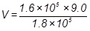
1
or
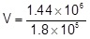
V = 8.0 (cm³)
1
an answer of 8.0 (cm³) scores 3 marks
(e) work is done on the air (in the tyre)
1
so the temperature (of the air) increases
allow the (average) kinetic energy of the particles increases
1
[11]

