How do we evaluate?
TASK
1.Where would you rather spend your time and why?

2.Would you rather text someone or call them and why?

3.What pet would you like to own and why?

All of these things are evaluating.
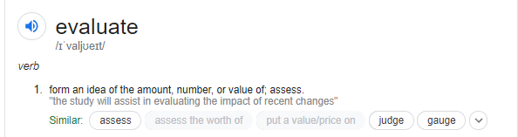
You evaluate every day of your life. You make a judgement based on the facts in front of you and make decisions.

TASK
Think back to what kind of relationship Mr and Mrs Foster have.
Do you think Mrs Foster should go to prison?
Do you understand why she let her husband die?
Challenge: Do you sympathise with Mrs Foster?

TASK
A student having read this short story said ‘the woman was justified in killing her husband’. To what extent do you agree?

- Choose a number on the line.
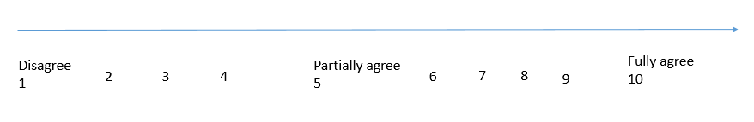
- Explain why you think this. Use the sentence starters below.
QUOTATION MARKS ROUND THE QUOTATION

I fully agree/ partially agree/ disagree with the statement that ‘the woman was justified in killing her husband’
For example ‘…………………………..’
This suggests that…….
The use of the word/noun/verb/adjective/method …suggests that..
This makes the reader feels…

