Dessinez un cadenas pour
le Pont des Arts
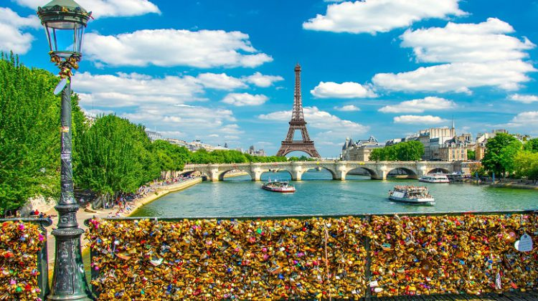

The Pont des Arts connects the Institut de France with The Louvre. The bridge was originally constructed in 1804 during the reign of Napoleon. The original Pont des Arts suffered two aerial bombardments during World War I and II, as well as numerous collisions with boats before collapsing in 1979 after a ship rammed into it.
The present-day bridge was built in 1984 and is now a UNESCO World Heritage Site along with the rest of the Seine Riverfront in Paris. The Pont des Arts is a popular spot for picnics and open-air art studios. The bridge’s position along the Seine River and The Louvre makes it a popular spot for photographers as well.
The Pont des Arts is most famous for being the Lock Bridge in Paris. Visitors to the bridge attach personalized padlocks to its railing and throw the keys away in the Seine River. Despite the government of Paris removing many of the locks in 2015, over a million more (approximately 45 tons) have been placed on the bridge since then.
