Measuring specific heat capacity

Setting the scene
Objects of the same mass but made of different substances need different amounts of energy to raise their temperature by the same amount.
Each substance has its own specific heat capacity, which tells us how much energy is needed to raise the temperature of 1 kg of that substance by 1°C.
The equation for calculating specific heat capacity from energy and temperature measurements is:
Method
- Check the mass of the aluminium block (it may be written on the block, or your teacher will be able to tell you).
- Wrap the insulation securely around the block, and place it on an insulating mat.
- With the power supply switched off, set up the apparatus as shown in the diagram.
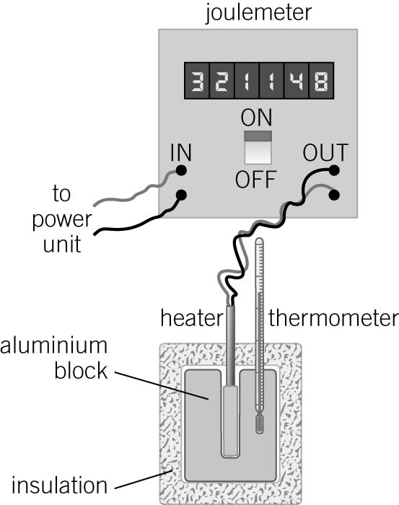
- Check with your teacher that the joulemeter is correctly connected to the heater and the power supply.
- Place the thermometer in the aluminium block and measure the temperature of the block. Record this as the ‘starting temperature’ of the block.
- Switch the joulemeter on and record the ‘starting’ reading of the joulemeter.
- Switch the power supply on.
- Watch the reading on the thermometer, and when it reaches about 15°C above the starting temperature, switch off the power supply.
- Record the joulemeter reading and the thermometer reading.
- The thermometer reading might continue to increase for up to a few minutes after the heater has been switched off. Measure and record the highest reading of the thermometer after the heater was switched off.
Questions
- Complete the following paragraph by choosing the correct word or phrase from the underlined options.
While the heater is switched on, energy is transferred from the heater to the block by heating. The temperature of the block increases. The amount of energy transferred is measured using the joulemeter. The temperature change of the block is measured using the thermometer . (6 marks)

Student follow-up
Different materials have different heat capacities. The heat capacities of three materials are given in the table below. You will need to use these in some of the questions below.
Substance | Water | Aluminium | Iron | Lead
Specific heat capacity in J / kg °C | 4200 | 900 | 390 | 130
- Aluminium’s specific heat capacity shows that 900 J of energy are needed to raise the temperature of 1 kg of aluminium by 1 °C.
a Compared with aluminium, is water harder or easier to heat up? Explain your answer. (HINT – Which one needs the most energy to increase the temperature by 1°C) (2 marks)
Water is harder as it takes more energy to raise the temeprature of 1Kg by 1°C
b Compared with aluminium, is lead harder or easier to heat up? Explain your answer. (2 marks)
Lead is easier than Aluminium as it takes less energy to raise the temperature of 1Kg by 1°C
- In each of the pairs below, both blocks are going to be heated so that they change their temperatures as shown.
For each pair, circle which block needs more energy to heat it.
a block A (because it has more mass) or block B (1 mark)
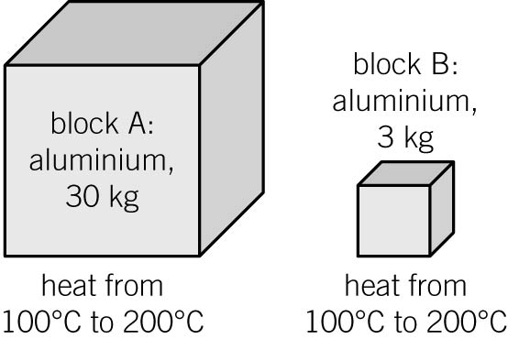 b block A or block B (As you are heating it by a 100°C more than block A) (1 mark)
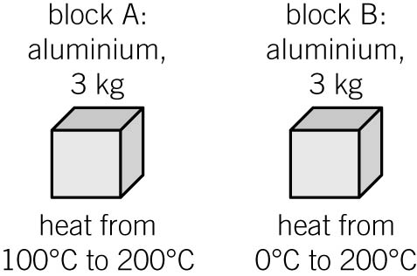
c block A or block B (1 mark)
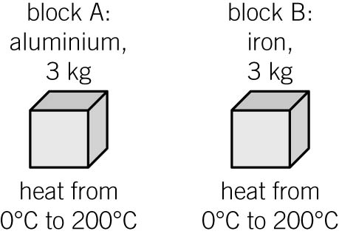
- In this question, calculate energies using the equation:
energy (J) = mass (kg) × specific heat capacity (J/kg °C) × temperature change (°C).
a Calculate how much energy is needed to raise the temperature of 1 kg of water by 5 °C.
1 X 4200 X 5 = 21,000 J
(3 marks)

b Calculate how much energy is needed to raise the temperature of 1 kg of lead by 5 °C.
1 X 130 X 5 = 650J
(2 marks)

