Factorising – Single bracket and Quadratic – ANSWERS ARE AT THE END OF THE VIDEO
SET1
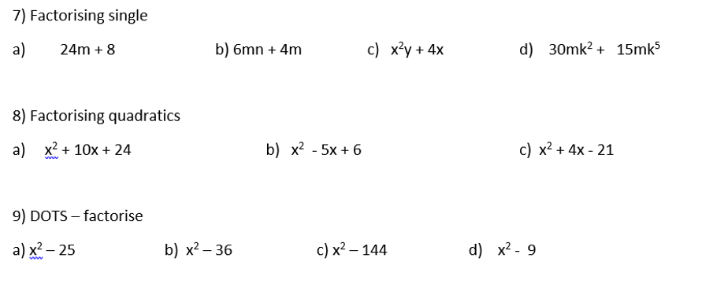
SET 2
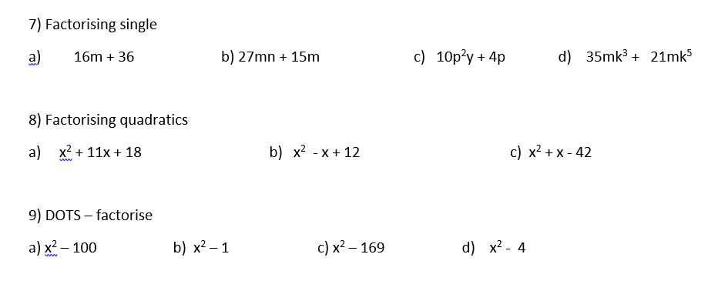
Extra Quadratic Practice
