Y10 Music Industry
Do Now:
- A B C D 3. A B C D
- A B C D

Starter:

What is wrong?
GRIT

What is wrong?
GRIT

Discuss the IMPLICATIONS questions
IMPLICATION: ‘The conclusion that can be drawn from something’

You must DRAW CONCLUSIONS from the statement/question that is given.
= What would happen if? :
Your exam will contain two 8-mark questions based on this format,
each will be based on a scenario.

- Define: important words briefly
- Pros: beneficial (good) conclusions
- Cons: disadvantageous (bad) conclusions
- Your Conclusion: ‘Therefore’
= your balanced opinion
IMPLICATIONS Framework

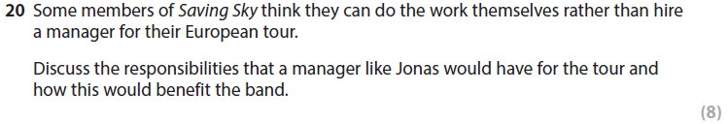
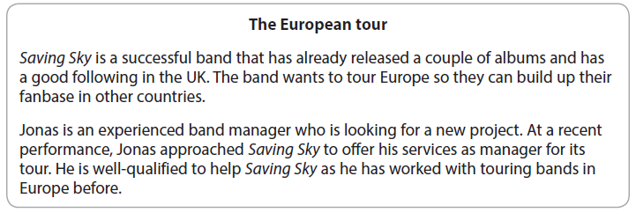
GRIT

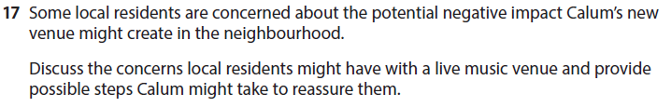
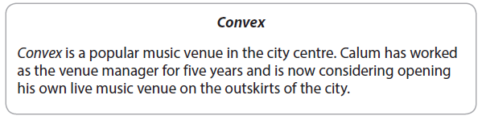
GRIT

