Year 7 French – la méteo (the weather)
- Can you translate these sentences in to English?

Bonjour! Je m’appelle Madame Champion.
J’ai 28 ans.
Mon anniversaire c’est le 15 décembre.
Dans mon sac il y a un crayon, un stylo noir et une gomme.
J’aime le foot et le tennis car c’est très super.

- Fill in the gaps with the correct letters. Can you translate them in to English as well?
lu_di
mard_
me_cre_i
_eudi
ve_dre_i
_amedi
di_anc_e
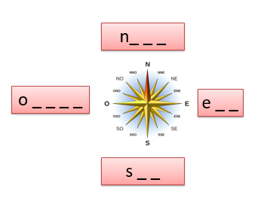

- Match up the weather symbols with the correct phrase by writing the number next to the phrase.
- Il fait chaud
- Il fait froid
- Il y a du soleil
- Il y a du vent
- Il y a du brouillard
- Il y a des nuages
- Il y a de l’orage
- Il pleut
- Il neige
- Il gèle
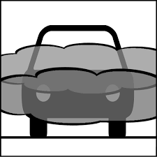
10
9
8
7
6
5
4
3
2
1
- Listen. What is the weather like? Write in the correct letter.
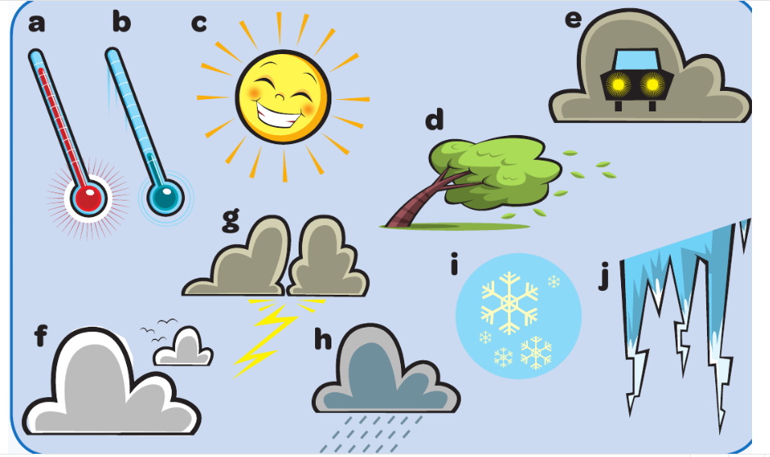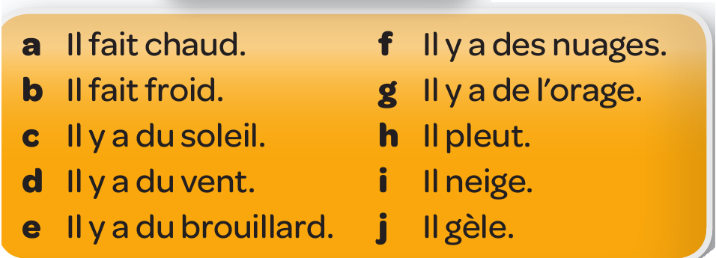
1. 6.
2. 7.
3. 8.
4. 9.
5. 10.

- Create your own weather forecast for France. You need to draw the symbols and label them with the correct French. Use the vocabulary provided to help you.
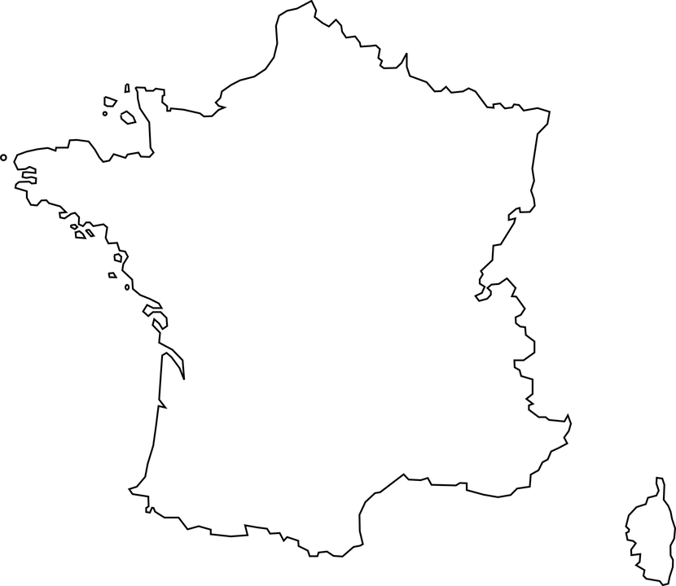

Où?
in the north dans le nord
in the east dans l’est
in the south dans le sud
in the west dans l’ouest
of France de la France
Le climat
It’s hot il fait chaud
It’s cold il fait froid
It’s sunny il y a du soleil
It’s windy il y a du vent
It’s foggy il y a du brouillard
It’s cloudy il y a des nuages
It’s stormy il y a de l’orage
It’s raining il pleut
It’s snowing il neige
It’s icy il gèle

