Ratio Name________________________
Section A
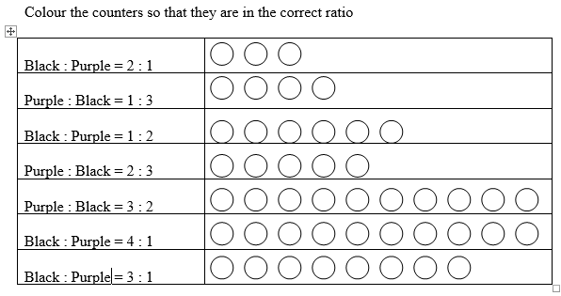
Section B Sharing a ratio
1) Dawn and Jane share 9 sweets in the ratio 1:2. Draw how many each gets in the boxes:
Dawn Jane

Total for Dawn:_______

Total for Jane: _______

2) Eric and Mark share 21 sweets in the ratio 3:4. Draw how many each gets in the boxes:
Eric Mark
Total for Eric:_______

Total for Mark: _______

3) Jenny and Sharon share 14 toffees in the ratio 2:5. Draw how many each gets in the boxes:
Jenny Sharon
Total for Jenny:_______

Total for Sharon: _______

4) Mike and Neil share 16 mints in the ratio 1:3. Draw how many each gets in the boxes:
Mike Neil
Total for Mike:_______

Total for Neil: _______

5) Katy and Mel share 22 chocolates in the ratio 3:8. Draw how many each gets in the boxes:
Jenny Sharon
Total for Jenny:_______

Total for Sharon: _______

6) Jim, Donna and Tim share 14 sweets in the ratio 1:2:4. Draw how many each gets in the boxes:
Jim Donna Tim
Total for Jim:_______
Total for Donna: _______
Total for Tim: _______

Section C Sharing an amount
- Share £12 in the ratio of 1:3
- Share £30 in the ratio of 4:6
- Share £25 in the ratio of 4:1
- Share £16 in the ratio of 5:3
- Share £33 in the ratio of 7:4
Extra Practice – Do working out below.
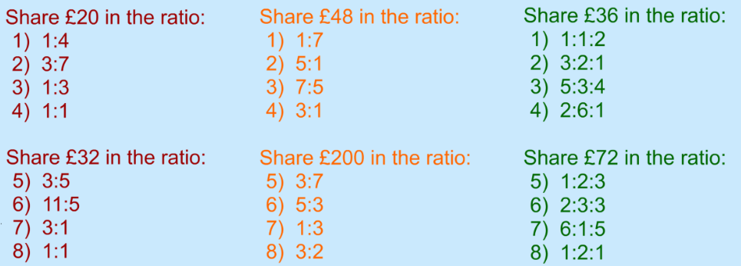
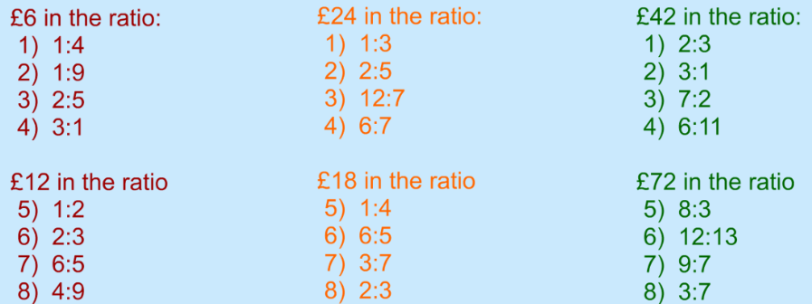
Section D Worded Questions
1. Share £48 between Alan and Barbara in the ratio 2:1
2. Share £60 between Laura and Robert in the ratio 1:3
3. Share 80 marbles between Stuart and Carl in the ratio 4:1
4. Share 91 sweets between Peter and Becky in the ratio 4:3
5. Share 70 coloured beads between Janet and Christine in the ratio 3:2
6. Share £120 between Carly and Paul in the ratio 3:5
7. Share 350ml of milk between a cat and her kitten in the ratio 4 : 3.
8. Share 1.2 litres of milk between a dog and a cat in the ratio 7:5
9. Share 240g of sweets between Alison and Stephen in the ratio 3:5
10. Share 120g of cereal between Stuart and Julie in the ratio 3:7
11. Paul is 12 and Gemma is 15. They share a £5400 inheritance from their aunty in the ratio of their ages. How much do they each receive?
12. John scored 15 points and Fiona scored 17 points in a TV quiz show. They shared the prize money of £2720 in the ratio of points scored. How much did they each receive?
13. Alan Becky and Charlie share 72 sweets in the ratio 2:3:4. How many sweets do they each receive?
14. Paula Robert and Karl share £240 in the ratio 4:5:3. How much money do they each receive?
15. A piece of wood 2.8m long is cut into 3 pieces in the ratio 4:3:7. Find the length of each piece.

Challenge a
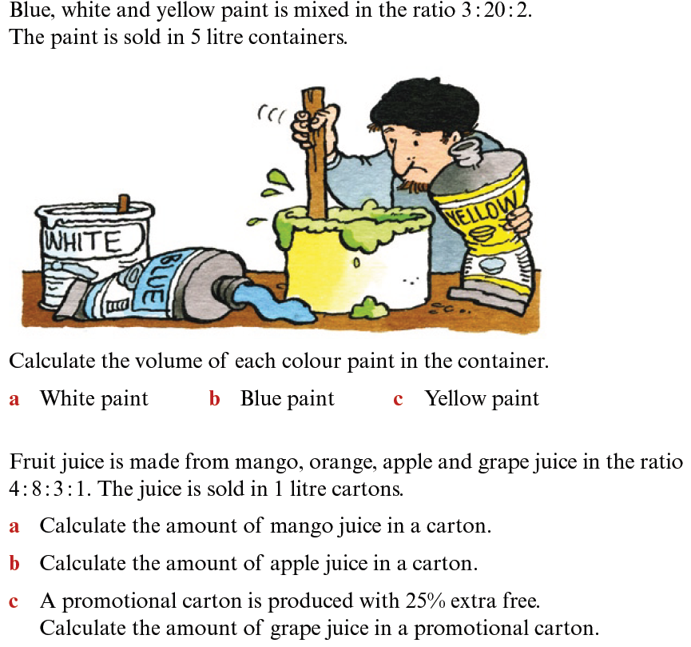
Challenge b
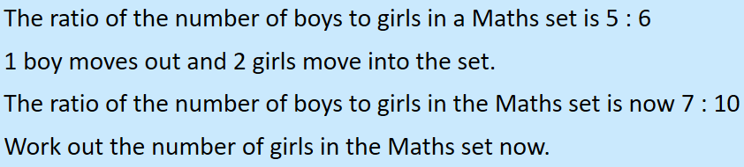
Challenge c
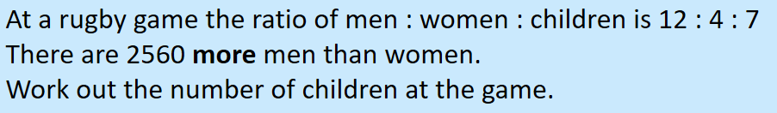
Challenge d
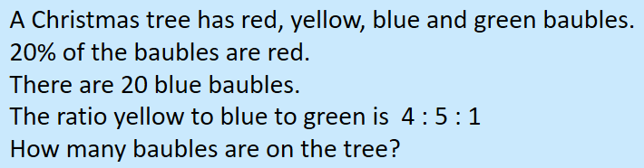
Challenge e
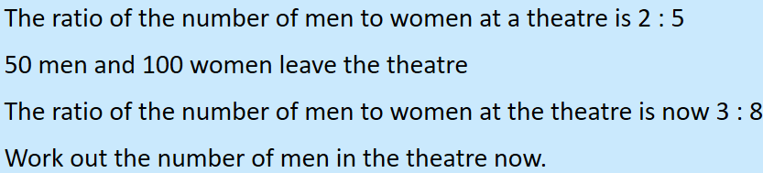
Challenge f
