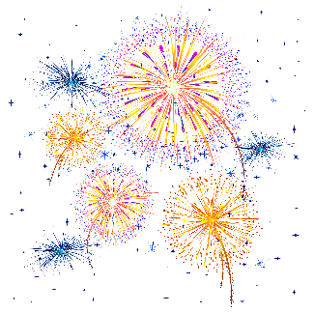
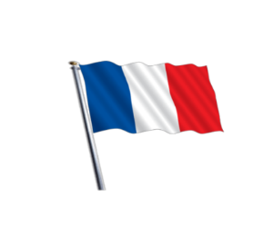
Les fêtes françaises
A Les mois ( the months)
- ____ ________________________________
- ____ ________________________________
- ____ ________________________________
- ____ ________________________________
- ____ ________________________________
- ____ ________________________________
- ____ ________________________________
- ____ ________________________________
- ____ ________________________________
- ____ ________________________________
- ____ ________________________________
- ____ ________________________________
B Les mots clés (key words)
- le jour ________________________________________
- la fête ________________________________________
- la liberté ________________________________________
- La Bastille ________________________________________
- aujourd’hui ________________________________________
- un jour férié ________________________________________
- Les Champs-Elysées _________________________________
- partout ________________________________________
- les feux d’artifice____________________________________
C What date is ‘le quatorze juillet’ ? ________________________________
D Put the pictures in the correct order
1 2 3 4

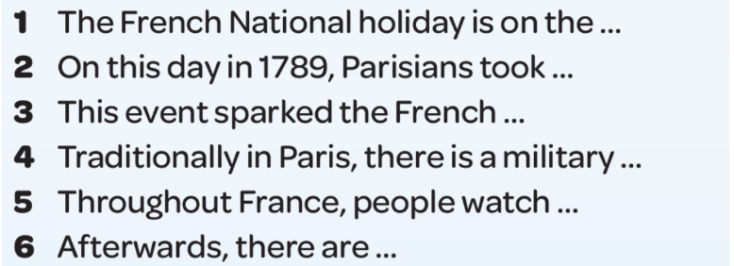
E Can you complete these sentences in English ?

F Write down the 4 important dates that are on the slide.
- _____________________________________________
- _____________________________________________
- _____________________________________________
- _____________________________________________

G What does ‘c’est’ mean? _____________________________________
What does ‘ce n’est pas’ mean? _______________________________

H Fill in the missing words. Use the slide.
Le ___________c’est la Fête des Rois.
_________ un jour férié.
Traditionnellement, il y a _____________.
On _________________.

I Now write similar pargraphs about the 3 other festivals on the slide.
________________________________________________________________________________________________________________________________________________________________________________________________________________________________________________________________________________________________________________________________________
_______________________________________________________________________________________________________________________________________________________________________________________________________________________________________________________________________________________________________________________________________
_________________________________________________________________________________
___________________________________________________________________________________________________________________________________________________________________________________________________________________________________________________________________________________________________________________________________________________________________________________________________________________________________________________________________________________________________________
Ton défi Challenge task Can you now write about your birthday and Christmas using the same format? Add intensifiers and opinions too.
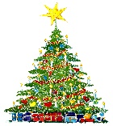
________________________________________________________________________________________________________________________________________________________________________________________________________________________________________________________________________________________________________________________________________________________________________________________________________________________________________________________________________________________________________________________________________________________________________________________________________________________________________________________________________________
____________________________________________________________________________________________________________________________________________________________________________________________________________________________________________________________________________________________________________________________________________________________________________________________________________________________________________________________________________________________________________
__________________________________________________________________________________ ____________________________________________________________________________________________________________________FInalement__________________________________________________________________________________________________________________
________________________________________________________________________________________________________________________________________________________________________________________________________________________________________________________________________________________________________________________________________
________________________________________________________________________________________________________________________________________________________________________________________________________________________________________________________________________________________________________________________________________
________________________________________________________________________________________________________________________________________________________________________________________________________________________________________________________________________________________________________________________________________________________________________________________________________________________________________________________________________________________________________________________________________________________________________________________________________________________________________________________________________________

