Stem and Leaf diagrams
- Draw out the stem and leaf diagram for each set of numbers below.
- Find the averages
Notes on averages
- mode is the most common number (the one that appears the most)
- median is the middle number (or the middle of the middle two numbers) when all of the numbers are in order
- mean – add all the numbers together, find the total, divide by the amount of numbers you added
- range is the highest take away the lowest

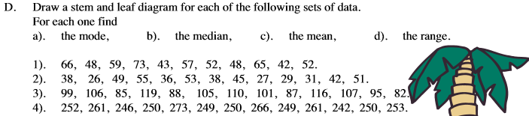

Answers to check
