It will help if you draw these out on paper
eg for 1a) probability that both catch multiply 0.9 x 0.7 = 0.63
USE A CALCULATOR/PHONE CALCULATOR
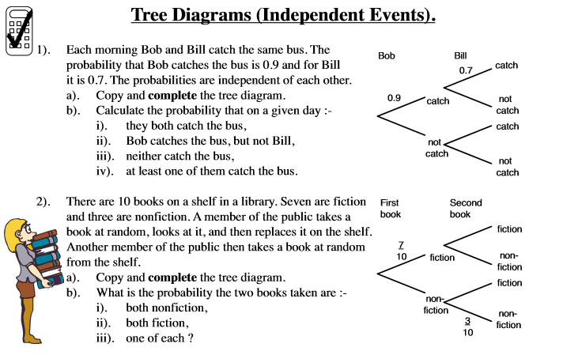
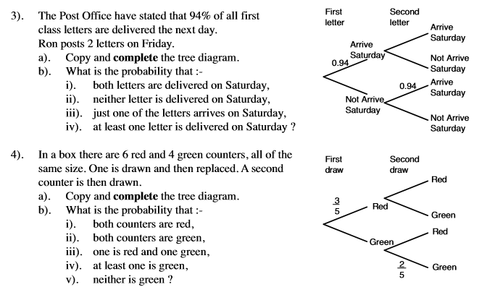

ANSWERS
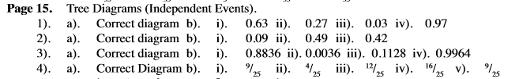

Answers

