Q1.
(a) A resistor is a component that is used in an electric circuit.
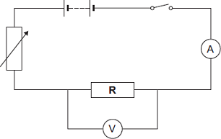
(i) Describe how a student would use the circuit to take the readings necessary to determine the resistance of resistor R.
______________________________________________________________
______________________________________________________________
______________________________________________________________
______________________________________________________________
______________________________________________________________
______________________________________________________________
______________________________________________________________
______________________________________________________________
______________________________________________________________
______________________________________________________________
______________________________________________________________
______________________________________________________________
______________________________________________________________
______________________________________________________________
(6)
(ii) Explain why the student should open the switch after each reading.
______________________________________________________________
______________________________________________________________
______________________________________________________________
______________________________________________________________
(2)
(iii) In an experiment using this circuit, an ammeter reading was 0.75 A.
The calculated value of the resistance of resistor R was 16 Ω.
What is the voltmeter reading?
______________________________________________________________
______________________________________________________________
Voltmeter reading = ________________ V
(2)
(iv) The student told his teacher that the resistance of resistor R was 16 Ω.
The teacher explained that the resistors used could only have one of the following values of resistance.

10 Ω | 12 Ω | 15 Ω | 18 Ω | 22 Ω
Suggest which of these resistors the student had used in his experiment.
Give a reason for your answer.
______________________________________________________________
______________________________________________________________
______________________________________________________________
______________________________________________________________
(2)
(b) The diagram shows a fuse.
Describe the action of the fuse in a circuit.
___________________________________________________________________
___________________________________________________________________
___________________________________________________________________
___________________________________________________________________
___________________________________________________________________
___________________________________________________________________
___________________________________________________________________
___________________________________________________________________
(3)
(Total 15 marks)
Q2.
Most electric kettles use the ac mains electricity supply.
(a) Complete the sentence.
The ac mains supply has a potential difference that continuously
____________________ polarity
(1)
Figure 1 gives the power output of three electric kettles.
Figure 1
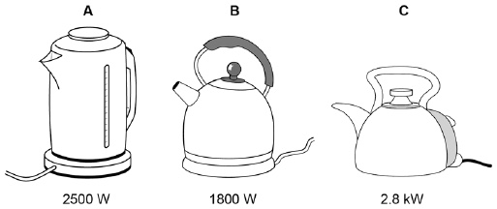
A student investigated how the power output of a kettle affected the time taken to boil a fixed volume of water.
The water in all three kettles had an initial temperature of 25 °C.
(b) What type of variable was the time?
Tick one box.

Control
Dependent
Independent
(1)
(c) Which kettle will boil the water in the shortest time?
Give a reason for your answer.
Kettle ______________________________________________________________
Reason ____________________________________________________________
___________________________________________________________________
___________________________________________________________________
(2)
(d) Figure 2 shows how the amount of energy transferred by a kettle varies with time.
Figure 2
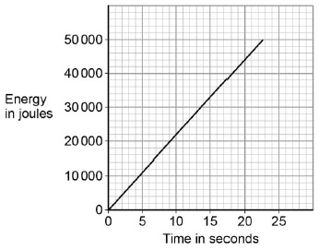
The power output of the kettle is given by the gradient of the graph.
Calculate the power output of the kettle.
___________________________________________________________________
___________________________________________________________________
Power output = ____________________ W
(2)
(e) Write down the equation that links charge flow, current and time.
___________________________________________________________________
(1)
(f) Calculate the current through the kettle when 2400 coulombs of charge flows in 250 seconds.
___________________________________________________________________
___________________________________________________________________
___________________________________________________________________
___________________________________________________________________
Current = ____________________ A
(3)
(Total 10 marks)
Q3.
(a) The diagram shows the inside of an incorrectly wired three-pin plug.
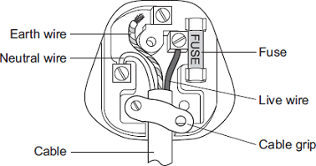
(i) What two changes need to be made so that the plug is wired correctly?
1. ____________________________________________________________
______________________________________________________________
2. ____________________________________________________________
______________________________________________________________
(2)
(ii) The fuse inside a plug is a safety device.
Explain what happens when too much current passes through a fuse.
______________________________________________________________
______________________________________________________________
______________________________________________________________
______________________________________________________________
(2)
(b) Each of these pictures shows an electrical appliance being used in a bathroom.
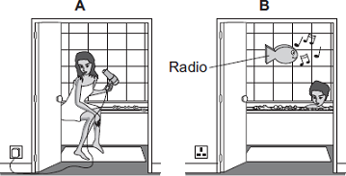
Using the hairdryer in picture A is dangerous. However, it is safe to use the battery-operated radio in picture B.
Explain why.
___________________________________________________________________
___________________________________________________________________
___________________________________________________________________
___________________________________________________________________
(2)
(Total 6 marks)
Q4.
(a) A washing machine is connected to the mains electricity supply using a cable and three-pin plug.
Figure 1 shows a three-pin plug.
Figure 1
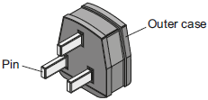
Name the materials used in the structure of a plug. Give the reason why each material is used.
Pin ________________________________________________________________
___________________________________________________________________
Outer case _________________________________________________________
___________________________________________________________________
(1)
(b) The three-pin plug contains a fuse. The fuse is connected to one of the wires inside the cable.
(i) Which one of the wires inside the cable is the fuse connected to?
______________________________________________________________
(1)
(ii) The fuse is a thin wire inside a closed glass tube. The wire acts as a resistor.
What effect does a current through a wire have on the wire?
______________________________________________________________
(1)
(iii) The power of the washing machine varies between 0.7 kW and 2 kW depending on which part of the wash cycle is operating.
Calculate the maximum current drawn from the mains electricity supply by the washing machine.
The mains electricity supply is at a potential difference of 230 V.
______________________________________________________________
______________________________________________________________
______________________________________________________________
Current = __________________________ A
(2)
(c) Figure 2 shows how the mains electricity cable is connected to the washing machine.
The earth wire is connected to the metal case of the washing machine.
Figure 2
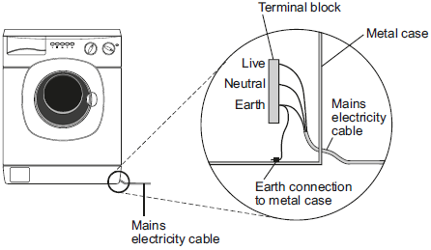
If a fault makes the metal case live, the earth wire and fuse inside the plug prevent the mains cable from overheating and causing a fire.
Explain how.
___________________________________________________________________
___________________________________________________________________
___________________________________________________________________
___________________________________________________________________
(2)
(d) New research has shown that many people underestimate the hazards of using mains electricity.
It is important that people do understand the hazards of using mains electricity.
Suggest why.
___________________________________________________________________
___________________________________________________________________
___________________________________________________________________
(1)
(Total 9 marks)
Q5.
A student finds some information about energy-saving light bulbs.
(a) A 30W light bulb uses 600J of electrical energy in a certain period of time. In that time, it produces 450 J of light energy. The rest of the energy is wasted.
(i) Calculate the energy wasted by the light bulb in this period of time.
______________________________________________________________
Wasted energy = _________________ J
(1)
(ii) What happens to the energy wasted by the light bulb?
______________________________________________________________
______________________________________________________________
(1)
(iii) Calculate the efficiency of this light bulb.
______________________________________________________________
______________________________________________________________
Efficiency = ______________________________
(2)
(iv) Calculate the period of time, in seconds, during which the 600 J is provided to the 30 W light bulb.
______________________________________________________________
______________________________________________________________
Time = _____________ s
(2)
(b) A company that makes light bulbs provides information about some of their products.
The table shows some of this information.

 | Power in watts | Lifetime in hours | Cost of bulb in £
Filament bulb | 60 | 1250 | 2.00
LED bulb | 12 | 50 000 | 16.00

(i) Suggest why it is important to confirm this information independently.
______________________________________________________________
(1)
(ii) A homeowner is thinking about replacing his filament bulbs with LED bulbs.
A 12 W LED bulb gives the same light output as a 60 W filament bulb.
Suggest reasons why the homeowner is likely to choose LED bulbs.
Use the information given in the table.
______________________________________________________________
______________________________________________________________
______________________________________________________________
______________________________________________________________
(2)
(iii) State one factor, other than efficiency, that is important when considering the choice of a bulb for lighting in the home.
______________________________________________________________
______________________________________________________________
(1)
(Total 10 marks)
Q6.
(a) Describe the difference between an alternating current (a.c.) and a direct current (d.c.).
___________________________________________________________________
___________________________________________________________________
___________________________________________________________________
___________________________________________________________________
(2)
(b) The diagram shows how the electric supply cable is connected to an electric kettle.
The earth wire is connected to the metal case of the kettle.
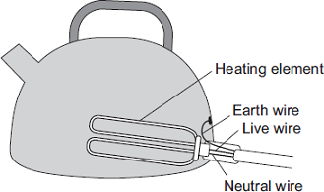
If a fault makes the metal case live, the earth wire and the fuse inside the plug protect anyone using the kettle from an electric shock.
Explain how.
___________________________________________________________________
___________________________________________________________________
___________________________________________________________________
___________________________________________________________________
(2)
(Total 4 marks)
Q7.
An electrician is replacing an old electric shower with a new one.
The inside of the old shower is shown in Figure 1.
Figure 1
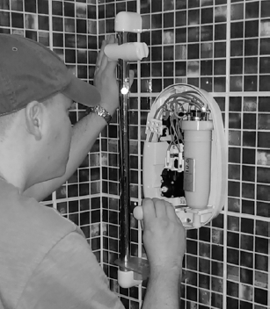
© Michael Priest
(a) If the electrician touches the live wire he will receive an electric shock.
Explain why.
___________________________________________________________________
___________________________________________________________________
___________________________________________________________________
___________________________________________________________________
___________________________________________________________________
___________________________________________________________________
___________________________________________________________________
___________________________________________________________________
(4)
(b) Different electrical wires need to have a cross-sectional area that is suitable for the power output.
Figure 2 shows the recommended maximum power input to wires of different cross-sectional areas.
Figure 2
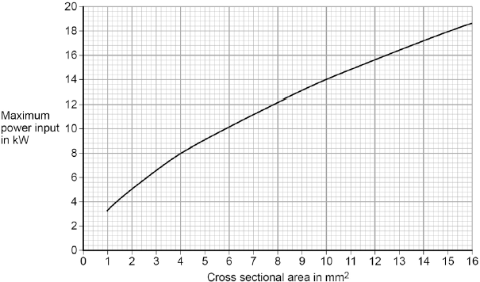
The new electric shower has a power input of 13.8 kW.
Determine the minimum diameter of wire that should be used for the new shower.
The diameter, d, can be calculated using the equation:
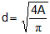
A is the cross-sectional area of the wire.
___________________________________________________________________
___________________________________________________________________
Minimum diameter = _________________________ mm
(2)
(c) The charge that flows through the new shower in 300 seconds is 18 000 C.
The new electric shower has a power of 13.8 kW.
Calculate the resistance of the heating element in the new shower.
Write down any equations you use.
___________________________________________________________________
___________________________________________________________________
___________________________________________________________________
___________________________________________________________________
___________________________________________________________________
___________________________________________________________________
___________________________________________________________________
Resistance = _______________________ Ω
(5)
(Total 11 marks)

Mark schemes
Q1.
(a) (i) any six from:
• switch on
• read both ammeter and voltmeter
allow read the meters
• adjust variable resistor to change the current
• take further readings
• draw graph
• (of) V against I
allow take mean
• R = V / I
allow take the gradient of the graph
6
(ii) resistor would get hot if current left on
1
so its resistance would increase
1
(iii) 12 (V)
0.75 × 16 gains 1 mark
2
(iv) 15 (Ω)
1
16 is nearer to that value than any other
1
(b) if current is above 5 A / value of fuse
1
fuse melts
allow blows / breaks
do not accept exploded
1
breaks circuit
1
[15]
Q2.
(a) changes
allow reverses
1
(b) dependent
1
(c) kettle C
or
2.8 kW
1
highest power (output)
allow higher power (output)
1
(d) values for gradient calculation shown on graph or on answer lines
1
power input = 2200 (W)
accept an answer that rounds to 2200 (W) for 2 marks
1
(e) charge flow = current × time
allow Q = It
1
(f) 2400 = I × 250
1
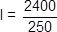
1
I = 9.6 (A)
an answer of 9.6 (A) scores 3 marks
1
[10]
Q3.
(a) (i) connect the earth wire (to pin)
answers must be in terms of correcting the faults
1
screw cable grip (across cable)
accept tighten the cable grip
1
(ii) any two from:
• fuse gets (very) hot
• fuse melts
accept blows for melts
do not accept break / snap fuse / blow up
• circuit breaks / switches off
accept stops current flowing
2
(b) any two from:
• hairdryer is plugged into mains (electricity socket)
it refers to hairdryer
hairdryer works from the mains
or
hairdryer is using 230 V
accept 240 for 230
• water conducts electricity
do not accept water and electricity don’t mix
• radio is low power / current / pd / voltage
accept radio not connected to the mains
do not accept radio is waterproof
• (the current in / pd across) hairdryer more likely to give a (fatal) electric shock
accept the idea of electrocution if hairdryer is wet
accept the idea of radio not causing electrocution if wet
2
[6]
Q4.
(a) pin
made from brass because it is (hard and) a (good electrical) conductor
accept copper for brass
metal is insufficient
heat conductor on its own negates
1
outer case
plastic/rubber because it is a (good electrical) insulator
heat insulator on its own negates
1
(b) (i) live
1
(ii) makes it hot/warm
melts is insufficient
1
(iii) 8.7
accept an answer that rounds to 8.7
allow 1 mark for correct substitution ie 2000 = 230 × I
an answer of 0.0087 or 0.009 or 3.0(4) or 5.65 or 5.7 gains 1 mark
2
(c) a (large) current goes from the live wire to the earth wire
accept metal case for live wire
accept a current goes from live to earth
do not accept electricity for current
1
(which causes) the fuse to (overheat and) melt
accept blow for melt
break is insufficient
do not accept snap / blow up for melt
1
(d) reduce chance of an electric shock
accept to reduce the risk of an accident
accept prevent electric shock
accept prevent electrocution
accept prevent or reduce the risk of an (electrical) fire
accept an electric shock can kill you
accept it can kill you
accept so you can use it safely
1
[9]
Q5.
(a) (i) 150
1
(ii) transferred to the surroundings by heating
reference to sound negates mark
1
(iii) 0.75
450 / 600 gains 1 mark
accept 75% for 2 marks
maximum of 1 mark awarded if a unit is given
2
(iv) 20 (s)
correct answer with or without working gains 2 marks
correct substitution of 600 / 30 gains 1 mark
2
(b) (i) to avoid bias
1
(ii) use less power and last longer
1
1 LED costs £16, 40 filament bulbs cost £80
or
filament costs (5 times) more in energy consumption
1
(iii) any one from:
• availability of bulbs
• colour output
• temperature of bulb surface
1
[10]
Q6.
(a) d.c. flows in (only) one direction
1
a.c. changes direction (twice every cycle)
accept a.c. constantly changing direction
ignore references to frequency
1
(b) a current flows through from the live wire / metal case to the earth wire
accept a current flows from live to earth
do not accept on its own if the current is too high
1
this current causes the fuse to melt
accept blow for melt
do not accept break / snap / blow up for melt
1
[4]
Q7.
(a) (because the) potential of the live wire is 230 V
1
(and the) potential of the electrician is 0 V
1
(so there is a) large potential difference between live wire and electrician
1
charge / current passes through his body
allow voltage for potential difference
1
(b) diameter between 3.50 and 3.55 (mm)
allow correct use of value of cross-sectional area of 9.5 to 9.9 (mm²) with no final answer given for 1 mark
2
(c) 18000 = I × 300
1
I = 18000 / 300 = 60
1
13 800 = (60²) × R
1
R = 13 800 / 60²
1
3.83 (Ω)
1
allow 3.83(Ω) with no working shown for 5 marks
answer may also be correctly calculated using P = IV and V = IR if 230 V is used.
[11]

