What is a paragraph?
- A paragraph is a group of sentences about one main idea.
Why do we use paragraphs?
- They break up long chunks of writing, making it clearer and more interesting for the reader.
- They provide a clear structure and order to our writing.
- If we do not use paragraphs the reader becomes confused about our ideas.

We use paragraphs when we change
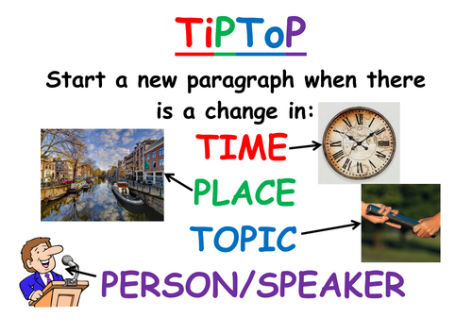
Example:

We left school at 7.30 in the morning on a big old coach to get to Paignton Zoo for 9am. Whilst we were on the coach the teachers told us to take our bags with us and gave us our instructions for the day.
Change of time and place
When we finally arrived at the Zoo we were allowed to go and see the animals straight away. The first stop was the tiger’s cage. The tigers were huge and ferocious looking, the teachers would not let us stay there for long.
Change of time

Next we went to see the snakes. The snakes were having a feed and were eating mice. The girls started screaming hysterically after watching the snakes devour the mice. Consequently the teachers decided it was time to stop for lunch!
Change of time

A few hours later we went to see the elephants having a wash. This was the highlight of my day because the elephant shook water all over us- it was very funny.
Change of time

We got back to school late, we were all tired but happy.
“This is my favourite school trip ever” said my friend Jimmy.
“Mine too” I agreed. It really had been a fantastic day.

Task: Add the paragraphs to the following:
Disneyland – the happiest place on earth! What more could you want, than all of your favourite childhood characters in one place, ready to greet you and take hilarious photographs? I’m immediately transported back to the years of my youth, feeling carefree and full of energy. Bright smiles are contagious as I cuddle Micky Mouse and pose next to Donald Duck, their warm hugs wrapping me up like a present at Christmas. It’s surreal to see the likes of Elsa from Frozen and Buzz LightYear strolling around like the world is theirs; I feel like I never have to face adult problems again. As I walk down the unnaturally clean streets, my mouth waters greedily for the sweets in vivacious shop windows. Lollies of every colour imaginable, and more flavours than you knew existed. Pastries, chocolates, and candyfloss galore, spilling over the display cabinets, which shine and glisten in the perfect spot-light sun. I lick the sugar-candy treat on the whittled white stick grasped tightly in my sweaty palm, smiling as the sour taste dances across my taste buds. I am almost immediately distracted by the ecstatic screams of thrill-seekers, whisked away by towering, monstrous rollercoasters. The riders are brightly coloured blurs and their voices linger in the air around me, long after they have looped around the rattling track, like rockets returning home from a space mission. How I want to ride every one of them. Before giving it much consideration, I dart away to the nearest queue, packed with milling people and excited laughter. Finally, it’s time! The gargantuan Disney castle looms above my head, illuminated by florescent lights and flashing beams. A spectacular silhouette against the pitch black sky, as thousands of tourists hurry to get a good view. Before long, a dazzling streak of sparks lights up the sky, indicating that the final show is about to start. I stand, feeling like the luckiest person in the world, as I watch the legendary Disney fireworks display.

Please go back through your circus argument and add paragraphs where we need them using the symbol ‘// ’.
You cannot get a high mark in AO5 without organising your work.

Challenge: Sometimes a short paragraph is used effectively. E.g.
The Dursleys had everything they wanted, but they also had a secret, and their greatest fear was that somebody would discover it. They didn't think they could bear it if anyone found out about the Potters. Mrs. Potter was Mrs. Dursley's sister, but they hadn't met for several years; in fact, Mrs. Dursley pretended she didn't have a sister, because her sister and her good-for-nothing husband were as unDursleyish as it was possible to be. The Dursleys shuddered to think what the neighbors would say if the Potters arrived in the street. The Dursleys knew that the Potters had a small son, too, but they had never even seen him. This boy was another good reason for keeping the Potters away; they didn't want Dudley mixing with a child like that.When Mr. and Mrs. Dursley woke up on the dull, gray Tuesday our story starts, there was nothing about the cloudy sky outside to suggest that strange and mysterious things would soon be happening all over the country. Mr. Dursley hummed as he picked out his most boring tie for work, and Mrs. Dursley gossiped away happily as she wrestled a screaming Dudley into his high chair.
None of them noticed a large, tawny owl flutter past the window.
Is there anywhere you could add a short paragraph in to your circus argument.

Once you’ve added your paragraphs in to your circus argument please can you put it all together and save it here:
https://forms.office.com/Pages/DesignPage.aspx?origin=shell#FormId=zz3XjXy17EC3-HVbUS2fe48zv6YWp7dAkeICTpoHhsVUMTZIWEtJMDhGNlIyM0JURU1YMFdWS1M3Ty4u

If you’re struggling please email me
Briday.peers@oasiswintringham.org

