18/5/20 – Plans, elevations and solids
For each of the 8 shapes below, match up the plan, front and side view for each from the 2-d shapes underneath.
Refer to the MathsWatch video for support
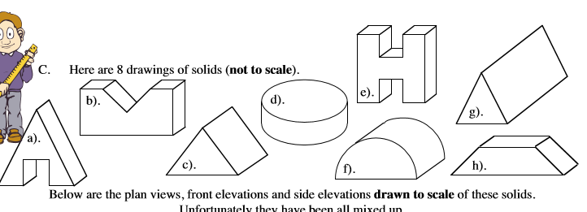

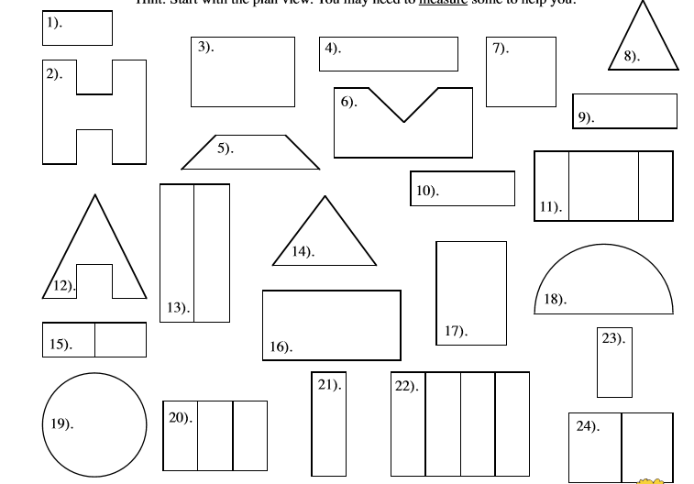

Answers

