basicsphotography

THE EXPOSURE TRIANGLE
Each of the three aspects of the triangle relate to light and how it enters and interacts with the camera.
The three elements to photography are:
- ISO: The measure of a digital camera sensor’s sensitivity to light
- Aperture: The size of the opening in the lens when a picture is taken
- Shutter Speed: The amount of time that the shutter is open
It is at the intersection of these three elements that an image’s exposure is worked out. Any change in one of the elements will impact the others. This means that you can never really isolate just one of the elements alone but always need to consider the others.
ISO
In traditional (film) photography ISO (or ASA) was the indication of how sensitive a film was to light. It was measured in numbers (100, 200, 400, 800 etc). The lower the number the lower the sensitivity of the film and the finer the grain in the shots you are taking.
In Digital Photography ISO measures the sensitivity of the image sensor. The same principles apply as in film photography – the lower the number the less sensitive your camera is to light and the finer the grain.
Higher ISO settings are generally used in darker situations to get faster shutter speeds. For example an indoor sports event when you want to freeze the action in lower light. However the higher the ISO you choose the noisier* shots you will get. *By noisier, I mean the amount of grain on an image.
Aperture is the opening in the lens, when you hit the shutter release button of your camera a hole opens up that allows your cameras image sensor to catch a glimpse of the scene you want to capture. The aperture that you set impacts the size of that hole. The larger the hole the more light that gets in and the smaller the hole the less light.
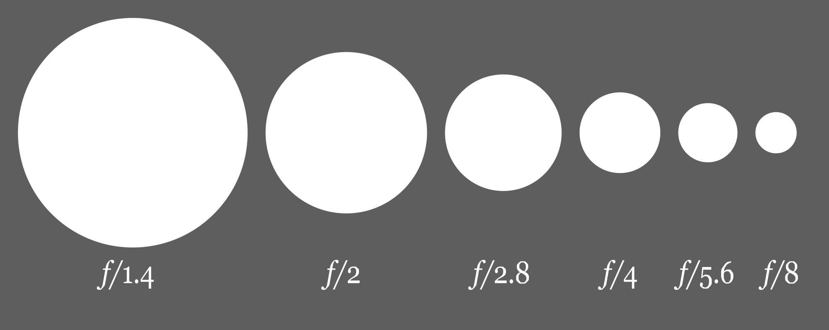
Aperture is measured in ‘f-stops’. They are often referred to as f/number - for example f/2.8, f/4, f/5.6,f/8,f/22 etc. Moving from one f-stop to the next doubles or halves the size of the amount of opening in the lens (and the amount of light getting through).
APERTURE
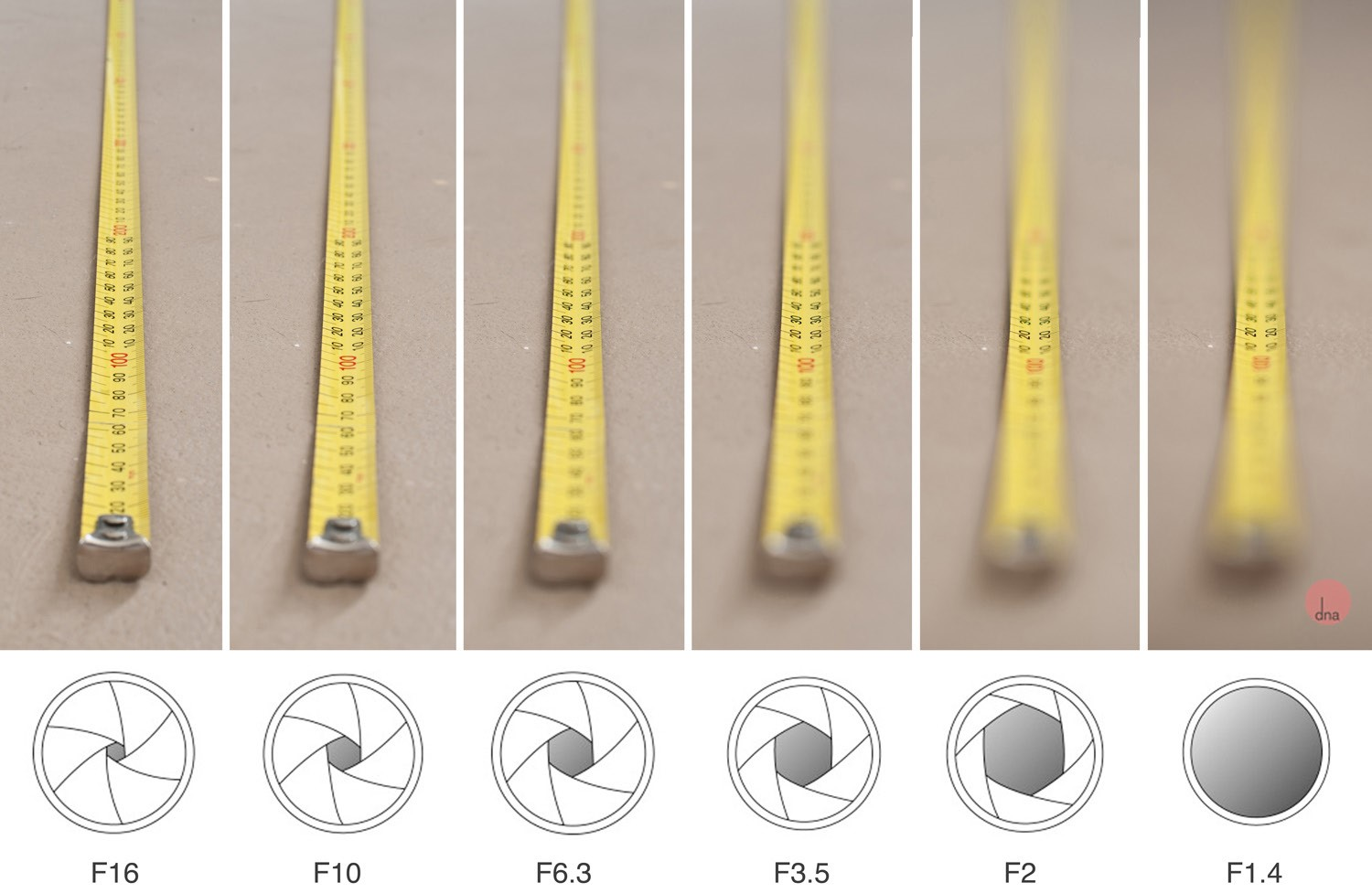
Keep in mind that a change in shutter speed from one stop to the next doubles or halves the amount of light that gets in also. This means if you increase one and decrease the other you let the same amount of light in.

DEPTH of FIELD
Depth of Field (DOF) is the amount of your shot that will be in focus. Large depth of field means that most of your image will be in focus whether it is close to the camera or far away.
Small/shallow depth of field means that only part of the image will be in focus and the rest will be fuzzy. Aperture has a big impact upon depth of field. Large aperture will decrease depth of field while small aperture will give you larger depth of field.
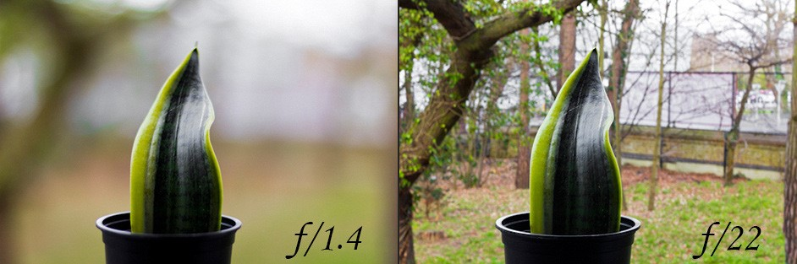
Basically, small numbers mean small DOF and large numbers mean large DOF*. (*to make it easier to remember*)

SHUTTER SPEED
Shutter speed is ‘the amount of time that the shutter is open’.
In film photography it was the length of time that the film was exposed to the scene you are photographing and similarly in digital photography shutter speed is the length of time that your image sensor ‘sees’ the scene you’re attempting to capture.
Shutter speed is measured in seconds, the bigger the denominator the faster the speed, for example: 1/1000 is much faster than 1/30.
However, anything slower than 1/60 is very difficult to use without getting camera shake. Camera shake is when your camera is moving while the shutter is open and results in blur in your photos.

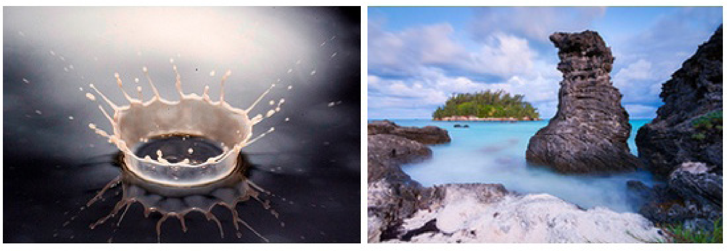
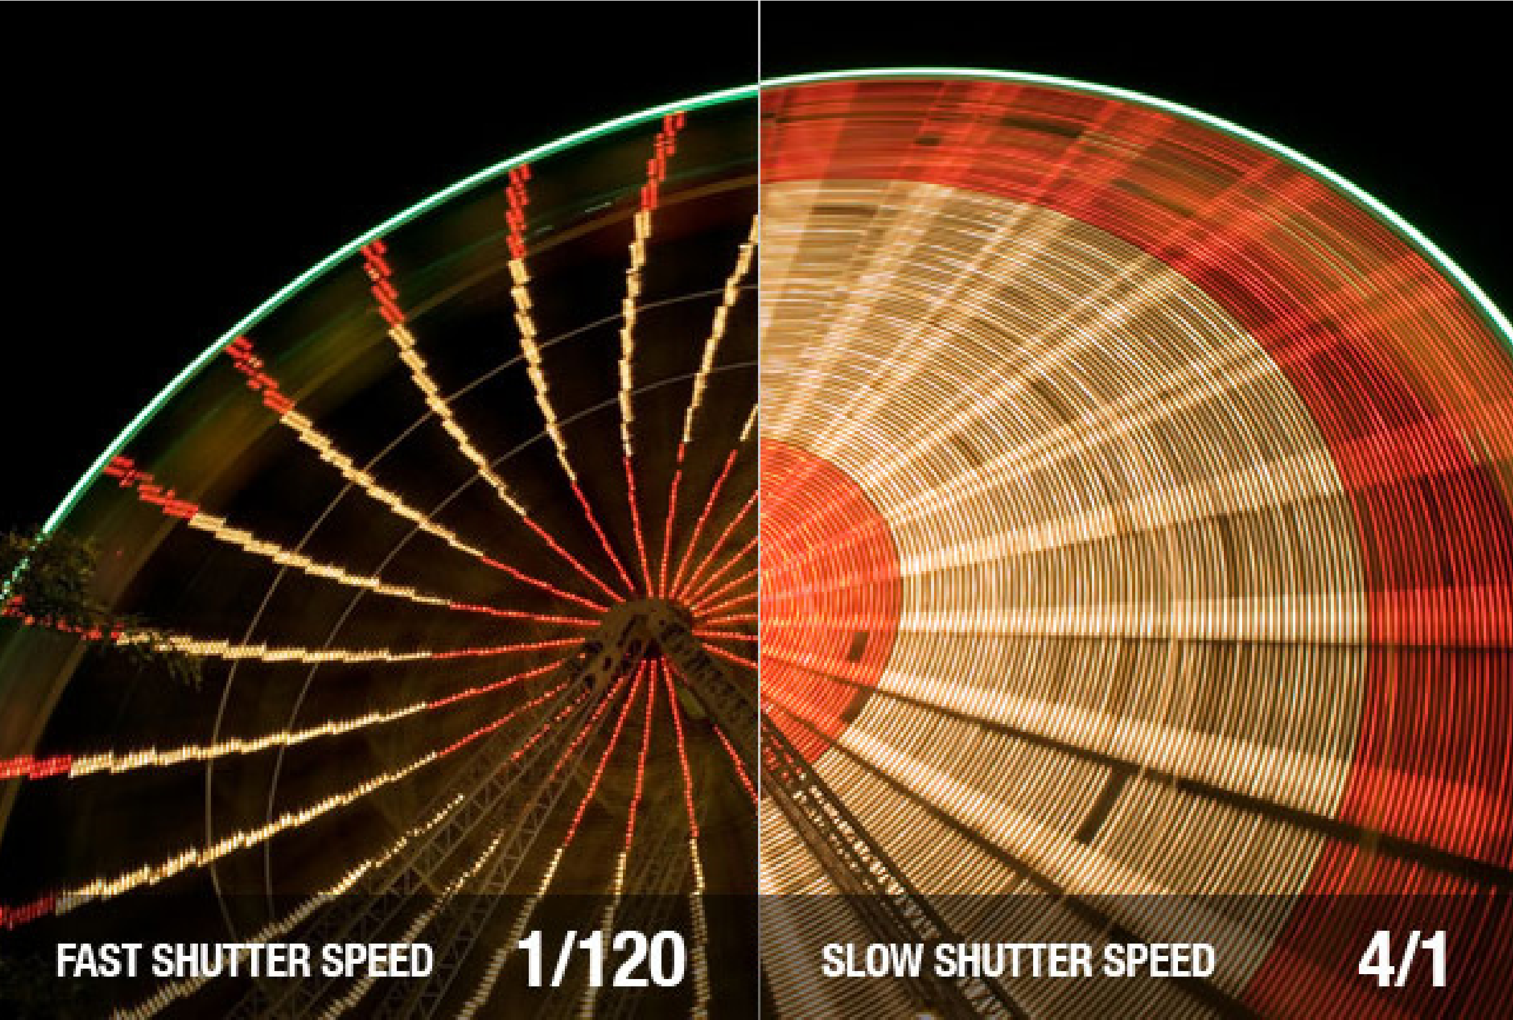
SHUTTER SPEED CONTINUED
FAST SHUTTER SPEED
SLOW SHUTTER SPEED
Takes photo right away.
Takes time to capture.
Freezes Motion Slows Motion
If you are using a slow shutter speed (anything slower than 1/60) you WILL need to use a tripod.

DIGITAL LONG EXPOSURE
Some cameras also give you the option for very slow shutter speeds that are not fractions of seconds but are measured in seconds: For example, 1 second, 10 seconds, and 30 seconds etc. These are used in very low light situations, when going after special effect and/or when trying to capture a lot of movement in a shot.
For Example, when taking a photo of a waterfall or seascape and want to show how fast the water is flowing, or when taking a shot of star trails and want to show how the stars move over a long period of time, or other moving objects/people. However, in all these cases you NEED to use a tripod when shooting long exposure or you run the risk of ruing the shots by adding camera movement. (We do not want camera movement). Some cameras give you the option to shoot in ‘B’ (bulb) mode*.
*Bulb mode lets you keep the shutter open for as long as you hold it down.
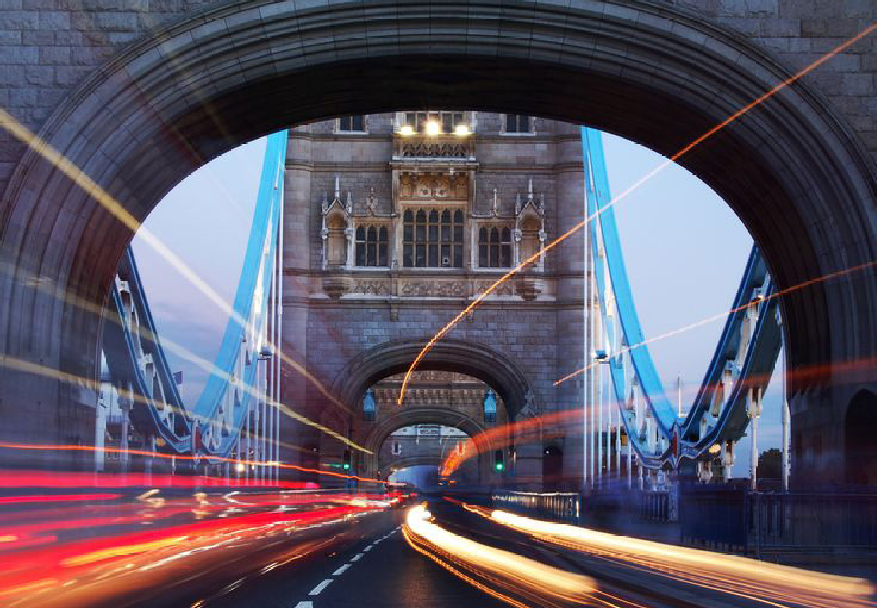
Another thing to consider when choosing shutter speed is the focal length of the lens you are using. Longer focal lengths will accentuate the amount of camera shake you have and so you will need to choose a faster shutter speed. The ‘rule’ of thumb to use with focal length is to choose a shutter speed with a denominator that is larger than the focal length of the lens. For example if you have a lens that is 50mm 1/60th is probably ok but if you have a 200mm lens you’ll probably want to shoot at around 1/250.

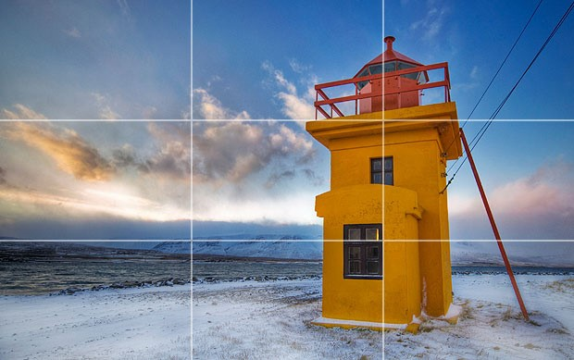
basicscomposition

THE RULE OF THIRDS
Imagine that your image is divided into 9 equal segments by 2 vertical and 2 horizontal lines. The rule of thirds says that you should position the most important elements in your scene along these lines, or at the points where they intersect. Doing so will add balance and interest to your photo.
LEADING LINES
Some cameras even offer an option to superimpose a rule of thirds grid over the LCD screen, making it even easier to use.
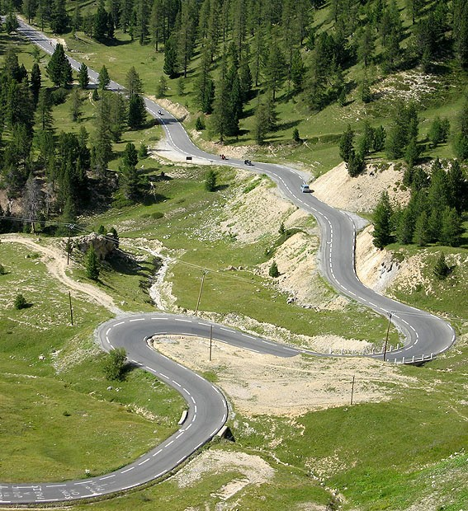
When we look at a photo, our eye is naturally drawn along lines. By thinking about how you place lines in your composition, you can affect the way we view the image, pulling us into the picture, towards the subject, or on a journey “through” the scene. There are many different types of line - straight, diagonal, curvy, zigzag, radial etc - and each can be used to enhance our photo’s composition

SPIRAL COMPOSITION
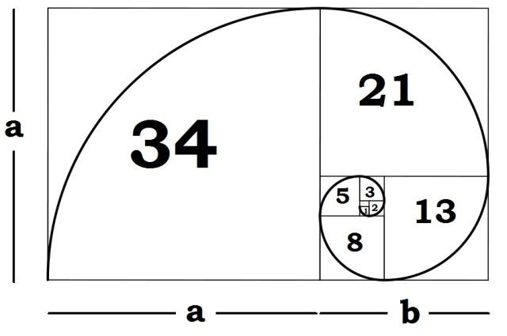
If you have read The Da Vinci Code, you know the Fibonacci sequence: you start with the number 1, add the previous whole number, and make an endless series of numbers with that pattern. So the series looks like this:
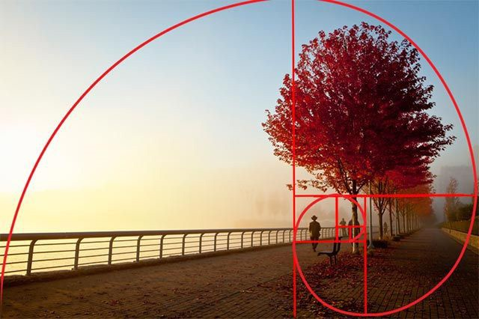
1 , 1 , 2 , 3 , 5 , 8 , 1 3 , 2 1 , 3 4 , 5 5 , 8 9 …
In terms of actual photography,
you don’t need to worry about the
technical explanation. Fibonacci
Spirals are useful for nearly every
kind of photography,
however, they
are especially good for landscapes
and wide shots.
As you can see, the
spiral
basically
has a way of leading your eye
naturally from the focal point
outwards.
HOW TO USE THE SPIRAL
Fibonacci discovered that this “golden spiral” appears in several places throughout nature, from DNA molecules to flower petals, from hurricanes to the Milky Way. More importantly, the Fibonacci spiral is pleasing to the human eye.
Adrian Bejan, professor of mechanical engineering at Duke’s Pratt School of Engineering, says the golden ratio is aesthetically pleasing because of the evolution of human vision. Long story short, our brain has to process everything our eyes see. The quicker it can process something, the more pleasing it is.
Any image with the golden ratio is processed faster by the brain, so it sends a signal that such an image is aesthetically pleasing.
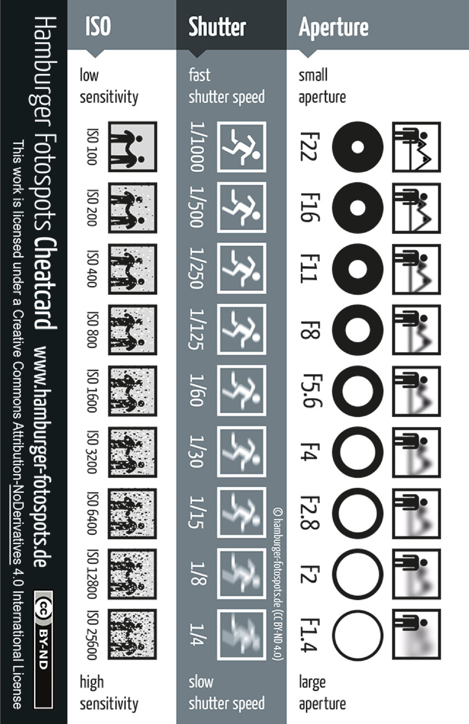
cheat sheet
Photography

