Investigating the character: Creating a monologue
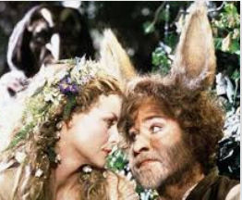
Directors will often encourage actors to improvise and create imaginary scenes that happen outside the text of the play. This helps the actors’ understand the characters better.
In this lesson you will take on the role of an actor playing Bottom or Titania. You will experiment with creating and performing a monologue to help you understand how the characters’ feel.

Task 1 (30 Minutes)
Write a monologue (a solo speech) given either by Bottom, expressing his thoughts on the situation he finds himself in, or Titania, expressing her feelings about how she has found true love, and no longer loves Oberon. Think about where these characters are mentally and emotionally and put that into your writing. You might want to include stage directions. Write your monologue in the box below.
Character…….

Task 2 (20 minutes)
Rehearse your monologue, think about your use of movement, physical and vocal skills and eye-contact with the audience. To help the audience understand your character
Either perform this monologue to a family member or record yourself performing this monologue

Task 3 (10 Minutes)
Assess your performance – think about tone, volume, inflection, expression, characterisation and believability.
In my performance I tried to show

I did this by

A strength of my performance was

Because

Next time I would improve by

