Year 7 French – les animaux
- Can you translate these animals in to English?

le tigre ____________________________
le loup ____________________________
l’éléphant ____________________________
le lion ____________________________
le zèbre ____________________________
l’hippopotame ____________________________
le girafe ____________________________
la hyène ____________________________
le singe ____________________________
le rhinocéros ____________________________

- Try to work out where your teachers ships are.

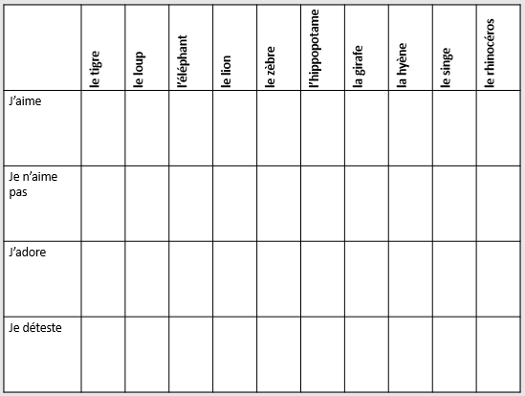

- Underline/highlight all of the words you know or can work out.

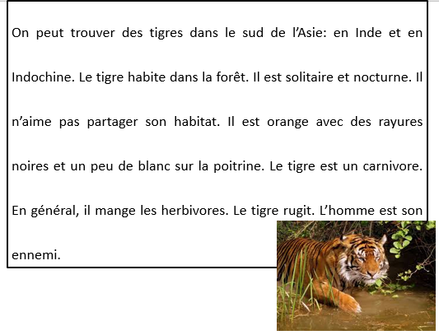
- In the second column, write what you think each word means. Don’t worry if you don’t know them all.

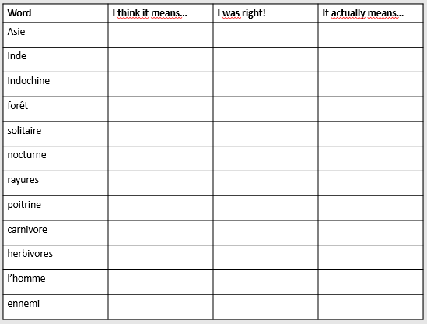
- Try to fill in the Idenity card for the text that you have just looked at.

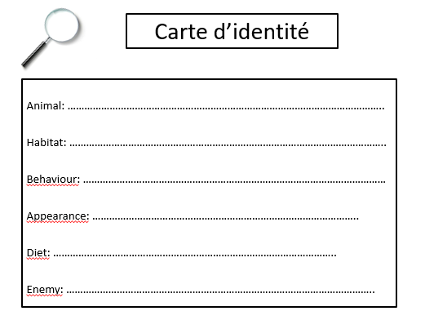
- Colour the thermometer to show your understanding and write a reason below.

