Year 7 English, Lesson 2 – Similes Worksheet WC 13.7.20
How can we create effective similes to make our description really interesting to read?

DOW NOW
Think back to the last few lessons….
- What does ‘detail’ mean?.......................................................................................................................
- What are the 5 senses? …………………………………………………………………………………………………………………….
- What does atmosphere mean? …………………………………………………………………………………………………………
Challenge: What did these keywords mean? Cobalt Luminous Vibrant

What is a simile? A simile is where we compare 2 things using ‘like’ or ‘as’.
You must compare 2 things that make sense though.

TASK 1
Which simile describes the sand the best? Why?
- The sand was as soft as cotton wool.
- The sand was like walking on marbles.
………………………………………………………………………………………………………………………………………………………………………………………………………………………………………………………………………………………………………………………………………………
Challenge: Think of your own simile to describe the sand.

TASK 2
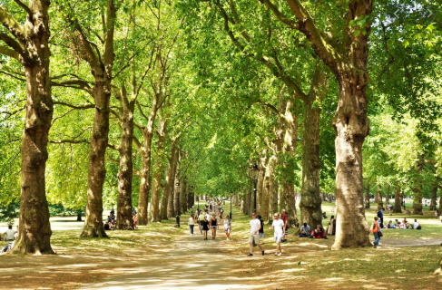
Which simile is best for describing these trees? Why?
Think about the atmosphere (mood) of the picture.
- The trees were like umbrellas protecting me from the sun.
- The trees were like monsters crowded together.
………………………………………………………………………………………………………………………………………………………………………………………………………………………………………………………………………………………………………………………………………………………
Challenge: Think of your own simile to describe the trees or anything else in the picture.
…………………………………………………………………………………………………………………………………………………………………………………………………………………………………………

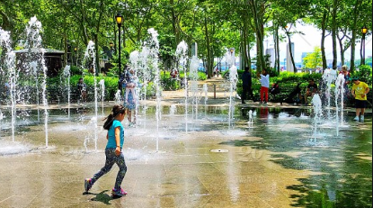
Which simile is best for describing the water? Why?
Think about the atmosphere (mood) of the picture.
- The water droplets were like glass smashing on the ground.

- The water droplets were like diamonds glittering in the sunlight.

………………………………………………………………………………………………………………………………………………………………………………………………………………………..
Challenge: Think of your own simile to describe the water or anything else in the picture.
…………………………………………………………………………………………………………………………………………………………………………………………………………

TASK 3
Let’s add some details to these similes.
- The sand was as soft as cotton wool.

- The trees were like umbrellas protecting me from the sun.

- The water droplets were like diamonds glittering in the sunlight.
Challenge: Use ambitious vocabulary (WOW words).

TASK 4
Think of as many similes as you can to describe this picture.
The fireworks were as colourful as…
The fireworks were as loud as…
The fireworks were like…..
The sky was…..
The river was…..
The tower looked like…..

TASK 5
Think back to the last few lessons. Remember to zoom in and use the senses.
You must include some similes.
Challenge: Include personification. Remember this is when you give non-living things human characteristics. For example: ‘The clouds danced across the sky’. (clouds can’t dance, people do)

Above the city the fireworks......................................................................................................................
...................................................................................................................................................................
...................................................................................................................................................................
...................................................................................................................................................................
...................................................................................................................................................................
...................................................................................................................................................................
...................................................................................................................................................................
...................................................................................................................................................................
...................................................................................................................................................................

TASK 6
Self-assessment – Read through your paragraph from task 5 and then complete the sentences below.
I was trying to create the atmosphere of………
I think I did this by using the simile ………
This simile worked because………

My favourite part of my description is……………
because…….

