Geography Worksheet
LO: Do the impacts of a natural hazard change depending on where you live?
Task 1
On the following image identify what the picture shows from the word bank below it.
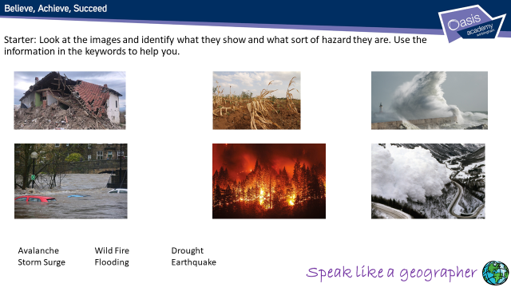
Task 2
Listen to what I say about this table and the data it provides. From this identify which of these countries is a HiC or LiC based on the data, and for a challenge explain your answers.
 | Nepal | Japan | USA | Philippines | UK
Population | 30,327,877 | 125,507,472 | 332,639,102 | 109,180,815 |  | 65,761,117
GDP per person | $2,700 | $42,900 | $59,800 | $8,400 |  | $44,300
Literacy rates | 67.9% | 100% | 100% | 98% |  | 100%
Life expectancy | 71.8 years | 86 years | 80.3 years | 70 years |  | 81.1 years
Hospital beds per 1000 people | 3 | 13.4 | 4 | 1 |  | 3.5
HIC or LIC?
Challenge:
I think this because

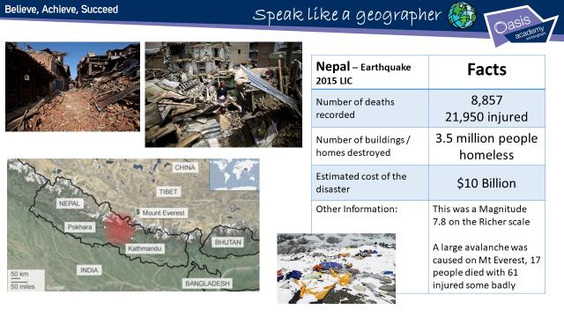
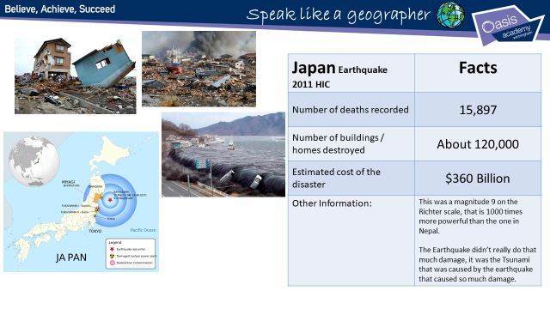
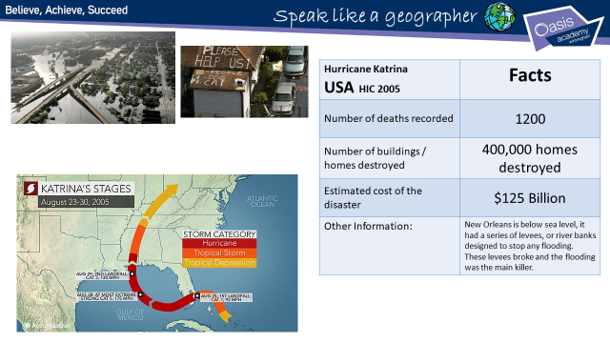
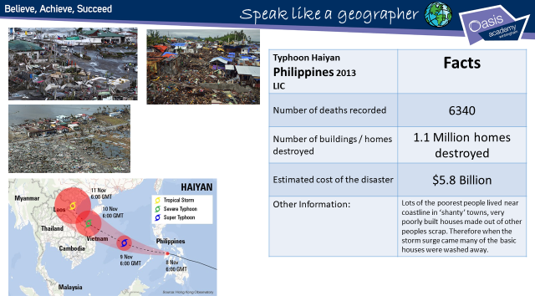

Task 3
Rank these natural hazards into the most and least damaging explaining your answer. (9 marks)
Japan Earthquake (2011), Nepal Earthquake (2015), Typhoon Haiyan (2013), Hurricane Katrina (2005)
From the information provided we can see that all these natural disasters where bad. However as geographers we need to look at the figures in more detail. We also need to think about the natural hazard itself, did it cause the problems or was it things that happened because of the hazard that caused the problems?
So the question: You will need to write your answer on a separate sheet of paper.
You could use this type of format to answer the question if you want:
I think the most damaging natural hazard was……..
I think this because……..
I think the next most damaging natural hazard was………
I think this because…….
I think the third most damaging natural hazard was………
I think the natural hazard that caused the least damage out of the four was…….
I think this because……..
Overall I think that natural hazards cause the most problems in (HiCs or LiCs)………this is because………

