Geography L2 Y8 VHA L.O. What effects do humans have on the rainforest? Causes of Deforestation in the Amazon
Mineral Extraction
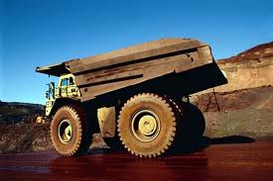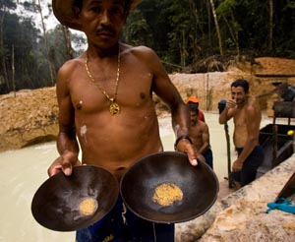
Huge deposits of _____________________________ _________and many other minerals can be found below the Amazon Rainforest. Mining companies have _____________ ___________________through the forest to____________________________________.
However, many miners are illegal and independent.

Population Pressure
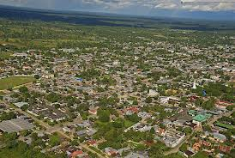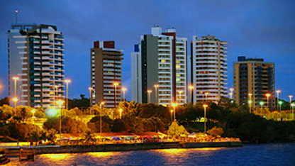
The population is __________ which is putting pressure on the Amazon rainforest. Areas of the rainforest are being _________ to develop new towns and cities. People are encouraged to move from ______ to the Amazon. They also have hope of finding better jobs such as, __________ ________ and __________ all of which encourage deforestation.

Commercial Cattle Ranching
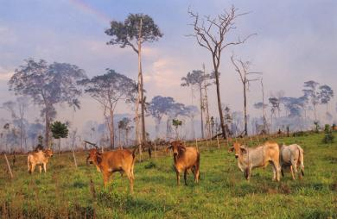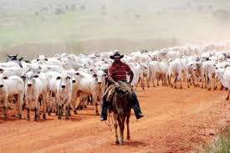
This is run by large _________________ which sell beef mainly to ______________ in developed countries. These companies _______ the forest and replace trees with _________ ________to _______ the cows. The _______________________________ soon declines as____________ are lost. Many ranches have simply increased size because of the __________ for beef from _______ income countries. _____ of deforestation in the Amazon was by cattle ranching.

Transport and Road building
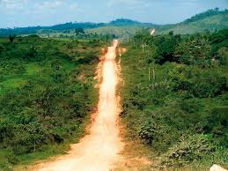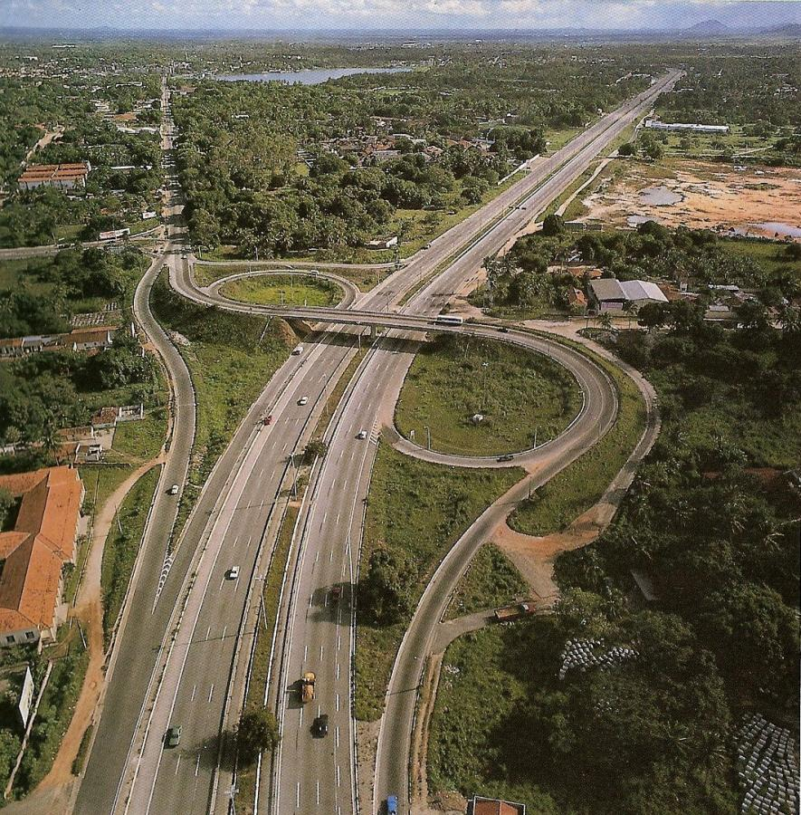
New ________ and i___________ have been built across the rainforest. The largest of these is _______________ ___________________ which is _______ long. These roads were built to_________
________________________. Once a road has been built, _______________________and areas of forest beside the road are cleared.
The increase in demand for beef, wood and housing and lead to the need for more _________ routes.

Logging
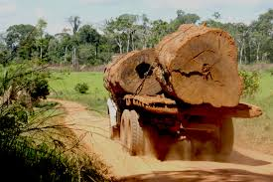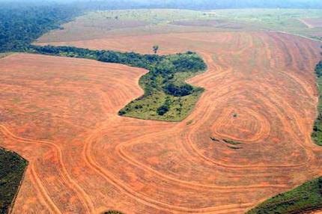
There’s great demand for _____________________ such as mahogany and rosewood. Consumers in HICs find these deep red woods ___________. They are prepared to pay a _______ price for furniture and fittings made from them. Wood can also be sold on to make _______ products.

Information help sheet: Causes of Deforestation in the Amazon
Population Pressure
The population of Amazonia has increased from 2 million in 1960 to over 30 million in 2000. New towns and cities such as Maraba and Carajas have been developed and forest has been cleared to make space for them. People have moved to the rainforest to find better jobs in mining, construction and logging.

Mineral Extraction
Huge deposits of oil, iron ore, aluminium, gold and many other minerals can be found below the Amazon Rainforest. Mining companies have felled (Cut down) trees and built roads through the forest to reach these deposits. Companies often drill or dig open-cast mines in the ground. Trees and soil are removed and rivers are polluted by chemicals. The Carajas Project is an iron ore mine that is the largest of its type in the world. However, many miners are small, illegal and independent.

Commercial Cattle Ranching
This is run by large transnational companies which sell beef mainly to fast-food chains in developed countries. These companies burn the forest and replace trees with grass or soya beans to feed the cattle. Zeebu cattle are reared as they are best suited to the humid climate. The quality of the soil soon declines as nutrients are lost. Many ranches have simply increased size because of this. Between 2000 and 2005, 60% of deforestation in the Amazon was caused by cattle ranching.

Transport and Road building
Over 12,000km of new roads have been built across the rainforest along with other infrastructures. The largest of these is the Trans Amazonian Highway which is 5300km long. These roads were built to transport timber, minerals, crops and people. Once a road has been built, more and more settlers are attracted to the area and areas of forest beside the road are cleared.

Logging
There’s great demand for hardwood trees such as mahogany and rosewood. Consumers in HICs find these deep red woods attractive and pay high prices for furniture and fittings made from them. Random logging means that for every tree that is cut down at least 30 more might be destroyed in the process. 5 million hectares of forest are lost each year in the Amazon as a result.

The Effects of Deforestation on the Amazon
Activity: Look at the information blocks below. Shade the key with four different symbols/colours or letters and then sort the information below into the correct four categories:
Key:
Why is deforestation happening? | Resources of the Amazon Rainforest | Local effects | Global effects
One third of the world’s trees still grow in the Amazon Rainforest. | Minerals provide the region with a vast natural resource. They include diamonds and gold. | Land covered in rainforest is cleared for settlement (places for people from the outside to live).
Deforestation has a direct effect on global climates, contributing to the Greenhouse effect. | Deforestation has an impact on the world’s oxygen supply, as one third is stored in the Rainforests. | Large multi-national companies use the land to run cattle farms, to sell beef to developed countries.
Timber, mainly hardwoods, is taken for markets in developed countries. This is a valuable source of income for Brazil. | A typical patch of Rainforest, holds 1500 species of plant, 750 species of trees, 700 species of animals | One quarter of the world’s fresh water is stored in the Amazon Basin and this store will be reduced if the Rainforest is cut down.
Some of the cattle ranchers and settlements have been abandoned, due to poor soil quality on the previous Rainforest area | Reduction in the number of tribe’s people, a decrease by 96%. Land taken from them. | Soil becomes infertile (not as nutrient rich) as the canopy layer is removed and the rainfall can remove more of the soil.
As large areas of the Rainforest are cut down there is a loss in biodiversity. | There are 25 million landless people in Brazil – new land is needed for settlements | Hydro-electric power is an important renewable resource.
To develop all of Brazil, the government has developed a series of roads into the Amazon Rainforest. | There is a growing need for land to be used for farming – cattle and agriculture. | The Rainforest is used as a world tourist site and is protected as a world heritage site.

