Year 8 Simile handout

An adjective is a ______________ word.
Examples:
1.
2.
3.
Challenge: add an adjective to the following sentence to make it even more descriptive.
She walked down the street.

Picture 1
Which simile is best suited for the mood in this picture? 1 or 2. Circle your answer
Challenge:

Picture 2
Which simile is best suited for the mood in this picture? 1 or 2. Circle your answer
Challenge:

Which similes make sense? Tick the ones that work.

- The lion was as fierce as a mouse.
- Snow topped the mountain like icing sugar.
- The sun glowed like a glow-stick.
- The mountain was as large as a fly.
- The silk was as soft as sandpaper.
- Like candy floss the fluffy clouds floated peacefully in the sky.
- The setting sun was like a matchstick
Challenge: explain why they work.
Using suitable similes –Finish the following similes.
The moon glowed like…
Raindrops dropped down the window pane like…
The rose petals are as delicate as…
The icicles pointed downwards like…
Challenge: include adjectives in your description to extend the simile. For example her cheeks are red like a delicate rose.

Complete these similes but try to avoid the obvious clichés!
As hot as…

As tough as…

As pale as…

Soft like…

Challenge: add some adjectives to these similes to make them even more descriptive.

Extending our description. Improve the simile: The stars were like spotlights.
- Add in an adjective to describe the stars.
- Add in an adjective to describe the spotlights.
Challenge: where could you include more verbs or adjectives in your simile to improve your description?
The mountains stood tall like…

The stars were gathered together as if…

Like a guiding light…

Challenge: add an adjective or two to your writing so that it makes the similes more descriptive.
Rather than saying: ‘The snow was like a blanket.’
You could say: ‘The fluffy snow was like a soft blanket.’

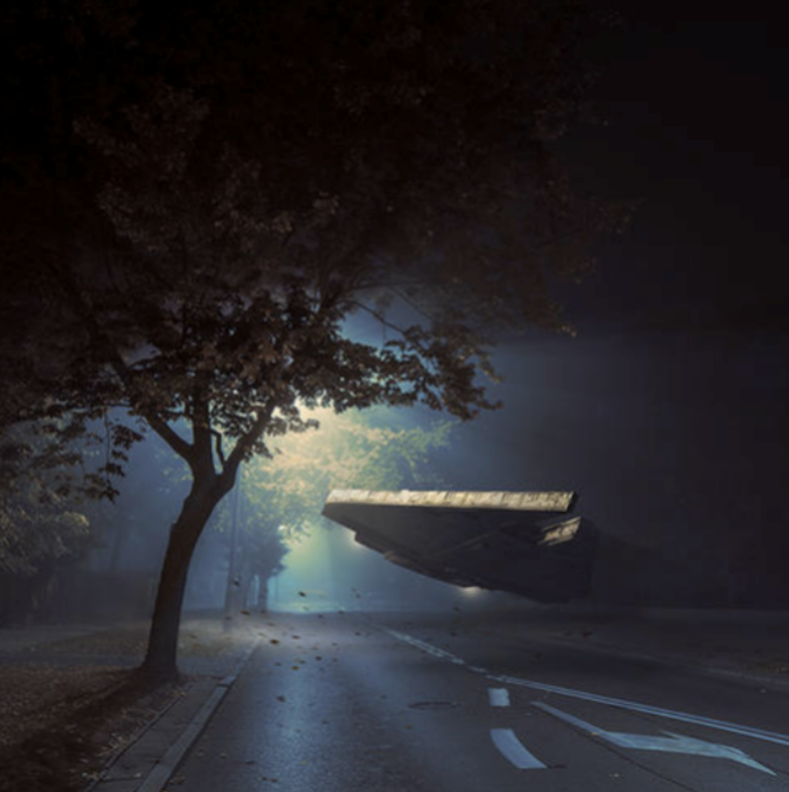
You are going to write a description on the image to the left. But first, you will need to come up with some similes in the table.

Object​ | What does it look like?​ | What could I compare it to?​ | Simile​
The floating object | Concrete, a spaceship | Hoverfly? | Floated in the air like a hoverfly.​
The trees

The street lamps

Challenge: What is further on down the street?

Challenge: pick one of the objects you can see in the image and write a few sentences about it, using personification. Remember: this is when we give something that is not human, human qualities.

Main Task: Write a description of the image, using your simile grid to help you.
The humming noise had disturbed Matthew, and he’d shot bolt upright in bed. After taking a deep breath, he raced his way downstairs to see what was going on in the street…
Things to include:
- Similes
- Interesting verbs
- A tone that suits the atmosphere of the picture.
Challenge: include an example of a metaphor in your work.
Champion challenge: include an example of personification in your work.
You can use the sentence starter above to help you, if you need it.

Self-Assessment
Have you included:
- Similes
- Interesting verbs
- A tone that suits the atmosphere of the picture.
- Challenge: a metaphor.
- Champion Challenge: an example of personification
What went well with your work?
How could you improve your work?
What do you need to include?
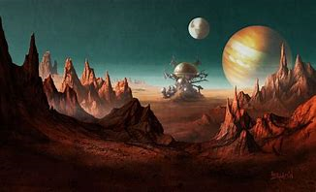
Extension Task:
Write a description of the image on the right.
Things to include:
Similes
Interesting verbs
A tone that suits the atmosphere of the picture.
Challenge: include an example of a metaphor in your work.
Champion challenge: include an example of personification in your work.

