LES FOOTBALLEURS
Objectif: ________________________________________________________

Les mots clés
je vais _________________________________________
aller _________________________________________
faire _________________________________________
jouer _________________________________________
manger _________________________________________
porter _________________________________________
anglais(e) _________________________________________
français(e) _________________________________________
gagner _________________________________________

What does ‘les baskets’ mean?

Match up pictures and words.
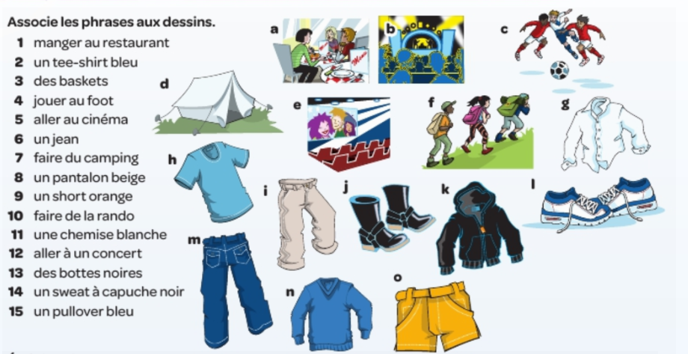

1 8
2 9
3 10
4 11
5 12
6 13
7 14
15
Create 6 short paragraphs. Use the pictures above.

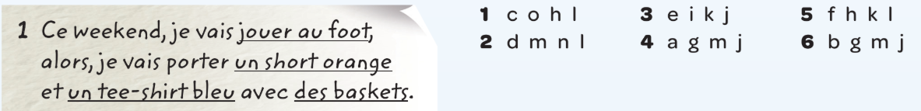

________________________________________________________________________________________________________________________________________________________________________________________________________________________________________________________________________________________________________________________________________________________________________________________________________________________________________________________________________________________________________________________________________________________________________________________________________________________________________________________________________________________________________________________________________________________________________________________________________________________________________________________________________________________________________________________________________________________________________________________________________________________________________________________________________________________________________________________________________________

Facts about Paul Pogba
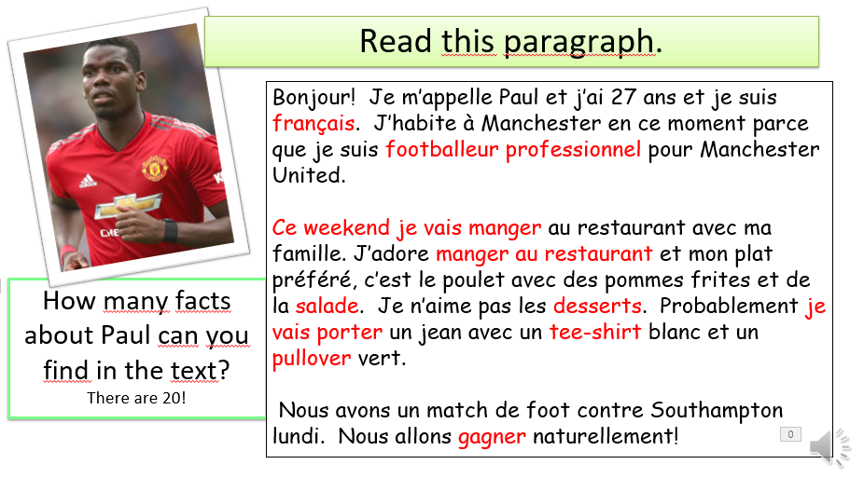

1 2
3 4
5 6
7 8
9 10
11 12
13 14
15 16
17 18
19 20
1 11
2 12
3 13
4 14
5 15
6 16
7 17
8 18
9 19
10 20

Write a longer paragraph about one of the other footballers.
Think about the words and phrases you have already used in this lesson.

Challenge: Add additional information.
E.g. Can you describe the person’s hair, eyes and build? What kind of person is he/she? What do you think of him/her?
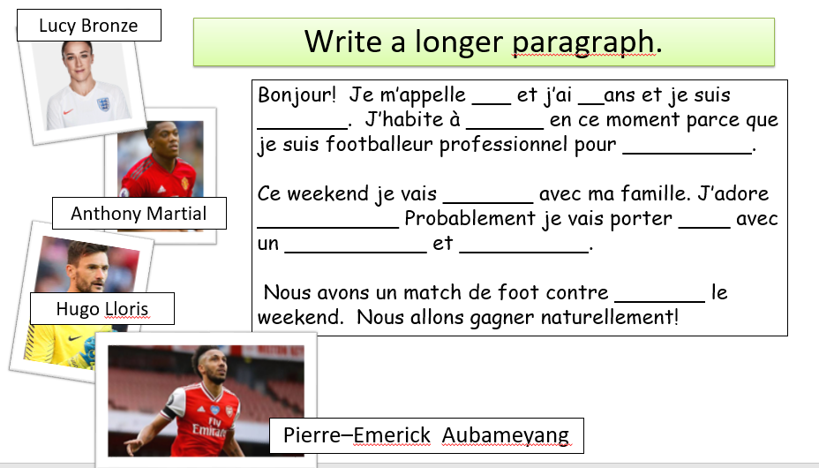

_________________________________________________________________________________________________________________________________________________________________________________________________________________________________________________________________________________________________________________________________________________________________________________________________________________________________________________________________________________________________________________________________________________________________________________________________________________________________________________________________________________________________________________________________________________________________________________________________________________________________________________________________________________________________________________________________
____________________________________________________________________________________________________________________________________________________________________________________________________________________________________________________________________________________
____________________________________________________________________________________________________________________________________________________________________________________________________________________________________________________________________________________

Finalement!
2 questions

1._______________________________________________________________________________________________________________
________________________________________________________

2_______________________________________________________________________________________________________________________________________________________________________

