Date:_______________________________
Do Now
__________________________________________________________________________________________________________________________________________________________________________________________________________________________________________________________________________________________________________________________________________________________________
Starter
Climate change is a ______-_______ change in the earth’s climate. We know this is occurring because of evidence such as __________________ and _________________. Humans are one cause of climate change. For example when we burn f__________ f_______ to create energy for cars or f___________. These produce G________________ Gases such as Carbon Dioxide which lead to the Enhanced G________________ E_________.
In order to manage climate change, we can use methods of M___________ and A_____________. Mitigation is ___________________________________________________________.
Adaptation is __________________________________________________________.

Mitigation – Explain how the following can be used to slow down climate change.
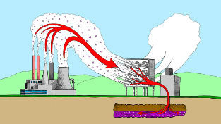
Carbon Capture
________________________________________________________________________________________________________________________________________________________________________________________________________________________________________________________________________________________________________________________________________________________________________________________________________

________________________________________________________________________________________________________________________________________________________________________________________________________________________________________________________________________________________________________________________________________________________________________________________________________
Afforestation
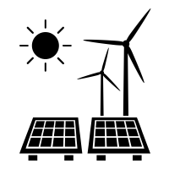
Renewable Energy
________________________________________________________________________________________________________________________________________________________________________________________________________________________________________________________________________________________________________________________________________________________________________________________________________

Adaptation – Match the effect of climate change to the adaptation management strategy
Poor crop production due to high temperatures and low rainfall |  | Coastal flood defences such as sea walls
 |  | Water Butts
Global water shortages resulting in drought |  | Drip Irrigation
 |  | Flood resistant housing
Flood risk due to rising sea levels |  | Reservoirs
 |  | Drought-resistant crops

