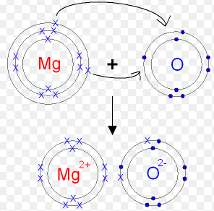

Score / 10

**In this example**

Mg is __________.

O is ___________.

Mg is a ______l

O is a _____-metal.

Mg has ___ electrons in its outer shell.

O has ___ electrons in its outer shell.

Mg will give up or t________ its electron to ______.

**On the top diagram…**

1. What do the 2 arrows show is moving?
2. On the bottom diagram what has happened to the 2 electrons from magnesium?
3. Why do you think that Mg has a 2+ charge and O has a 2- charge?

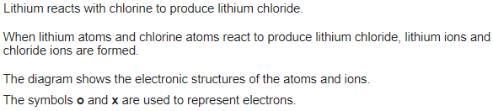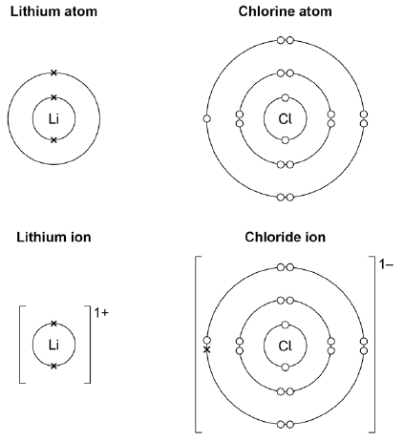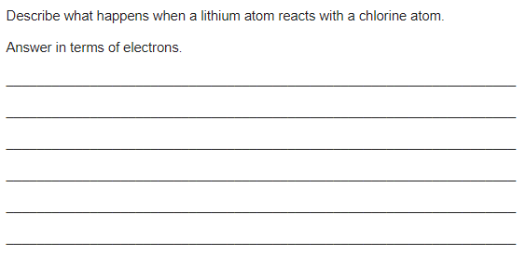

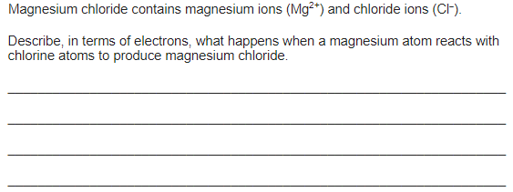

Extension:

