TASK - Writing a letter as Mrs Foster.
We have read the story of Mrs Foster and her husband. We know the dark secret she keeps when she visits her family in Paris.

Re-read this section of the story below.
“She met her grandchildren, and they were even more beautiful in the flesh than in their photographs. They were like angels, she told herself, so beautiful they were. And every day she took them for walks, and fed them cakes, and bought them presents, and told them charming stories.
Once a week, on Tuesdays, she wrote a letter to her husband a nice, chatty letter - full of news and gossip, which always ended with the words “Now be sure to take your meals regularly, dear, although this is something I’m afraid you may not be doing when I’m not with you.”
When the six weeks were up, everybody was sad that she had to return to America, to her husband. Everybody, that is, except her. Surprisingly, she didn’t seem to mind as much as one might have expected, and when she kissed them all good-bye, there was something in her manner and in the things she said that appeared to hint at the possibility of a return in the not too distant future.”

Mrs Foster always wrote to her husband, even though she already knew he was dead. Why did she do this?
__________________________________________________________________________________________ _____

You are going to pretend that you are Mrs Foster writing to your husband at home in New York. You have been in Paris 3 weeks now and have been doing all sorts of things with your daughter’s family.

What sort of things do you think Mrs Foster included in the letters to her husband? What do you think she would have wanted him to know about her trip?

Challenge: Think about the last paragraph in the extract above. What hints do we get in this part of the text that Mrs Foster was looking to change in the future?
What were her plans?
Would she have mentioned this in her letters to her husband? Why/why not?

Have a look at my example of how you can write your letter to ‘your husband’ from Mrs Foster.

Dear Eugene,
It’s been a week since I wrote to you and I wanted to keep you updated with everything I have been doing with our daughter and grandchildren. It really has been the most marvellous three weeks, such a liberating time where I have felt free to enjoy Paris.
It is the most remarkable city. The Eiffel Tower is so pretty at night, there are beautiful lights that sparkle and look like stars winking at everyone. I have climbed over 200 steps to get to the very top and the view is phenomenal. You can see the whole of Paris, the streets snaking away like the secret catacombs beneath the city.
The children ask about you all the time. They want to know what their ‘grand-pere’ (grandfather) is like and when he is coming to visit them. They are desperate to show you the beautiful churches and take you on a river cruise on the Seine.
Your daughter also wants to make sure you are coping without me. She sends her love and thanks you for the combs you have sent for her.
Now be sure to take your meals regularly, dear, although this is something I’m afraid you may not be doing when I’m not with you.

I’ll be home before you know it,
Your loving wife.

Can spot any clues that I have added that show that Mrs Foster already knows her husband is dead…

Your turn! - Write 3 paragraphs about the things Mrs Foster has been doing in Paris. Make sure you write it in the form of a letter.
Look below for some handy hints for the different landmarks she could have visited with her grandchildren. Think about how you can include these in your writing.

Things that are in Paris that you could use in your letter
The Eiffel Tower
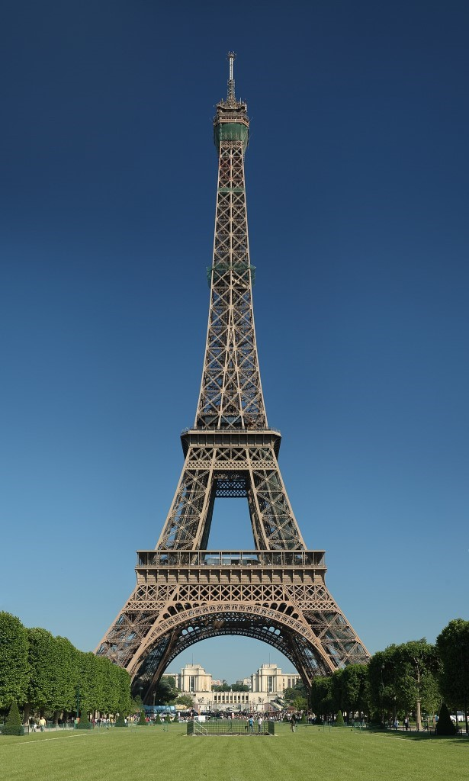
Notre Dame – a huge cathedral
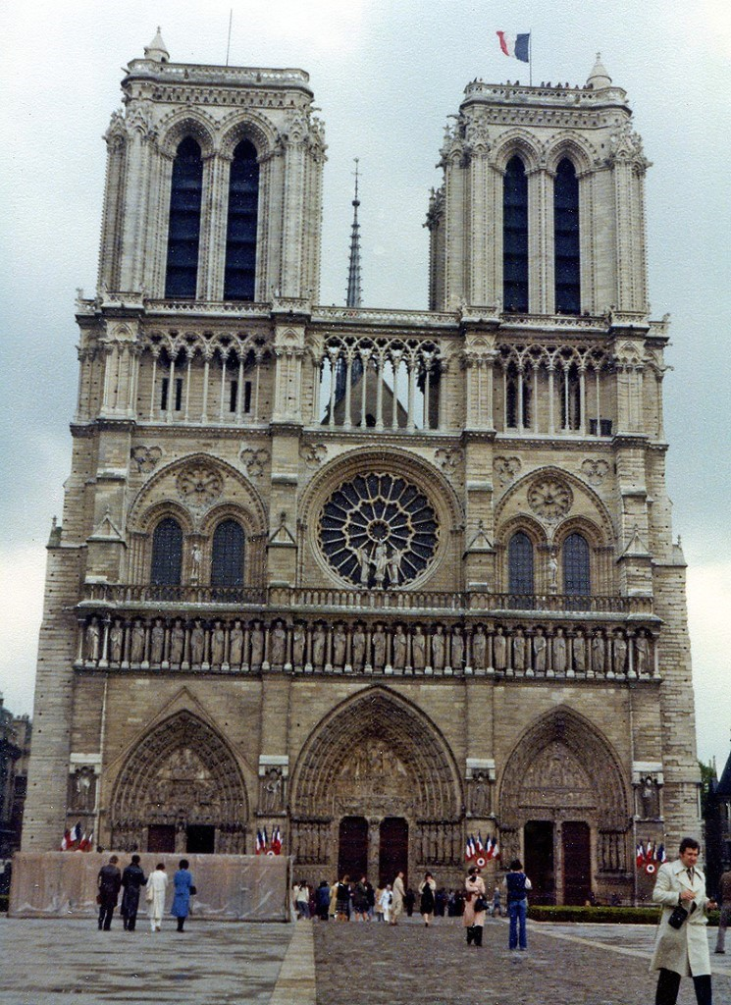
The Louvre – the world’s largest art museum where the ‘Mona Lisa’ hangs

Seine River- for an evening river cruise
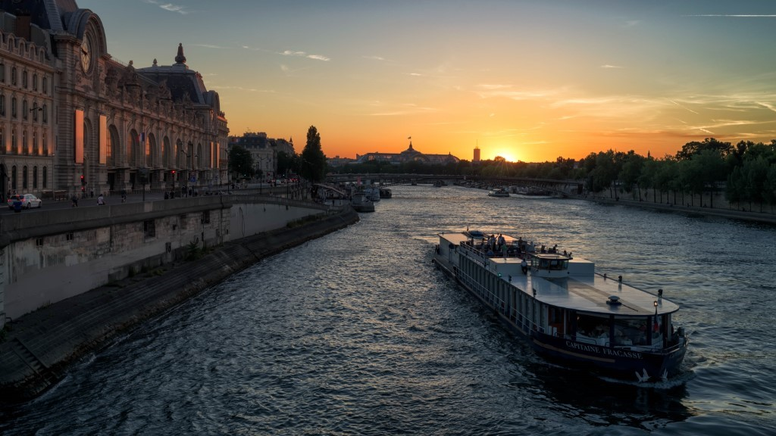
Bustling cafes for baguettes and croissants
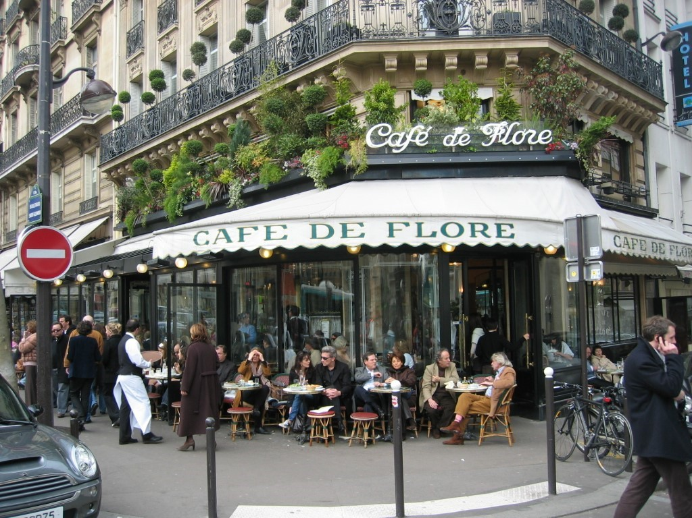
Sentence stems:
Dear Eugene,
I wanted to write to you to let you know…
During my time in Paris I have been…

