Work, energy, and power

Aims
In this exercise, you will read the summary text provided and answer questions relating to work, energy, and power.
Learning objectives
After completing this activity, you should be able to:
- state the units of energy and power
- define work and power
- describe energy stores and transfers for some processes
- calculate the work done and the power transferred.
Setting the scene
Work is done when forces are used to transfer energy between stores. When a body is lifted off the ground, energy is transferred to a gravitational potential store. When an elastic band is stretched, energy is transferred to an elastic potential store. When a body is pulled across the ground and experiences friction, energy is transferred to a thermal store.
Work is calculated using the equation:
work done (J) = force (N) × distance (m)
The force has to be in the same direction as or the opposite direction to the direction of motion for work to be done.
You can calculate energy stored in a spring using the equation:
energy stored (J) = × spring constant × extension2
Power is energy transferred per second or the ‘rate’ of energy transfer. The more energy transferred between stores per second, the greater the power rating. This is shown by the equation:
power (J/s or W) =
Energy and power are both scalar quantities as they have a size but not a specific direction.
Questions
1 Fill in the spaces in the statements below to complete the sentences. Use the words, numbers or units from the box provided, using each one only once. (10 marks)
600 more longer joule J/s
shorter kinetic watt scalar greater

a The unit of energy is the …………………… and the unit of power is the …………………… .
b The energy store of a moving car is mostly …………………… energy.
c If a force of 20 N moves a distance of 30 m then the amount of work done will be …………………… J.
d A power of 1 W is the same as 1 …………………… .
e The power rating will be greater if work is done over a …………………… period of time.
f The …………………… that a device is used for and the …………………… its power rating, the …………………… energy will be transferred.
g Energy and power have a size or magnitude, but no specific direction, so they are …………………… quantities.

2 Calculate the work done in each of the examples below:
a A car being pushed with a resultant force of 800 N for 30 m.

(3 marks)
b A book of mass 850 g being lifted onto a shelf that is 4.5 m above the desk on which it was initially placed. (HINT – 850g = 0.85Kg or 8.5N)

(3 marks)
c A spring with spring constant 40 N/m being stretched from 12 cm to 20 cm.

(3 marks)
3 Fill in the missing values in the table below. (5 marks)
Power | Energy transferred | Time in s
 | 3000 J | 60
1200 W |  | 3600
800 W | 2.8 × 109 J
 | 0.02 J | 2 × 10−3
1.2 kW | 900 MJ

Set 1-3 should have a go at question 4 as a challenge. For all other groups this is optional.
4 A man of mass 85 kg runs up a flight of stairs of height 4.6 m in a time period of 12 s.
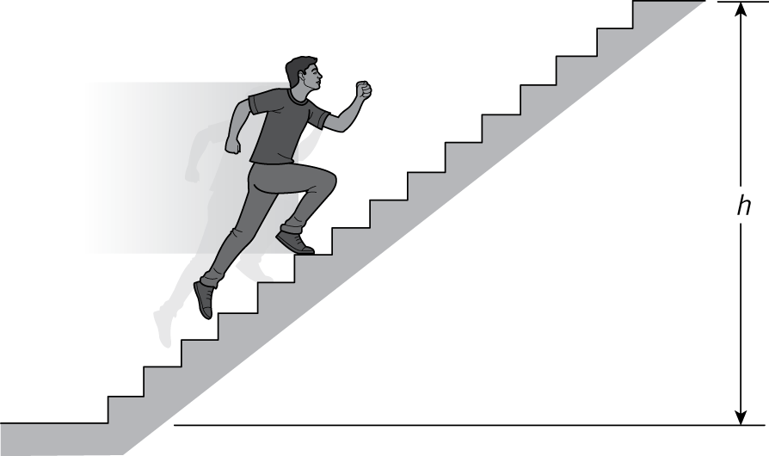
a Calculate the man’s power rating when doing this.
HINT – you will need to calculate work done first! –This will tell you the amount of energy transferred.

(3 marks)

