Year 10 COVID work
Atomic structure information sheet
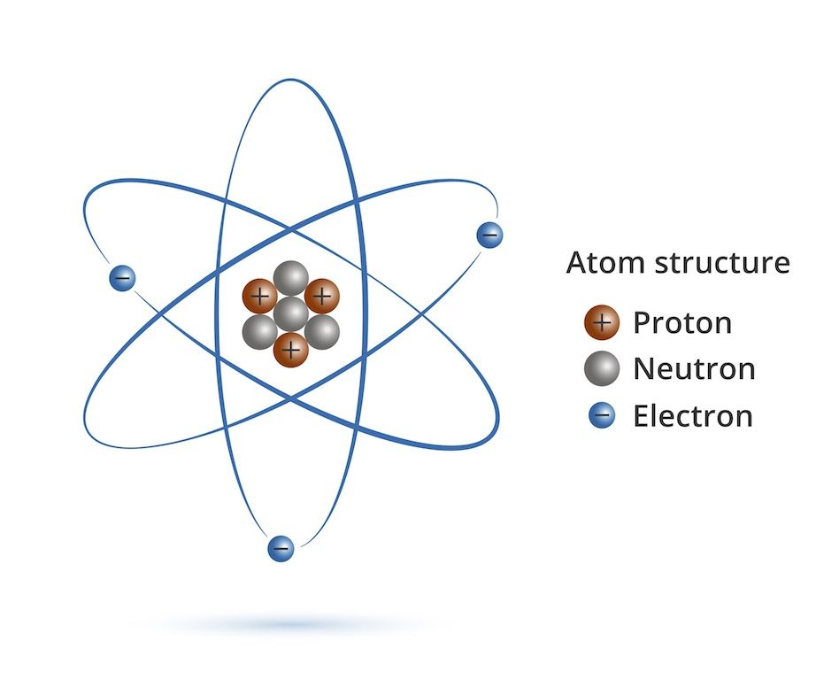
Please read the information then answer the exam questions.
The Atom
The atom contains 3 smaller particles.
The protons, the neutrons and the electrons.
Protons have a positive charge.
Electrons have a negative charge.
Neutrons are neutral.

Protons and neutrons live together in the middle, called the nucleus.
Electrons are constantly moving around the outside of the atom.

Protons and neutrons are relatively the same size.
Electrons, compared to protons, are so small they are almost negligible in mass.

The number of protons decides the element. If an atom has 6 protons, it is carbon.

Electron levels
Electrons in atoms are arranged into energy levels.
A neutral atom will have the same amount of electrons as protons, eg oxygen has 8 protons, so an oxygen atom will have 8 electrons.
The first energy level contains a maximum of 2 electrons, the next level contains max 8 and the next level’s maximum is also 8.

Oxygen has 8 electrons, so they will be organised: 2, 6.

1st energy level Outer energy level.

The periodic table

The periodic table is organised into groups and periods.
Groups go down Periods go across.

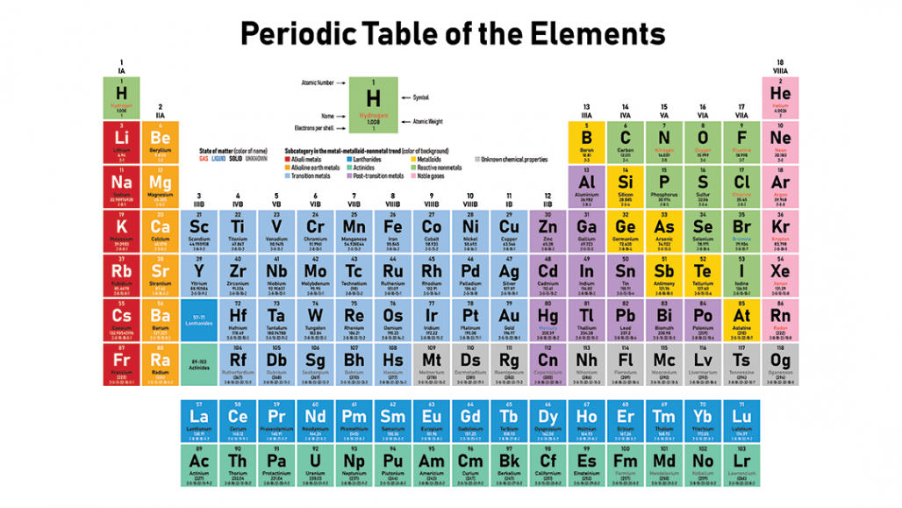
The group the atom is in, is equal to the number of electrons in the outer energy levels, for example, lithium is in group one, it has 1 electron in the outer energy level. Chlorine, in group 7, has 7 electrons in the outer energy levels.
Period 3
Group 1

