Activity 1: mapping hot deserts
Use the internet to label your map with the names of the countries where there are hot deserts (you can list them if you don’t want to print/use tech). You could also draw on the Equator and Tropics of Cancer and Capricorn.

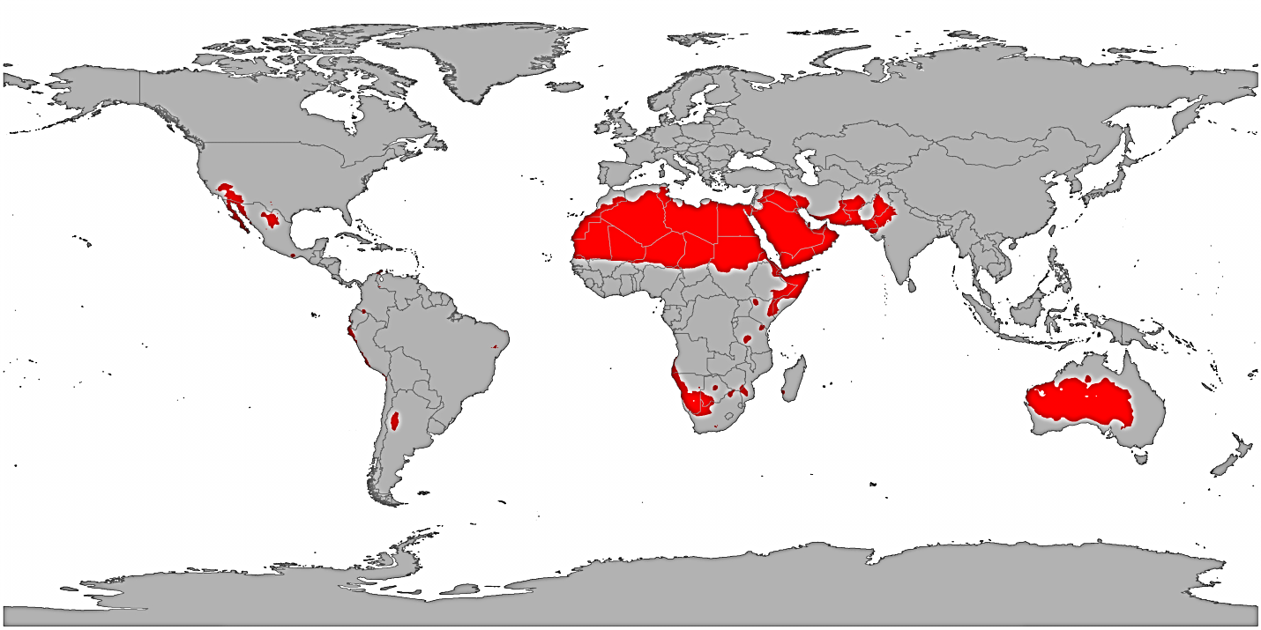

Activity 2: diamond-nine
Which factors affect the development of hot desert environments?
- Look at the nine physical challenges, arrange them from the most important factor to the least in a diamond shape. Annotate your diamond with your justifications. You must include a justification for the most and least important factors as a minimum.
- Then repeat this activity for the human challenges to development.

Physical challenges:

Arid climate | Shifting sands | Thin vegetation
Floods | Thin soils | Salty soils
Extreme heat | Wind erosion and dust storms | Hostile ecosystem

Human challenges:

Remote | Population growth | High cost of providing water
Pollution threats | Existing nomadic populations | Lack of roads
Desertification | Salinisation | The need for conservation

Conclusion:
Which are the greatest challenges – human or physical? Justify your opinion (9).

