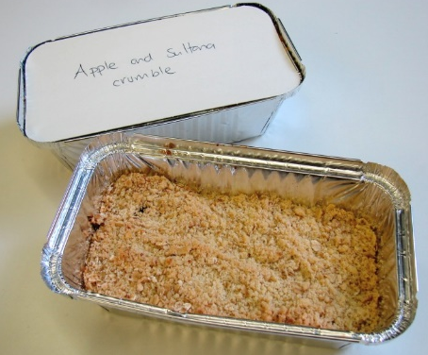
Technology work year 7
Apple and sultana crumble

Questions to be completed

Name two different fruits you could use to make this dish
..................................................................................................................................................................
What are the weights of the ingredients needed for this dish?
..................................................................................................................................................................
What other ingredients could you add in to the topping?
..................................................................................................................................................................
How long should it be in the oven for to ensure it is cooked thoroughly?
..................................................................................................................................................................
Give 2 examples of what you could use if fresh fruit is not available.
..................................................................................................................................................................
What could this dish be served with give 3 examples?
..................................................................................................................................................................
What temperature should the oven be set at?
..................................................................................................................................................................

Extension
Design your own fruit crumble. Draw colour and annotate your design.

