Data collection
Use the information from this group of people to help you answer the questions below.
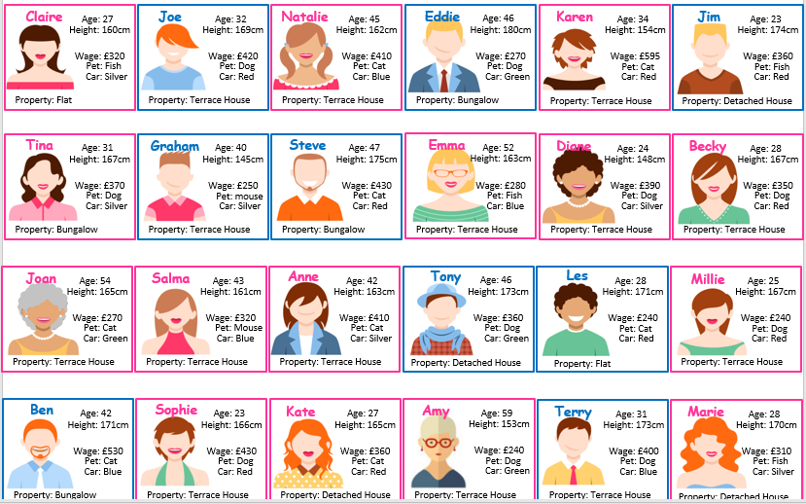

- Complete the table to show how many people are men/ women
Gender | Tally | Frequency
Men
Women

2. Complete the table to show the different type of house each person has:
Type of House | Tally | Frequency
Flat
Terraced House
Detached House
Bungalow

(i) write down the number of people who live in a flat …………………………
(i) what type of house is most frequently lived in? ……………………………….
3. Complete the table to show the type of pet owned by each person. Hint!!! Don’t forget to fill in anything that is missing….
 | Tally | Frequency
Dog
Cat
Fish
Mouse

(i) What is the most popular pet? ……………………………………………………..
(ii) What is the least popular pet? ……………………………………………………
(iii) How many more people own a dog than a cat? ………………………..
4. Below, design your own data collection sheet to show the colour or car that each person has and fill it in from the online profiles.

(i) How many more red cars are there than blue cars?..................................................
(ii) Which car colour is the least popular?........................................................................

Age | Tally | Frequency
21 - 30
30 - 40
40 - 50
50 - 60
5. Johnny has designed his own data collection sheet to show the range in ages of the men and women

(i) Johnny has made a mistake; can you see what he has done wrong?
…………………………………………………………………………………………………………………………………………………
(ii) Below, show what you would change to Johnny’s data collection sheet to make it right and fill in the data from the online profiles.
Age | Tally | Frequency

(iii) Which age has the highest frequency? …………………………………………………………………..
6. Look at the wages per week each person earns.
(i) What is the largest salary that is earnt?..........................................
(ii) What is the smallest salary that is earnt? …………………………………….
(iii) Thinking of suitable intervals, design your own data collection sheet below to show the weekly salary that is earnt each week.

(iiii) Now that you have collected your data, write down 3 things that it tells you.

1.

2.

3.

Challenge
- Design a suitable data collection sheet to show the range of heights of the men and women.

Answers

- Men 9 women 14
- Flat 1 terrace 14 detached 4 bungalow 4
- 1
- Terrace
- Dog 10 Cat 8 Fish 4 Mouse 2
- Dog
- Mouse
- 2
- Design your own collection sheet
- Answers could vary because the columns overlap. For example age 30 is in two columns, so which box would you use. You need to ensure the column numbers do not overlap.
- Largest is £595 smallest is £240
Design your own.

