Data Collection
Ben’s diagram shows the colour of cars in a car park. Use this information to answer the questions below.
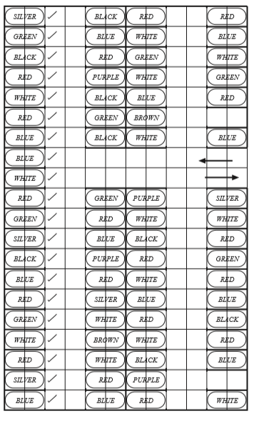

Questions
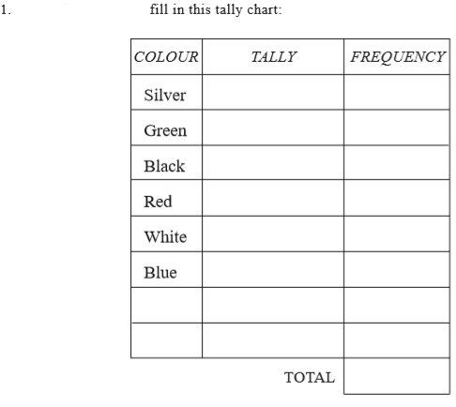
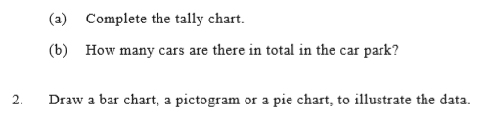

Answers
Silver 5
Green 8
Black 8
Red 18
White 13
Blue 11
Brown 2

